Supporting Information

Figure S1. Triplets locations and the current species distribution 3
Table S1. Stand characteristics for the 12 triplets 4
Appendix A. Backdating and volume estimation 5
Appendix B. Measures of stand structure 7
Vertical species profile index (A_{index}) 7
Relative vertical Species Profile Index (A_{rel}) 7
Coefficient by Gini for characterizing the size and growth hierarchy 7
Table S2. Values of height:diameter (h/d) and height to crown base:diameter ratio for monospecific and mixed-species stands 9
Table S3. Crown allometry functions of Scots pine and Maritime pine 10
Figure S2. Comparison of main starn traits for P. sylvestris and P. pinater pure stands 11
Figure S3. Relative productivity for mixed stands in relation to the neighboring pure stands 12
Figure S4. Correlation values for relative productivity with stand and structure attibutes 13
Figure S5. Relationship between relative productivity with stand ans structural attributes 14

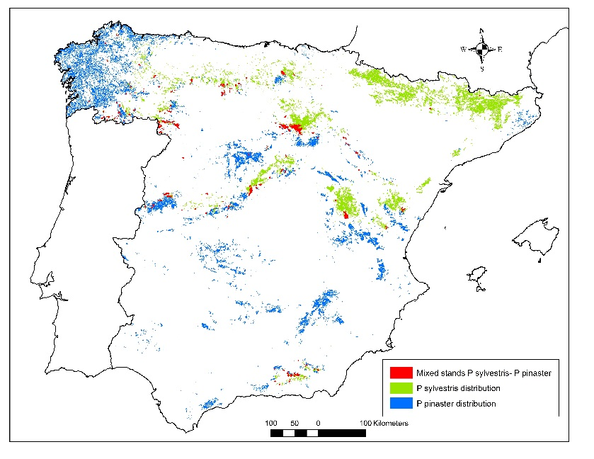

Figure S1. a) Distribution of Pinus pinaster (blue), Pinus sylvestris (green) and mixed stands (red) in Spain, black frame marked the study area. b) The locations of the 12 triplets of Pinus sylvestris and Pinus pinaster (red circles with black center) in relation to the Spanish National Forest Inventory (NFI). NFI plots were considered as pure stands when basal area of the target species was higher than 90% (PS -green dots- for P. sylvestris and PT -blue dots- for P. pinaster) and mixed stands (MM -red dots-) when both species accounted for at least 90% of the basal area and the proportion of each species was higher than 15%.
Table S1. Stand density index (SDI), mean age, and site index (SI) of monoculture and mixed-species plots of the 12 triplets of Scots pine and Maritime pine. Species comparison of stand density index (SDI) between monocultures and mixed stands are in terms of the SDI of mixed-species scaling up to 1 ha using the species’ mixing portions (see Evaluation of mixing effects on stand productivity section). SDI in mixed stands is the sum of contribution of both species to the stand density.
Triplet |  | Scots pine in monoculture | Maritime pine in monoculture | Scots pine in mixture | Maritime pine in mixture | Mixed stand
 | SDI | 898 | 1345 | 1168 | 1130 | 1142
1 | Age | 139 | 68 | 101 | 78
 | SI | 17 | 21 | 14 | 21
 | SDI | 966 | 1290 | 1511 | 1461 | 1478
2 | Age | 107 | 116 | 90 | 82
 | SI | 17 | 18 | 20 | 22
 | SDI | 1054 | 1178 | 988 | 956 | 968
3 | Age | 91 | 103 | 106 | 107
 | SI | 20 | 17 | 17 | 17
 | SDI | 1028 | 876 | 1202 | 1162 | 1186
4 | Age | 112 | 117 | 120 | 118
 | SI | 23 | 19 | 23 | 23
 | SDI | 1007 | 1312 | 1289 | 1246 | 1262
5 | Age | 117 | 101 | 128 | 118
 | SI | 23 | 20 | 20 | 21
 | SDI | 905 | 1062 | 1143 | 1106 | 1119
6 | Age | 120 | 90 | 113 | 124
 | SI | 20 | 17 | 20 | 18
 | SDI | 721 | 810 | 802 | 775 | 794
7 | Age | 41 | 38 | 43 | 44
 | SI | 31 | 27 | 29 | 27
 | SDI | 696 | 759 | 708 | 685 | 694
8 | Age | 42 | 46 | 40 | 44
 | SI | 31 | 29 | 29 | 27
 | SDI | 940 | 1374 | 1265 | 1223 | 1244
9 | Age | 93 | 100 | 86 | 83
 | SI | 20 | 21 | 23 | 26
 | SDI | 998 | 1379 | 1255 | 1213 | 1241
10 | Age | 100 | 109 | 102 | 107
 | SI | 23 | 20 | 23 | 23
 | SDI | 1314 | 1355 | 1272 | 1230 | 1247
11 | Age | 86 | 105 | 93 | 101
 | SI | 23 | 17 | 20 | 23
 | SDI | 958 | 1413 | 1156 | 1118 | 1134
12 | Age | 78 | 78 | 62 | 65
 | SI | 26 | 18 | 23 | 23
SI, site index as the dominant height (m) at age 100 based on the site index curves by Rojo and Montero (1996) and Bravo-Oviedo et al., (2007) for Scots pine and Maritime pine, respectively.

Appendix A. Backdating and volume estimation

Evaluating the effect of mixing species on stand standing volume and volume growth requires information on both the current and past diameter and height of a tree. Volume estimates are typically derived from species-specific equations, which calculate volume as a function of tree diameter and height.

We were able to quantify past diameters directly from tree-ring measures in cored trees. For non-cored trees, a linear regression model was fitted by plot and species to reconstruct the dbh over bark for each plot and species:

id_{t} = a₀ + a₁*dbh₂₀₁₄

where id_{t} is the stem diameter increment for the period t (2004 - 2014), and a₀ and a₁ are intercept and slope of the linear model (OLS regression). Once the diameter increment had been determined, we calculated the dbh in 2004 for all non-cored trees, along with other stand characteristics such as quadratic mean diameter and stand basal area.

To reconstruct individual tree heights for Scots pine and Maritime pine, and to estimate the heights in 2004, we used generalized height-diameter functions that were parameterized for each species in the same study region (Lizarralde, 2008). Both were derived from the Schröder and Álvarez (2001) and Schumacher functions, where h = the height of tree (dm), dbh = the tree diameter at breast height over bark (mm), ho = stand dominant height (dm), dq = quadratic mean diameter of the stand (mm), and b₀… b₃ are specific parameters.

$h=13+\left(27.0392+1.4853∙ho-0.1437∙dq\right)∙e^{\left(\frac{-8.0048}{\sqrt{dbh}}\right)}$ ; for Scots pine

$h=13+\left(32.3287+1.6688∙ho-0.1279∙dq\right)∙e^{\left(\frac{-11.4522}{\sqrt{dbh}}\right)}$ ; Maritime pine

The quadratic mean diameter of the stand and tree dbh at the beginning of the period were calculated, from the 2014 inventory and the tree ring width records, as explained earlier. However, reconstruction of the dominant height required species-specific site index curves depending on stand age. For this purpose, past dominant height was estimated using the site index curves developed by Rojo and Montero (1996) and Bravo-Oviedo et al. (2007) for Scots pine and Maritime pine, respectively.

Past tree height (h₁) was then calculated by multiplying the 2014 measured tree height (h₂) by the proportional difference between its estimated past and current tree height, $\hat{h}$₁ and $\hat{h}$₂, respectively, thereby avoiding negative height growths in the h₁ reconstruction. Stem height reconstruction in mixed plots was based on the species-specific dominant height and quadratic mean diameter in the stand.
$h_{1}=h_{2}\frac{{\hat{h}}_{t1}}{{\hat{h}}_{t2}}$

We calculated standing stand volume (V), periodic stand volume growth (PIV=V-V₂₀₀₄), and their mean annual volume increment (PAIV=(V-V₂₀₀₄)/t) using reconstructed diameters and heights for individual trees and species-specific volume functions (Rodríguez & Broto, 2014):

$v=0.000051∙ {dbh}^{1.845867}∙h^{1.045022}$ ; for Scots pine

$v=0.000048∙ {dbh}^{1.929098}∙h^{0.976356}$ ; for Maritime pine

where, $v$ is the total tree volume (m³), h is the tree height (m), and dbh is tree diameter at breast height over bark (cm).

Bravo-Oviedo, A., del Río, M., Montero, G., 2007. Geographic variation and parameter assessment in generalized algebraic difference site index modelling. For. Ecol. Manage. 247, 107–119. doi:10.1016/j.foreco.2007.04.034
Lizarralde, I., 2008. Dinámica de rodales y competencia en las masas de Pino silvestre (Pinus sylvestris) y Pino negral (Pino pinaster Ait.) de los Sistemas Central e Ibérico meridional. Doctoral Thesis. Universidad de Valladolid, Spain.
Schröder, J.; Álvarez, J.G., 2001. Comparing the performance of generalized diameter-height equations for Maritime pine in Northwestern Spain. Forstw. Cbl. 120: 18-23
Schumacher, F.X., 1939. A new growth curve and its application to timber yield studies. J. For. 37: 819-820
Rodríguez, F., Broto, M., 2014. Ecuaciones de volumen comencial para las principales especies maderables de Castillas y León. doi:10.1007/s13398-014-0173-7.2
Rojo, A., Montero, G., 1996. El pino silvestre en la Sierra de Guardarrama. Ministerio de Agricultura, Pesca y Alimentación, Madrid - España.

Appendix B. Measures of stand structure

Vertical species profile index (A_{index})
The A_{index} characterizes the vertical structure of stands by quantifying the extent to which the stand structure deviates from that of a single-layered pure stand (A_{index} = 0.0). The more heterogeneous the vertical profile, the higher A_{index} becomes (Pretzsch, 1998). In addition to the proportion of the species within a stand, A_{index} takes into account the presence of these species in different height zones:
$$A_{index}=-\sum_{i=1}^{S}{\sum_{j=1}^{Z}{p_{ij}}}×\ln{p_{ij}}$$
where S represents the number of species in the stand, Z the number of height zones, N the total number of individuals, n_{ij} the number of individuals of the species i in zone j, and p_{ij} the proportion of a species in the height zone p_{ij} =n_{ij}/N. Thus the overall species diversity and the vertical spatial occupancy of the species present in the forest stand were quantified.

We calculated A_{index} dividing each plot into three height zones j= (1, 2, 3), which constituted 0–50%, 50–80% and 80–100% of the maximum stand height, respectively.

Relative vertical Species Profile Index (A_{rel})
A_{rel} quantifies the relative degree of structural diversity, i.e., the observed diversity in relation to the maximum structural diversity for the given number of species and number of zones distinguished (Pretzsch, 2009). Therefore A_{index} can be standardized, so that comparisons can be made between stands in which the number species differ.

$$A_{rel }={A }_{index}×\ln\left(S×Z\right)×100$$

Where, S represents the number of species in the stand and Z the number of height zones.

Coefficient by Gini for characterizing the size and growth hierarchy
The coefficient by Gini and curve by Lorenz can be used for quantifying the size or growth hierarchy between the trees in forest stands. A Gini coefficient = 0.0 means that all trees are equal in size (Binkley et al., 2006). These have been used to comparison how mixing can modify the hierarchy between the trees between mixed and pure stands (Pretzsch & Schütze, 2014). Gini coefficient can reveals whether species mixing can favour the stem volume or stem volume growth towards small understory trees compared with pure stands.
$$GC= \frac{\sum_{i-1}^{n}{\sum_{j=1}^{n}{\left|x_{i}-x_{j}\right|}}}{2n \left(n-1\right)× \overline{x}}$$

for quantifying the relative distribution of tree volume (GC_{v}) and volume growth (GC_{iv}), respectively, between the trees in mixed versus pure stands of all 12 triplets. Variables x_{i} and x_{j} denote volume or volume growth for the ith, respectively the jth tree in the stand with i =1…n trees. Gini coefficient for tree volume and volume growth were calculated separately for both species of each triplet and used for indicating the effect of tree species mixing. The higher GC the stronger the inequality of size or growth between the trees.

Binkley, D., Kashian, D.M., Boyden, S., Kaye, M.W., Bradford, J.B., Arthur, M.A., Fornwalt, P.J., Ryan, M.G., 2006. Patterns of growth dominance in forests of the Rocky Mountains, USA. For. Ecol. Manage. 236, 193–201
Pretzsch, H., 2009. Forest Dynamics, Growth and Yield. Springer Berlin Heidelberg, Berlin, Heidelberg. 281-283pp.
Pretzsch, H., 1998. Structural diversity as a result of silvicultural operations. Lesnictvi-forestry 44, 429–439.
Pretzsch H, Schütze G, 2014. Size-structure dynamics of mixed versus pure forest stands. For Syst 23:560–572.

Table S2. Mean values and standard error of height:diameter ratio (h/d) and height to crown base:diameter ratio for monospecific and mixed-species stands of Scots pine and Maritime pine.

Structure traits | PS_{pure} |  | PT_{pure} |  |  | PS_{mix} |  | PT_{mix} |  | Mix_{obs}
 | mean | SE | mean | SE |  | mean | SE | mean | SE | mean | SE
h/d_{mean} | 0.71 | 0.02 | 0.56 | 0.01 |  | 0.71 | 0.03 | 0.56 | 0.02 | 0.64 | 0.02
h/d_{min} | 0.47 | 0.02 | 0.39 | 0.01 |  | 0.45 | 0.02 | 0.43 | 0.02 | 0.42 | 0.01
h/d_{max} | 1.15 | 0.07 | 0.85 | 0.04 |  | 1.14 | 0.10 | 0.79 | 0.04 | 0.97 | 0.06
hcb/d_{mean} | 0.54 | 0.02 | 0.42 | 0.01 |  | 0.54 | 0.03 | 0.42 | 0.02 | 0.49 | 0.02
hcb/d_{min} | 0.31 | 0.02 | 0.27 | 0.03 |  | 0.32 | 0.02 | 0.29 | 0.02 | 0.30 | 0.02
hcb/d_{max} | 0.94 | 0.06 | 0.70 | 0.04 |  | 0.91 | 0.08 | 0.63 | 0.04 | 0.77 | 0.05
PS, Pinus sylvestris and PT, Pinus pinaster; mean, minimum (min) and maximum (max) values of height:diameter ratio (h/d) and height to crown base:diameter ratio (hcb/d).

Table S3. Crown allometry functions of Scots pine and Maritime pine. Log linear regression parameters (confidence intervals) of height – diameter (h-d) and height to crown base – diameter (hcb-d) functions by species and composition.

Species | Model | composition | intercept | Slope | R² | p-value
P. sylvestris | h-d | Mixed | 0.3068  (0.235 - 0.377) | 0.6718  (0.642 - 0.723) | 0.57 | 0.003
 |  | pure | 0.4476  (0.397 - 0.498) | 0.5826  (0.549 - 0.618) | 0.51
 | hcb-d | Mixed | -0.9136  (-0.189 - 0.06) | 0.8676  (0.801 – 0.939) | 0.56 | 0.017
 |  | pure | 0.0645  (-0.015 – 0.144) | 0.761  (0.708 – 0.819) | 0.31
P. pinaster | h-d | Mixed | 0.0713  (-0.031 - 0.173) | 0.7834  (0.720 - 0.852) | 0.68 | <0.001
 |  | pure | 0.2786  (0.225 - 0.332) | 0.6385  (0.603 - 0.675) | 0.59
 | hcb-d | Mixed | -0.2463  (-0.396 - -0.096) | 0.9138  (0.822 – 1.015) | 0.51 | 0.509
 |  | pure | -0.2027  (-0.295 - -0.110) | 0.8757  (0.816 - 0.939) | 0.42
Significant differences in slope between fitted composition models (mixed vs. pure), p-value <0.05.

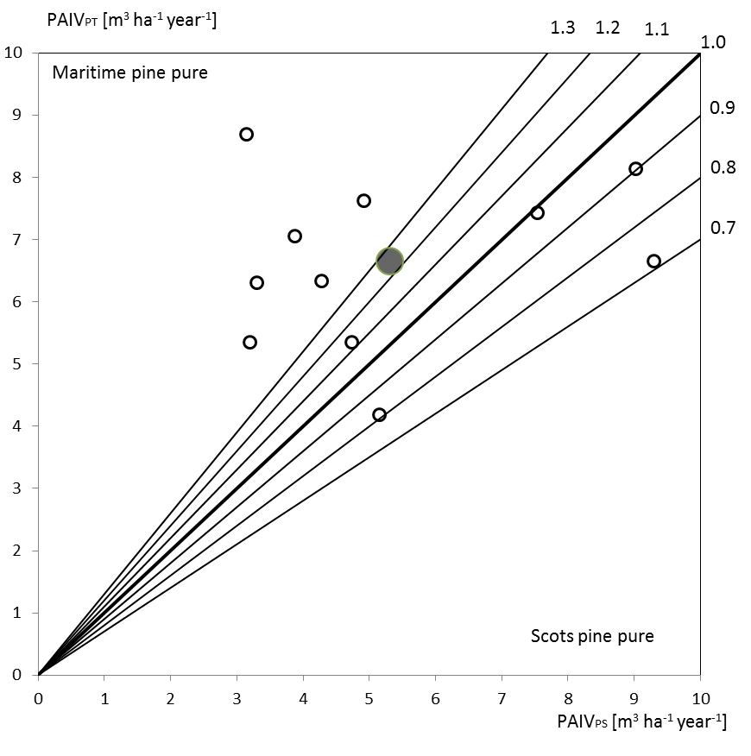
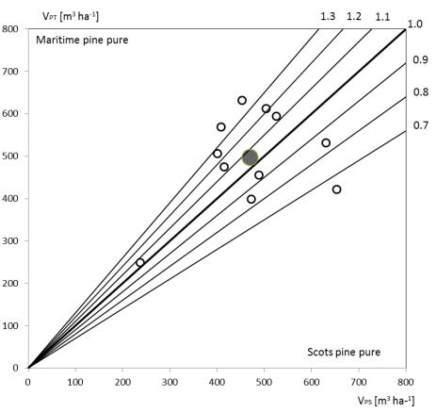
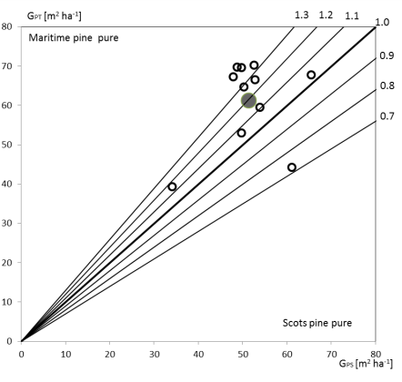
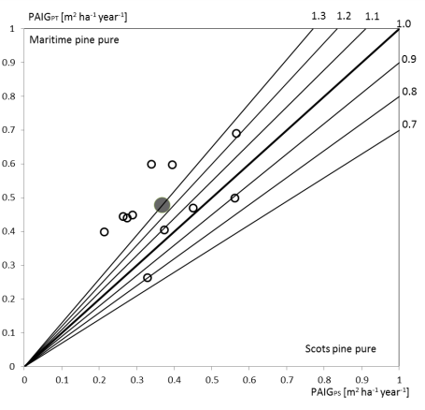
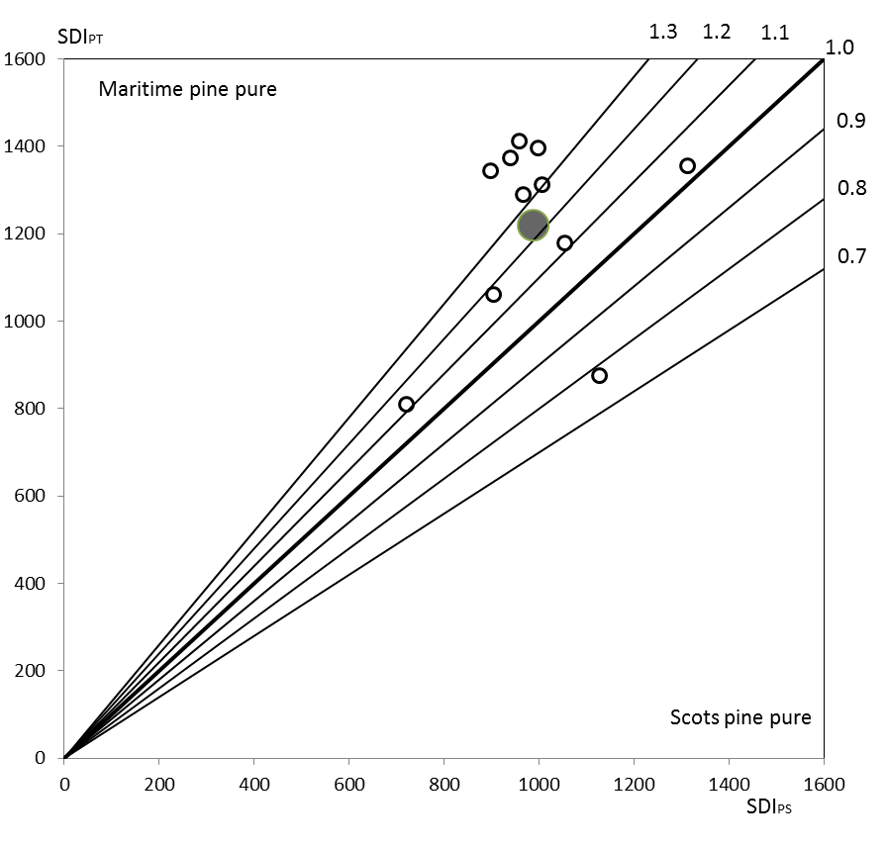

Figure S2. Comparison of main stand traits for pure Scots pine (x-axis) and pure Maritime pine stands (y-axis). Values closer to the bisector line indicate greater equality of pure-stand traits for both species. White circles represent observed values and the large gray circle indicates the mean values of all triplets.

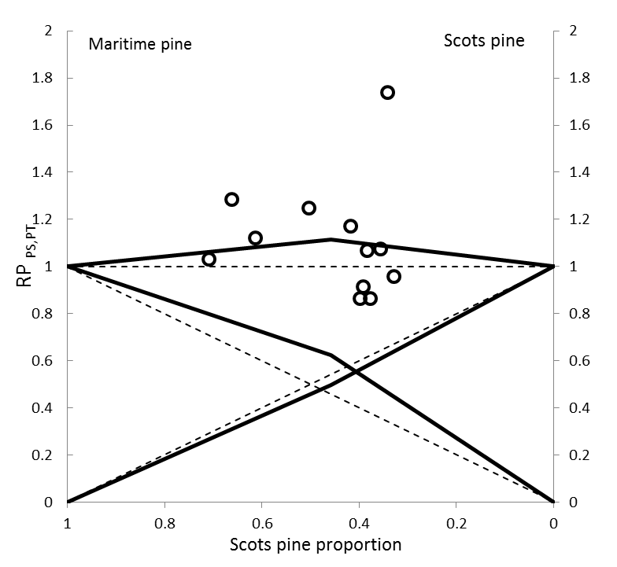

Figure S3. Cross diagram showing the mixing effect on relative productivity for annual volume increment for Maritime pine and Scots pine and total mixed stand in relation to the productivity of the neighboring pure stands. The points represent the observed relative volume productivity of mixed versus pure stands. The left (Maritime pine) and right (Scots pine) ordinates in the cross diagrams represent species relative productivity (RP_{PS,(PT)} and RP_{(PS),PT}) and the abscissa the mixing portion of Scots pine (m_{PS,(PT)}). Solid lines indicate growth in mixtures and the corresponding broken lines show the expected growth in monocultures. The upper lines show whole stand and crossing lines species-specific productivity.

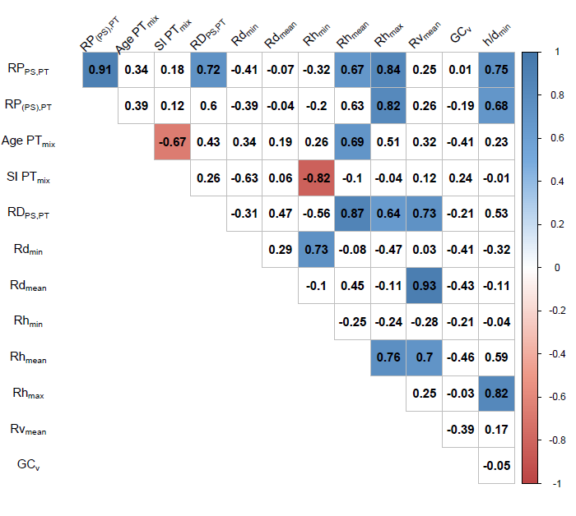
Figure S4. Correlation coefficient values for relative mixed stand productivity, for whole stand (RP_{PS,PT}) and for P. pinaster in mixture (RP_{(PS),PT}), with site, age and structural attribute ratios between Maritime pine in mixed-species and monoculture stands (PT_{mix} vs. PT_{pure}). White grid cells indicate non-significant coefficients (p <0.05).

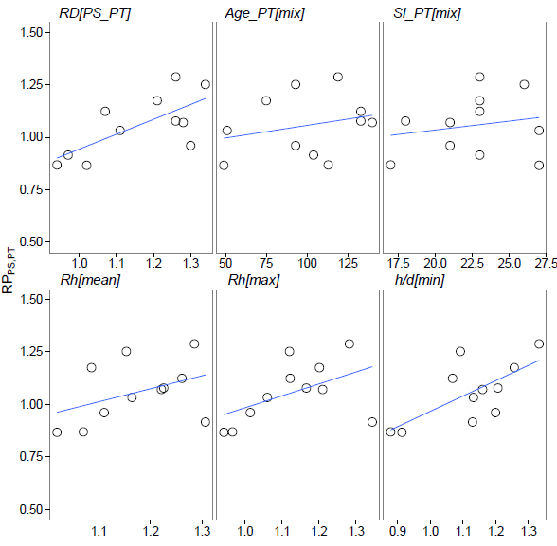
Figure S5. Relationship between relative productivity at stand level (RP_{PS,PT}) and relative stand density (RD_{PS,PT}), age and site index for P. pinaster in mixture, and selected ratios (Rd_{mean}, Rd_{max}, and Rh/d_{min}) indicating the multiplicative mixing effect for Maritime pine at the species level.

