Analysis of Data Quality in Digital Smart Cities: The Cases of Nantes, Hamburg and Helsinki
José L. Hernández¹, Ana Quijano¹, Rubén García¹, Pierre Nouaille², Lukas Risch³, Mikko Virtanen⁴ and Ignacio de Miguel⁵
¹Energy Division, CARTIF Technology Centre, Parque Tecnológico Boecillo 205, Boecillo, Spain
²Direction Territoriale Ouest, CEREMA, Rue René Viviani, Nantes, France
³Senate Chancellary – Department of European Affairs, Free and Hanseatic City of Hamburg, Hamburg, Germany
⁴VTT Technical Research Centre of Finland Ltd Espoo, P.O. Box 1000, Finland
⁵Optical Communications Group, University of Valladolid, Valladolid, Spain
{josher, anaqui, rubgar}@cartif.es, pierre.nouaille@cerema.fr, lukas.risch@sk.hamburg.de, mikko.virtanen@vtt.fi, ignacio.miguel@tel.uva.es
Keywords: Data quality, Digitalisation, Smart Cities, Data, Completeness, Correctness
Abstract: The Smart Cities concept is supported by the use of Information and Communication Technologies (ICT), which enables the digitalisation of the city assets. Then, cities are nowadays driven by data, with a clear dependency on the data collection approaches. Decisions and criteria for urban transformation therefore rely on data and Key Performance Indicators. However, one question remains and refers the reliability and credibility of data that guide the decision-making processes. Many efforts are made in the definition of the data quality methodologies, but not in analysing the real situation about data collection is smart cities. This paper applies a methodology to quantitatively analyse the real quality of the data-sets in the cities of Nantes, Hamburg and Helsinki. This work is under the umbrella of mySMARTLife project (GA #731297). The main conclusion or lessons learnt is the need for more appropriate methods to increase data quality, instead of defining new methodologies. Data quality requires improvements to make better informed decisions and obtain more credible Key Performance Indicators.

1 Introduction
Nowadays, cities are responsible for more than 60% of greenhouse gas emissions (Eurostat-a, 2022). To tackle this issue, the European Commission has established ambitious plans to reduce the emissions in 55% in contrast to current practices by 2030 (2030 Climate & Energy Framework, 2022), reaching climate neutrality by 2050.
For than end, cities need a transformation towards Smart Cities and must integrate multiple perspective and verticals such as energy, mobility, nature, economy or water management, among others. All of them supported by the integration of the Information and Communication Technologies (ICT) (Batty, 2012), approaching digital cities.
Digitalisation relies on data and new technologies like IoT (Internet of Things) to be able to monitor the city assets. Nevertheless, main challenges lie in the quality of the data and, thus, the accuracy and confidence when making decisions.
Efforts are put on the definition of urban platforms, acting not only as repository of information, but ingesting, transforming data, as well as calculating indicators and exposing useful information to make better informed decisions. The mySMARTLife EU project (mySMARTLife, 2022), with GA #731297, works in this direction. The project, with more than 150 actions taking place in the cities of Nantes, Hamburg and Helsinki, aims at reducing the energy demand of buildings, promoting e-mobility and creating urban data platforms following an open specifications framework (Hernández, 2020). Under the scope of the project, all the actions must be monitored with real data to extract conclusions and calculate impacts, making data quality essential. In this context, this paper presents quantitative results of real data quality in urban city platforms (Nantes, Hamburg and Helsinki) through the application of a methodology developed within mySMARTLife project.
The paper is organised as follows. Section 2 provides a background about data quality and the existing analysis techniques. Section 3 describes the methodology applied in mySMARTLife for data quality. Section 4 continues with a set of examples about completeness and correctness of data in the three cities of Nantes, Hamburg and Helsinki. Section 5 extracts a set of conclusions and future work.

2 Background
As it has been already introduced, cities are currently working on their transformation to become more resilient and climate neutral. However, how could anyone determine the level of smartness or carbon neutrality? The answer to this question is the application of evaluation frameworks that are driven by KPIs (Quijano, 2022). The calculation of the indicators relies on real data, which, due to occasional gaps, out of range and other errors in the collection and processing, does not provide useful insights (Alanne, 2021).Data quality is then crucial, not only in the assessment, but also in the creation of intelligent data-driven services (Hassan, 2021).
Data quality indicators could be split into several groups (Schmidt, 2021):
- Integrity, which refers to whether data comply with structural and technical requirements or not.
- Completeness, which focuses on the avoidance of data gaps according to the frequency and expected distribution of data.
- Correctness, represented by consistency and accuracy, which refers to out of range identification, in other words, error-free data.
- Timeliness, i.e., how up to data to data-sets are.
- Interpretability, which means the extent to which data can explain the reality.
- Accessibility, which, in the case of smart cities, is the data availability via open data portals or APIs (Application Programming Interface).
- Interoperability, which is described as the ability to access and process data from heterogeneous data sources.

Despite the efforts, data quality is still the main challenge in the digitalisation of cities, but, the reliability is questionable due to the data issues (e.g. communication or infrastructure problems) (Sin Yong Teng, 2021). Moreover, traceability of the errors is not easy (Hossein Motlagh, 2020), mainly taking the big amounts of data being collected into account. Additionally, there is no consensus about governance of data (Ender, 2021) and data-sets are managed in silos, limiting the accessibility (Abraham, 2019).
Having all these aspects in mind, a methodology to quantify the aforementioned quality indicators has been defined in the framework of mySMARTLife and applied in the cities of the project.

3 METHODOLOGY for data quality assessment
mySMARTLife project has developed urban data platforms in three lighthouse cities: Nantes, Hamburg and Helsinki with an open specifications’ framework and interoperability mechanisms and surveillance modules. (Hernández, 2020).
Within the methodology approached in the project, a statistical definition has been followed to determine the level of quality for data in the urban platforms, which is qualified by completeness and correctness indicators defined as follows:
- Completeness is calculated as equation 1
Completeness = nc / ne * 100 | (1)
where the number of collected samples (nc) is the counter of total samples stored in the databases and the number of samples to be expected (ne) is calculated as equation 2.
ne= freq * iter * time | (2)
The term freq is the data collection frequency, while iter is the number of iterations and time corresponds with the data collection span. For instance, considering a frequency of 1 minute along 1 hour, the period factor would be 60 iterations, with a total of expected samples equal to 60.
- Correctness is determined by the values within the range to be expected, as depicted in equation 3.
x_{min} ≤ x ≤ x_{max} | (3)
Where x_{max} = upper limit and and x_{min} = lower limit. Here, the meaning of the values to be expected should be remarked. In contrast to the sensor range, which also sets up maximum and minimum values, the value to be expected is the one that is a normal quantity, between reasonable lower and upper limits (x_{min}, x_{max} respectively). For example, an indoor temperature sensor could measure -5ºC, which is inside the physical sensor measurement range, but it is considered as abnormal value. In the case of energy meters, usually, these measure cumulative values, so that infinite is the maximum value and cannot have negative values.
As established in the project, data quality reporting is executed every 6 months, obtaining an overview of the quality indicators in each data quality report which helps to identify how suitable are data collected for the KPIs calculation. Within each report, if a data-set is identified as non-compliant with the completeness and correctness criteria, granularity of data report is reduced (i.e. from the 6-months aggregation to monthly values) to determine the reasons of the deviations with respect to the quality criteria.
According to the timeline of mySMARTLife, data collection started in December 2019, when the interventions in the three cities finished (although some actions present delays in the implementation). Six reports are expected to be delivered during mySMARTLife project duration.
- 1st report (Dec‘19-May‘20)
- 2nd report (June‘20-Nov‘20)
- 3rd report (Dec‘20-May’21)
- 4th report (Jun'21-Nov'21)
- 5th report (Dec’21-May’22)
- 6th report (June’22-Sept’22)
Four of them are reported at the time of writing this paper and while the first three reports have been fully analysed, only initial insights of the fourth report are included.
According to (Araújo, 2017), it should be indicated that data completeness can be below 100%, being 80% a reasonable threshold to consider data as compliant with quality requirements. mySMARTLife has slightly resized this number and a traffic light analysis has been performed where values of completeness lower than 75% are considered non-valid, values with more than 90% are very high-quality data, whereas between 75% and 90% are considered with enough quality for further KPI calculation.

4 Cases of NANTES, HAMBURG AND HELSINKI
As introduced, around 150 actions have been implemented in the three lighthouse cities in the mySMARTLife project: Nantes (France), Hamburg (Germany) and Helsinki (Finland) under the pillars energy, mobility and ICT. ¡Error! No se encuentra el origen de la referencia. summarises the type of project interventions in which data quality method is applied.
Table 1: Lighthouses interventions in energy and mobility pillars
Category | Interventions
Buildings | High-performance districts for Retrofitted and New buildings
Energy systems | Digital boilers, PV, Organic PV films, Hybrid solar power, Batteries
City infrastructure | District heating with RES, Hydrogen injection in district heating, Solar power plant, Wind farm with storage, Waste heat, Smart heating islands, Heat pumps, Smart lighting
e-Mobility | Electrification of public fleet (XXL eBus, Autonomous bus, e-cars, e-bikes), Car sharing
Charging infrastructure | Solar road, Smart/fast/renewable charging stations

4.1 Nantes
The first batch of interventions selected comprises the hybrid solar power system plus the retrofitting of individual houses. This intervention consists of two data-sets: renewable production by the panels in electricity (i.e. elec_prod_ind_houses) and domestic hot water (i.e. therm_prod_ind_houses). Figure 1 depicts the completeness along the four periods. It can be observed as the two initial periods cover 100% of samples, while third period reduces the electricity production to 83% and fourth period is empty. This picture highlights the requirements in terms of surveillance systems to generate alarms for avoiding data losses as it is the case.
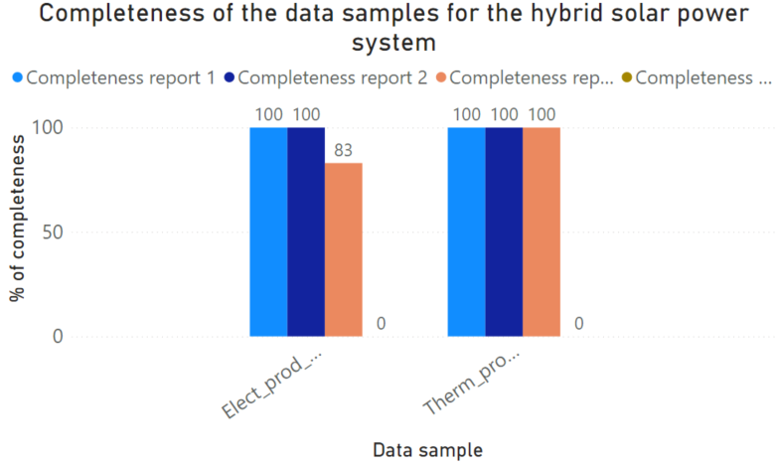
Figure 1: Analysis of data completeness during the 4 reports for the intervention of hybrid solar power system in Nantes
In terms of correctness, energy monitoring production relies on energy meters, which, as explained before, are cumulative and it should be only checked that they are not negative. In this perspective, Figure 2 represents the maximum values for each of the periods (except the fourth one that does not contain any data sample). In dashed black, the maximum expected production for electricity and, in dashed pink, the maximum expected thermal production. It can be extracted that electricity production is less than the expected maximum value; therefore, working as expected. Nevertheless, thermal production exceeds the maximum expected value in report #3.
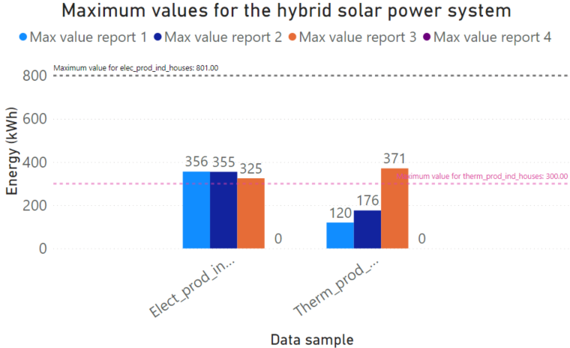
Figure 2: Data range of the hybrid power system variables in Nantes
Another example is related to PV (Photovoltaics) plants and displayed in Figure 3, which is very common in smart cities data collection. The first report is empty due to the delays in the intervention, but progressively, data completeness increased, reaching 100% in the fourth report. This is the typical schema, where first years entail the commissioning of the monitoring systems (SmartCities Marketplace, 2018).
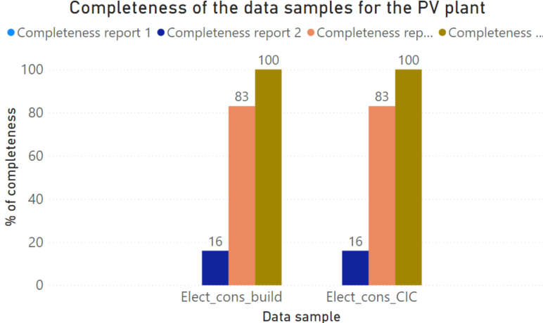
Figure 3: Data completeness analysis during the 4 reports for the intervention of PV plant in Nantes
4.2 Hamburg
Starting with the intervention related to the hydrogen-based district heating, it can be observed that the behaviour is similar to the PV plant in Nantes. As already explained, according to the Smart Cities Marketplace (SmartCities Marketplace, 2018), first years are focused on the calibration of the sensors and systems, which is perfectly observed in Figure 4. The first report only contains 26% of the data samples, but second and third reports increase up to 96% and 99%, respectively. The fourth report is not documented; therefore, no statistical analysis is available.
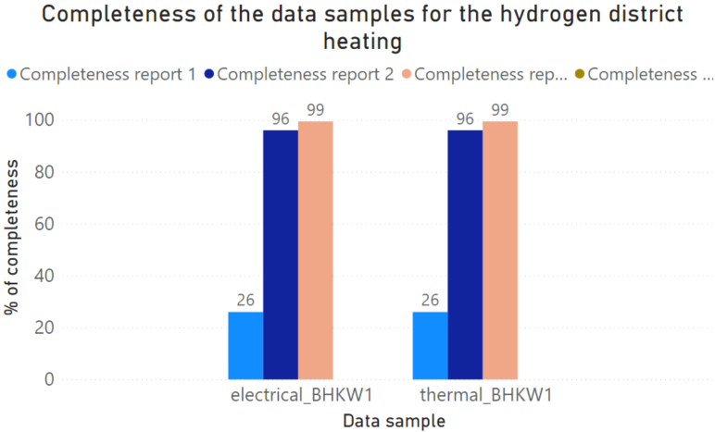
Figure 4: Data completeness analysis of the data-set for the hydrogen-based district heating in Hamburg
Due to the nature of the meter for the hydrogen-based district heating, i.e. cumulative values, extracting the maximum values range is not valuable. That is to say, cumulative meters provide appended values, i.e. summing the new value over the previous one and instantaneous energy values can be only obtained by subtracting consecutive samples. Then, these measurements can reach infinite values and that is the reason why the analysis of correctness, complementary to the completeness, of this specific action is not included here. In this line, an interesting case is the one of the PV on roofs. This intervention comes from previous years and just integrated data into the digital urban platform. That is the reason why 100% completeness is achieved along the four reports. However, in terms of maximum values, as depicted in Figure 5, all the reports exceed the maximum value for the generated electrical energy of the PV. The reason is a slight change in the configuration parameters than those from the original design, allowing the detection of this misalignments or mismatching. In other words, without the application of this quality assessment procedure, this error probably would have never been detected.
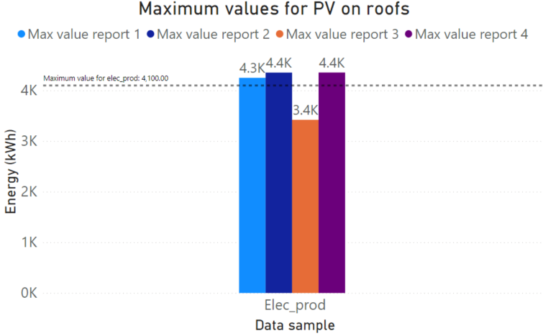
Figure 5: Data range of the PV on roofs electricity generation in Hamburg
4.3 Helsinki
The first selected action to illustrate the data quality in Helsinki is the Viikki environmental house. It consists of five variables, as observed in Figure 6. It is worth to mention this Viikki house stated its monitoring prior to the project, while new energy management strategies and geothermal pumps are part of the mySMARTLife context. Moreover, this building is considered as one of the most energy efficient office buildings in Helsinki. These are the reasons why there are very high values since the beginning of the data collection for the total electricity and thermal consumption, as well as PV production. However, it is a good example to demonstrate that there are no error-free data collection approaches. The new variables introduced within the project refer to the inlet and outlet temperatures of the geothermal system. As expected, similar to previous examples, data completeness is higher each report, but the last report reduces the percentage of completeness due to communication errors in data transmission.
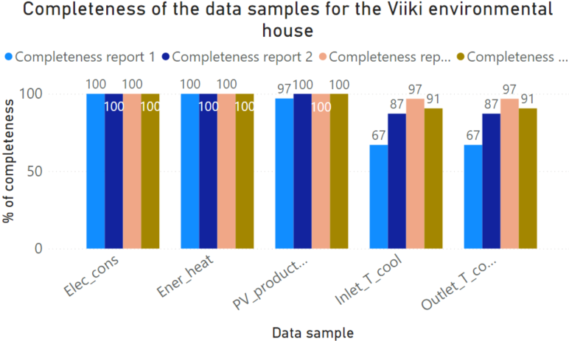
Figure 6: Data completeness analysis of the data-set for the Viiki environmental house in Helsinki
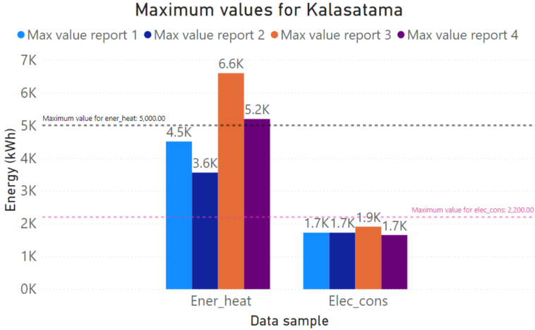
Figure 7: Data range of the Kalasatama high-performance district in Helsinki
In terms of correctness, the Kalasatama high-performance district intervention, illustrated in Figure 7, is selected and shows the case of out of range values, but these cannot be considered low quality. As it has been explained in the methodology, maximum and minimum values are expected according to the experience. In this specific case, the building demand is known, but the effects of COVID-19 are highlighted. Figure 7 depicts the exceed of the building heating energy consumption during 3rd and 4th periods, when the Nordic COVID-19 strategy encouraged working at home when possible. This implies the increase of energy use to achieve comfort along the entire day, incrementing the required thermal energy. It is then clear that these values cannot be classified as low-quality values, but abnormal, which is the main objective of the data quality approach. That is to say, not only discarding data-set, but finding evidences of non-expected behaviours as the case of Kalasatama.

3 discussion
Data quality is pivotal to make accurate decisions and calculate KPIs when evaluating performance of city interventions. Data quality methodologies are developed with high interest in the research field. However, real status of the data quality should be investigated. This is the case of the analysis performed in this paper in the three cities of Nantes, Hamburg and Helsinki. In this line, the need to put efforts in better data collection approaches should be remarked.
According to the Smart Cities marketplace monitoring guide (SmartCities Marketplace, 2018), real data quality is not reached until one year and a half have passed since the end of the interventions. Figure 8 draws the stages that are set along the time. While year 0 is considered as the finalisation of the interventions, year 1 is related to the commissioning, when data collection is being polished and errors or bugs are being corrected. From the beginning of the year 2 to mid-year, the optimisation of the data gathering process is conducted and, since second year and a half, the optimal operation is expected.
Figure 8: Smart Cities marketplace monitoring guide
This is exactly the case of mySMARTLife project. As illustrated in Figure 9, Figure 10 and Figure 11, the increase of quality from first year to second year is notable. In Nantes, it can be observed as the second year (dark blue) for the interventions contributes more than the 50% of the quality, while first year quality is very limited. Hamburg shows something similar, although, in this case, the increment has been lower (i.e. better performance during first year). In contrast, Helsinki offers similar numbers during both years analised, mainly due to the reason that many actions were monitored before mySMARTLife.
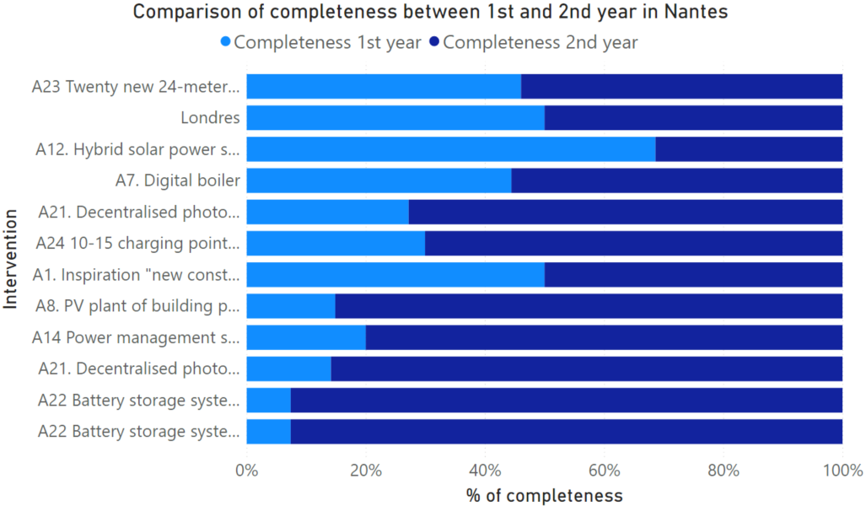
Figure 9: Comparison of the data completeness during years 1 and 2 for the interventions in the city of Nantes
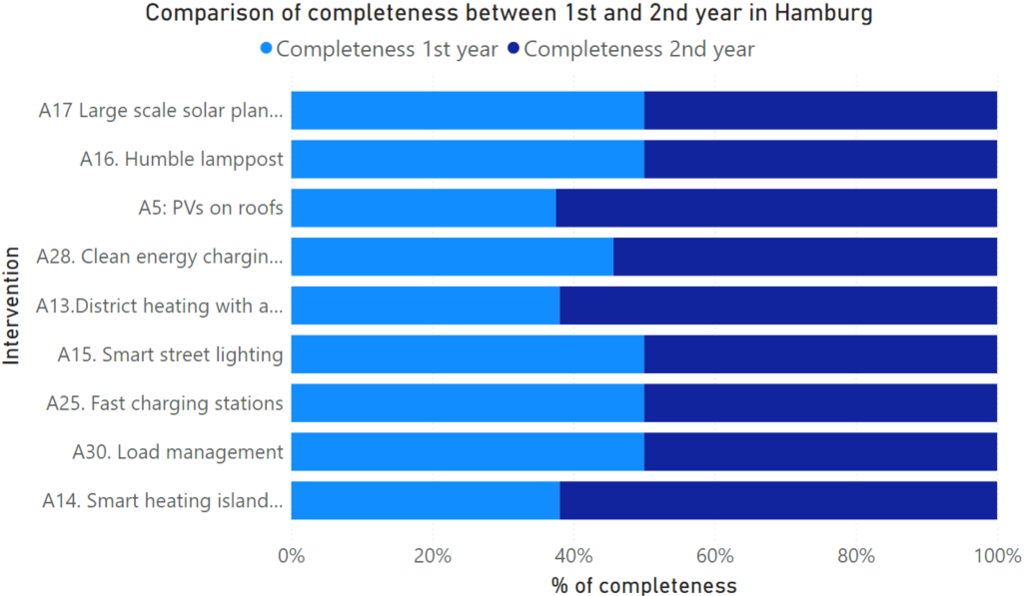
Figure 10: Comparison of the data completeness during years 1 and 2 for the interventions in the city of Hamburg
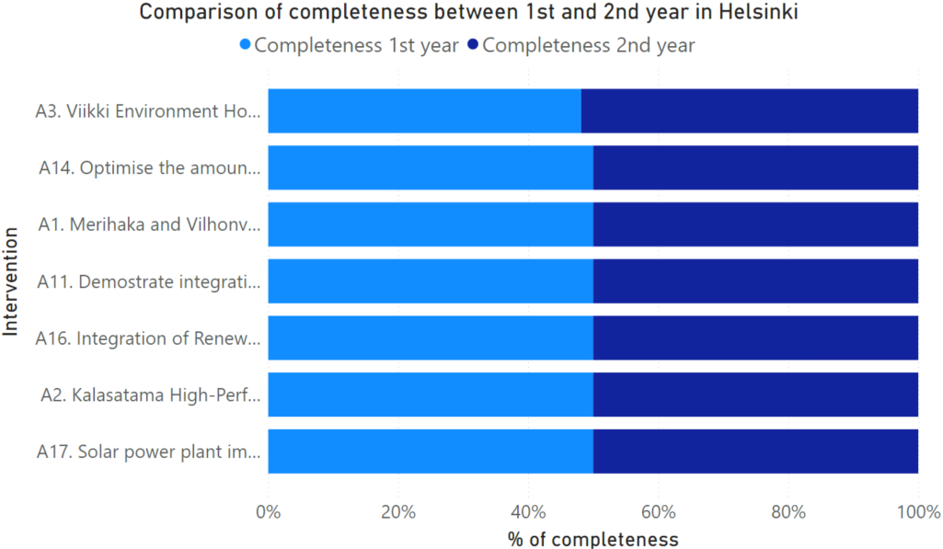
Figure 11: Comparison of the data completeness during years 1 and 2 for the interventions in the city of Helsinki
Finally, as introduced in the methodology, a three-range assessment is made for the data completeness of the three cities. Table 2 collects the results for Nantes actions (numbered) during the first year (reports R1 and R2) and a half (third report R3), which evidences the previous sentence about the increase of data quality along first year. Not all the actions are included, discarding those with delays and; therefore, not reported.
Table 2: Analysis of the completeness according to the established ranges in the methodology for the Nantes actions during the three first reports (R1, R2 and R3)
Action | Data sample | R1 | R2 | R3
A1 | Ener_dem_DH | 100 | 100 | 100
A12 | Elect_prod_ind_houses | 100 | 100 | 83
 | Therm_prod_ind_houses | 100 | 100 | 100
A14 &  A27 | Elect_cons_charg_stat | 0 | 50 | 100
A21a | Elec_prod | 0 | 33 | 100
A21b | Elect_injection | 100 | 100 | 100
 | Elect_cons_build | 0 | 33 | 100
 | Elect_injection | 0 | 33 | 100
 | Elec_prod | 0 | 33 | 100
A22 &  A27 | Elect_bat | 0 | 16 | 100
 | Elect_stored_batt | 0 | 16 | 100
A23a | Dist_ebus | 100 | 100 | 100
 | Ener_cons_ebus | 100 | 100 | 100
 | Nb_pass_ebus | 50 | 33 | 100
 | Nb_trips_ebus | 100 | 100 | 100
A24 | Charg_stat_uptime_ebus | 0 | 83 | 100
 | Ener_deliv_ebus | 40 | 42 | 90
 | Nb_charg_op_ebus | 0 | 83 | 100
A7 | DHW_cons | 100 | 100 | 100
 | qDHW | 100 | 100 | 100
 | Elect_cons_build_PL | 0 | 0 | 0

In the case of Hamburg (Table 3), data completeness observed demonstrates an increment in specific actions. There are cases with 100% of completeness already due to monitoring starting before the reporting. Anyway, many of the actions are green or yellow lights during the third report (R3) with some minor exceptions for data samples, which also demostrates the incremental data quality in smart cities.
Table 3: Analysis of the completeness according to the established ranges in the methodology for the Hamburg actions during the three first reports (R1, R2 and R3)
Action | Data sample | R1 | R2 | R3
A15 | Elect_cons_pub_light | 100 | 100 | 100
A16 | Elect_cons_pub_light | 100 | 100 | 100
 | Elect_cons_pub_light | 100 | 100 | 100
 | Elect_cons_pub_light | 100 | 100 | 100
A25 | Ener_deliv_fast | 100 | 100 | 100
 | Nb_charg_op_fast | 100 | 100 | 100
 | Nb_diff_users | 100 | 100 | 100
A28 | Ener_deliv_charging point | 90 | 86 | 86.7
 | ev-status | 64 | 55 | 88.8
A3 | Elec_com | 0 | 0 | 0
 | Ener_heat_use | 0 | 0 | 0
A30a | Ener_deliv_fleet | 100 | 100 | 100
A19a-b | 1.OG - R.129 - Zulüfter - Leistung | 0 | 0 | 0
 | PV Prod. (kWh) | 33 | 100 | 100
 | Stromzähler - Propangas Kältemaschine (2Q1) - Leistung | 0 | 0 | 0
A17 & A20 | Elec_prod_WT1 | 100 | 100 | 100
 | Elec_prod_WT2 | 100 | 100 | 100
 | Elec_prod_WT3 | 100 | 100 | 100
 | Elec_prod_WT4 | 100 | 100 | 100
 | Elec_prod_WT5 | 100 | 100 | 100
A5 | Elec_prod | 100 | 100 | 100
 | Elec_prod | 50 | 100 | 100
 | Elec_prod | 0 | 0 | 0
 | Elec_prod | 0 | 0 | 0
 | Elec_prod | 0 | 0 | 33
A13 & A18 | electrical_BHKW1 | 26 | 96 | 99.4
 | electrical_BHKW2 | 97 | 96 | 99.4
 | gas_BHKW1 | 26 | 96 | 99.4
 | gas_BHKW2 | 26 | 96 | 99.4

Finally, Helsinki, which already was highly digitalised, demonstrates that more mature cities in monitoring strategies can reach very valuable values in terms of data quality, hence, better-informed decisions. Table 4 is almost green with the exception for the new data samples introduced in the project, which follow the same trend as explained before.
Table 4: Analysis of the completeness according to the established ranges in the methodology for the Helsinki actions during the three first reports (R1, R2 and R3)
Action | Data sample | R1 | R2 | R3
A1 | Elec_cons | 100 | 100 | 100
 | Ener_heat | 100 | 100 | 100
A2 | Elec_cons | 100 | 100 | 100
 | Ener_heat | 100 | 100 | 100
A3 | Elec_cons | 100 | 100 | 100
 | Ener_heat | 100 | 100 | 100
 | Inlet_T_cool | 67 | 87.2 | 96.8
 | Outlet_T_cool | 67 | 87.2 | 96.8
 | PV_production | 97 | 99.98 | 99.99
A14 & A16 | DC_consumption | 100 | 100 | 100
 | DC_prod | 100 | 100 | 100
 | DH_consumption | 100 | 100 | 100
 | DH_prod | 100 | 100 | 100
 | DC_prod_HP | 100 | 100 | 100
A16 | DH_prod_HP | 100 | 100 | 100
A17 & A18 | PV_production1 | 100 | 100 | 100
 | PV_production2 | 100 | 100 | 100
 | PV_production3 | 100 | 100 | 100
To summarize, after having received four raw quality reports, 39% of the actions reach at this early stage more than 12 months of high-quality data and 47% of actions report lower values for completeness and correctness. The remaining 14% of the actions refer to those interventions with deviations and later starting monitoring date. Therefore, it was not possible to report them yet during the periods of this preliminary analysis of data quality.

6 conclusions
Smart Cities are not only the future but the present. Therefore, transformation plans for more liveable spaces and more efficient cities are required. Decisions should be made on the basis of real and reliable data. Nevertheless, data, when available, usually lacks of enough quality to make rationale decisions.
On the other hand, digitalisation of cities is slowly progressing and quality checks are not periodically carried out. This paper aimed at assessing the real data quality in cities, focused on the three cities of Nantes, Hamburg and Helsinki. Methodologies are wide and diverse, but these are not being implemented properly. In this sense, the major lesson learnt is the necessity of establishing the grounds since design. The mySMARTLife project already considered data quality when defining the open specifications framework through the interoperability mechanisms and surveillance modules.
Even though efforts have been made in the project, this study shows that data quality procedures should not simply be implemented, but follow-up processes are required. Having this in mind, mySMARTLife established 6-month periodic analysis of data, extracting qualitative values of data quality for two main indicators: correctness and completeness. In terms of correctness, out of range values allow identifying abnormal situations in the performance of the energy systems, mobility facilities or city infrastructures. Moreover, completeness indicates the data gaps to provide credible and reliable results.
The three cities demonstrate that maturity levels in the digitalisation processes are critical. Helsinki, more advanced in digitalisation, already reports very high data quality indicators. Nantes and Hamburg provided a reduced data quality in the analysis performed, but with good values considering that the first year of data collection usually requires corrections and commissioning activities. After the first year, data quality increases, leveraging data platforms to gather raw data, obtaining information and, thus, extracting knowledge. mySMARTLife project is currently analysing the 4th report, although some results have been shown along the paper. Additionally, two additional reports are planned for the next stages of the project. That is to say, the future plan is to continue analysing data quality to extract best practices in the assessment methods.
Acknowledgements
Authors would like to thank the mySMARTLife consortium and rest of partners involved in the project for the support. Also, the authors would like to thank the European Commission for funding the project under GA #731297 of the H2020 programme.
References
EUROSTAT-a. Statistics on European cities. [online] https://ec.europa.eu/eurostat/statistics-explained/index.php?title=Statistics_on_European_cities. Accessed on 21st February 2022.
EU Research and Innovation. (2018). Final Report of the High-Level Panel of the European Decarbonisation Pathways Initiative; European Commission.
2030 Climate & Energy Framework. Available online: https://ec.europa.eu/clima/policies/strategies/2030_en. Accessed on 22nd February 2022.
Batty, M., Axhausen, K.W., Giannotti, F. et al. (2012). Smart cities of the future. Eur. Phys. J. Spec. Top. 214, 481–518.
Hernández, J.L.; García, R.; Schonowski, J.; Atlan, D.; Chanson, G.; Ruohomäki, T. (2020). Interoperable Open Specifications Framework for the Implementation of Standardized Urban Platforms. Sensors, 20, 2402. https://doi.org/10.3390/s20082402.
mySMARTLife project. GA #731297, [online] https://www.mysmartlife.eu/mysmartlife/, accessed on 22nd February 2022.
Quijano, A.; Hernández, J.L.; Nouaille, P.; Virtanen, M.; Sánchez-Sarachu, B.; Pardo-Bosch, F.; Knieilng, J. (2022). Towards Sustainable and Smart Cities: Replicable and KPI-Driven Evaluation Framework. Buildings, 12, 233.
Alanne, K. and Sierla, S. (2021). An overview of machine learning applications for smart buildings, Sust. Cities Soc., vol. 76, p. 103445.
Hasan, Z. and Roy, N. (2021). Trending machine learning models in cyber-physical building environment: A survey, WIREs Data Mining and Knowledge Discovery, vol. 11, no. 5, p. e1422.
Schmidt, C.O., Struckmann, S., Enzenbach, C. et al. (2021). Facilitating harmonized data quality assessments. A data quality framework for observational health research data collections with software implementations in R. BMC Med Res Methodol 21, 63.
Sin Yong Teng, Michal Touš, Wei Dong Leong, Bing Shen How, Hon Loong Lam, Vítězslav Máša. (2021). Recent advances on industrial data-driven energy savings: Digital twins and infrastructures, Renewable and Sustainable Energy Reviews, Vol. 135, 110208.
Hossein Motlagh, N.; Mohammadrezaei, M.; Hunt, J.; Zakeri, B. (2020). Internet of Things (IoT) and the Energy Sector. Energies, 13, 494.
L. Ender, (2021). Data Governance in Digital Platforms: A case analysis in the building sector, Dissertation.
Abraham, R., Schneider, J., Vom Brocke, J. (2019). Data governance: A conceptual framework, structured review, and research agenda. International Journal of Information Management, 49, pp. 424-438.
Open Geospatial Consortium. (2019). OGC SensorThings API Part 1 Sensing Version 1.1.
Araújo, T. B., Cappiello, C., Kozievitch, N. P., Mestre, D. G., Pires, C. E. S., & Vitali, M. (2017). Towards reliable data analyses for smart cities. In Proceedings of the 21st International Database Engineering & Applications Symposium (pp. 304-308).
SmartCities Marketplace. (2018). Technical Monitoring Guide. Technical report. European Commission

https://orcid.org/0000-0002-7621-2937
https://orcid.org/0000-0002-0366-7375
https://orcid.org/0000-0002-0358-8001
https://orcid.org/0000-0001-7982-5117
https://orcid.org/0000-0002-1084-1159

