TITULO SILICONE MICROBUBBLES AFTER ANTI-VEGF INJECTIONS IN PATIENTS WITH ARMD: INCIDENCE QUANTIFICATION AND SECONDARY OCT ARTIFACS.

AUTORES

The authors don´t have conflicts of interest to declare.

INTRODUCTION

Age-related macular degeneration (AMD) is the leading cause of blindness in people over 65 in the western world. The incidence increases with population aging with an estimated prevalence is 8.7%.¹ The neovascular form of the disease (nAMD) has a rapid and aggressive progression but intravitreal anti-VEGF treatments can halt the vision loss in most patients.² These drugs must be reinjected periodically and the average number of intravitreal injections (IVI) is very variable according to the studies (4.2 to 7.5 the first year), although better results are obtained in studies with higher number of injections.³
Anti-VEGF drugs are supplied in glass bottles with a volume of drug several times greater than needed for a dose (0.05ml). For reasons of cost, hospital pharmacies prepare the doses / injection for each patient in disposable plastic syringes⁴. During the manufacture of these syringes, silicone oil (SO) derivatives are used to coat the surfaces of the syringe and the needle to improve the sliding of the plunger, facilitating the injection⁵. Small microbubbles of this coating can penetrate the vitreous chamber when injecting the drug. The presence of silicone microbubbles in the vitreous has been observed with different injected agents, confirming that the origin of these microbubbles is the syringe or the needle and not the medication itself. ^{6,7} By increasing the number of patients treated with intravitreal injections and the number of injections in the same patient, the occurrence of this complication can increase. Prevalence is very different among published studies varying from 0,03%, 44% until 67,6%, ^{8, 9, 10} probably because the methods to evaluate the presence of silicone microbubbles are not the same in each study. The usual method is direct exam with the slitlamp. Optic Coherence Tomography (OCT) has also been used to objectively and qualitatively assess vitreous opacities^{11,12}. It is also known that vitreous opacities can induce artifacts in OCT but significance of this fact in case of silicone microbubbles has not been deeply studied.
The objective of present study is to report the incidence of vitreous silicone microbubbles in nAMD patients treated with intravitreal anti-VEGF agents in our daily clinical practice, to quantify them, and to determine its possible relationship with the number of injections. Also, we aim to evaluate until what extent these microbubbles could induce artifacts that would preclude the evaluation when using the OCT, an exploration which is very important in the treatment decision.

METHODS

Study Design:
Observational, descriptive, cross-sectional study of patients with nAMD in intravitreal anti-VEGF treatment.

Subjects of Study:
Patients with a diagnosis of neovascular ARMD seen in the Ophthalmology Department of Palencia Hospital Complex between October 2018 and June 2019 in treatment with injections of intravitreal anti-VEGF for at least one year were included. These patients have always received treatment with anti-VEGF drugs repackaged in hospital pharmacy. Hospital pharmacy in Palencia Hospital Complex is in a different building of the Ophthalmology Department, located 4 Km away one from each other.
Patients with any ocular media opacities that may affect direct visualization of the silicone microbubbles were excluded. Other exclusion criteria were had received intravitreal corticosteroid treatment or refusal of the patient to participate in the study.

Study Variables:
Next variables were recorded from the files of patients: age, gender, number of injections since the beginning of the treatment and months of treatment, noting if the patient received anti-VEGF treatment in one eye or both eyes.
Detection and quantification of silicone microbubbles was conducted one month after the last injection by biomicroscopic examination in mydriasis with slit lamp without lens for viewing
anterior vitreous and with a 78 diopters lens of for the visualization of the posterior vitreous. The number of microbubbles was quantified in: 0 or absent or no microbubbles; 1 or scarce (from 1 to 10 microbubbles); 2 or moderate (from 10 to 30) and 3 or countless (more than 30).

All the patients were explored using fast macular OCT scans performed with Spectralis® (Heidelberg Engineering, Heidelberg, Germany) with follow-up protocol centered in the fovea. The recorded OCT scan obtained at the last visit was considered for the study. To measure shadowing OCT artifacts, the following was contemplated: 0-no artifacts; 1-artifacts that prevented seeing some layers of the retina; 2-artifacts that prevented seeing all layers of the retina; 3-artifacts that prevented seeing the retinal thickness.
In the presence of artifacts, the location of these was classified into foveal (ETDRS 1mm), extrafoveal (EDTRS 3mm).

Artifacts in OCT were attributed to silicone oil microbubbles when there were missing sections of the scan that correspond with the vitreous opacity caused by the microbubbles. Besides, in cases of shadowing indorsed to silicone microbubbles, the first OCT scans obtained before any treatment was compared to discard pretreatment vitreous opacities.

Statistical Analysis:
Statistical analyses were performed using SPSS 20. The Lilliefors Kolmogorov-Smirnov test was used as normal test or Shapiro-Wilks test for small samples. Qualitative variables were expressed as percentages as the gender variable. The distribution of continuous quantitative variables was expressed as average, standard deviation (ED), minimum and maximum as the age variable.

The Spearman coefficient was used to correlate the quantitative variable of
IVI and the ordinal variable of microbubble frequency. The result will be between -1 and 1, if it approaches 1 or -1 it will have a strong correlation; while the closer to 0 the correlation will be weak.

A p value of 0.05 was considered statistically significant.

Pearson's chi-square test was used to assess the relationship between two variables. If the expected frequencies were small, Fisher's exact test was used. The T of Student or his non-parametric Mann-Whitney U alternative was used to prove the differences between the means of two independent groups if the assumption of normality is not valid.

All the patients signed an informed consent to participate in the study.
The study was conducted in accordance with the recommendations of the Declaration of Helsinki and was approved by the Medical Research Ethics Committee of Palencia Hospital Complex.

RESULTS

Final sample comprised 142 treated eyes of 98 patients with a mean age of 82 years (+ 7.3; range 65-97), that have received 2.377 injections. The demographic data of the included patients are shown in table 1. The patients were in treatment an average of 44.7 (+ 26.8) months and received an average of 16,74 (+10.4) IVI until the evaluation.

In the study, 127 (89.4%) injected eyes, presented silicone microbubbles in the vitreous chamber. In 62 (43.6%) of the cases had countless microbubbles, 36 (25,4%) and 29 (20,4%) had scarce and moderate microbubbles respectively (Figure1). Many cases of countless microbubbles appeared in clusters (Figure 2).

The eyes with no SO microbubbles had received an average of 8.6 IVI, while the eyes with microbubbles had received an average of 17,7 IVI (p<0,001). There was a positive correlation between the number of injections and the frequency of the appearance of SO microbubbles (rho =0.7) (Table 2).

OCT artifacts were detected in 11 treated eyes (7,5%) of 9 patients (9.2%). In 8 eyes artifacts prevented seeing some layers of the retina, in 3 eyes artifacts prevented seeing all layers of the retina and there are not cases with artifacts that prevented seeing the retinal thickness. In 2 cases the artifacts were located in the foveal region and in 9 were extrafoveal.

DISCUSSION

We found a very high incidence of silicone microbubbles in the vitreous chamber of nAMD patients in antiVEGF treatment, and found a positive correlation between the number of IVI and the number of microbubbles. The presence of microbubbles only precluded the correct OCT evaluation in 7,5% of eyes.

The incidence of microbubbles in the present study is higher than in other published studies.^{9,10} The great incidence of silicone microbubbles could be due to multiple reasons: on the one hand the systematic search for the microbubbles could have increase the report on this complication. On the other hand, variations in the injection technique, type of syringe used, packaging process or possible mishandling of the repackaged doses (as sudden variations in temperature, exposure of the syringes to light, agitation of the syringes) could have also influenced this data. ¹³⁻¹⁶ Melo et al. also found a high incidence of this complication and a positive correlation between the number of IVI and the presence of silicone microbubbles.¹⁰
We have not found in the literature other studies that quantify the number of microbubbles, so we have no comparative references. It is noteworthy that many of our patients showed clusters of countless microbubbles that probably came from a singular injection.

Until what extend the presence of silicone microbubbles drives to meaningful clinical complications as intraocular pressure elevation by blockage of trabecular meshwork, inflammation or significant myodesopsias have been largely discussed.¹⁴ Large bubbles
seems to cause of myodesopsias, in some cases of such intensity that vitrectomy was considered.¹⁷ Although we have studied the number of microbubbles and not its size, if the microbubbles accumulate in clusters could also produce myodesopsias.
Although the presence of microbubbles rarely prevented a correct evaluation of the OCT scans, it was a real problem in 7,5% of the eyes studied in which treatment decision was more difficult, and this is not negligible.

It would be desirable to reduce the incidence of this problem by using syringes and needles without SO, or with the least amount of SO possible as syringes with optimized siliconization, baked-on siliconization, or to use a pre-filled syringe.^{13,18} Prefilled syringes are subjected to an optimized siliconization process that minimizes the risk of transfer of SO to the drug solution.¹⁹ On the other hand, they suffer less manipulation, which could further reduce the release of silicone microbubbles to the drug and therefore to the vitreous.²⁰

Patients should be informed about the probability of accumulation of SO microbubbles in the vitreous and its possible consequences.¹⁴ but further studies are needed to better understand the real clinical consequences of SO microbubbles after anti-VEGF injections. Correlation between the presence and abundance of SO microbubbles and intraocular pressure elevation in our sample is our next project.

Although the sample can be considered representative as demographic data were in accordance with the demographics of AMD described in the Spanish population and other reports,^{21, 22} our study was carried out in a single hospital and there may be inherent issues in the pharmacy, type of syringe, packaging process, etc. that could be a limitation of the study.

In summary, the presence and abundance of silicone microbubbles is correlated to the number of intravitreal injections. Besides its possible clinical complications these microbubbles can also produce OCT artifacts, which can hinder the treatment decision.

REFERENCES

1. Velez-Montoya R, Oliver SC. N, Olson J.L, Fine S.L, Quiroz-Mercado H, Mandava N. Current knowledge and trends in age-related macular degeneration: genetics, epidemiology, and prevention. Retina. 2014; 34(3):423-41.

2. Wong T.Y, Liew G, Mitchell P. Clinical Update: New treatments for age-related macular degeneration. Lancet. 2007; 370 (9583): 204-206
3. Chong V. Ranibizumab for the treatment of wet AMD: a summary of real-world studies. Eye (Lond) 2016; 30(2): 270–286.
4. Olea JL, Gómez-Resa M, Cervera-Peris MM, Aragón JA. Silicone oil droplets in repackaged anti-vascular endothelial growth factors for intravitreal injections: In search of the main source of contamination. Eur J Ophthalmol. 2019; 1120672118823133.
5. Krayukhina E, Tsumoto K, Uchiyama S, Fukui K. Effects of syringe material and silicone oil lubrication on the stability of pharmaceutical proteins. J Pharm Sci. 2015; 104(2):527-35.
6. Sampat KM, Garg SJ. Complications of intravitreal injections. Curr Opin Ophthalmol. 2010; 21(3):178-83.
7. Bakri SJ, Ekdawi NS. Intravitreal silicone oil droplets after intravitreal drug injections. Retina. 2008; 28(7):996-1001.
8. Khurana RN, Chang LK, Porco TC. Incidence of Presumed Silicone Oil Droplets in the Vitreous Cavity After Intravitreal Bevacizumab Injection with Insulin Syringes. JAMA Ophthalmol. 2017; 135(7):800-803.
9. Scott IU, Oden NL, VanVeldhuisen PC, Ip MS, Blodi BA, Antoszyk AN. SCORE Study Investigator Group. SCORE Study Report 7: Incidence of Intravitreal Silicone Oil Droplets Associated with Staked on vs Luer Cone Syringe Design”. Am J Ophthalmol 2009; 148(5):725–732.
10. Melo GB, Dias Junior CS, Morais FB, Cardoso AL, Figueiredo AGA, Lima Filho AAS, Rodrigues EB, Emerson GG, Maia M. Prevalence of silicone oil droplets in eyes treated with intravitreal injection. Int J Retina Vitreous. 2019; 5:34.
11. Kennelly KP, Morgan JP, Keegan DJ, Connell PP. Objective assessment of symptomatic vitreous floaters using optical coherence tomography: a case report. KBMC Ophthalmol. 2015; 15:22.
12. Avellaneda PF, Breazzano MP, Yannuzzi LA. OCT Artifact With Retained Silicone Oil Droplet. Ophthalmol Retina. 2019;3(10):866.
13. Melo GB, Santos da Cruz NF, Emerson GG, Rezende FA, Meyer CH, Uchiyama S, Carpenter J, Shiroma HF, Farah ME, Maia M, Rodrigues EB. Critical Analysis of Techniques and Materials Used in Devices, Syringes, and Needles Used for Intravitreal Injections. Review Prog Retin Eye Res. 2020; 18;100862.
14. Schargus M, Frings A. Issues with Intravitreal Administration of Anti-VEGF Drugs. Clin Ophthalmol. 2020; 14:897-904.
15. Melo GB, Emerson GG, Dias CS Jr, Morais FB, Lima Filho AS, Ota S, Farah ME, Rodrigues EB, Maia M, Belfort R Jr. Release of silicone oil and the off-label use of syringes in ophthalmology. Br J Ophthalmol. 2020;104(2):291-296.
16. Dias Júnior CS, Cardoso AL, Figueiredo AGA, Ota S, Melo GB. Agitation of the syringe and release of silicone oil. Eye (Lond). 2020; 3.
17. Avery RL, Castellarin AA, Dhoot DS, Pieramici DJ, Nasir MA, Steinle NC, et al. Large silicone droplets after intravitreal bevacizumab (Avastin). Retin Cases Brief Rep. 2019; 13(2):130-134.
18. Reuter B, Peterson C. Syringe Siliconization Trends, methods, analysis procedures. TechnoPharm. 2012; 2(4):238e244.
19. Woodcock C, Walsh M, Kurstjens N. Characteristics and potential benefits of the ranibizumab pre-filled syringe. Clin. Experiment. Ophthalmol. 2014; 42:125-125.
20. Liu L, Ammar DA, Ross LA, Mandava N, Kahook MY, Carpenter JF. Silicone oil microdroplets and protein aggregates in repackaged bevacizumab and ranibizumab: effects of long-term storage and product mishandling. Invest Ophthalmol Vis Sci. 2011; 52(2): 1023–1034.
21. Mitchell P, Liew G, Gopinath B, Wong TY. Age-related Macular Degeneration. Review Lancet. 2018; 392(10153):1147-1159.
22. Spanish Eyes Epidemiological (SEE) Study Group. “Prevalence of age-related macular degeneration in Spain”. Br J Ophthalmol. 2011; 95(7):931–6.

Tables

Table 1: Demographic data and study data
 | FREQUENCY (%)
GENDER | Men 40 (40,8%)
 | Women 58 (59,2%)
 | Total 98(100%)
N^{ER} TREATED EYES | Only RE | 29(29,6%)
 | Only LE | 25(25,5%)
 | BE | 44(44,9%)
 | Total | 142 (100%)

BE (Both eyes). LE (left eye). RE (right eye)

Table 2: Results of the biomicroscopic exam. Microbubble quantification in the vitreous cavity and relationship with the number of injections

 |  | FREQUENCY | AVERAGE NUMBER OF INJECTIONS | SIGNIFICANCE | CORRELATION COEFFICIENT
ABSENT (10,6%) |  | 15 (10,6 %) | 8,6 | p<0,001 | 0,7
PRESENT (89,4%) | Scarce | 36 (25,4%) | 17,7
 | Moderate | 29 (20,4%)
 | Countless | 62 (43,6%)
 | TOTAL | 142 (100%)

Absent: 0 microbubbles. Scarce: 1-10 microbubbles. Moderate 10-30 microbubbles. Countless> 30 microbubbles.

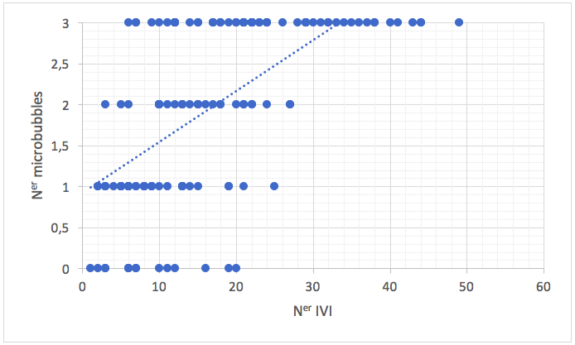
Figure 1: Graph showing the direct relationship between the number of intravitreal injections (IVI) per eye and the number of microbubbles in vitreous.
(MICROBUBBLES 0: Absent: 1: scarce (from 1 to 10 microbubbles); 2: moderate (from 10 to 30) and 3: countless (more than 30)

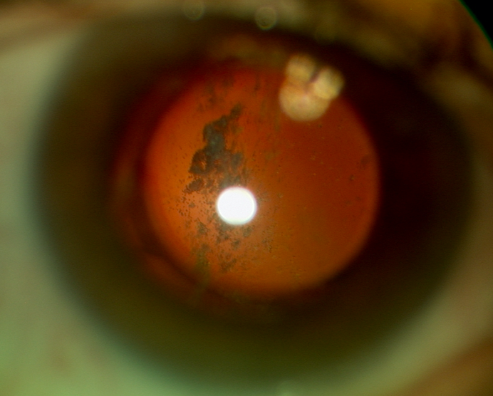

Figure 2: Countless microbubbles in the vitreous disposed as clusters in the same location.

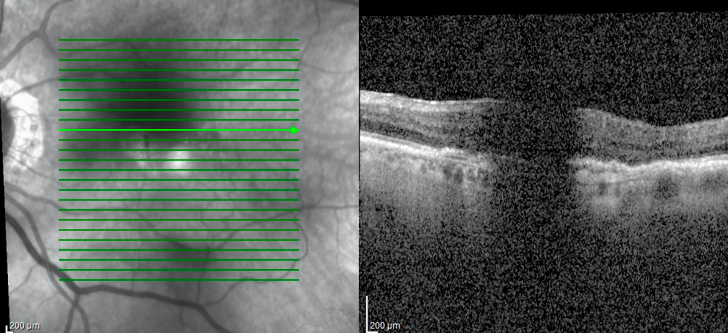
Figure 3: An example of OCT shadowing artifacts that precluded the correct OCT evaluation and treatment decision.

