A novel approach for nutrients recovery from municipal waste as biofertilizers by combining electrodialytic and gas permeable membrane technologies

Veronica Oliveira a,b, , Celia Dias-Ferreira a,c, Isabel González-García d, João Labrincha b, Carmo Horta a,e,

María Cruz García-González d

a *Research Centre for Natural Resources, Environment and Society (CERNAS), Portugal*

b *Materials and Ceramic Engineering Department, CICECO, University of Aveiro, Campus Universitário de Santiago, 3810-193 Aveiro, Portugal*

c *Departamento de Ciências e Tecnologia (DCeT), Universidade Aberta, Lisboa, Portugal*

d *Agricultural Technological Institute of Castilla y León (ITACyL) Ctra. Burgos, km. 19, 47071 Valladolid, Spain*

e *College of Agriculture, Polytechnic Institute of Castelo Branco, Quinta da Senhora de Mércules, 6001-909 Castelo Branco, Portugal*

*Keywords:* Phosphorus Nitrogen Struvite

Nutrient recycling Waste valorization Seawater

a b s t r a c t

The recovery of valuable materials from waste fits the principle of circular economy and sustainable use of resources, but contaminants in the waste are still a major obstacle. This works proposes a novel approach to recover high-purity phosphorus (P) and nitrogen (N) from digestate of municipal solid waste based on the combination of two independent membrane processes: electrodialytic (ED) process to extract P, and gas permeable membranes (GPM) for N extraction. A laboratory ED cell was adapted to accommodate a GPM. The length of waste compartment (10 cm; 15 cm), current intensity (50 mA; 75 mA) and operation time (9 days; 12 days) were the variables tested. 81% of P in the waste was successfully extracted to the anolyte when an electric current of 75 mA was applied for 9 days, and 74% of NH+ was extracted into an acid-trapping solution. The two purified nutrient solutions were subse- quently used in the synthesis of a biofertilizer (secondary struvite) through precipitation, achieving an efficiency of 99.5%. The properties of the secondary struvite synthesized using N and P recovered from the waste were similar to secondary struvite formed using synthetic chemicals but the costs were higher due to the need to neutralize the acid-trapping solution, highlighting the need to further tune the process and make it economically more competitive. The high recycling rates of P and N achieved are encouraging and widen the possibility of replacing synthetic fertilizers, manufactured from finite sources, by secondary biofertilizers produced using nutrients extracted from wastes.

4

1. Introduction

Phosphorus (P) and nitrogen (N) are two of the primary nutri- ents required for crop growth. These nutrients are provided to the plants by adding mineral and/or organic fertilizers to the soil. Phosphate rock reserves, the raw material used for the manufac- turing of P fertilizers, are estimated to be exhausted in the next 50–100 years according to Cordell et al. (2009) and Cordell and White (2014) or in 300 years according to Hidalgo et al. (2020). This raises the critical issue of ensuring a continuous supply of P- fertilizers to feed mankind in the future. Even though the produc- tion of N-based fertilizers is not at risk, since these are produced

using atmospheric N2 (through the Haber-Bosch process) (Zin and Kim, 2021), for each ton of NH3 fertilizer produced 1.6 ton of carbon dioxide is emitted (Garcia-González and Vanotti, 2015). In the interest of decarbonisation it is highly relevant to find bio- based substitutes for N synthetic fertilizers.

Organic wastes are recognised sources of both P and N. Each European citizen produces on average 492 kg/year of municipal solid waste (MSW) (Eurostat, 2020), roughly 45% of which is organic waste (Karim and Wetterhan, 2020). Altogether, 9.9 mil- lion tonnes/year of organic waste are produced in Europe, contain- ing 396 thousand tonnes of P and 1982 thousand tonnes of N (Sokka et al., 2004). Currently, this waste is mostly treated by anaerobic digestion, generating at the end of process a sludge- like material: the digestate. In spite of its high nutrient content, digestate has no commercial value and represents a cost, needing further treatment (e.g. through composting) before being disposed

in landfills or used for non-agricultural applications (e.g. in for- ests). Agricultural use of digestate is done only in a minority of cases and at very small scales due to the risk posed by the potential presence of contaminants. For this reason, the large-scale recovery of P and N from the digestate is currently not done. Prior to any potential valorization of P and N from digestates is firstly necessary to extract and separate these nutrients from the remaining waste components.

Electrodialytic (ED) process is an extraction technology that can be used to extract valuable elements from wastes. ED separates ions by selective transportation across ion exchange membranes under the influence of an electric field. In particular, negative ions

(e.g. PO3—) are attracted to a positive anode (+) while positive ions

NH3 + H+ →NH4+ (2)

When compared with other traditional N recovery technologies (e.g. reverse osmosis, air stripping towers and zeolite adsorption), GPM demands less energy (0.18 kWh/kg NH3), is carried out at low pressure, and does not require wastewater pre-treatment or the addition of any alkali reagent (Dube et al., 2016; Zarebska et al., 2015).

It is hypothesized in this work that coupling GPM and ED is a viable process for simultaneously extracting of N and P from wastes. Besides the P-rich solution obtained by the ED process, a N rich solution will be also obtained by the GPM process. The N recovered will be further tested as an alternative source of this ele-

4 2+ ment for the precipitation of struvite, thus avoiding the use of syn-

(e.g. metals like Cu ) move towards a negative cathode (-) (Ebbers et al., 2015). This working mode assures the advantage of this tech- nology over other extraction techniques, because it allows the sep- aration of positive and negative species at the same time. For this reason, ED has been used to extract different elements from a wide range of waste streams: from heavy metals (such as copper, lead, zinc and cadmium) from mine tailings, wood, ashes, soils, sedi- ments and sludges, to elements such as chloride (Ferreira et al., 2005; Jensen et al., 2010; Kirkelund et al., 2019).

More recently, the research community has explored ED to extract P from sewage sludge (Guedes et al., 2017, 2015), sewage sludge ash (Guedes et al., 2014; Ottosen et al., 2020) and MSW (after anaerobic digestion) (Oliveira et al., 2020a, 2019, 2018). As P mainly exists as anionic species (H2PO—, HPO2—, PO3—), most

4

4

4

thetic N-sources. The combination of these two membrane technologies - ED and GPM - for simultaneous extraction of P and N has never been tried before, and is explored in this work for the first time to turn the synthesis of secondary struvite into a more sustainable process.

The following goals have been set: i) development of an innova- tive lab-scale set-up that combines ED and GPM that serves as the proof-of-concept for the simultaneous extraction of N and P from MSW digestate; (ii) comparison of two different sources of materi- als when producing a fertilizer: materials recovered from wastes versus synthetic chemicals.

1. Materials and methods

of P contained in the waste moves to the anode during ED, while contaminants such as heavy metals are positively charged and move towards the opposite side. For this reason, ED allows the recovery of a P-rich solution in the anode side, which is virtually free of metal contaminants. Oliveira et al. (2020a, 2020b, 2018) have successfully produced a granular biofertilizer using the P- rich solution resulting from the ED processing of MSW. This was achieved through a precipitation reaction that yield a sec- ondary struvite (MgNH4PO4·6H2O), according to Eq. (1) (Rahman et al., 2014):

# Mg2+ + NH + + H PO — + 6H O → MgNH PO ·6H O + 2H+

* 1. *Digestate collection and characterization*

The digestate used in this study was collected from an anaero- bic digester of MSW in Portugal. The sample was transported to the laboratory and was kept at ±5 **°**C in the dark until the beginning of the experiments. The digestate had a pH of 9.2–9.3, an electric con- ductivity (EC) of 5.75 ± 0.33 mS cm—1, a water content of

68.4 ± 0.2%, a total Kjeldahl N (TKN) of 0.95 ± 0.02% and N- ammonium (NH+) of 0.31 ± 0.01%, a total P concentration of 2.50

4

± 0.02 mg g—1, Ca of 54.03 ± 4.21 mg g—1 and Mg of 3.99 ± 0.71

mg g—1 (average values ± standard deviation).

4 2 4 2

4 4 2

(1)

* 1. *ED plus GPM set-up for simultaneous P and N extraction*

For the synthesis of secondary struvite is necessary to add ammonium (NH+) and magnesium (Mg) in stoichiometric propor- tions, as given by Eq. (1): each kg of secondary struvite requires for its synthesis 0.07 kg of NH+ and 0.10 kg of Mg. In the previous work conducted by Oliveira et al. (2020), synthetic chemicals were used, namely i) ammonium chloride salt, as N source and, ii) mag- nesium chloride hexahydrate salt, as Mg source. In future large- scale P extraction through ED plus precipitation of secondary stru- vite, the need of these synthetic chemicals would certainly repre- sent an additional cost and an environmental burden due to the footprint associated with their extraction, production and trans- port. An original work performed by Shadell et al. (2020) explored the use of seawater as source of Mg in struvite precipitation, thus alleviating the burden of synthesising this chemical, but the use of secondary N sources for struvite precipitation has not yet been reported.

4

4

Gas Permeable Membranes (GPM) have been used for the

extraction of N from wastes. N recovery from swine wastewater using GPM has recently been reported with up to 99% efficacy (García-González et al., 2015; Garcia-González and Vanotti, 2015). GPM technology is based on the passage of gaseous NH3 contained in the liquid waste through a microporous, hydrophobic membrane, followed by its capture and concentration in a strip- ping solution on the other side of the membrane (Riaño et al., 2019), according to Eq. (2):

The experiments were carried out using an adaption of the sim- ple ED set-up previously described by Oliveira et al. (2019) and depicted in Fig. 1a. Briefly, the original set-up comprises a three cylindrical compartment reactor (made of Plexiglas) with an inter- nal diameter of 80 mm. Anode and cathode compartments are 50 mm long while the waste compartment is 100 mm long. One anion-exchange membrane (AEM) (AR204R, Suez) was used to sep- arate the anode from the waste compartment while one cation exchange membrane (CEM) (CR67R, Suez) was used to separate the waste and cathode compartments. Each membrane has an effective surface area of 50.3 cm2.

Electrode rods composed of platinum coated titanium (Permas- cand, Sweden) with a 3 mm diameter and 50 mm length are used, one at the cathode (—) and another in the MSW digestate compart- ment (+). When the pH of MSW digestate suspension decreased below 3, the electrode (+) was moved to the anode compartment. A power supply E3612A (Hewlett Packard, USA) was connected to the reactor to generate an electric field and to maintain the cur- rent density constant during ED experiments. One overhead stirrer (LBX OS20 series, Barcelona) was used to homogenise the waste suspension.

For the ED plus GPM experiments the original set-up (Fig. 1a) was adapted: a tubular, hydrophobic GPM of expanded polyetrafluoroethylene (e-PTFE) (Philips Scientific Inc., Rock Hill,

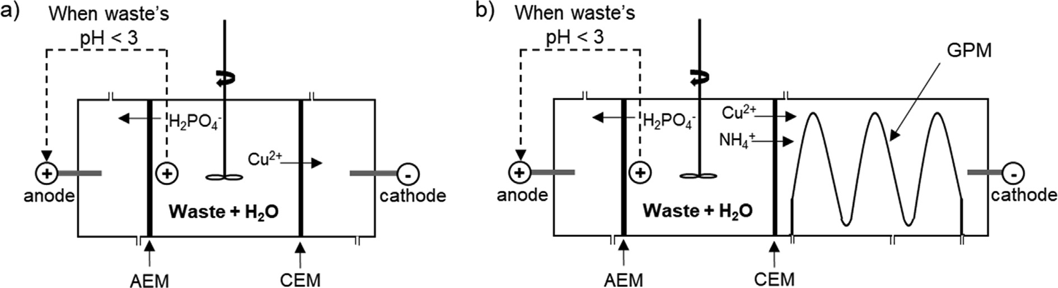

Fig. 1. Schematic original ED reactor (a) and novel ED reactor coupled with GPM (b) for simultaneous extraction of P and N from MSW digestate (AEM, anion exchange membrane; CEM, cation exchange membrane).

SC) was attached to a 3 × 4 cm plastic mesh that served as physical support to keep the membrane in place and was introduced at the cathode compartment. The GPM had a length of 500 mm, an outer diameter of 5.2 mm, a wall thickness of 0.56 mm, and a density of

0.95 g cm—3.

At the end of experiments, the volumes of anolyte, catholyte, HCl and digestate suspension solutions were registered and sam- ples were taken for determination of P and NH+ concentrations.

The percentage of P extracted during ED process was calculated as the amount of P in the anolyte at the end of experiment divided by the initial quantity of P contained in the MSW digestate (Eq.

4

(3)). The percentage of NH+ extracted during ED and GPM pro-

* 1. *ED plus GPM experiments* 4 +

Three extraction experiments were carried out sequentially. Table 1 shows the experimental conditions tested, which were defined after evaluating the results obtained in the previous exper- iment. As this set-up was tested for the first time, this strategy was adopted because it enables modifying the experimental variables that influence the extraction process. The amount of digestate placed in waste compartment, current intensity and operation time were the variables tested.

The experiments were performed by adding the digestate sus- pension (prepared with distilled water at a liquid to solid ratio of 2.5) to the waste compartment. The anode and cathode compart- ments were filled with 0.01 M NaNO3, (anolyte: 500 mL; catholyte: 900 mL) which was recirculated between the electrode compart- ments and the glass flasks using two Plastomec pumps. The GPM was filled with 150 mL of 1 N HCl which was continuously recircu- lated to a storage tank using a peristaltic pump (PG instruments, PS 181, United Kingdom).

During the extraction experiments, the power source was turned on and set to assure a constant current. pH and electric con- ductivity were measured daily in the electrolyte solutions, diges- tate suspension and HCl solution, using a HANNA (Combo) probe. When necessary, HNO3 1:1 was added into the cathode compart- ment, to dissolve the metal hydroxide precipitates formed nearby the cation exchange membrane, and distilled water was added into the waste compartment, to keep constant the digestate suspen- sion’s volume. Current intensity and voltage drop across the ED cell were recorded daily. Samples of the solutions from the anolyte, HCl and digestate suspension were taken at 24 h intervals to monitor P and NH+ contents.

4

cesses was defined as the amount of NH4 that was captured by the acid in relation to the initial amount present in the MSW diges- tate (Eq. (4)).

# %ED — extracted P

## mass of P in the anolyte solution at the end

= *mass of P in MSW digestate at the start* × 100 (3)

# %ED + GPM — extracted NH+

4

*mass of NH*+ *in the HCl solution at the end*

# = 4 × 100 (4)

## mass of NH+ in MSW digestate at the start

4

* 1. *Synthesis of a biofertilizer: secondary struvite precipitation and characterization*

In the current work, the synthesis of a biofertilizer was per- formed through the precipitation of secondary struvite. It required the addition of N and Mg sources. Two different sources of N and Mg were tested: a synthetic chemical and an alternative material. For Mg, the synthetic source was MgCl2·6H2O (Merck) while the alternative was seawater from a sandy beach located at Figueira da Foz, Coimbra, Portugal, where it was collected in the sea inlet. The seawater was transported to the laboratory, left to settle and kept at ±5 **°**C in the dark until use. Seawater’s pH was 6.8, EC was

>20 mS cm—1, Mg content was 1 510 mg L—1 and P content was

below detection limit (<0.5 mg L—1).

For N, the synthetic source used was NH4Cl (Panreac) while the alternative was N recovered from MSW digestate using the GPM.

Table 1

Experimental conditions tested for simultaneous P and N extraction from MSW digestate using ED plus GPM (*in duplicate).

|  |  |  |  |  |  |
| --- | --- | --- | --- | --- | --- |
| Code | Mass of sample in waste compartment, g | Length of waste compartment (L), cm | Current intensity (I), mA | Current density, mA cm—2 | Operation time, d |
| L15 | 200 | 15 | 50 | 1.0 | Total: 12 d  N extraction: 12 d |
|  |  |  |  |  | P extraction:12 d |
| L10 | 140 | 10 | 50 | 1.0 | Total: 12 d  N extraction: 12 d |
|  |  |  |  |  | P extraction:12 d |
| I75* | 140 | 10 | 75 | 1.5 | Total: 9 d  N extraction: 6 d |
|  |  |  |  |  | P extraction: 9 d |

For such purpose, the HCl solution collected at the end of I75 exper- iment containing NH+ was used.

4

In total, three struvite precipitation experiments were per- formed to investigate the effect of using alternative N and Mg sources on secondary struvite properties: i) STRUVITE-S: uses syn- thetic N and Mg sources; ii) STRUVITE-SA: uses alternative N (ex- tracted from MSW digestate using ED + GPM) and synthetic Mg sources; iii) STRUVITE-A: uses alternative N (extracted from MSW digestate using ED + GPM) and alternative Mg (obtained from seawater).

Struvite precipitation followed the method described in detail by Oliveira et al. (2020). Briefly, N and Mg sources were added to 100 mL of the anolyte solution (rich in P) obtained at the end of I75 experiment, while in agitation, and pH was quickly raised to around 9 using 5 M NaOH. The amount of N and Mg added in each experiment was calculated based on the Mg:N:P = 2:2:1 M ratio. The suspension was then left under slow stirring for 1 h, to pro- mote the formation and growth of the struvite crystals. Afterwards, the agitation was stopped, and the suspension was filtered through

a 0.45-lm membrane filter (Whatman ME25/21ST) to collect the

precipitates.

P content in the liquid fraction of the suspension was deter- mined to calculate the efficiency of P precipitation (in percentage) which was defined as the amount of P present in solution at the end of precipitation experiment divided by the initial amount of P in solution (Eq. (5)).

## % precipitated P

*mass of P in solution at the end of precipitation*

= *mass of P in solution at the beginning* × 100 (5)

Precipitates were dried at 40 **°**C for 48 h and characterized by X- ray powder diffraction (XRD) to identify the crystalline phases. A PANalytical X’Pert PRO diffractometer was used, operating at 40 mA and 45 kV applying Cu radiation. Patterns were scanned within 5–80**°** (2h) with a step size of 0.026**°** and a step time of

96.39 s. Scanning electron microscopy coupled with energy disper- sion spectroscopy (SEM-EDS) analyses of the precipitates were car- ried out using a Hitachi SU-70 equipped with EDS – Bruker using a XFlash 5010 detector.

The P recycling efficiency was defined as the percentage of P ini- tially contained in the MSW digestate that was converted into stru- vite. It was calculated by multiplying the percentage of ED- extracted P (%) by the percentage of precipitated P.

* 1. *Analytical procedures*

The water content of the MSW digestate was measured by the weight difference before and after drying (at 105 **°**C in a forced draft oven for 48 h) of approximately 10 g of material (in tripli- cate). The pH and electric conductivity values were measured in 1:2.5 MSW digestate:distilled water suspensions, after 1 h and 30 min of agitation, respectively, using a HANNA (Combo) probe (in triplicate). Total P, Ca and Mg contents in the MSW digestate were measured after a pre-treatment described in the Danish Stan- dard DS259: 0.5 g of sample was placed into a digestion tube and

20.0 mL of 1:1 HNO3 was added. The tubes were heated in a block digester (SCP Science) at 120 **°**C, for 2 h. Then the samples were fil- tered through qualitative filter and diluted to 50 mL (in triplicate). The same pre-treatment procedure was applied to the MSW diges- tate suspension samples collected during nutrient extraction experiments, using 5 mL of sample instead.

An atomic absorption spectrometer (PinAAcle 900 T, PerkinEl- mer) was used to quantify the Ca and Mg contents in the pre- treated samples and in the seawater.

P concentration was determined by the vanadomolybdophos- phoric acid colorimetric method at a wavelength of 470 nm (spec- trophotometer T80+ SW, PG instruments).

TKN and NH+ concentrations were determined using the method reported in Bremmer (1979).

4

1. Results and discussion
   1. *Development of a lab-scale experimental setup combining ED and GPM for the simultaneous P and N extraction from MSW digestate*

A new lab-scale setup combining ED and GPM was developed based on the existing laboratory ED cell (described in Section 2.2).

* + 1. *Selection of the GPM position*

In the original (non-modified) ED set-up (Fig. 1a) used for P extraction, N is present in the MSW digestate placed in the central compartment. During ED, the pH of MSW digestate rapidly decreased from ≈9 to ≈2 and therefore N is expectably present as NH+, a positively charged specie that theoretically moves to the cathode compartment by electromigration. Once at the cath- ode, N is converted from the ionic NH+ form into the gaseous NH3 (ammonia) given the high pH at the cathode compartment. The high pH value at the cathode compartment is caused by the electrolysis of water that occurs at the cathode (—) during the ED process. Specifically, a reduction occurs at the cathode (—) accord- ing to Eq. (6). Hydroxyl ions are generated as a result, creating alka- line conditions in this compartment.

4

4

# 2H2O + 2 e— →2 OH— + H2 (6)

Since the goal of our work was to recover N concomitantly to P during ED, the GPM could be placed either in the waste compart- ment or in the cathode compartment of the conventional ED cell. It was decided to place the GPM in the cathode compartment because N is present there as NH3 and can be directly captured by the GPM. By using this design option, N arriving at the cathode compartment should be expectably captured by the membrane without the need to impose additional pH adjustments; the reac- tions already occurring at the cathode during the ED extraction of P should be enough. The heavy metals (positively charged) that are also present at the cathode were not expected to interfere with N capture: the GPM, being hydrophobic and selectively permeable to the gas, does not allow the crossing-over of heavy metals in aqueous media. Therefore, the solution of NH4Cl inside the mem- brane will be free from any metal contaminant and can be used as a source of N in the process of struvite precipitation.

* + 1. *Selection of stripping solution*

In the vast majority of previous studies using GPM for N cap- ture, sulphuric acid (H2SO4) was used as stripping solution and, as a consequence, NH+ ions were recovered in the form of ammo- nium sulphate (García-González et al., 2016, 2015). Since the objective of the current work is the recovering of a solution similar to the ammonium chloride salt previously used for struvite precip- itation, HCl was used as stripping solution. In these conditions N is expected to be recovered as NH4Cl, as intended, according to Eq. (7):

4

# NH3 + HCl → NH4+ + Cl— (7)

* + 1. *Experimental setup combining ED and GPM*

To build the new laboratory scale cell for the simultaneous N and P extraction, a tubular GPM was placed in the cathode com- partment. The integration of such membrane required some dimensional adaptations: the length was increased from 5 cm to

15 cm, while catholyte volume raised from 500 to 900 mL. Inlet and outlet holes were drilled at the cathode compartment and con- nectors were used to fix both ends of the GPM at these locations. The final setup used to carry out the simultaneous P and N extrac- tion from MSW digestate is represented in Fig. 1b.

* 1. *Extraction of P and N using the novel ED plus GPM integrated* *process*

After its development, the new ED plus GPM setup was tested for the N and P extraction from MSW digestate. Overall, a substan- tial reduction in NH+ and P concentrations in the MSW digestate were observed over time in all experiments, with NH+ electromi- grating to the cathode side and being captured by the GPM, while P electromigrated to the anode side, being concentrated in the ano- lyte (Fig. 2).

4

4

* + 1. *N and P extraction in the first experiment (L15)*

The NH+ concentration reached 2204 mg L—1 in the HCl solution

4

at the end of the L15 experiment (Fig. 2a) which corresponds to an extraction for NH+ of 70% (Table 2). NH capture by the GPM con-

up in the anolyte. By following this strategy, no energy is spent to transport other negatively charged ions across the AEM in the first stage, and only when P ions are solubilized does the eletromi- gration to the anolyte begin. However, the pH decreasing rate in the MSW digestate suspension until a value <3 is reached (Fig. 3) was lower than anticipated (considering the previous work of Oliveira et al. (2019)). This might be the result of using a longer compartment and to the deficient stirring of the waste suspension, making the distance that ions need to travel longer, before they get to the anode or cathode ends. As a result, there was a substantial decrease in the percentage of ED-extracted P when compared to circa 90% extraction attained in that mentioned work (Oliveira et al., 2019).

* + 1. *N and P extraction in the second experiment (L10)*

Experiment L10 represents the second attempt to simultane- ously extract P and N. In L10 the length of the compartment with MSW digestate was shortened to 10 cm (from 15 cm) in order to ensure a stronger stirring conditions and diminish the migration

4 3 + path.

tinuously increased until day 5, when the NH4 concentration in the HCl solution reached 3080 mg L–1, representing an average daily

The NH+ concentration in the HCl solution inside the GPM was 1180 mg L—1 (Fig. 2b) with an average daily extraction of 68 mg of

extraction of 95 mg of NH+. After this time, there was no additional +

4

+ 4 NH4. These values were lower than observed in the first experi-

increase in the NH4 concentration in the HCl solution, despite the continuous decrease of NH+ concentration of in the digestate sus- pension until the end of the experiment (Fig. 2a). This decrease

4

of NH+ in the MSW digestate compartment is caused by the elec-

ment (L15) because a reduced amount of waste was also used. A slightly lower NH+ extraction (64%, see Table 2) was obtained. Sim- ilarly to the L15 experiment, the NH3 capture by the GPM continu-

+

4

4 + + ously increased until day 4; after this time, the NH4 concentration

tromigration of NH4 to the catholyte. When in the catholyte, NH4 either remains in solution, or, if the pH surpasses 8, it is converted into gaseous NH3 that will diffuse across the GPM, being collected in the acidic solution circulating inside the GPM. After day 5, NH3 is no longer captured by the membrane (no increase of NH+ concen- tration in the HCl solution occurred), meaning that NH+ has being accumulated in the catholyte solution. Analysis of catholyte showed that approximately 9% of the initial NH+ was found in this solution at the end of experiment. This probably occurred because the pH of catholyte was no more adequate (<3) from day 5

4

4

4

onwards to promote the conversion of NH+ to gaseous NH . So,

in the HCl solution decreased. In this experiment, the NH3 loss through volatilization was slightly higher than that observed in L15 (≈6%) which led to a lower NH+ extraction. After day 5 no more N was extracted.

Contrarily to what was anticipated, the percentage of ED- extracted P was similar to the one obtained in the first experiment (71%). P was mostly extracted until day 9.

4

+ 4 3 *3.2.3. N and P extraction in the third experiment (I75)*

no more NH4 was extracted after day 5, even if its removal from the MSW digestate continued until the end of the experiment.

On the other hand, a decrease of NH+ in HCl solution after day 5 occurred. This was probably due to: i) rise of the HCl solutions’ vol- ume as a consequence of osmotic distillation (water vapour cap-

4

ture, as reported by Riaño et al. (2019)), which caused a dilution

In the third experiment (I75), a higher electric current was applied to the system (75 mA instead of 50 mA) and the time allowed for extraction was reduced from 12 to 6 days for N and from 12 to 9 days, for P, following the results obtained in the pre- vious experiment (L10).

The NH+ extraction reached ≈74 ± 11% in only 6 days, repre-

effect on the NH+ concentration; and, ii) loss of NH from the sys- 4

4 + 3 senting an augment of nearly 10% when compared to the value

tem. Since the mass balances for NH4 showed a loss of less than 3%, the main cause for the decrease of the concentrations is attributed to the increase in the volume of acid.

On the other side of the ED cell, P was also extracted at the ano-

lyte. At the end of the L15 experiment the percentage of ED-

obtained in the L10 experiment. The NH+ concentration in the HCl solution at the end of experiment was 1644 mg L–1, and in this case, only 3 days of experiment were necessary to reach the max- imum concentration (1988 ± 131 mg L—1; average daily extraction

of 106 ± 8 mg NH+). Despite the decrease of NH+ concentration in

4

extracted P reached approximately 70%, a value that is similar to 4 4

NH+ extraction (Table 2). P extraction from MSW digestate

4

HCl solution observed from day 3 until the end of experiment

(caused by water vapour capture), the mass of NH+ extracted into

occurred in two sequential stages. In the first stage, the electrode (+) was placed in the compartment with the MSW digestate and a gradual acidification occurred (Fig. 3) due to the reaction taking place at the anode that generates hydrogen ions (Eq. (8). The low pH achieved promotes the P solubilisation from the MSW digestate.

# 2H2O → 4H+ + O2 (g) + 4 e— (8)

At day 7, the pH in the MSW digestate suspension reached a value below 3 and the electrode (+) was moved to the anode com- partment. From this point onwards, the P that had been solubilized started the electromigration to the anode compartment, building

4

the HCl solution increased in the same period, causing an extrac- tion efficiency increment of 8% (from 66% to the final 74 ± 11%). The reduction of operation time from 12 days to 6 days decreased the total capture of water vapour by the membrane from 122 mL (in L10) to 77 mL (in I75), which contributed to the higher NH+ con- centrations in this solution when compared to the previous experiments.

4

Like NH+, the percentage of ED-extracted P was also higher than in L10 experiment; approximately 81 ± 3% of initial P amount in the MSW digestate was found in the anolyte solution. The increase of current intensity in this experiment (75 mA) clearly promoted a faster NH+ and P extraction.

4

4

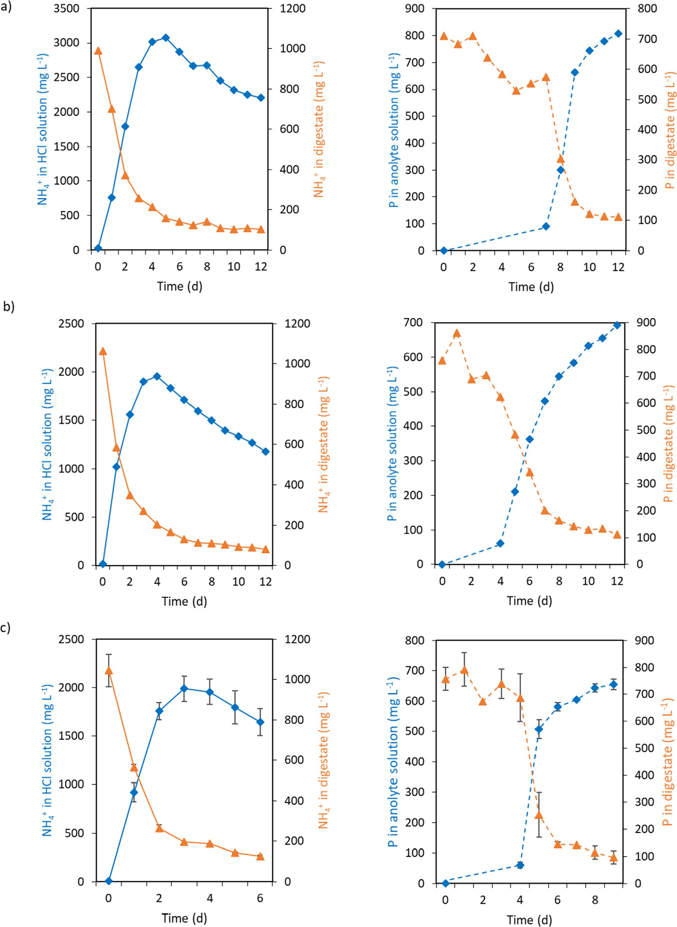

Fig. 2. Concentration of NH+ (full line) and P (dashed line) in the HCl and anolyte solutions (), respectively and, in the digestate () during ED plus GPM experiments: L15 (a), L10 (b) and I75 (c). The error bars in experiment I75 represent the standard deviation of duplicate experiments (L15 and L10 were not carried out in duplicate).

4

Table 2

Amount of nutrients at the beginning and at the end of ED plus GPM experiments in the MSW digestate compartment, in the anolyte (for P) and in the stripping solution of HCl (for NH+) together with extraction efficiencies (standard deviation of duplicate experiments is shown in parenthesis).

4

|  |  |  |  |  |
| --- | --- | --- | --- | --- |
| Experiment | Initial mass in MSW digestate compartment (mg) | Final mass in MSW digestate compartment (mg) | Mass in HCl for NH+, or in anolyte for P (mg) | Extraction efficiency (%) |
| NH+ L15 | 668.7 | 76.8 | 467.3 | 69.9 |
| L10 | 494.3 | 43.1 | 315.0 | 63.7 |
| I75 | 486.0 (37.4) | 59.2 (2.0) | 355.8 (26.1) | 73.6 (11.0) |
| P  L15 | 479.1 | 82.2 | 333.2 | 69.5 |
| L10 | 353.1 | 60.0 | 249.6 | 70.7 |
| I75 | 352.2 (20.1) | 64.4 (16.7) | 283.3 (5.0) | 80.5 (3.2) |

4

4

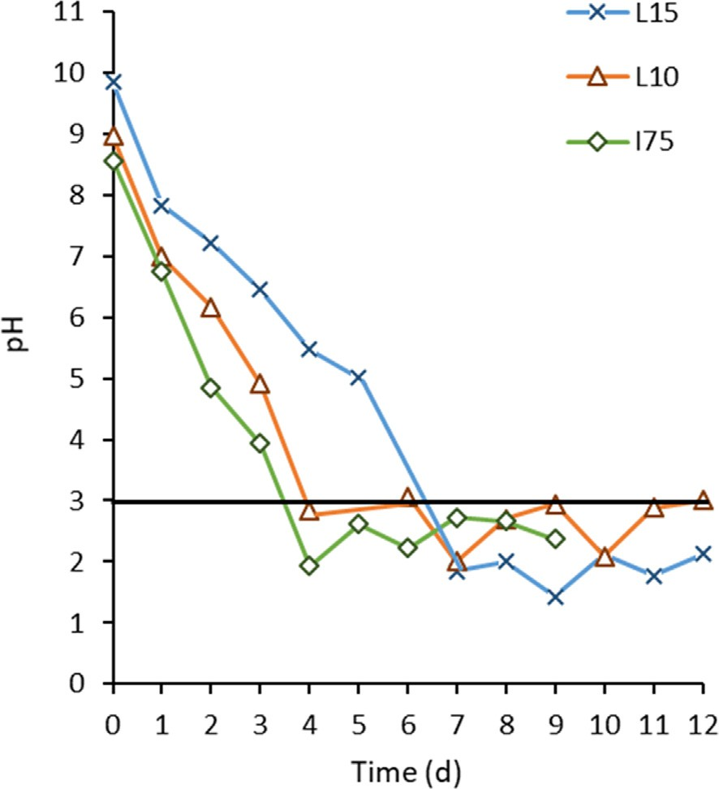respect to secondary struvite, the nucleation rate of crystals is also reduced, thus affecting the aggregation of secondary struvite crys- tals (Shaddel et al., 2020). The corresponding EDS spectra showed strong peaks of Mg, P and O elements for the three obtained precip- itates, consistent with struvite composition (Fig. 4c; N element is not detected by this technique). Furthermore, a weak peak of Ca element was detected in the secondary struvite produced with sea- water (STRUVITE-A). Chemical analysis of the seawater revealed Ca concentration of 837.5 mg L—1, corresponding to Mg:Ca molar ratio of 2:1. Anyway, the presence of Ca did not inhibit the precipitation of secondary struvite and non-crystalline phase was identified in STRUVITE-A (Fig. 4a), because the Mg:Ca ratio was high enough to minimize simultaneous precipitation of amorphous calcium phosphates (Le Corre et al., 2005). In further experiments, it is important to ensure that seawater’s Mg:Ca ratio is >2:1.

These results confirm that a high-quality biofertilizer - sec- ondary struvite - can be produced from N and Mg alternative sources instead of synthetic ones.

Fig. 3. Digestate suspensions’ pH measured in the L15, L10, and I75 extraction experiments. The full black line ( ) indicates the pH value from which the P extraction from MSW digestate into the anolyte was initiated.

* 1. *Evaluation of the properties of the synthesised biofertilizer – secondary struvite – using synthetic and alternative N and Mg sources*

In all experiments, where secondary struvite was synthesised, the percentages of P precipitated were superior to 99.5%, meaning that practically all the P in solution was recovered in solid form, regardless the N and Mg sources used. This result is in line with precipitation efficiencies reported by Oliveira et al. (2020) (up to 98%).

Purity of the secondary struvite was confirmed by XRD (Fig. 4a). XRD spectra confirm that 100% of the three precipitates obtained were identified as MgNH4PO4·6H2O The diffraction peaks of the precipitates correspond to struvite and no other crystalline phases were detected. Fig. 4b shows the particle morphology of STRUVITE- A, STRUVITE-S and STRUVITE-SA. STRUVITE-S (synthetic N and Mg sources) and STRUVITE-SA (alternative N and synthetic Mg) have dendritic shape. The use of seawater as Mg source changes the par- ticles morphology, and irregular cubic crystals were obtained instead (STRUVITE-A). The simultaneous presence of other ions in seawater might be responsible for such morphological alterations (Shaddel et al., 2020). SEM images also showed some degree of aggregation of the secondary struvite crystals formed using seawa- ter, while STRUVITE-S and STRUVITE-SA particles remain sepa- rated. As the seawater reduces the initial supersaturation with

* 1. *Preliminary assessment of the economic implications of replacing synthetic N and Mg salts by alternative materials on the synthesis of a biofertilizer*

An economic evaluation for the production of 1 kg of secondary struvite using different N and Mg sources in the precipitation pro- cess was carried out. The data used in these calculations were retrieved from the previously described precipitation experiments which generate (i) STRUVITE-S, STRUVITE-SA and STRUVITE-A. Industrial prices of the reagents required for the precipitation of secondary struvite were gathered from supply companies. The cost for N recovery using a GPM technology at a pilot-scale plant was previously reported by Molinuevo-Salces et al. (2020) as

2.07 € kg N recovered–1. Since the electricity cost was the same in

the three experiments (0.07 €), only the chemical reagents costs were considered. Fig. 5 compares the total costs of the three approaches considered.

By using a synthetic N source for struvite precipitation the cost is approximately 3€ per kg of struvite produced (0.72 kg; unit cost: 3.84 € kg—1; Fig. 5a). The cost is significantly reduced when alter- native N source (N extracted from MSW digestates) is used: about 1€, representing a reduction of 80% for the N supply (Fig. 5b, c). By contrast, the use of seawater as source of Mg was costlier (3€; Fig. 5c) than using the synthetic Mg salt MgCl2·6H2O (1€; 2.04 kg

- unit cost: 0.5 € kg—1). Because the Mg concentration in seawater is low, 167 L of seawater will be required to synthesize 1 kg of stru- vite; so the higher cost is related to the transport of seawater from the ocean to the waste treatment plant (65 km, unit cost: 0.02 € L—1). From an environmental point of view, Shaddel et al. (2020) has previously reported that CO2 eq. emissions from MgCl2 use (≈1.9 kg CO2 eq.) are higher than when seawater is used (1.7 kg CO2 eq.), considering similar Mg:P molar ratio as in the cur-

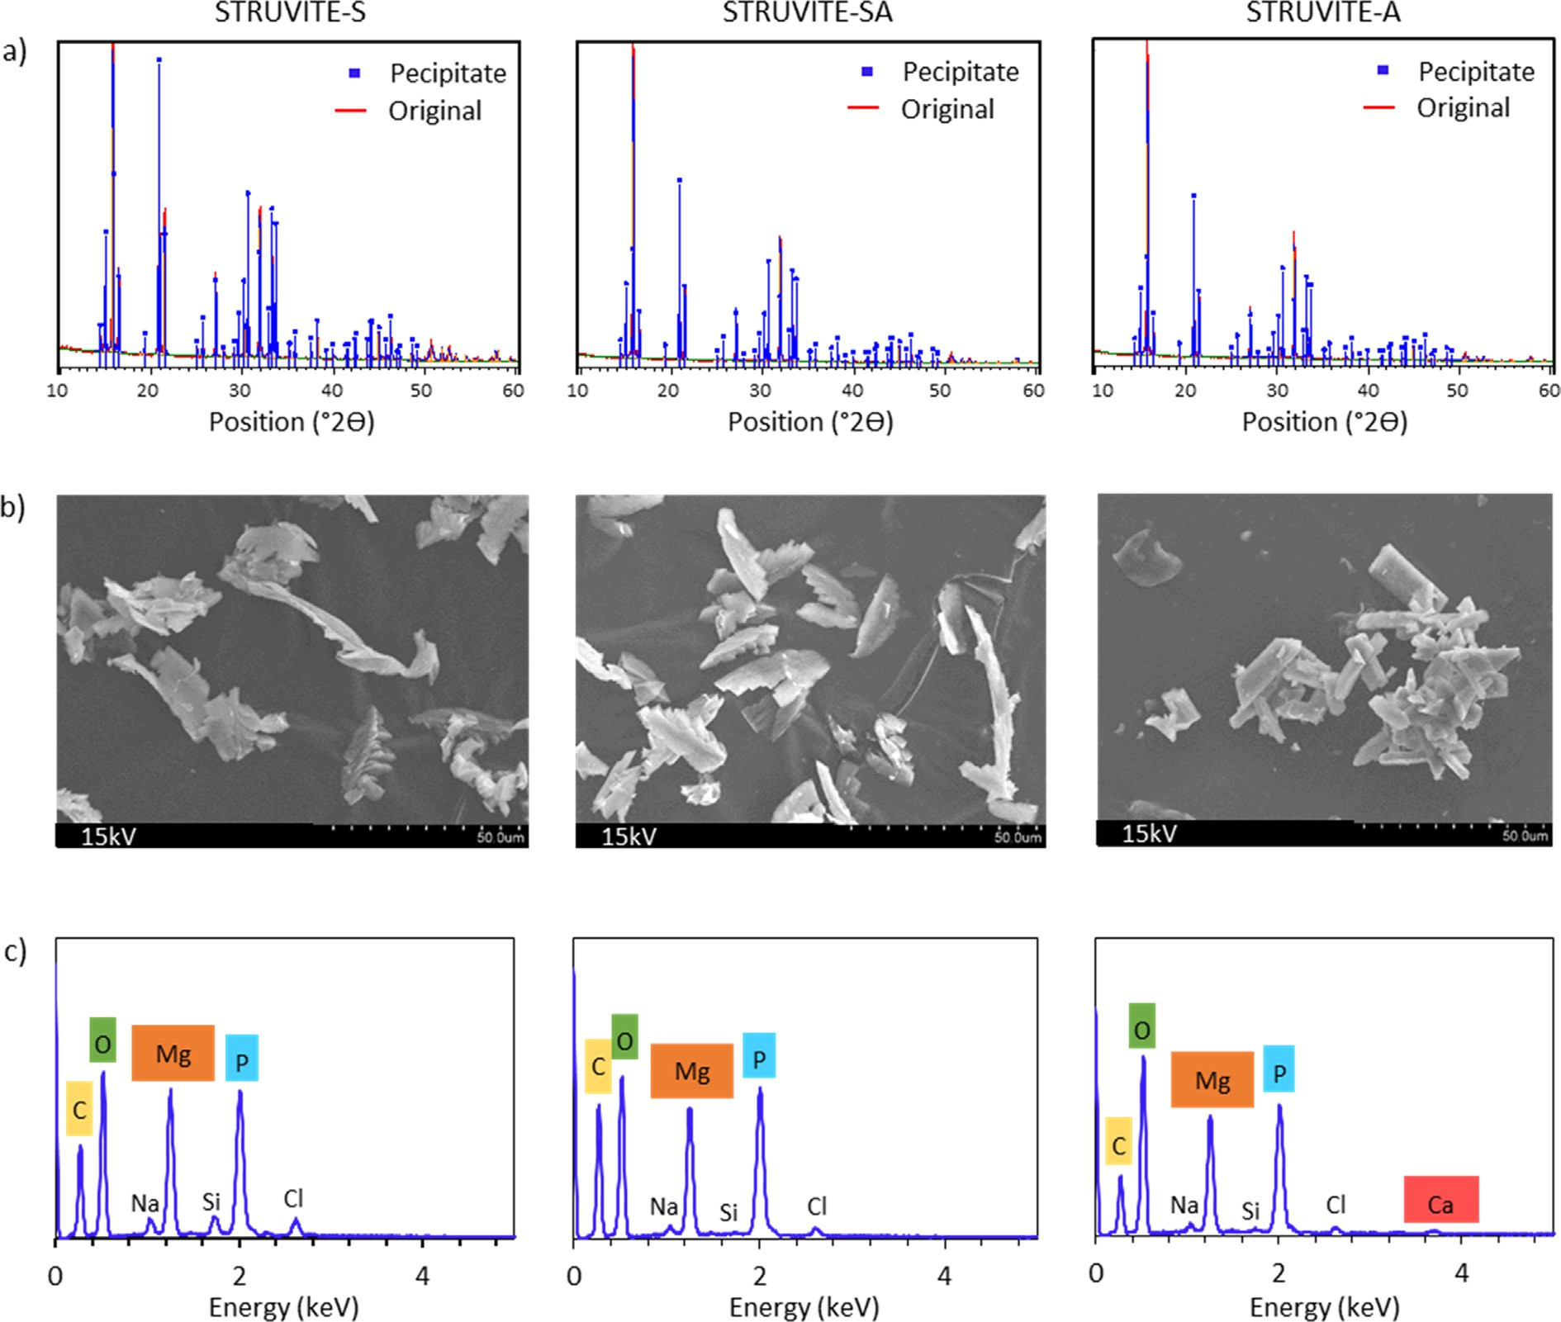

Fig. 4. X-Ray diffraction diagrams (a), corresponding EDS spectra (c) of the obtained biofertilizers precipitates with synthetic N and synthetic Mg sources (STRUVITE-S), with alternative N (recovered from digestate using GPM) and synthetic Mg sources (STRUVITE-SA), and alternative N (recovered from digestate using GPM) and alternative Mg (obtained from seawater) (STRUVITE-A).

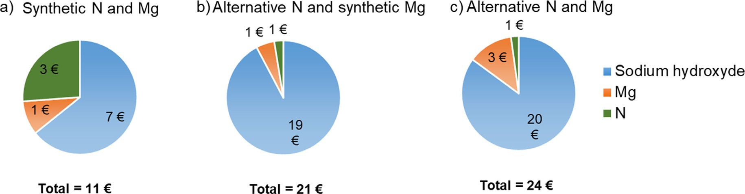

Fig. 5. Contribution of each input for the operational costs (in euros) for production of 1 kg of secondary struvite with following conditions a) synthetic N and Mg sources (STRUVITE-S), b) alternative N and synthetic Mg sources (STRUVITE-SA) and c) alternative N and Mg sources (STRUVITE-A).

4

rent work; hence the replacement of MgCl2·6H2O by seawater is expected to contribute to make the secondary struvite synthesis more environmentally attractive.

In all approaches, NaOH consumption to rise the pH during chemical precipitation of struvite (STRUVITE-S: 18 kg; STRUVITE- SA: 51 kg; STRUVITE-A: 54 kg; unit cost: 0.375 € kg—1; Fig. 5) cor- responds to the major cost contributor (represents 64% of the total

costs in STRUVITE-S and up to 92% in the STRUVITE-SA and STRUVITE-A). The use of seawater instead of synthetic Mg requires a slightly higher NaOH amount (54 kg instead 51 kg). But it is the use of alternative N source that involves larger NaOH consumption, due to the highly acidic pH of the N recovered solution (pH < 1). The pH of the acidic solution increases as NH+ is been captured by the membrane (García-González et al., 2015), therefore, the cap-

turing process can be stopped when the pH of the acidic solution becomes neutral, the lowering the consumption and cost of NaOH. Furthermore, the quantity of NaOH added during secondary stru- vite production depends on the final pH target; in our case, a pH = 9 was chosen, but it is possible to carry out secondary struvite precipitation at lower pH values. Further works should be per- formed to find the optimal pH for precipitation, without compro- mising the quality of secondary struvite.

The total costs of reagents, when alternative sources were used (STRUVITE-A and STRUVITE-SA), were 2 times higher than by using synthetic sources (STRUVITE-S) (Fig. 5). This means that, under the conditions tested herein, the synthesis of secondary struvite using N and Mg sourced from alternative materials (21 € — 24 €) is not cost-competitive with the use of synthetic N and Mg sources (11€). From an environmental point of view, waste treatment to obtain by-products as biofertilizers through nutrient recovery is preferable to the use of raw materials from mining sources, as those contribute to reduce resource depletion, and accomplish with the circular economy principles adopted by the European

Union (European Commission, 2015).

1. Conclusions

The recycling of 81% of the P present in MSW digestate into a biofertilizer was successfully achieved using an innovative setup combining ED and GPM.

Two solutions virtually free of contaminants were produced: one solution rich in P (the anolyte), resulting from the extraction of 81% of the P contained in the MSW digestate and one solution rich in NH+ (stripping solution), resulting from the extraction of 74% of NH+ present in the waste. These solutions were used for the synthesis of a biofertilizer, namely secondary struvite, through a highly efficient precipitation process (99.5%). The results obtained in the current work showed that the combination of ED and GPM technologies for simultaneous P and N extraction is promising. The percentages of P and NH+ extracted from MSW digestate are still limited and further improvement is required before potential up-scaling of the process is considered. In further works different strategies involving reactor design and electric cur- rent intensities should be explored.

4

4

4

The synthesis of the secondary struvite using alternative mate-

rials, such as N extracted from MSW digestate and seawater as a source of Mg, showed to be as feasible as when synthetic chemicals were used; high purity secondary struvite was obtained in both cases. The preliminary evaluation of costs showed that the synthe- sis of struvite using alternative materials is more expensive than by using synthetic ones. Further process optimisation is necessary attempting to reduce reagents consumption/costs, but the results herein obtained are encouraging. The tested solutions have signif- icant environmental advantages, since recycling of P from wastes and the replacement of synthetic fertilizers that are manufactured from finite sources by secondary biofertilizers produced from organic wastes reduce non-renewable resource depletion and stimulates the circular economy implementation. To widen the possibilities of large-scale P and N recycling, other organic wastes produced in large amounts should be tested (e.g. sewage sludge from wastewater treatment plants, animal manures or wastewaters).

References

[Bremmer, J.M., 1979. Total nitrogen. In: Black, C.A., Evans, D.D., White, J.L.,](http://refhub.elsevier.com/S0956-053X(21)00124-0/h0005) [Ensminger, L.E., Clarck, F.E. (Eds.), Methods of Soils Analyses. Amercian](http://refhub.elsevier.com/S0956-053X(21)00124-0/h0005) [Society of Agronomy, Wisconsin, USA, pp. 1149–1178](http://refhub.elsevier.com/S0956-053X(21)00124-0/h0005).

Cordell, D., Drangert, J.O., White, S., 2009. The story of phosphorus: global food security and food for thought. Glob. Environ. Chang. 19, 292–305. [https://doi.](https://doi.org/10.1016/j.gloenvcha.2008.10.009) [org/10.1016/j.gloenvcha.2008.10.009](https://doi.org/10.1016/j.gloenvcha.2008.10.009).

Cordell, D., White, S., 2014. Life’s bottleneck: sustaining the world’s phosphorus for a food secure future. Annu. Rev. Environ. Resour. 39, 161–188. [https://doi.org/](https://doi.org/10.1146/annurev-environ-010213-113300) [10.1146/annurev-environ-010213-113300](https://doi.org/10.1146/annurev-environ-010213-113300).

Dube, P.J., Vanotti, M.B., Szogi, A.A., García-González, M.C., 2016. Enhancing recovery of ammonia from swine manure anaerobic digester effluent using gas-permeable membrane technology. Waste Manag. 49, 372–377. [https://doi.](https://doi.org/10.1016/j.wasman.2015.12.011) [org/10.1016/j.wasman.2015.12.011](https://doi.org/10.1016/j.wasman.2015.12.011).

Ebbers, B., Ottosen, L.M., Jensen, P.E., 2015. Comparison of two different electrodialytic cells for separation of phosphorus and heavy metals from sewage sludge ash. Chemosphere 125, 122–129. [https://doi.org/10.1016/j.](https://doi.org/10.1016/j.chemosphere.2014.12.013) [chemosphere.2014.12.013](https://doi.org/10.1016/j.chemosphere.2014.12.013).

European Commission, 2015. Communication from the commission to the European parliament, the council, the European economic and social committee and the committee of the regions - closing the loop - an Eu action plan for the circular economy. Brussels.

Eurostat, 2020. Municipal waste statistics [WWW Document]. URL [https://ec.](https://ec.europa.eu/eurostat/statistics-explained/index.php/Municipal_waste_statistics%23Municipal_waste_treatment) [europa.eu/eurostat/statistics-explained/index.php/Municipal_waste_](https://ec.europa.eu/eurostat/statistics-explained/index.php/Municipal_waste_statistics%23Municipal_waste_treatment) [statistics#Municipal_waste_treatment](https://ec.europa.eu/eurostat/statistics-explained/index.php/Municipal_waste_statistics%23Municipal_waste_treatment) (accessed 5.12.20).

Ferreira, C., Ribeiro, A., Ottosen, L., 2005. Effect of major constituents of MSW fly ash during electrodialytic remediation of heavy metals. Sep. Sci. Technol. 40, 2007– 2019. <https://doi.org/10.1081/SS-200068412>.

Garcia-González, M.C., Vanotti, M.B., 2015. Recovery of ammonia from swine manure using gas-permeable membranes: effect of waste strength and pH. Waste Manag. 38, 455–461. <https://doi.org/10.1016/j.wasman.2015.01.021>.

García-González, M.C., Vanotti, M.B., Szogi, A.A., 2016. Recovery of ammonia from anaerobically digested manure using gas-permeable membranes. Sci. Agric. 73, 434–438. <https://doi.org/10.1590/0103-9016-2015-0159>.

García-González, M.C., Vanotti, M.B., Szogi, A.A., 2015. Recovery of ammonia from swine manure using gas-permeable membranes: effect of aeration. J. Environ. Manage. 152, 19–26. <https://doi.org/10.1016/j.jenvman.2015.01.013>.

Guedes, P., Couto, N., Mateus, E.P., Ribeiro, A.B., 2017. Phosphorus recovery in sewage sludge by electrokinetic based technologies: a multivariate and circular economy view. Waste Biomass Valor 8, 1587–1596. [https://doi.org/10.1007/](https://doi.org/10.1007/s12649-017-9985-y) [s12649-017-9985-y](https://doi.org/10.1007/s12649-017-9985-y).

Guedes, P., Couto, N., Ottosen, L.M., Ribeiro, A.B., 2014. Phosphorus recovery from sewage sludge ash through an electrodialytic process. Waste Manag. 34, 886– 892. <https://doi.org/10.1016/j.wasman.2014.02.021>.

Guedes, P., Magro, C., Couto, N., Mosca, A., Mateus, E.P., Ribeiro, A.B., 2015. Potential of the electrodialytic process for emerging organic contaminants remediation and phosphorus separation from sewage sludge. Electrochim. Acta 181, 109–

117. <https://doi.org/10.1016/j.electacta.2015.03.167>.

Hidalgo, D., Corona, F., Martín-Marroquín, J.M., 2020. Nutrient recycling: from waste to crop. Biomass Convers. Biorefinery, in press. [https://doi.org/10.1007/](https://doi.org/10.1007/s13399-019-00590-3) [s13399-019-00590-3](https://doi.org/10.1007/s13399-019-00590-3).

Jensen, P.E., Ferreira, C.M.D., Hansen, H.K., Rype, J.-U., Ottosen, L.M., Villumsen, A., 2010. Electroremediation of air pollution control residues in a continuous reactor. J. Appl. Electrochem. 40, 1173–1181. [https://doi.org/10.1007/s10800-](https://doi.org/10.1007/s10800-010-0090-1) [010-0090-1](https://doi.org/10.1007/s10800-010-0090-1).

Karim, M., Wetterhan, J.T., 2020. A comparative study of solid waste management in the United States, Europe and Asia. Ann. Civ. Environ. Eng. 4, 003–011 <https://doi.org/10.29328/journal.acee.1001019>.

Kirkelund, G.M., Jensen, P.E., Ottosen, L.M., Pedersen, K.B., 2019. Comparison of two- and three-compartment cells for electrodialytic removal of heavy metals from contaminated material suspensions. J. Hazard. Mater. 367, 68–76. [https://doi.](https://doi.org/10.1016/j.jhazmat.2018.12.063) [org/10.1016/j.jhazmat.2018.12.063](https://doi.org/10.1016/j.jhazmat.2018.12.063).

Le Corre, K.S., Valsami-Jones, E., Hobbs, P., Parsons, S. a., 2005. Impact of calcium on struvite crystal size, shape and purity. J. Cryst. Growth 283, 514–522. <https://doi.org/10.1016/j.jcrysgro.2005.06.012>.

Molinuevo-Salces, B., Riaño, B., Vanotti, M.B., Hernández-González, D., García- González, M.C., 2020. Pilot-scale demonstration of membrane-based nitrogen recovery from swine manure. Membranes (Basel) 10, 270. [https://doi.org/](https://doi.org/10.3390/membranes10100270) [10.3390/membranes10100270](https://doi.org/10.3390/membranes10100270).

Oliveira, V., Dias-Ferreira, C., Labrincha, J., Rocha, J.L., Kirkelund, G.M., 2020a. Testing new strategies to improve the recovery of phosphorus from anaerobically digested organic fraction of municipal solid waste. J. Chem. Technol. Biotechnol. 95, 439–449. <https://doi.org/10.1002/jctb.6037>.

Oliveira, V., Kirkelund, G.M., Horta, C., Labrincha, J., Dias-Ferreira, C., 2019. Improving the energy efficiency of an electrodialytic process to extract phosphorus from municipal solid waste digestate through different strategies. Appl. Energy 247, 182–189. <https://doi.org/10.1016/j.apenergy.2019.03.175>.

Oliveira, V., Kirkelund, G.M., Labrincha, J., Dias-Ferreira, C., 2020b. Struvite quality assessment during electrodialytic extraction. In: Vilarinho, C., Castro, F., Gonçalves, M., Fernando, A.L. (Eds.), Wastes: Solutions, Treatments and Opportunities III. CRC Press - Taylor & Francis Group, pp. 236–242. [https://](https://doi.org/10.1201/9780429289798-38) [doi.org/10.1201/9780429289798-38](https://doi.org/10.1201/9780429289798-38).

Oliveira, V., Labrincha, J., Dias-Ferreira, C., 2018. Extraction of phosphorus and struvite production from the anaerobically digested of organic fraction of municipal solid waste. J. Environ. Chem. Eng. 6, 2837–2845. [https://doi.org/](https://doi.org/10.1016/j.jece.2018.04.034) [10.1016/j.jece.2018.04.034](https://doi.org/10.1016/j.jece.2018.04.034).

Ottosen, L.M., Bertelsen, I.M.G., Jensen, P.E., Kirkelund, G.M., 2020. Sewage sludge ash as resource for phosphorous and material for clay brick manufacturing.

Constr. Build. Mater. 249, 118684. [https://doi.org/10.1016/](https://doi.org/10.1016/j.conbuildmat.2020.118684) [j.conbuildmat.2020.118684](https://doi.org/10.1016/j.conbuildmat.2020.118684).

Rahman, M.M., Salleh, M.A.M., Rashid, U., Ahsan, A., Hossain, M.M., Ra, C.S., 2014. Production of slow release crystal fertilizer from wastewaters through struvite crystallization - a review. Arab. J. Chem. 7, 139–155. [https://doi.org/10.1016/j.](https://doi.org/10.1016/j.arabjc.2013.10.007) [arabjc.2013.10.007](https://doi.org/10.1016/j.arabjc.2013.10.007).

Riaño, B., Molinuevo-salces, B., Vanotti, B., 2019. Application of gas-permeable membranes for-semi-continuous ammonia recovery from swine manure. Environments 6. <https://doi.org/10.3390/environments6030032>.

Shaddel, S., Grini, T., Ucar, S., Azrague, K., Andreassen, J.P., Østerhus, S.W., 2020. Struvite crystallization by using raw seawater: improving economics and environmental footprint while maintaining phosphorus recovery and product quality. Water Res. 173, 115572. <https://doi.org/10.1016/j.watres.2020.115572>. [Sokka, L., Antikaeinen, R., Kauppi, P., 2004. Flows of nitrogen and phosphorus in](http://refhub.elsevier.com/S0956-053X(21)00124-0/h0145) [municipal waste: a substance flow analysis in Finland. Prog. Ind. Ecol. 1, 165–](http://refhub.elsevier.com/S0956-053X(21)00124-0/h0145)

[186](http://refhub.elsevier.com/S0956-053X(21)00124-0/h0145).

Zarebska, A., Nieto, D.R., Christensen, K.V., Søtoft, L.F., Norddahl, B., 2015. Ammonium fertilizers production from manure - a critical review. Crit. Rev. Environ. Sci. Technol. 45, 1469–1521. [https://doi.org/10.1080/](https://doi.org/10.1080/10643389.2014.955630)

[10643389.2014.955630](https://doi.org/10.1080/10643389.2014.955630).

Zin, M.M.T., Kim, D., 2021. Simultaneous recovery of phosphorus and nitrogen from sewage sludge ash and food wastewater as struvite by Mg-biochar. J. Hazard. Mater. 403, 123704. <https://doi.org/10.1016/j.jhazmat.2020.123704>.