**A general treatment to study molecular complexes stabilized by hydrogen, halogen and carbon bond networks: Experiment and theory of (CH2F2)n···(H2O)m**

Camilla Calabrese,[a,b] § Weixing Li,[c] § Giacomo Prampolini,[d] Luca Evangelisti,[c,e] Iciar Uriarte,[a,b] Ivo Cacelli,[d,f] Sonia Melandri,[c] and Emilio J. Cocinero [a,b]*

[a] Dr. C. Calabrese, Dr. I. Uriarte, Dr. E. J. Cocinero  
Departament of Physical Chemistry  
University of the Basque Country (UPV/EHU)  
Barrio Sarriena, S/N, 48940, Leioa (Spain)  
E-mail: [emiliojose.cocinero@ehu.es](mailto:emiliojose.cocinero@ehu.es)

Homepage: <http://grupodeespectroscopia.es/MW/>

[b] Dr. C. Calabrese, Dr I. Uriarte, Dr. E. J. Cocinero  
Fundación Biofísica Bizkaia  
CSIC (UPV/EHU), 48080, Bilbao (Spain)

[c] Dr. W. Li, Dr. L. Evangelisti, Dr. S. Melandri  
Dipartimento di Chimica “Giacomo Ciamician”  
Università degli Studi di Bologna  
via Selmi 2, I-40126 Bologna (Italy)

[d] Dr. G. Prampolini, Dr. I. Cacelli

Istituto di Chimica dei Composti OrganoMetallici (ICCOM-CNR)  
Area della Ricerca  
via G. Moruzzi 1, I-56124 Pisa (Italy)

[e] Dr. L. Evangelisti

Department of Chemistry

University of Virginia  
McCormick Road, VA 22903 Charlottesville (USA)

[f] Dr. I. Cacelli

Dipartimento di Chimica e Chimica Industriale

Università di Pisa  
via Risorgimento 35, I-56126 Pisa (Italy)

§ Dr. C. Calabrese and Dr. W. Li have contributed equally to this work.

Supporting information for this article is given via a link at the end of the document.

**Abstract:** Rotational spectra of several difluomethane water adducts have been observed using two broadband chirped pulse Fourier transform microwave (CP FTMW) spectrometers. The experimental structures of (CH2F2)···(H2O)2, (CH2F2)2···(H2O), (CH2F2)···(H2O)3 and (CH2F2)2···(H2O)2 were unambiguously identified with the aid of 18 isotopic substituted species. A subtle competition between hydrogen, halogen and carbon bonds is observed and a detailed analysis was performed on the complex network of non-covalent interactions, which stabilize each cluster. The study shows that the combination of stabilizing contacts networks is able to reinforce the interaction strength through a cooperative effect, which can lead to large stable oligomers.

The importance of non‑covalent forces cannot be overemphasized, as they are at the origin of the existence of any condensed phase. Among the different kind of interactions, which may occur at intermolecular level, the hydrogen bond (HB) is by far the most known. Its chameleon‑like nature is able to stabilize static structures and mediate dynamic processes, and HB plays a key role in many chemical processes and biologically relevant functions.[1] Broadly speaking, the HB takes place whenever a D‑H···Y‑Z interaction can be established, where the atoms D and Y are more electronegative than the H atom. The atoms D and Y are called the donor and the acceptor, respectively. This general definition not only refers to strong HBs, formed when both D and Y are strong donors or acceptors (e.g. O or N), but can be extended to include weak hydrogen bonds (WHB), in which the binding partners have only a modest electronegativity. This can arise when either a weak donor (e.g. C‑H or S‑H), a weak acceptor (halogens or π‑clouds) or both kind of species are involved. The WHB, also defined as non‑conventional HB, is characterized by energy less than 16 kJmol‑1 and takes place when directional preferences are present. In fact, electrostatic forces which rule the HB interactions, rather than dispersion forces (which are more proper of the van der Waals interactions), rule the HB interactions, and tend to form linear WHB with deviations observed up to 110°.[2] Of note and the same context, the appearance of other non‑covalent weak interactions as halogen bonds,[3] carbon interaction[4] or beryllium bonds[5] have emerged in recent years.

In this regard, from the experimental point of view, the high‑resolution spectroscopic techniques are the only ones that provide unequivocal and accurate information to characterize any type of interaction. In the past two decades a deeper insight into WHBs and halogen bonds has been achieved by successfully combining experimental techniques, in particular Fourier‑transform microwave spectroscopy (FT‑MW) with computational approaches, essentially based on quantum mechanical (QM) methods.[6–10] The unique sensitivity of rotational spectroscopy allows an accurate characterization with atomic resolution of (W)HBs or halogen bonds providing the assignment of single conformers, even differing only for minor geometric variations. However, its applicability has been limited to 1‑3 subunits where a few stabilizing interactions were involved.[10,11] The development in the last years of chirp-pulsed Fourier transform microwave (CP‑FTMW) spectroscopy opens the possibility of studying larger oligomers. Very few systems, where several subunits and a large number of weak interactions are involved,[12–14] have been studied to date. Certainly, the rotational assignment of this type of oligomers to such a high level of resolution is a challenge that can only be completed with the help of state‑of‑the‑art calculations.

From a computational point of view, two major challenges have to be faced when dealing with weak interactions: the capability to efficiently explore complex interaction potential energy surfaces (IPESs), often characterized by shallow, quasi‑degenerate, local minima, whose number clearly increase with the dimensions of the cluster,[15–23] and the accuracy required for a reliable and balanced estimate of non‑covalent interactions. One of the best molecular benchmarks as regards weak interactions is difluoromethane (CH2F2, DFM hereafter), having a pair of weak proton donors and a pair of weak proton acceptors, so that it can span a large variety of intermolecular arrangements.[24–26] Actually, besides their importance in critical processes as atmospheric ozone depletion, freons are molecular species of fundamental interest in the context of WHB and halogen frameworks.[27,28]

In this work, the competition between different classes of stabilizing interactions has been revealed using CP‑FTMW spectroscopic technique, investigating for the first-time trimers and tetramers of DFM and water, as stable gas phase oligomers. In 1999, Caminati *et al*.[29] firstly studied the interaction between water with DFM using the Stark modulated free jet absorption millimeter‑wave spectrometer,[30,31] and occasionally found a set of evenly spaced lines, which were finally assigned to the spectrum of DFM dimer.[25] The presence of the water induces a strong HB quenching all other types of interactions in the 1:1 adduct, while the dimer is characterized by a triple WHB network where the DFM acts as a double proton donor and as a double proton acceptor.[26] Since that, the way to the study of higher adducts has been opened: after 8 years the DFM trimer, 28 and another 7 years later the tetramer were detected by means of pulsed‑jet FTMW spectrometer.[6,7,32] The subunits of both oligomers are held together by a WHB network, giving rise to a cyclic arrangement in the trimer and a rhomboid form for the tetramer. The number of WHB increases to the second power passing from the dimer to the trimer (from 3 to 9), while the tetramer is stabilized by 16 WHBs. Exploiting the potential of CP‑FTMW spectroscopy, we have extended the study between DFM and water, analyzing the trimers (CH2F2)‑(H2O)2, (CH2F2)2‑(H2O) and two tetramers (CH2F2)‑(H2O)3 and (CH2F2)2‑(H2O)2. Unraveling the structure of heteroclusters composed by more than two moieties, formed by the different combinations of DFM and water, is interesting as it highlights the kind of competitive interactions stabilizing each complex, making possible to assess if others interactions might have a key role. In 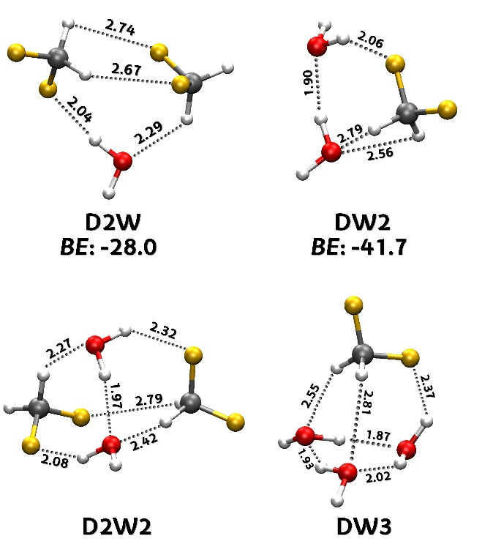fact, the whole range of possible HBs can be achievable, from moderately strong (OH···O) HBs between two water molecules, to WHB’s of different types as strong donor – weak acceptor (O‑H···F), weak donor – strong acceptor (C‑H···O) and the most elusive yet efficient, weak donor ‑ weak acceptor (C‑H···F). Additionally, halogen‑halogen contacts (C‑F···F) or halogen bonds (C‑F···O) could be present in this kind of large oligomers. Such complexes should be stabilized by a subtle interplay of all the aforementioned contributions and, could yield a wealth of structural and dynamical information, allowing for a further step in the comprehension of non-covalent bonds. Moreover, the coexistence of single and bifurcate interactions could lead to further stabilization patterns.

The first step required for approaching such a rich panorama of possible non‑covalent interactions concerns the choice of an accurate theoretical strategy, able to identify the most stable conformers for the two trimers (CH2F2)···(H2O)2 and (CH2F2)2···(H2O), hereafter respectively labelled DW2 and D2W, and the two tetramers (CH2F2)···(H2O)3 and (CH2F2)2···(H2O)2, namely DW3 and D2W2. Indeed, the conformational casuistry of these systems is enormous, as the oligomers can be stabilized by several types of weak interactions (OH···O, O‑H···F, C‑H···O, C‑H···F, C‑F···F and C‑F···O), coexisting simultaneously with very similar stabilization energies. When trimers and tetramers are considered, the presence of cooperative networks makes very difficult to evaluate *a priori* an evident preference, since the balance is very subtle with many oligomers almost isoenergetic. It is then clear that conventional transferrable force-fields, used routinely in Molecular Mechanics (MM), do encounter many difficulties to predict this kind of systems. Even if the force-field is parameterized specifically for each system (with a not negligible computational burden), due to the limitation of the classical model potentials constituting the force-field, further refinement, based on some higher level QM methods, appears to be necessary.3,4 As far as intermolecular interactions are concerned, it is well known that the best compromise between accuracy and computational cost is offered by the density functional theory (DFT), with respect to more accurate yet expensive wave-function based (WF) techniques as second order Mœller‑Plesset perturbation (MP2) or Coupled Cluster (CC). Nonetheless, the accuracy of the results obtained by a specific DFT functional is well known to significantly depend on the investigated system, especially when WHBs are involved.[18,22,33–35] Recently,3,4 the identification of homo-clusters of two, three and four DFM units obtained with the dispersion corrected DFT functional B97D[36] was found in good agreement with both experimental data and, as far as the dimer and the trimer are concerned, with QM predictions previously obtained at MP2 level.[25,32] Unfortunately, up to our knowledge, the performances of the B97D functional in presence of DFM and water molecules were never extensively benchmarked, so its adoption should be taken with care. Conversely, despite more computationally expensive, besides the good agreement found with B97D for the aforementioned DFM clusters, MP2 was successfully applied in several works to describe WHBs,[2] and in particular the DFM···H2O interaction.[29]

**Figure 1.** Most stable predicted conformations of D2W, DW2, D2W2 and DW3 complexes calculated at the MP2/6 311++G(d,p) level. Binding Energies (BE) are expressed in kJmol-1. The most important intermolecular interactions are highlighted and the corresponding distances are reported in Å.

**Figure 2.** Broadband rotational spectra of DFM with water (in MHz). The experimental spectra are represented by black trace, while the simulated spectra created from the fitted parameters of each species are represented by colored traces. In the top panel, the spectrum of DFM with H2O is displayed in the left hand; while the spectrum of DFM with D2O is in the right hand. In the bottom panel, the spectra of DFM with H2O (left) and DFM with D2O (right) are shown after cutting all the lines of the species of previous works.[6,25,26,29,32]

To circumvent these issues, we here resort to a two-steps computational screening protocol, based solely on QM calculations, exploiting both the DFT benefits and the MP2 accuracy. For all investigated species, a first preliminary exploration of the clusters IPESs is carried out at DFT level with the B97D functional. Concretely, a number of different starting points, prepared in consideration of the possible symmetry and WHB networks that could be established, is subjected to a geometry optimization, evaluating the binding energy (BE) of each final conformer. The second step, computationally more expensive, is then only performed on a selection of the most stable clusters, and consists in a further geometry optimization, carried out at MP2 level. Eventually, the final MP2 optimized arrangements are classified in terms of BE, and the rotational constants and dipole moments are predicted and compared to the experimental findings. Further details on the whole screening protocol can be found in the Supporting Information (SI), where all the optimized structures and spectroscopic parameters are also listed (Figures S1‑S9 and Tables S1‑S4). The most stable predicted conformations for each oligomer are displayed in Figure 1 and were used as starting point to experimental analysis.

The rotational spectra were recorded by means of two different CP‑FTMW spectrometers, covering the frequency ranges 2‑8 GHz (equipment at the University of Virginia)[37] and 6‑18 GHz (equipment at the University of the Basque Country UPV/EHU),[38] and the details are reported in the Experimental Section of SI. Both spectra have a similar S/N ratio and are quite congested (see Figure 2). Firstly, the transitions frequencies already observed in the previous works for (DFM)2, (DFM)3, (DFM)4 and (DFM)···(H2O) with S/N ratios 9250, 1325, 25, 1250 respectively, were removed.

It can be observed in the lower panel of Figure 2 that after removing the already known species, a significant amount of rotational transitions remained in the spectra. Based on our predictions, the oligomers DW2, D2W, DW3 and D2W2 could be successfully assigned. In particular, 43 different frequencies (S/N~230) were assigned to DW2 *μ*a‑R type transitions with splitting pattern, and no *μ*b‑ and *μ*c‑type lines were found, in agreement with the negligible values of the corresponding MP2 prediction (see Table S1). As regards the heavier oligomers D2W (S/N~450), DW3 (S/N~200) and D2W2 (S/N~100), their presence in the spectra is still notable. 121, 103 and 158 different frequencies were measured for the D2W, DW3 and D2W2 species, respectively. In the case of D2W and DW2 the rotational transitions exhibit a splitting pattern due to large amplitude motions of water molecule. All the rotational frequencies were fitted with Watson *S*‑reduced Hamiltonian in the *I*r representation.[39] The fitted spectroscopic parameters together with the types of dipole moment transition patterns, point out that observed oligomers correspond to the most stables structures of each species (see SI for the complete dataset). However, several compositions of clusters have similar rotational constants due to flexibility of the systems. In order to ensure the assignments and achieve a straightforward and unequivocal identification, a third experiment was performed in Bilbao. A mixture of H2O:D2O (1:1) was added to DFM cylinder instead of using pure water. In this

|  |  |  |  |  |  |  |  |  |  |  |
| --- | --- | --- | --- | --- | --- | --- | --- | --- | --- | --- |
| **Table 1.** Experimental and theoretical rotational constants of the observed clusters at MP2/6 311++G(d,p) level of theory. | | | | | | | | | | |
|  | D2W | | | DW2 | | | D2W2 | | DW3 | |
| Exp. | | Theo. | Exp. | | Theo. | Exp. | Theo. | Exp. | Theo. |
|  | *v*=0 | *v*=1 |  | *v*=0 | *v*=1 |  |  |  |  |  |
| *A*/MHz | 2248.046(7) | 2248.189(7)[a] | 2305 | 5249.79(8) | 5249.99(9) | 5560 | 1759.4166(4) | 1744 | 2755.9026(8) | 2801 |
| *B*/MHz | 1096.505(1) | 1096.513(1) | 1103 | 1729.538(3) | 1729.659(3) | 1736 | 763.3093(1) | 737 | 1182.2330(5) | 1213 |
| *C*/MHz | 860.5630(6) | 860.5101(6) | 873 | 1316.198(2) | 1316.167(3) | 1339 | 696.9655(1) | 699 | 1105.3436(4) | 1140 |
| *σ*/kHz[b] | 10.1 | |  | 9.9 | |  | 5.8 |  | 8.1 |  |
| *N*[c] | 121 | |  | 43 | |  | 158 |  | 103 |  |
| [a] Error in parentheses in units of the last digit.  [b] Root‑mean‑square deviation of the fit.  [c] Number of fitted transitions. | | | | | | | | | | |

way, the analysis of various isotopologues was carried out. A total of three, ten and five different isotopologues species were fitted using the same procedure than before for DW2, D2W and D2W2, respectively (see Tables S9‑S11). The comparison between the substitution structures (*r*s, obtained using Kraitchmann method[40]) and the theoretical ones (*r*e) validated the assignments, all spectroscopic constants and principal axes coordinates are given in SI (Tables S5‑S7 and S9‑S11). It should be highlighted that the theoretical estimates are not very accurate for these kinds of weakly bound complexes where many weak interactions and motions are involved; see the comparison between the set of rotational constants in Table 1. Hence, the assignment of these clusters becomes a difficult task, especially when hydrogen (light) atoms are involved in weak interactions. Furthermore, the presence of tunneling effects that involve different hydrogen atoms of the water molecules, affect the corresponding coordinates increasing the deviation from the predictions.

In order to deepen the knowledge on the different kinds of interactions which hold these clusters together, and understand the driving forces responsible of their aggregation, we performed a quantitative and qualitative analysis. To quantify contributions of the various non‑covalent interactions, the Bader’s quantum theory of atoms in molecules (QTAIM) was applied supported also by the non‑covalent interactions (NCI) method.[41,42] The first approach makes it possible to evaluate the presence or absence of bonds stabilizing the molecular structure, identifying the bond critical points (BCPs) and bond paths for each cluster. In this analysis, also the 1:1 adduct of DFM (DW, hereafter) and DFM dimer were considered. Secondly, it is possible to visualize and verify the non‑covalent interactions determined through the NCI method, based on the electron density (*ρ*), its gradient (*s*) and its derivatives (*λ*). The colored iso‑surfaces reveal the attractive and repulsive nature of each interaction. The results are summarized in Figure 3.

Considering the observed dimers, it is clear that the presence of an oxygen atom represents the strongest driving force to keep the subunits more tied together. In fact, while the DW complex is stabilized by two HBs (O‑H···F and C‑H···O), the homodimer needs up to four weaker interactions to preserve its stability (2 x C‑F···H; C‑H···F and C‑F···F). It can be noted that, in addition to the three HBs already determined, the QTAIM method reveals a halogen‑halogen contact (C‑F···F; ‑6.8 kJmol‑1), its stabilization energy is of the order of the WHBs. In addition, the attractive character of this contact is also evidenced in the corresponding NCI plot (Figure 3). These four interactions characterize the cooperative union of this dimer. The global interaction of DFM dimer is higher than DW, ‑24.6 *vs.* ‑18.1 kJmol‑1, despite the absence of the oxygen atom that could create stronger HBs.

Adding a molecule of water to both systems, does not alter the observed trend: the complex containing two molecules of water required a lower number of interactions to be held together, with respect to D2W. In particular, in DW2 the predominant interaction is a moderate HB (O‑H···O) between the two water molecules. This allows to obtain a more compact and tied cluster, characterized by a cyclic triangular arrangement defined by other two WHBs (O‑H···F and C‑H···O). Checking more carefully the BCPs and the intermolecular distances of this adduct, it can be noted that only one BCP (#3 → 2.79 Å) is detected for C‑H···O type WHB. The option of bifurcated bond is not preferred. Nevertheless, a secondary attractive (green area) interaction can be recognized looking to the NCI iso‑surface, involving the same oxygen atom and the other hydrogen of the DFM moiety, as revealed also by the shorter intermolecular distance (2.56 Å, see Figure 1). Regarding the D2W trimer, the global cyclic triangular arrangement is maintained, but only moderate HBs can be formed, so the oligomer requires four weaker interactions to keep it together (O‑H···F, C‑H···O, F‑C···F and C‑H···F). One of these interactions (BCP #3), is represented by an unexpected F‑C···F contact. This unusual stabilizing interaction has already characterized in the literature[4] as carbon bond, and it is preferred over other WHBs as C-H···F in this case, the corresponding NCI plots also show this stabilization.

The 2:2 tetramer is formed with the insertion of the second water molecule onto the cyclic triangular geometry, creating a tetrahedral like arrangement. This leads to have a net of 6 interactions which stabilize this cluster, starting from a moderate HB between the two water moieties (O‑H···O), as occurred in DW2. It is interesting to note that this strong HB causes the main distortion with respect to a regular tetrahedron, shortening the O···O distance (2.9 Å) and elongating the C···C distance (4.2 Å) between the two DFM unit, which still interact through the only WHB of the C‑H···F type (BCP #6). In this case, halogen‑halogen interactions are not observed. The D3W adopts a pyramidal structure, with the three water molecules forming the base of the pyramid, thanks to 3 strong HBs (O-H···O) and at the top of the pyramid lies the difluoromethane, stabilized by 3 WHBs (O-H···F and 2x C-H···O).

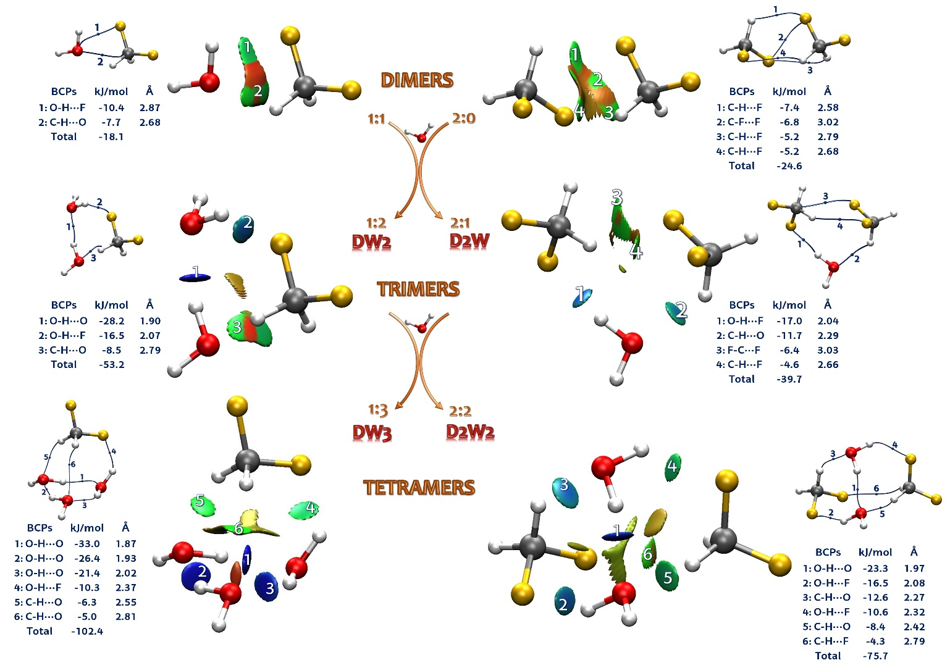**Figure 3.** Quantitative analysis of attractive and repulsive interactions using the QTAIM procedure and NCI iso‑surfaces. The energy values of attractive contacts (QTAIM) and interaction distances (MP2/6‑311++G(d,p)) are also reported. Blue and green colored areas indicate the presence of strong and weak attractive interactions, respectively. The red color signifies repulsive interactions. The Bond Critical Points (BCPs) paths are also represented as blue lines. The iso‑surface of the NCI analysis was build using *s* = 0.5 and a blue‑green‑red color scale from −0.02 < sign(*λ*2) *ρ*(*r*) < +0.01 au.

A further important factor to evaluate the stability of each cluster is the binding energy (BE). The corresponding values computed at the MP2/6‑311++(d,p) can be also compared with the sum of the energies of each BCPs, detected with the QTAIM method. Both procedures have limits, nevertheless these values reflect the structural parameters characterizing each system, and through the comparison, it is possible to derive trends that can be considered more representative. In general, the values obtained summing all the BCPs interactions are greater than the MP2 ones (see Table S8), but regarding the trimers both methods are consistent in estimating the DW2 the more closely bonded. The presence of a greater number of oxygen atoms creates stronger interactions, in particular the settlement of the first strong HB, making the system more compact. Another interesting observation regards the large stability of these oligomers with respect to the fragmentation. This is confirmed comparing their BE to the sum of the values of the corresponding adducts with which they are formed. For this purpose, the dimers have to be taken into consideration, and it can be noted that in all the cases the interaction energy of the cluster is considerably higher. For instance, D2W2 can be conceived as the merge of the two corresponding homodimers (DFM and water), or the adduct of two DW unit. In both cases, the resulting values are quite lower with respect to the BE calculated for the tetramer (see Table S8 and Figure S10), enhancing the overall effect of the WHB network on the stabilization of the tetrameric structure with respect to the separate dimer arrangements. In general, the computed BEs are consistent with the average values found in literature for each kind of HB involved.[1,2,43]

In summary, the combination of rotational spectroscopy, especially with spectrometers of the CP‑FTMW type with high resolution and sensitivity, and accurate computational screening protocols based on QM calculations, has allowed the observation for first time of four different hetero‑clusters between DFM and water (D2W, DW2, D2W2 and DW3). Moreover, 18 substituted isotopologues confirmed unambiguously the observed clusters. The study shows the subtle balance and competition between different stabilizing interactions such as hydrogen, halogen and carbon bonds. The analysis of how these two moieties interact in the progression to form larger aggregates highlighted that the oxygen atom, which its greater electron donor character increases the strength of the interactions, decreasing at the same time the number of bonds needed to keep the cluster together, represents what most affect the stability of each cluster. Actually, if in DFM‑tetramer 16 weak interactions were needed to stabilize the oligomer, in the D2W2 tetramer only 6 WHBs are enough to establish a stable arrangement. Nevertheless, the ability to create a dense network of different weak interactions, which make the cluster more compact, is the main driving force for the stabilization of each system.

**Acknowledgements**

We thank MINECO (CTQ2017-89150-R), Basque Government (PIBA-2018-11), the UPV/EHU (PPG17/10), Fundación BBVA and University of Bologna (RFO) for the financial support. C.C thanks MINECO for a Juan de la Cierva contract. Computational and laser resources of the UPV/EHU were used in this work. L. E. was supported by Marie Curie fellowship PIOF-GA-2012-328405. W. L. thanks China Scholarships Council (CSC) and “MARCO POLO” program of Unibo for financial support. We acknowledge the CINECA award under the ISCRA initiative, for the availability of high-performance computing resources and support. We thank Prof. Brooks Pate for the help and availability of his laboratory equipments.

**Keywords:** non covalent interactions • rotational spectroscopy • quantum chemical calculations • difluoromethane • molecular clusters

[1] G. R. Desiraju, *Angew. Chemie - Int. Ed.* **2011**, *50*, 52–59.

[2] S. Melandri, *Phys. Chem. Chem. Phys.* **2011**, *13*, 13901–11.

[3] A. C. Legon, *Angew. Chemie Int. Ed.* **1999**, *38*, 2686–2714.

[4] D. Mani, E. Arunan, *Phys. Chem. Chem. Phys.* **2013**, *15*, 14377–14383.

[5] O. Brea, O. Mó, M. Yáñez, I. Alkorta, J. Elguero, *Chem. Commun.* **2016**, *52*, 9656–9659.

[6] G. Feng, L. Evangelisti, I. Cacelli, L. Carbonaro, G. Prampolini, W. Caminati, *Chem. Commun.* **2014**, *50*, 171–173.

[7] G. Prampolini, L. Carbonaro, G. Feng, L. Evangelisti, W. Caminati, I. Cacelli, *J. Chem. Theory Comput.* **2014**, *10*, 2204–2211.

[8] S. Melandri, M. E. Sanz, W. Caminati, P. G. Favero, Z. Kisiel, *J. Am. Chem. Soc.* **1998**, *120*, 11504–11509.

[9] L. Evangelisti, G. Feng, P. Écija, E. J. Cocinero, F. Castaño, W. Caminati, *Angew. Chemie Int. Ed.* **2011**, *50*, 7807–7810.

[10] E. J. Cocinero, R. Sánchez, S. Blanco, A. Lesarri, J. C. López, J. L. Alonso, *Chem. Phys. Lett.* **2005**, *402*, 4–10.

[11] J. L. Alonso, S. Antolínez, S. Blanco, A. Lesarri, J. C. López, W. Caminati, *J. Am. Chem. Soc.* **2004**, *126*, 3244–3249.

[12] C. Perez, M. T. Muckle, D. P. Zaleski, N. Seifert, B. Temelso, G. C. Shields, Z. Kisiel, B. H. Pate, *Science* **2012**, *336*, 897–901.

[13] J. Thomas, X. Liu, W. Jager, Y. Xu, *Angew. Chemie - Int. Ed.* **2015**, *54*, 11711–11715.

[14] J. Thomas, N. A. Seifert, W. Jäger, Y. Xu, *Angew. Chemie - Int. Ed.* **2017**, *56*, 6289–6293.

[15] S. Grimme, J. Antony, S. Ehrlich, H. Krieg, *J. Chem. Phys.* **2010**, *132*, 154104.

[16] L. A. Burns, Á. V.- Mayagoitia, B. G. Sumpter, C. D. Sherrill, *J. Chem. Phys.* **2011**, *134*, 84107.

[17] S. Grimme, *Wiley Interdiscip. Rev. Comput. Mol. Sci.* **2011**, *1*, 211–228.

[18] W. Hujo, S. Grimme, *Phys. Chem. Chem. Phys.* **2011**, *13*, 13942–13950.

[19] K. E. Riley, J. A. Platts, J. Řezáč, P. Hobza, J. G. Hill, *J. Phys. Chem. A* **2012**, *116*, 4159–4169.

[20] M. B. Goldey, B. Belzunces, M. Head-Gordon, *J. Chem. Theory Comput.* **2015**, *11*, 4159–4168.

[21] J. Řezáč, P. Hobza, *Chem. Rev.* **2016**, *116*, 5038–5071.

[22] G. Prampolini, P. R. Livotto, I. Cacelli, *J. Chem. Theory Comput.* **2015**, *11*, 5182–5196.

[23] G. Prampolini, M. Campetella, N. De Mitri, P. R. Livotto, I. Cacelli, *J. Chem. Theory Comput.* **2016**, *12*, 5525–5540.

[24] L. Martinache, D. Boucher, J. Demaison, J. C. Deroche, *J. Mol. Spectrosc.* **1986**, *119*, 225–228.

[25] W. Caminati, S. Melandri, P. Moreschini, P. G. Favero, *Angew. Chemie Int. Ed.* **1999**, *38*, 2924–2925.

[26] S. Blanco, J. C. López, A. Lesarri, J. L. Alonso, *J. Mol. Struct.* **2002**, *612*, 255–260.

[27] Q. Gou, L. Spada, E. J. Cocinero, W. Caminati, *J. Phys. Chem. Lett.* **2014**, *5*, 1591–1595.

[28] W. Caminati, S. Melandri, A. Maris, P. Ottaviani, *Angew. Chemie - Int. Ed.* **2006**, *45*, 2438–2442.

[29] W. Caminati, S. Melandri, I. Rossi, P. G. Favero, G. Ciamician, V. Uni, *J. Am. Chem. Soc.* **1999**, *121*, 10098.

[30] C. Calabrese, A. Maris, L. Evangelisti, L. B. Favero, S. Melandri, W. Caminati, *J. Phys. Chem. A* **2013**, *117*, 13712–8.

[31] C. Calabrese, A. Vigorito, A. Maris, S. Mariotti, P. Fathi, W. D. Geppert, S. Melandri, G. W. D., S. Melandri, W. D. Geppert, et al., *J. Phys. Chem. A* **2015**, *119*, 11674–11682.

[32] S. Blanco, S. Melandri, P. Ottaviani, W. Caminati, *J. Am. Chem. Soc.* **2007**, *129*, 2700–2703.

[33] Á. Vázquez-Mayagoitia, C. D. Sherrill, E. Aprà, B. G. Sumpter, *J. Chem. Theory Comput.* **2010**, *6*, 727–734.

[34] K. E. Riley, M. Pitoňák, J. Černý, P. Hobza, *J. Chem. Theory Comput.* **2010**, *6*, 66–80.

[35] K. S. Thanthiriwatte, E. G. Hohenstein, L. A. Burns, C. D. Sherrill, *J. Chem. Theory Comput.* **2011**, *7*, 88–96.

[36] S. Grimme, *J. Comput. Chem.* **2004**, *25*, 1463–1473.

[37] C. Pérez, S. Lobsiger, N. A. Seifert, D. P. Zaleski, B. Temelso, G. C. Shields, Z. Kisiel, B. H. Pate, *Chem. Phys. Lett.* **2013**, *571*, 1–15.

[38] I. Uriarte, C. Pérez, E. Caballero-Mancebo, F. J. Basterretxea, A. Lesarri, J. A. Fernández, E. J. Cocinero, *Chem. - A Eur. J.* **2017**, *23*, 7156.

[39] J. K. G. Watson, *Vibrational Spectra and Structure*, Elsevier Science Publishers, New York, Amsterdam, **1977**.

[40] J. Kraitchman, *Am. J. Phys.* **1953**, *21*, 17–24.

[41] R. F. W. Bader, *Atoms in Molecules: A Quantum Theory*, Oxford University Press, Oxford, UK, **1994**.

[42] E. R. Johnson, S. Keinan, P. Mori-Sánchez, J. Contreras-García, A. J. Cohen, W. Yang, *J. Am. Chem. Soc.* **2010**, *132*, 6498–6506.

[43] W. A. Herrebout, M. A. Suhm, *Phys. Chem. Chem. Phys.* **2011**, *13*, 13858.

|  |  |  |  |  |
| --- | --- | --- | --- | --- |
| COMMUNICATION | | | | |
| Four different hetero-clusters between difluoromethane and water have been observed thanks to the combination of high resolution and sensitivity of modern CP-FTMW spectroscopy and accurate screening protocols based on quantum mechanical calculations. |  |  |  | Camilla Calabrese,[a,b] § Weixing Li,[c] § Giacomo Prampolini,[d] Luca Evangelisti,[c,e] Iciar Uriarte,[a,b] Ivo Cacelli,[d,f] Sonia Melandri,[c] and Emilio J. Cocinero [a,b]*  **A general treatment to study molecular complexes stabilized by hydrogen, halogen and carbon bond networks: Experiment and theory of (CH2F2)n···(H2O)m** |
|  |  |