**An experimental journey from gas phase to solution reveals the predominance of non-anomeric conformers in D‑Lyxose**

Camilla Calabrese,1,2 Patricia Écija,1 Ismael Compañón,3 Montserrat Vallejo‑López,1 Álvaro Cimas,4 Maider Parra,1,2 Francisco J. Basterretxea,1 Iñaki Santos,5 Jesús Jiménez-Barbero,6,7,8 Alberto Lesarri,9 Francisco Corzana,*,3 and Emilio J. Cocinero*,1,2

1 Departamento de Química Física, Facultad de Ciencia y Tecnología, Universidad del País Vasco (UPV/EHU), 48080 Bilbao, Spain

2 Fundación Biofísica Bizkaia (CSIC‑UPV/EHU), 48080 Bilbao, Spain.

3 Departamento de Química, Centro de Investigación en Síntesis Química, Universidad de La Rioja, 26006 Logroño, Spain.

4 Laboratoire Analyse et Modélisation pour la Biologie et l’Environnement, LAMBE UMR8587, Université d’Évry val d’Essonne, 91025 Évry, France.

5 SGIker UPV/EHU, Centro Joxe Mari Korta, Tolosa Hiribidea 72, 20018 Donostia, Spain.

6 Departamento de Química Orgánica II, Facultad de Ciencia y Tecnología, Universidad del País Vasco (UPV/EHU), 48080 Bilbao, Spain.

7 IKERBASQUE, Basque Foundation for Science, 48009, Bilbao, Spain.

8 Chemical Glycobiology Laboratory, CIC bioGUNE, Bizkaia Technology Park, Building 800, 48160 Derio, Spain.

9 Departamento de Química Física y Química Inorgánica – IU CINQUIMA, Facultad de Ciencias, Universidad de Valladolid, 47011 Valladolid, Spain.

Correspondence should be addressed to E. J. C. or F. C.:

[emiliojose.cocinero@ehu.es](mailto:emiliojose.cocinero@ehu.es)

[francisco.corzana@unirioja.es](mailto:francisco.corzana@unirioja.es)

**Abstract**

Understanding the conformational preferences and intramolecular dynamics of carbohydrates is crucial to explain the interactions with their biological targets and in turn, to improve their use as therapeutic agents. Herein, we present experimental evidence that resolves the conformational analysis of the monosaccharide D‑lyxose, for which quantum mechanical (QM) calculations offered model‑dependent results. The study compares the structural preferences in the gas phase, determined by rotational spectroscopy, with those in solution, resolved by combining NMR and molecular dynamics (MD) simulations. Rotational results show that D‑lyxose adopts only pyranose forms in the gas phase. The α‑anomer exhibits both the 4C1 and 1C4 chairs with a ratio of 60:40, while the predominantly populated β‑anomer, whose effective structure at atomic resolution was determined by (13C, 2H and 18O) monoisotopic enriched samples, displays exclusively, the 4C1 form. Conversely, in aqueous solution, the most populated conformation is the α‑anomer, which features a 1C4 chair: the solvation studies also indicate that the β‑anomer is poorly solvated. These results (together with the larger dipole moment exhibited by the 1C4 form of the α‑anomer which may explain the preferences observed in solution) demonstrate the active role of water in the conformational preferences of this monosaccharide. Markedly, the main conformers found in the gas phase (β‑anomer in a 4C1 chair) and in solution (α‑anomer in a 1C4 form) are characterized by the lack of the stabilizing anomeric effect. From a mechanistic perspective, rotational spectroscopy, together with solid‑state NMR experiments corroborates that αβ or furanosepyranose interconversions are prevented in gas phase. The multi-technique strategy provides a powerful way of unravelling the role of water on the conformational preferences of challenging molecules, such as flexible monosaccharides - a pre-requisite to shedding light into their biological roles.

**Introduction**

Carbohydrates are the most abundant class of biomolecules in living organisms. Their molecular diversity encodes structural information that is essential in many physiological processes, such as protein folding and cell signaling, proliferation and differentiation.1,2 Glycan‑mediated interactions are also involved in bacterial adhesion, viral infection, inflammation, and immune system activation. Understanding the conformational choices of carbohydrates is therefore crucial for the elucidation of these interactions and in turn, the rational design of therapeutic agents based on carbohydrates.3,4

It is well‑known that water molecules play a pivotal role in the conformational preferences of saccharides.5 For example, Woods and co‑workers6 found an increment of the ω‑angles in the solvated *trans‑gauche* conformers of galactopyranosides in comparison to glucopyranosides - a finding that could be explained by the presence of water molecules that disrupt the hydrogen bonds within the carbohydrate. The presence of water pockets in the proximity of (1→6) branch points in starch drastically reduces their flexibility, facilitating the formation of the double‑helical amylopectin structure.7 The conformational behavior of the conserved core pentasaccharide, Man3(GlcNAc)2‑ found in *N*‑linked glycoproteins, is dictated by the surrounding water.8 Bridging‑water molecules have also been found responsible for the different conformational and hence, biological behavior, of the tumor‑associated Tn antigen (α‑*O*‑GalNAc‑Ser/Thr).9

Uncovering common mechanisms that involve the participation of water is thus of great significance for understanding the conformational behavior of carbohydrates and eventually, their molecular recognition features. To achieve this, their structures should first be determined in the absence of solvent, in an isolated environment: Fourier transform microwave (FTMW) spectroscopy in cooled supersonic expansions provides a unique tool for high‑resolution gas phase structural analysis, avoiding solvent or crystal effects. Conformers,10 tautomers,11 isotopologues12 or enantiomers13 can be identified unequivocally and accurate structures of each species can be obtained independently. The transfer of intact sugars into the gas phase has been greatly facilitated by the introduction of UV pico‑second laser vaporization, as first illustrated in the conformational analysis of ribose.14 In the condensed phase, NMR measurements, such as NOESY coupled with experiment‑guided molecular dynamics (MD) calculations, provide a powerful technique for determining the structures of flexible biomolecules in aqueous solution.5,15-17 MD calculations typically generate a distribution of low energy conformers which, by comparison with the experimental data, pick out the preferred structures from the menu of possibilities predicted by the classical force fields. The strategy of combining structural determinations of biologically relevant molecules in the gas‑phase and in solution provides a powerful means of establishing the role of water in their conformational preferences.

In the present work, this methodology has been applied to the conformational analysis of the monosaccharide D‑lyxose, a component of bacterial glycolipids.18 Previous quantum mechanical (QM) calculations performed on five‑carbon sugars (D‑ribose, D‑lyxose, 2‑deoxy‑D‑ribose, D‑xylose, and D‑arabinose) predicted a different behavior for D‑lyxose,19 with the furanose form as most stable, in contrast to the other aldopentoses for which the pyranose structures were preferred.

**Results and Discussion**

Our investigations started by creating an updated and comprehensive conformational landscape of D‑lyxose in the gas phase using several conventional QM *ab initio* (MP2) and density‑functional theory (B3LYP‑D3BJ and M06‑2X, see Figures S1-S3) approaches. The results proved strongly method‑dependent and therefore, inconclusive (details in Table S1). For example, B3LYP‑D3BJ and M06‑2X predict the β‑furanose form as the dominant structure (68% and 44%, at room temperature respectively) while MP2 estimates the α‑pyranose family as predominant (58%), with similar populations of 1C4 (25%) and 4C1 (33%) chair conformations. Further experimental data are therefore crucial.

|  |  |  |  |
| --- | --- | --- | --- |
| **Table 1.** Experimental rotational constants of the observed conformers. | | | |
|  | α‑Pyr‑1C4 | α‑Pyr‑4C1 | β‑Pyr‑4C1 |
| *A* [MHz] | 1700.9750(2)[a] | 1705.7259(7) | 2039.0468(2) |
| *B* [MHz] | 1321.1188(1) | 1291.7664(1) | 1177.9297(1) |
| *C* [MHz] | 977.58501(9) | 975.4310(2) | 842.7394(1) |
| *N* [b] | 36 | 31 | 36 |
| *σ* [kHz][c] | 1.2 | 2.1 | 1.5 |
| [a] Errors in parentheses in units of the last digit. [b] Number of fitted transitions. [c] Root‑mean‑square deviation of the fit. | | | |

The rotational spectrum of D‑lyxose was recorded by means of FTMW spectroscopy using ultrafast laser vaporization technique to transfer the carbohydrate into the gas phase.14,20 Three pyranose conformers (named as α‑Pyr‑1C4, α‑Pyr‑4C1, β‑Pyr‑4C1 in Figure 1) were observed. The three spectra were fitted to a semirigid asymmetric rotor Hamiltonian (Watson’s *S*‑reduction in the *Ir*‑representation), yielding the rotational parameters reported in Table 1 and Tables S2-S3. This result is in line with those previously obtained for aldopentoses (D‑ribose,14 2‑deoxy‑D‑ribose21,22 and D‑xylose21) where the pyranose forms were exclusively observed. Furanose and linear forms were not detected in the rotational spectrum.

Imagen que contiene mapa, texto

**Figure 1.** Left panel: Typical (normalized) rotational transitions of D‑lyxose for the three conformers observed in the gas phase: parent species (top) and 13C(1)‑C4H10O5 isotopologues (bottom). Each transition is doubled by an instrumental Doppler effect. Right panel: Solid‑state NMR spectra of D‑lyxose: parent species (top) and 13C(1)‑C4H10O5 (bottom). Percentages indicate the population of the different species in each experiment. In both cases related to the relative intensity of the transitions in the spectra. A different conformational composition of the initial solid samples (parent species and 13C(1)‑C4H10O5) is observed. In addition, a correlation between the population in the rotational spectra and solid-state NMR experiments is clearly appreciated. The structural information obtained by each technique is showed in the central row. The experimental structure of the β‑Pyr‑4C1 conformer, could be determined from the full isotopic substitution (atomic coordinates represented as small spheres).

From the structural perspective, the β‑Pyr anomer was only found in the 4C1 form in the gas phase: its structure is stabilized by a series of three cooperative hydrogen bonds O4H(eq)→O3H(eq)→O2H(ax)→O1H(eq) (Figure 1). In contrast, both chair conformations (1C4 and 4C1) are (weakly) populated the α‑anomer. While the α‑Pyr‑4C1 conformer shows the same hydrogen bond pattern than the β analogue (O4H(eq)→O3H(eq)→O2H(ax)→O5), the α‑Pyr‑1C4 structure is stabilized by a cooperative network O3H(ax)→O2H(eq)→O1H(eq) and an independent O4H(ax)→O5 hydrogen bond. The cooperative hydrogen bonding networks feature a counter‑clockwise orientation in the three conformers. This preference of counter‑clockwise arrangements over clockwise orientations has already been observed in other isolated monosaccharides14 and is favored by creating longer networks of cooperative hydrogen bond. In contrast, when the monosaccharides are hydrated this trend is reversed, the clockwise arrangement being predominant.14

The relative populations of the three observed conformers can be estimated experimentally from the relative intensities of the rotational transitions.22 Thus, assuming that no conformational relaxation occurs during the supersonic expansion, the experimental populations in the gas phase are: β‑Pyr‑4C1:α‑Pyr‑4C1:α‑Pyr‑1C4 = 82%:11(4)%:7(2)%. Strikingly, these data clearly indicate a predominance of the β‑Pyr‑4C1 form in the gas‑phase, against the control of the anomeric effect. It is important to note that none of the QM approaches aforementioned could predict the experimental data. The FTMW data can therefore be used as a real benchmarking of these computational methods.10

In terms of stability of the chair conformers, the main factors to consider are: a) maximizing the number and the strength of hydrogen bonds, where (eq)→(ax) and (ax)→(eq) contacts are stronger than (eq)→(eq) interactions (shorter bond lengths: 2.2‑2.3 Å versus 2.4‑2.5 Å); b) the anomeric effect;23 the preference of the hydroxyl group at the anomeric carbon to adopt an axial orientation over the less hindered equatorial arrangement; c) tendency of the rest of the hydroxyl groups to adopt in equatorial positions. Taking this into account, the preference of β‑Pyr‑4C1 conformer with respect the β‑Pyr‑1C4 one can be explained as follows: the β‑Pyr‑1C4 is stabilized by the anomeric effect. This stabilization was estimated to be about 14.6 kJ mol‑1 when the endocyclic oxygen is replaced by a methylene group (‑CH2‑), see Figures S5-S8. However, the presence of three hydroxyl groups with equatorial orientations in the β‑Pyr‑4C1 conformer prevails over the anomeric effect of the β‑Pyr‑1C4 geometry, which only displays a single hydroxyl group in equatorial disposition. In the α‑anomer, both chairs exhibit a similar pattern of hydrogen bonds and the same number of hydroxyl groups in equatorial positions. Consequently, the preference is reversed. Now, conformer α‑Pyr‑4C1, which is stabilized by the anomeric effect, predominates over α‑Pyr‑1C4 conformer which lacks such stabilization with a population 60:40 in the gas phase.

Next, we attempted to determine the structure of the three observed species in the gas phase with atomic resolution. To this purpose, eight isotopically enriched samples, including five monosubstituted 13C species (13CC4H10O5), two monodeuterated species at C‑1 and C‑2 (C5H9DO5) and 18O5, were analysed using the same approach described for the parent species. The rotational data allowed the structural determination of the β‑Pyr‑4C1 form (Figure 1 and Table S13). However, the α‑anomers could not be detected in the enriched samples.

In order to explain these observations, solid‑state NMR experiments were conducted on the unlabelled sample and the corresponding isotopologues. Interestingly, while the α- and β-anomers were present in the former species, only the β anomer could be observed for the commercially enriched isotopologues. The evidence that the α/β ratio found in the solid‑state NMR reflects the population of these isomers in the gas phase (Figure 1 and SI) unambiguously proves that α↔β or furanose↔pyranose mutarotations are not feasible in the gas‑phase and stresses the active role of water in these processes.

As a next step, we undertook a conformational analysis of D‑lyxose in aqueous solution by combining NMR measurements and MD simulations. According to the 1H NMR spectrum performed at 298 K, both anomers are present in solution with a ratio α/β= 66(5)/34(5) in both the unlabeled and enriched samples, proving the existence of mutarotation in water (Figure 2a). This finding agrees with previous reported studies that state that the α‑anomer is the most stable in solution.24 On the one hand, the analysis of 3*J*H1,H2 for the α-anomer (with a value close to 4.5 Hz), suggests the co‑existence of α‑Pyr‑1C4 and α‑Pyr‑4C1 conformers in solution, with a ratio *ca*. 70(5)/30(5) in favor of 1C4 chair (Figure 2a and SI).25 This observation contrasts with the solid‑state, where the behavior was the reverse (α/β = 13/86), with the 4C1 chair‑skeleton as predominant for the α‑anomer. On the other hand, the relatively small value of 3*J*H1,H2 (1.5 Hz) for the β‑anomer may indicate that the 4C1 chair is the most populated form of this anomer in water. In order to quantify the population of each conformer in solution, we performed a 2D‑NOESY experiment in D2O at 278 K (Figure 2b and SI). It must be noted that the α/β ratio and the values of the 3*J* were similar to those measured a 298 K, indicating that the population of the anomers and the chair conformers should not vary significantly at this temperature. In fact, no substantial changes were observed in the range 278‑363 K either (see SI), which indicates a similar conformational entropy for both geometries and high energy barrier for the α‑Pyr‑1C4 ‑ α‑Pyr‑4C1 interconversion. This result is in good agreement with our isolated MP2 estimation where the interconversion barrier is predicted to be around 45 kJ mol‑1 (see Figure S14). The experimental distances deduced from the 2D‑NOESY NMR data recorded at 278 K, together with the key 3*J* coupling constants, are shown in Table 2.

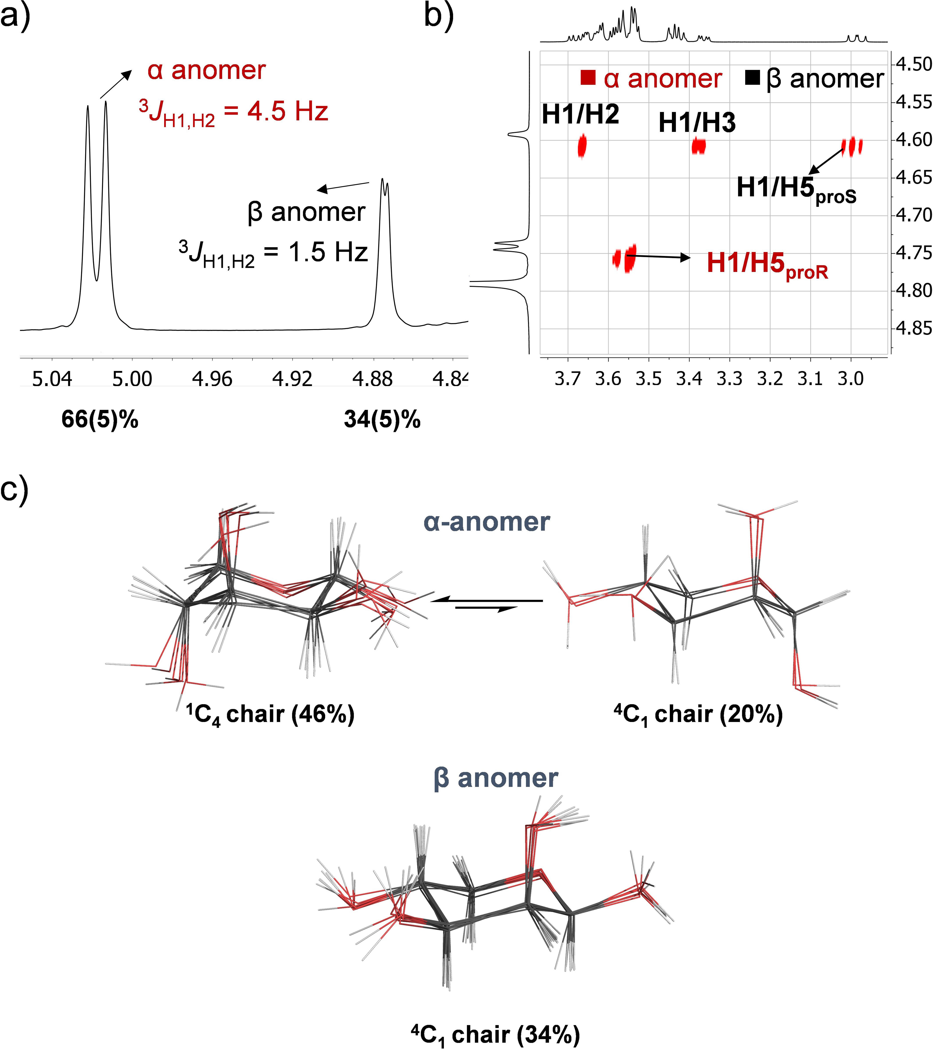

**Figure 2.** a) Section of the 1H NMR (500 MHz, D2O) of D‑lyxose showing the anomeric region recorded at 298 K. b) Zoom‑in of NOESY spectrum (500 MHz, D2O) of D‑lyxose at 278 K, indicating the most relevant cross‑peaks for conformational analysis. c) Structural ensembles derived from 0.2 µs experiment‑guided MD simulations showing the population of each anomer. While for the β‑anomer only the 4C1 conformer is populated in solution, the α‑anomer displays the two possible chair conformers.

These experiments were complemented by 0.5 s MD simulations in explicit water using the Molecular Mechanics AMBER 18 package,26 which was implemented with GLYCAM 0627 or the general Amber (GAFF2)28 force fields. Under these conditions, the simulations were biased by the conformer used as starting geometry and were therefore inadequate to reproduce the experimental data (Table 2 and SI). Hence, we performed 0.2 s experimentally‑guided MD simulations, with the distances derived from the NOESY experiments as time‑averaged restraints,29,30 following our well established protocol.31,32 Contrary to our expectations, we could not obtain a good agreement between the experimental and theoretical data when the simulations were accomplished with GLYCAM06 for the α‑anomer. In fact, these simulations overestimated the population of the α‑Pyr‑1C4 form (> 98%, SI). This problem was solved by employing GAFF2 (Table 2). According to these experimentally‑guided simulations, the β‑anomer adopts exclusively the typical 4C1 chair in water, while the α derivative displays mainly the 1C4 chair conformation, with a population around 70% (Figure 2c). This conclusion is also in good agreement with the values of 3*J*H1,H2 coupling constant mentioned above. Therefore, the population of D‑lyxose conformers in water is as follows: α‑Pyr‑1C4:β‑Pyr‑4C1:α‑Pyr‑4C1 = 46(5)%:34(5)%:20(5)%. As expected, no significant intramolecular hydrogen bonds (population < 10%) were detected in solution through the simulations (see SI). It should be noted that none of the dominant structures of the α and β‑anomers in solution are stabilized by the anomeric effect.

|  |  |  |  |
| --- | --- | --- | --- |
| **Table 2.** Comparison between the experimental and theoretical distances derived from MD simulations. | | | |
| Distance/3*J*H1,H2[a] | Experimental | 0.5 s unrestrained MD (GAFF)[b] | 0.2 s experiment‑guided MD (GAFF) |
| α‑anomer |  |  |  |
| H1‑H5proR | 2.4 | 4.2 | 2.6 |
| 3*J*H1,H2 | 4.5 | 7.8[c] | 4.1[c] |
| β‑anomer |  |  |  |
| H1‑H2 | 2.4 | 2.5 | 2.4 |
| H1‑H3 | 2.7 | 2.5 | 2.5 |
| H1‑H5proS | 2.6 | 2.6 | 2.6 |
| 3*J*H1,H2 | 1.5 | 1.3[c] | 1.5[c] |
| 3*J*H2,H3 | 3.2 | 3.2[c] | 3.0[c] |
| [a] Distances are given in Å and 3*J* in Hz. [b] Startingfrom 4C1 conformer. [c]Deduced from the dihedral values through the corresponding Altona equation and *Sweet J* software.25 | | | |

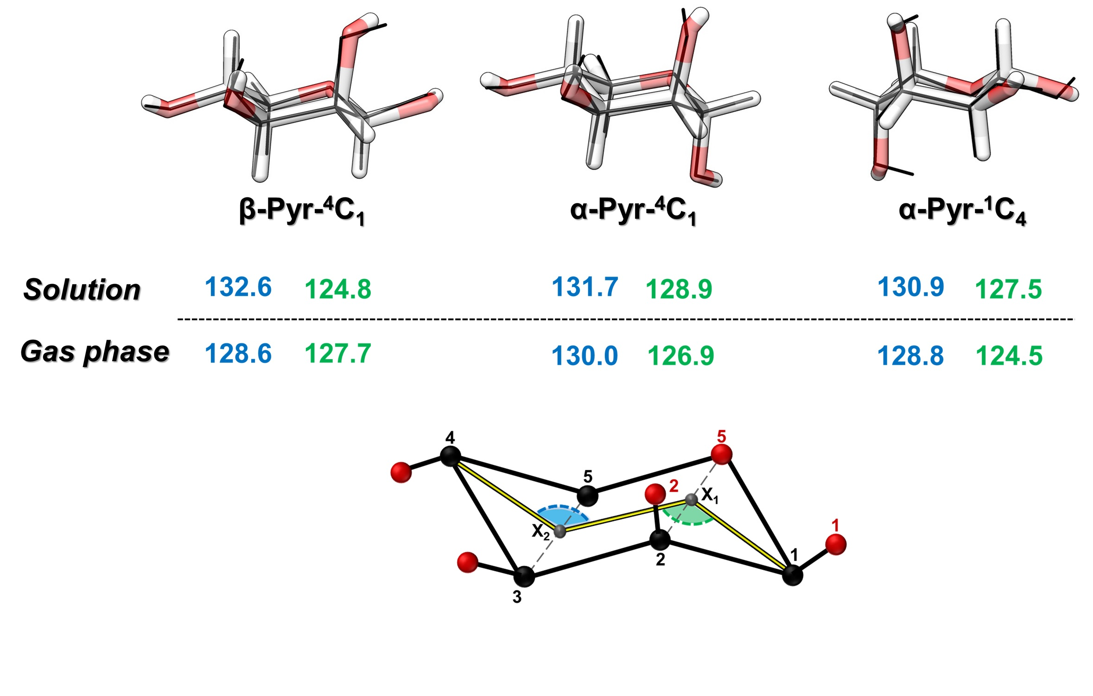

**Figure 3.** Comparison of the lyxose experimental structures in gas phase and solution (gas phase in black traces, overlapping the solvated molecule). The structural parameters (angles in degrees) obtained for the C4‑X2‑X1 and X2‑X1‑C1 angles are reported under the molecular structures.

The gas phase structures were then compared with those determined in solution by NMR and experimentally‑guided MD simulations (Figure 3). Interestingly, the chair‑skeletons are flattened in solution with the dihedral angle C5‑O5‑C3‑C2 very close to 180º in the three proposed structures (ranging from 176º to 179º). In contrast, in the gas phase, these values are within 171º ‑ 177º to favor the formation of stronger intramolecular hydrogen bonds. This trend is also observed in the puckering angles X1X2C4 and X2X1C1, which are larger in solution than in the gas phase. Notably, the only angle which is smaller in solution is the X2X1C1 for the β anomer.

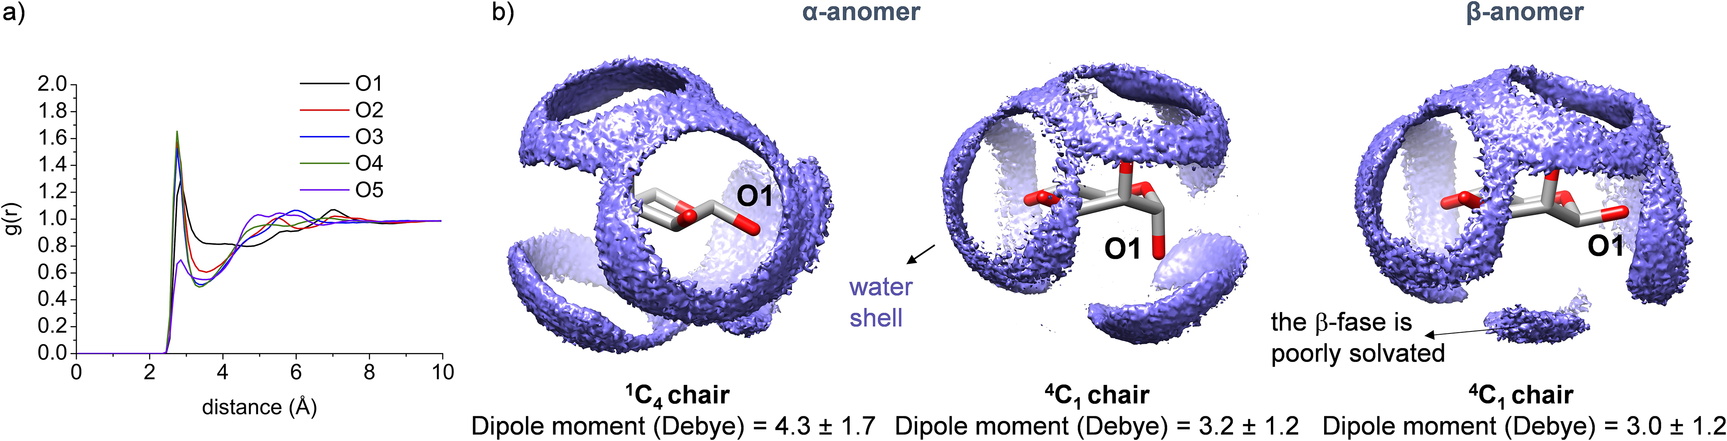

**Figure 4.** a) Radial distribution functions (RDF) calculated for oxygen atoms of α‑Pyr‑4C1 form of D‑lyxose in solution derived from unrestrained 0.5 µs MD simulations. (b) Averaged first hydration shell, together to the dipole moments (MP2/6‑311G++(d,p)) derived from unrestrained 0.5 µs MD simulations for the α‑ and β‑anomers.

We finally studied the first hydration shell of lyxose to further explore the role of water in the conformational preferences of the sugar. To this purpose, we calculated the radial distribution functions (RDF)33,34 for the oxygen atoms of the α and β‑anomers from the experimentally‑guided MD simulations. With the exception of the endocyclic oxygen (O5), the hydroxyl groups show a typical hydrophilic interaction with a well‑defined first hydration shell that features a density peak at 2.8 Å and a second hydration shell around 4.7 Å (Figure 4a and SI). This finding reinforces the idea that, in solution, D‑lyxose does not form intramolecular hydrogen bonds but strong intermolecular hydrogen bonds with water molecules. Secondly, we analyzed the MD simulations conducted with the GAFF2 force field without using any experiment restraint. Under these conditions, the interconversion between the two possible chairs was not observed for any of the anomers. This feature allowed us to characterize the solvation of each individual conformer in Figure 4. Interestingly, while the α‑anomers are completely solvated, with water molecules surrounding both the α‑ and β‑faces of the monosaccharide, the solvation of the β‑anomer is deficient, with the β‑face characterized by a poor solvation. These data agree with the smaller angle X2X1C1 observed in solution for the β‑anomer (Figure 3). This structure would allow a higher number of water molecules to be accommodated on the (hydrophilic) α‑face, reinforcing the idea that the (hydrophobic) β‑face is poorly solvated. This dual behavior (hydrophilic/hydrophobic) of carbohydrates has been previously observed.35,36 This circumstance may favor the preference of this monosaccharide to adopt mainly the α‑anomer form in solution. In addition, the higher value of the dipole moment displayed through the entire MD simulations by the α‑Pyr‑1C4 chair in comparison to the α‑Pyr‑4C1 conformer, could explain why this anomer adopts preferentially the 1C4 chair in solution.

**Conclusions**

A powerful multidisciplinary experiment‑theory strategy, based on rotational spectroscopy and QM in the gas phase and NMR and MD simulations in solution, has been applied successfully to the study of the conformational preferences and dynamics of the flexible carbohydrate D‑lyxose. In spite of the relative structural simplicity of this monosaccharide, our results prove that the observed experimental data cannot be unambiguously reproduced by purely computational methods, underlining the need for further experimentally guided theoretical developments. Rotational spectroscopy shows that the α‑anomer exhibits both the 4C1 and 1C4 chairs in the gas phase, with a 60:40 ratio. Interestingly, although both conformers display two hydroxyl groups in axial orientation, the preference for the 4C1 chair may be explained by the extra stabilization provided by the anomeric effect for this geometry. On the contrary, the β derivative, whose atomic resolution effective structure could be determined by using monoisotopic enriched samples, exclusively displays the 4C1 arrangement. The presence of three hydroxyl groups in axial position when the molecule adopts the 1C4 conformation, cannot counterbalance the additional stabilization provided by the anomeric effect, giving an insignificant population of this chair in the gas phase. In water, the α‑anomer is the most populated, and the two possible chairs (1C4 and 4C1) coexist. Notably, and opposite to that observed in the gas phase, the larger dipole moment determined for the 1C4 form may explain the preference observed in solution for this 3D‑arrangement. In line with the gas phase study, the β‑anomer exhibits only the 4C1 form in water. The weak solvation of the molecule associated with this arrangement supports the lower population of β‑anomer in water.

From a mechanistic viewpoint, the direct comparison of rotational spectroscopy with solid‑state NMR spectroscopic measurements proves that αβ or furanosepyranose interconversion is impeded in the gas phase.

Finally, the work here presented on the monosaccharide D‑lyxose represents an intermediate step for future studies of more complicated carbohydrates or glycopeptides and highlights the importance of a multidisciplinary approach to disentangle the structural features of this class of compounds.

**Acknowledgements**

We thank MINECO (projects CTQ2017‑89150‑R, CTQ2015‑68148‑C2‑2P, CTQ2015‑67727‑R), Basque Government (PIBA 2018‑11), Universidad de La Rioja (UNLR13‑4E‑1931), the UPV/EHU (PPG17/10), Fundación BBVA, the EU (Marie‑Sklodowska Curie ITN, *ProteinConjugates,* grant agreement No. 675007) for the financial support. C.C. thanks MINECO for a *Juan de la Cierva* contract. I.C. thanks Universidad de La Rioja for the FPI grant. Computational, laser and NMR resources of the UPV/EHU were used in this work. We thank Dr. Imanol Usabiaga (Università di Bologna) for his help with theoretical calculations.

**Competing financial interests**

The authors declare no competing financial interests.

**References**

(1) Glycoscience: Chemistry and Chemical Biology, 2nd ed. (Eds.: B. O. FraserReid, K. Tatsuta, J. Thiem, G. L. Coté, S. Flitsch, Y. Ito, H. Kondo, S.‑i. Nishimura, B.Yu), Springer, Berlin, 2009.

(2) Essentials of Glycobiology, 2nd ed. (Eds.: A. Varki, R. D. Cummings, J. D.

Esko, H. H. Freeze, P. Stanley, C. R. Bertozzi, G. W. Hart, M. E. Etzler), Cold Spring Harbor Laboratory Press, New York, 2009.

(3) Solís, D.; Bovin, N. V.; Davis, A. P.; Jiménez-Barbero, J.; Romero, A.; Roy, R.; Smetana, K.; Gabius, H.-J. *Biochim. Biophys. Acta* **2015**, *1850* (1), 186–235.

(4) Gabius, H.-J.; André, S.; Jiménez-Barbero, J.; Romero, A.; Solís, D. *Trends Biochem. Sci.* **2011**, *36* (6), 298–313.

(5) Woods, R. J. *Chem. Rev.* **2018**, *118* (17), 8005–8024.

(6) Kirschner, K. N.; Woods, R. J. *Proc. Natl. Acad. Sci. USA* **2001**, *98* (19), 10541–10545.

(7) Corzana, F.; Motawia, M. S.; Hervé du Penhoat, C.; van den Berg, F.; Blennow, A.; Perez, S.; Engelsen, S. B. *J. Am. Chem. Soc.* **2004**, *126* (40), 13144–13155.

(8) Barry, C. S.; Cocinero, E. J.; Carçabal, P.; Gamblin, D. P.; Stanca-Kaposta, E. C.; Remmert, S. M.; Fernández-Alonso, M. C.; Rudić, S.; Simons, J. P.; Davis, B. G. *J. Am. Chem. Soc.* **2013**, *135* (45), 16895–16903.

(9) Bermejo, I. A.; Usabiaga, I.; Compañón, I.; Castro-López, J.; Insausti, A.; Fernández, J. A.; Avenoza, A.; Busto, J. H.; Jiménez-Barbero, J.; Asensio, J. L.; Peregrina, J. M.; Jiménez-Oses, G.; Hurtado-Guerrero, R.; Cocinero, E. J.; Corzana, F. *J. Am. Chem. Soc.* **2018**, *140* (31), 9952–9960.

(10) Uriarte, I.; Melandri, S.; Maris, A.; Calabrese, C.; Cocinero, E. J. *J. Phys. Chem. Lett.* **2018**, *9* (7), 1497–1502.

(11) Melandri, S.; Evangelisti, L.; Maris, A.; Caminati, W.; Giuliano, B. M.; Feyer, V.; Prince, K. C.; Coreno, M. *J. Am. Chem. Soc.* **2010**, *132* (30), 10269–10271.

(12) Banser, D.; Schnell, M.; Grabow, J.-U.; Cocinero, E. J.; Lesarri, A.; Alonso, J. L. *Angew. Chem. Int. Ed.* **2005**, *44* (39), 6311–6315.

(13) Patterson, D.; Schnell, M.; Doyle, J. M. *Nature* **2013**, *497* (7450), 475–477.

(14) Cocinero, E. J.; Lesarri, A.; Écija, P.; Basterretxea, F. J.; Grabow, J.-U.; Fernández, J. A.; Castaño, F. *Angew. Chem. Int. Ed.* **2012**, *51* (13), 3119–3124.

(15) Revuelta, J.; Vacas, T.; Torrado, M.; Corzana, F.; González, C.; Jiménez-Barbero, J.; Menendez, M.; Bastida, A.; Asensio, J. L. **2008**, *130* (15), 5086–5103.

(16) Corzana, F.; Busto, J. H.; Jiménez-Oses, G.; Asensio, J. L.; Jiménez-Barbero, J.; Peregrina, J. M.; Avenoza, A. *J. Am. Chem. Soc.* **2006**, *128* (45), 14640–14648.

(17) Zhang, Z.; McCallum, S. A.; Xie, J.; Nieto, L.; Corzana, F.; Jiménez-Barbero, J.; Chen, M.; Liu, J.; Linhardt, R. J. *J. Am. Chem. Soc.* **2008**, *130* (39), 12998–13007.

(18) Khoo, K. H.; Suzuki, R.; Dell, A.; Morris, H. R.; McNeil, M. R.; Brennan, P. J.; Besra, G. S. *Biochemistry* **1996**, *35* (36), 11812–11819.

(19) Guler, L. P.; Yu, Y.-Q.; Kenttämaa, H. I. *J. Phys. Chem. A* **2002**, *106* (29), 6754–6764.

(20) Lesarri, A.; Mata, S.; Cocinero, E. J.; Blanco, S.; López, J. C.; Alonso, J. L. *Angew. Chem. Int. Ed.* **2002**, *41* (24), 4673–4676.

(21) Peña, I.; Mata, S.; Martín, A.; Cabezas, C.; Daly, A. M.; Alonso, J. L. *Phys. Chem. Chem. Phys.* **2013**, *15* (41), 18243–18248.

(22) Fraser, G. T.; Suenram, R. D.; Lugez, C. L. *J. Phys. Chem. A* **2000**, *104* (6), 1141–1146.

(23) Cocinero, E. J.; Carçabal, P.; Vaden, T. D.; Simons, J. P.; Davis, B. G. *Nature* **2011**, *469* (7328), 76–79.

(24) Rudrum, M.; Shaw, D. F. *J. Chem. Soc.* **1965**, *67*, 52–57.

(25) (a) Donders, L. A.; De Leeuw, F. A. A. M.; Altona, C. *Magn. Reson. Chem.* **1989**, *27* (6), 556–563. (b) Balacco G. *J. Chem. Inf. Comput. Sci.* **1996**, *36* (4), 885–887.

(26) Case, D.A.; Ben-Shalom, I.Y.; Brozell, S.R.; Cerutti, D.S.; Cheatham, T.E.; III, Cruzeiro, V.W.D.; Darden, T.A.; Duke, R.E.; Ghoreishi, D.; Gilson, M.K.; Gohlke, H.; Goetz, A.W.; Greene, D.; Harris, R.; Homeyer, N.; Izadi, S.; Kovalenko, A.; Kurtzman, T.; Lee, T.S.; LeGrand, S.; Li, P.; Lin, C.; Liu, J.; Luchko, T.; Luo, R.; Mermelstein, D.J.; Merz, K.M.; Miao, Y.; Monard, G.; Nguyen, C.; Nguyen, H.; Omelyan, I.; Onufriev, A.; Pan, F.; Qi, R.; Roe, D.R.; Roitberg, A.; Sagui, C.; Schott-Verdugo, S.; Shen, J.; Simmerling, C.L.; Smith, J.; Salomon-Ferrer, R.; Swails, J.; Walker, R.C.; Wang, J.; Wei, H.; Wolf, R.M.; Wu, X.; Xiao, L.; York, D.M.; Kollman P.A. (2018), AMBER 2018, University of California, San Francisco.

(27) Kirschner, K. N.; Yongye, A. B.; Tschampel, S. M.; González-Outeiriño, J.; Daniels, C. R.; Foley, B. L.; Woods, R. J. *J. Comput. Chem.* **2008**, *29* (4), 622–655.

(28) Wang, J.; Wolf, R. M.; Caldwell, J. W.; Kollman, P. A.; Case, D. A. *J. Comput. Chem.* **2004**, *25* (9), 1157–1174.

(29) Pearlman, D. A.; Kollman, P. A. *J. Mol. Biol.* **1991**, *220* (2), 457–479.

(30) Pearlman, D. *J. Biomol. NMR* **1994**, *4* (1), 1–16.

(31) Fernández-Tejada, A.; Corzana, F.; Busto, J. H.; Jiménez-Oses, G.; Jiménez-Barbero, J.; Avenoza, A.; Peregrina, J. M. *Chem. Eur. J.* **2009**, *15* (30), 7297–7301.

(32) Madariaga, D.; Martínez-Sáez, N.; Somovilla, V. J.; Coelho, H.; Valero-Gónzalez, J.; Castro-López, J.; Asensio, J. L.; Jiménez-Barbero, J.; Busto, J. H.; Avenoza, A.; Marcelo, F.; Hurtado-Guerrero, R.; Corzana, F.; Peregrina, J. M. *ACS Chem. Biol.* **2015**, *10* (3), 747–756.

(33) Soper, A. K. *Chem. Phys.* **2000**, *258*, 121–137.

(34) Corzana, F.; Motawia, M. S.; Penhoat, Du, C. H.; Perez, S.; Tschampel, S. M.; Woods, R. J.; Engelsen, S. B. *J. Comput. Chem.* **2004**, *25* (4), 573–586.

(35) Cocinero, E. J.; Stanca-Kaposta, E. C.; Scanlan, E. M.; Gamblin, D. P.; Davis, B. G.; Simons, J. P. *Chem. Eur. J.* **2008**, *14* (29), 8947–8955.

(36) Simons, J. P.; Davis, B. G.; Cocinero, E. J.; Gamblin, D. P.; Stanca-Kaposta, E. C. *Tetrahedron: Asymmetry* **2009**, *20* (6-8), 718–722.