Este artículo es la versión divulgativa publicada en la propia revista: https://www.arthuriana.com/tsw/love-and-tales
Love and Tales: A Bridge Between the Heart and Culture
Mar 30
By Mario Martín Páez
In the heart of a desert, a small flower-covered field glistens with dew surrounding a solitary tomb. Beneath it rest two bodies forever entwined by a shared destiny. Their story, immortalized as one of the most captivating and celebrated love tales in literature, is that of Layla and Majnun. Originally passed down through oral tradition, it was beautifully written by Jami in the 9th century hegira (15th c. CE). It tells of a love thwarted by rivalries and the authority of Layla’s father. In this tale, love is closely linked to suffering, especially during the separation of the lovers. In the end, Layla, unable to survive Majnun’s death, finds in her own passing an eternal reunion with her beloved.
Far from this desert and the Persian and Arab lands, the cold and cultural landscape of medieval Northern Europe was also enriched by stories of suffering lovers whose unions were only realized in death. While the themes may be familiar, the language, structure, and cultural context in which these tales emerged offer different ways of relating to both the text and love. Yet, the recurring theme sparks a deeper question: Why is love so often linked with grief and what does this connection reveal of the human condition?
Throughout history, love has woven countless stories that illuminate the diverse nature of the human condition. Even when put into writing, the expression of love does not remain confined to the text. Instead, it transcends its material form, shaping emotions and influencing ways of life. The dual nature of love stories (as both products and producers of culture) turns them into powerful links that bind individuals to broader cultural contexts. Along with the somatic and cultural expressions of love, these narratives showcase a diversity in the experience and conceptualization of love that is not only evident when comparing different societies but can also be found within the same social group. This diversity is reflected in ways love binds individuals to lovers, kin, friends, or god(s).
A reading informed by Anthropological studies can help us see how these love stories function on multiple levels, especially by analyzing the experiences and conceptions of love in relation to cultural contexts, social structures, and institutions. For instance, from a political point of view, the same love story can yield seemingly contradictory readings. Lovers’ defiance in these tales can be used to empower actions that legitimize desires over familial and societal authority. Conversely, the same love story can be interpreted as a cautionary tale, illustrating the impossibility (or irresponsibility) of pursuing romance to the detriment of political alliances and social obligations. As Lila Abu-Lughod has shown, the emotional expressions conveyed through poetry can be deeply embedded in social projects. These expressions are not solely shaped by the poets themselves but also by their audiences and social context (Abu-Lughod 208). These dynamics reveal that love, while deeply personal and internal, is simultaneously a social phenomenon, capable of shaping and challenging the status quo.
Understanding the societal reception of romantic narratives in the Middle Ages, however, presents difficult challenges. These narratives act as reflective mirrors, both capturing and (re)producing some of the values, aspirations, and tensions of their socio-cultural context.[1] Traces of this reflective quality can be observed even in the translations of these works into other cultural settings. Despite being foreign products, the very act of translating these stories indicates a resonance (or at least a strong interest) between the narrative and the social group for which they were adapted/translated.
A prominent example of this is the Old Norse Strengleikar, a translation of Marie de France’s lais, and Tristams saga ok Ísǫndar, a 13th century Old Norse adaptation of the Tristan and Isolde story. The fact that these stories found fertile ground in the Norse cultural landscape suggests that the themes of love embedded in them proved relevant/interesting to Old Norse audiences.[2] Participating in the courtly love tradition, these tales promote an understanding of love as suffering, even referring to love as an illness. Falling in love could provoke physical symptoms like pallor or fainting—evident signs of lovesickness. This specific malaise gained prominence in medieval medical traditions, particularly through the Viaticum of Constantine the African in the 11th century, which drew on Galenic theories (Wack 25). This dynamic is also reflected in Old Norse narratives, where such symptoms of lovesickness and emotional turmoil appear frequently in specific sources, further adapting the ideals of courtly love and its portrayal of emotional suffering into a new cultural context, although earlier references suggest that similar ideas about love previously existed.

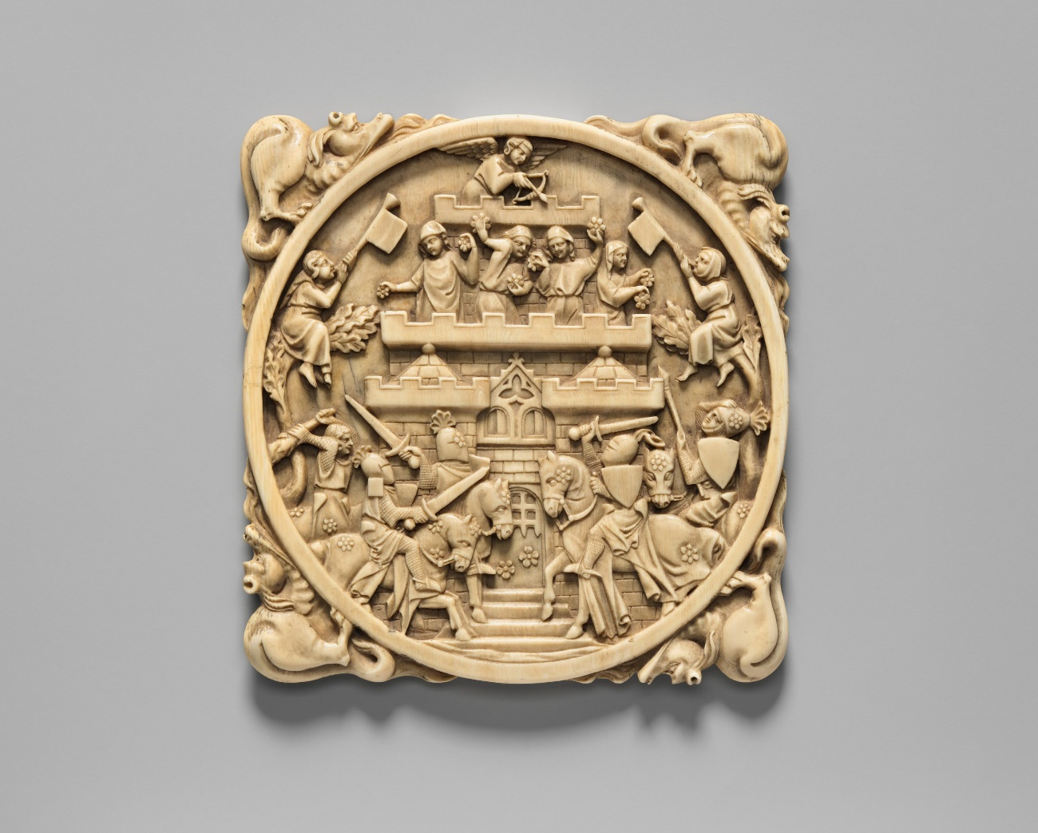

Love, Grief, and Joy
Scholarly discussions of romantic love in medieval literature often emphasize love’s disruptive nature and potential to defy norms and social order. Such narratives could be seen as cautionary tales that reinforce the need to maintain control and stability, possibly reflecting a ruler’s interest in promoting specific values at court. Thus, scholars have noted that romantic attachments can ignite social turmoil and chaos. Stefka G. Eriksen (220) argues that, in matters of romantic entanglement, chivalric sagas serve as ‘uncivilized examples’ for the king’s court.
However, these perspectives may not fully capture the complexities at play. A closer look makes evident a recurring pattern: themes of falling in love, separation, and death in these narratives suggest emotional turmoil. Both Tristams saga and the Strengleikar, as well as other stories like the celebrated Vǫlsunga saga,[3] present love as a source of both profound joy and deep suffering. Interestingly, the pain associated with love does not always stem from love itself, but often emerges when external circumstances make it impossible for love to be fully realized.
Falling in Love and Sickness
Falling in love might clearly become a direct source of suffering. In Tristams saga, for instance, love is often described as an illness (sótt); the character Blensinbil, for example, experiences symptoms that include fever, heat, and cold sweats as soon as she sees Kanelangres. Beyond these symptoms, the love that binds the central characters, Isolde and Tristan, is also the cause of deep suffering. The narrator suggests that the lovers are doomed to a life of sorrow brought on by their overwhelming desire for each other.
Yet, the very person who causes this emotional turmoil can also be the cure. In the story of Equitan from the Strengleikar, the protagonist suffers deeply because of a woman described as both his ailment and his potential remedy: ‘She is his fever, but she can be the cure of his pain . . . she can free him, she can cure him if she wants to, she can be his death if that is her ill will’ (Cook and Tveitane 70). The presentation of the beloved as the cure for the lover’s pain extends to their ability to heal them from other wounds or general suffering. Tristan, for example, is healed of his war wounds twice by Isolde, who is also the only one capable of mending the wounds that ultimately lead to his demise. This healing role is often occupied by women, and the dynamic suggests that, although the beloved may initially be a source of sorrow, what ultimately provides healing is the union between the lovers.
Not only does the presence of the beloved offer relief from suffering. In the moments when lovers can enjoy time together, there is a strong emphasis on the extreme joy that arises from their emotional bond. Common terms used to describe the state of the lovers include joy (fagnaðr), freedom (frælse) and peace (friði). However, this ideal state rarely endures, not necessarily because of intrinsic problems, but due to external forces that compel the lovers to part ways, leading to profound feelings of lament and sadness.
On the Separation of the Lovers
It is common for lovers who are not already bound by previous relationships to be forcibly separated by arranged marriages intended to forge political alliances. These separations bring about intense suffering, often described with terms like harmr (grief) and hugsótt – a complex term where hugr refers to various aspects of the self, including the mind, courage, affection, mood, and desire, indicating that a range of internal states are ‘sick.’ One of the most representative cases in Old Norse literature is that of Brynhildr, as reflected in Eddic poems and Vǫlsunga saga. In the latter, Brynhildr experiences deep emotional pain after being betrayed and separated from Sigurðr. She tells Gunnarr that he will not see her rejoice, drink, or give counsel, making it clear that her greatest sorrow (mestan harmr) was not marrying Sigurðr. This feeling is shared by Sigurðr, who, after confessing that he loved her more than himself, claims his most profound affliction was not being married to her—something he emphasizes in saying that his greatest grief (mesti harmr) was not recognizing his beloved before she wed another. Similarly, in the Strengleikar, Guiamar’s beloved is locked away in a tower to separate her from him, and she endures great sorrow (hugsótt), lamenting that she had ever seen Guiamar, as their union was impossible.
Two opposing models emerge here: the lovers’ union is associated with peace and happiness, while their separation leads to pain and distress. When these separations are enforced by the demands of arranged marriages which merely serve political purposes, these matrimonial alliances are not portrayed in favorable light. The political interests keeping the lovers apart are represented as obstacles to their peace and freedom, replacing the joy of their union with a profound affliction.
This intriguing tension mirrors the Old Norse/Icelandic societal context into which these stories were translated, where arranged marriages were indeed the norm. However, ideas about consent, particularly those endorsed by the Church, began to gain traction. By the mid-12th century, Catholic marriage doctrine had already taken root in Norway, likely coinciding with the establishment of the archbishopric in 1152. These ideas soon spread to Iceland, where Norwegian Archbishop Eysteinn, after condemning Icelandic chieftains for ignoring the sanctity of marriage, sent a letter to the country’s bishops in 1189 stressing the need for consent in marriage. However, it was not until the late thirteenth century that Icelandic law required a woman’s consent for a marriage to be legally recognized. These ideas emphasized the importance of mutual consent, stressing the need for both spouses to freely express their willing participation. While this shift towards recognizing consent introduced a new dynamic into the institution of marriage, it did not erode the political significance of these unions. As Agnes Arnórsdóttir argues, marriage began to unite couples, not just families, thus intertwining personal relationships and familial alliances.
But the portrayal of intimate relationships in these stories transcends the notion of consensual union as understood within Catholic traditions, as some narratives contain an oral past that predates this notion. Indeed, the tension between personal desire and the authority of the guardian—often the bride’s father or mother—is a recurring theme in societies where arranged unions are the norm (Shadle 241-262). In such contexts, marriages and the accompanying social structures are frequently presented as predestined and their inevitability underscored by the authoritative power of paternal figures over marital decisions. However, ethnographic studies reveal that when love is challenged by the dominance of arranged marriages, social constraints, and power struggles, it often finds its voice in unconventional forms of expression, such as poetry, literature, and music. Among the Australian Aborigines of Mangrove, as Burbank notes, elders claimed that modern films encouraged young people to fall in love, threatening their control over marriage arrangements. Similarly, Lila Abu-Lughod’s research on Egyptian Bedouin sentiments highlights how ‘love relationships pose such a threat to the system that they are the object of stringent control through symbolic manipulation’ (Abu-Lughod 208). In this context, the pain of unfulfilled love is often expressed through poetry, which is considered both subversive and powerful. Traditional Bedouin love stories vividly reproduce the tension between individual desires and the demands of kinship systems. These non-ordinary discourses can provide a means for people to challenge societal norms and inspire cultural change, using creative outlets to imagine alternative possibilities for personal and social relationships. As Charles Lindholm suggests,
Under the conditions of strong social constraint, well-formed primordial identities, and intense rivalry for power found both in centralized stratified societies and in certain kind of highly structured and internally competitive simpler social formations, the idealization offered by romantic love offers a way of imagining a different and more fulfilling life. (16)
Representations of romantic relationships in medieval tales likely mirrored societal values and anxieties, similarly negotiating personal desire with societal expectations. Beyond an intimate bond between individuals, love was a force linking people of similar status, particularly emphasizing the separation of the aristocracy from the general populace. Romantic narratives mainly feature lovers from noble families. The resulting implication is that lovesickness was a condition that primarily afflicted the noble class.
Beyond affection, noble qualities marked individuals with a ‘naturalized’ distinction. In many stories, it is crucial for lovers to share the same ӕði, a concept related to nobility that means ‘nature’ or ‘manners.’ Class distinctions remained as significant as they were in earlier models of consent. As Bjørn Bandlien notes, the form of consent predating the Church’s doctrinal influence—referred to as heroic consent—had its own distinctive features, chief among these, insistence on marriage between equals (jafnrӕði). This principle persisted in romance even after the Church introduced its new form of consent, where equality was redefined based on an individual´s nature and noble condition. Similarly, in her recent study on the rejection of love, Hannah Piercy demonstrates how love in Middle English romances is depicted as desirable while simultaneously shaping the qualities of the ideal partner. These qualities are closely tied to status, race, and faith, designating unequal relationships dangerous (Piercy 228). When combined with romantic attachment, these qualities underpinned the ideal foundations for a socially desirable marital bond.
This is often reinforced through classic trials that only ‘true lovers’ could overcome. Many stories blend love with the values of the dominant social class. In the Strengleikar, we see Gurún fall deeply in love with Eskia, who was abandoned by her parents at birth. The couple enjoys a period of happiness, but pressure mounts when Gurún’s knights and family urge him to marry another woman to secure a political alliance. Gurún reluctantly agrees, and his family arranges for him to marry Hӕsla, Eskia’s twin sister. Once Eskia’s identity is revealed (and her noble origin is certified), her parents regret their past actions and seek to make amends. Finally, the archbishop annuls the marriage between Gurún and Hӕsla and officially unites the former with Eskia.
Thus, love could be a useful tool for secular authorities, helping to maintain power within the ruling class. In these narratives, the ideal marriage bond extends beyond mutual affection. It depends on the compatibility of class. Love should not only fulfill personal desires, but also help preserve the status quo. This ideal was often destabilized, however, when political maneuvers prioritized alliances at the expense of love and mutual consent, revealing the tension between personal joy and the interests of power.
On Death and Love
The pain of losing a beloved is depicted as unbearable. In Tristams saga, for instance, when Isolde discovers Tristan has died, she succumbs to grief, dying alongside him, mirroring the fate of Tristan’s parents. This theme of love and loss also finds echoes in Eddic poetry, where the profound connection between lovers binds them beyond death. The tragic suicide of Brynhildr and the despair felt by Guðrún after the death of Sigurðr in Vǫlsunga saga, reaffirm the powerful effect of love, suggesting that these ties of affection can transcend the finality of death.
Although many of these romantic stories end in tragedy, instead of separating the lovers, death sometimes grants them the union life denied them. Tristan and Isolde are buried separately; nevertheless, nature reunites them: an oak tree grows from each grave, and their limbs intertwine above the church between the graves, symbolizing the lovers’ enduring bond. ‘And because of this,’ the narrator notes, ‘we can see how great the love between them had been’ (Kalinke 222), suggesting that the very obstacles to their love only served to magnify its depth and power. The fact that this intertwining happens above the church is no coincidence; it places a religious institution in a position of endorsing this union, hinting that love, even when forbidden in life, transcends material constraints, finding legitimation on God and nature. While this description could also be seen as love surpassing institutional religion, these narratives frequently portray religion as an ally in sanctifying or legitimizing such unions. For instance, in the lai Tveggia elskanda from the Strengleikar, two lovers are buried beneath the same gravestone inside a church. In the case of Eskia (described above), the relationship between the lovers is situated closer to God by the mediation of the archbishop. In any case, these stories suggest that even if lovers are separated in life, their union in death fulfills their deepest desire, offering an enduring example of true love.
A Final Remark
Medieval romantic narratives offer a vast field for interpretation and particularly benefit from gender studies. These stories frequently reflect societal expectations about the gendered experiences and expression of love and also conduct us to consider the attributes of the lovers and the qualities they admire in each other, whether these traits are mirrored or distinct. Such perspectives open compelling avenues for further inquiry.
Despite the varying interpretations, certain themes stand out. These narratives portray the interplay between love and suffering with a complexity that resists simplistic conclusions. Love, though it may be the cause of specific pain, is also a source of healing. The true source of lasting sorrow is often the separation of the lovers, which obstructs their path to mutual happiness and leaves them in perpetual yearning. This is most poignantly illustrated in the grief following a lover’s death, where the hope of reunion in the afterlife offers the only solace. Love is represented as an enduring force that transcends the trials of life and even the finality of death, capable of uniting souls beyond the constraints of earthly and social existence.
These kinds of tales, though rooted in their own time, continue to influence contemporary understandings and experiences of love. The close association between love and suffering is present not only in modern portrayals of romantic relationships but can also be present in everyday life. Anthropological and ethnographic studies show that these stories are still read, listened to, celebrated, and utilized in contemporary times, serving as tools for individuals to express complex emotions and to challenge, resist or defend societal norms. This can happen not only when arranged marriages prevent love from flourishing, but also when readers or listeners interpret the obstacles separating lovers in these narratives as representations of life’s difficulties in general. As a result, these tales not only empower individuals to challenge societal expectations but also influence internal constructions of love and social relationships, shaped by the cultural models embedded in the stories. Thus, these narratives can empower or inspire lovers to rise above difficulties, ultimately reinforcing a profound message eloquently captured by Percy Bysshe Shelley: ‘No more let Life divide what Death can join together.’

