UVaDOC Repository Deposit Cover Sheet
Manuscript version: Author Accepted Manuscript (AAM) / Postprint (pre-copyedited, author-produced)
Title: The relationship between burnout and job satisfaction in a sample of Spanish social workers
Authors: Rogelio Gómez-García; Siro Bayón-Calvo; Jezabel Lucas-García
Affiliation: University of Valladolid (Spain)
Publisher / Journal: The British Journal of Social Work (Oxford University Press)
Citation of the published Version of Record (VoR):
Gómez-García, R., Bayón-Calvo, S., & Lucas-García, J. (2021). The relationship between burnout and job satisfaction in a sample of Spanish social workers. The British Journal of Social Work, 51(8), 3115–3134.
DOI / Link to Version of Record: https://doi.org/10.1093/bjsw/bcaa150
Rights and re-use (required statement):
This is a pre-copyedited, author-produced version of an article accepted for publication in The British Journal of Social Work following peer review. The version of record Gómez-García, R., Bayón-Calvo, S., & Lucas-García, J. (2021). The relationship between burnout and job satisfaction in a sample of Spanish social workers. The British Journal of Social Work, 51(8), 3115–3134 is available online at: https://doi.org/10.1093/bjsw/bcaa150
Embargo: 12 months from publication. Online publication date: 17 September 2020. Embargo end date: 17 September 2021 (embargo satisfied).

The Relationship between Burnout and Job Satisfaction in a Sample of Spanish Social Workers

Abstract
Objective: Burnout and its relationship with job satisfaction has been addressed extensively. Research has focused mainly on diverse groups such as health care workers, teachers, and (more recently) social workers. This study aims to examine the relationships between the dimensions of burnout and job satisfaction among social workers. Method: A sample of 947 Spanish social workers was collected. We used a structural equation model using the PLS-SEM approach. A series of hypotheses were formulated to analyse the relationship between burnout dimensions and job satisfaction. Results: Emotional exhaustion is associated with high levels of depersonalisation and low levels of personal accomplishment. Different personal and work-related characteristics are significantly associated with various dimensions of burnout and job satisfaction. Conclusions: This study confirms a statistically significant relationship between burnout dimensions and job satisfaction.

Keywords
burnout, job satisfaction, social work, relationship, Spain, PLS-SEM

Introduction
Background
Burnout has been a widespread concern for several people-oriented professions, including healthcare, education and social services, with social workers being one of the main at-risk professionals (Maslach and Leiter, 2016). However, interest in the study of burnout in these professions, including social work, is relatively recent (Lim et al., 2010; Campbell et al., 2013).
In Spain, burnout among social workers has scarcely been studied, given that it was not until the 1980s that social work started to grow as a profession and academic discipline. This growth coincided with democratic socio-political changes, strongly reinforcing the development of healthcare professions (Hombrados-Mendieta and Cosano-Rivas, 2011).
Maslach and Jackson (1986) defined burnout as a prolonged response to chronic stressors in the workplace, whose key dimensions are emotional exhaustion (EE), depersonalisation (DP), and lack of personal achievement (PA). Some studies have evidenced the existence of high levels of burnout among social workers. Facal (2012) studied the prevalence of burnout in a sample of 15 social workers from community social services, concluding that 66.7% showed high degrees of burnout. Fuente-Roldán and Sánchez-Moreno (2012) analysed burnout in a sample of 100 social workers and founded that 25.3% of them suffered from burnout. Caravaca et al. (2018) conducted a study on 59 social workers who worked in prisons in Spain, and detected a high degree of burnout.
Other studies have found that the levels of burnout among social workers was not high. For example, Lazaro’s (2006) study with 402 Spanish social workers reported that social workers did not suffer high incidence of burnout. In another study based on a survey of 236 social workers, Cuesta (2007) detected that social workers do not suffer a high incidence of burnout. In the research carried out by Aragón (2006) with 1,161 professionals from different areas of Social Services, the percentage of professionals who suffered from burnout was lower than the percentages among other professionals not working in social services areas.
Lázaro (2004) argued that growing bureaucratisation, a lack of resources, role ambiguity, and intense contact with the clients may have contributed to burnout among Spanish social workers, making it an important topic for scientific investigation.
Following the definition given by Maslach and Jackson (1986), most models of burnout make explicit the causal theorising that has always been implicit in burnout research: certain factors (both situational and individual) cause people to experience burnout, and once burnout occurs, it causes certain outcomes (both situational and individual). Leiter and Maslach (2005) identified six organisational risk factors in many occupations. These factors are workload responsibilities, control, reward, community relationships within the organisation, fairness, and values in contrast to the organisational values. When a worker experiences an imbalance in one or more of these aspects, they are at risk of job burnout (Schaufeli et al., 2009). In terms of outcomes, burnout has frequently been associated with various forms of negative reactions and job withdrawal, including job dissatisfaction, low organisational commitment, absenteeism, intention to leave the job, and turnover (Maslach and Leiter, 2016).
With regard to the aforementioned dimensions of burnout, Taris et al. (2005) proposed a mixed sequential and parallel development model. This model indicates that high levels of EE lead to high levels of DP, which in turn lead to low PA levels. At the same time, EE has a direct effect on the reduction of PA levels. These suggest that EE arises from work stressors, that is, from being continually challenged by high work demands (i.e. work pressure and high emotional demands). Subsequently, employees can develop a DP attitude towards work as a coping strategy to distance themselves from stress (Taris et al., 2005).

Objectives and hypothesis formulation
This study has two aims: (a) to analyse the relationships between the dimensions of burnout (EE, DP, and PA) linked to the theoretical model proposed by Taris et al. (2005), and (b) to analyse the relationships between the dimensions of burnout (EE, DP, and PA) and job satisfaction.
Based on the studies reviewed in the previous subsection, we propose the following hypothesis:
Hypothesis 1. There is a significant and positive relationship between EE and DP. The model assumes that persistent DP may lead to a reduction in PA.
By emphasising the role of DP as an unsuitable coping strategy, Taris et al. (2005) predicted the feedback effects of DP on the other two Maslach Burnout Inventory (MBI) dimensions (i.e. EE and PA) to be such that EE increases and PA decreases, contingent on an earlier DP. DP has often been a coping strategy to reduce the sensation of burnout (Golembiewski et al., 1986; Taris et al., 2005; Jenaro et al., 2007). This conceptualisation is based on the Conservation of Resources theory (COR) (Hobfoll, 1989), which states that DP is not just a behavioural manifestation of burnout, but it also involves a strategy to control the losses and is utilised to avoid a further reduction in limited resources. COR predicts that, for a short time, this behavioural strategy can improve an employee’s ability to maintain an adequate performance level in stressful situations. In the long term, however, DP is expected to reduce access to social support. Consequently, depersonalised employees will become increasingly isolated, leading to a further decrease in resources for PA. Thus, we propose the following hypothesis:
Hypothesis 2. There is a significant and negative relationship between DP and PA.
Finally, the model also contains a separate distinct effect of EE on the reduction of PA. Thus, we propose the following hypothesis:
Hypothesis 3. There is a significant and negative relationship between EE and feelings of PA.
Job satisfaction (JS) acquires special relevance in the field of work and organisational psychology (Dormann and Zapf, 2001) due to its impact on both the individual and the organisation (Nagar, 2012). Hence, JS acts as an indicator of the individual’s well-being with regard to their work according to Spector (1997), who considers that job satisfaction can be understood as global feelings towards work and attitudes related to various aspects of work.
Furthermore, a systematic review by Saunders (2019) pointed out that JS is linked to several variables such as working hours, stress, and management support. Additionally, job dissatisfaction is associated with a greater intention to quit the job. Job satisfaction has been related to factors such as the following: salary (Lee and Lin, 2014); a persons’ emotions (Jepsen and Hung-Bin, 2003); relationships with co-workers (Asif et al., 2013), superiors, or bosses (Hon and Lu, 2010); a person’s liking for the activities; task autonomy; and commitment to their work (Nahar et al., 2013).
Regarding burnout and job satisfaction, numerous studies have concluded that the association between the two variables is negative. That is, as burnout sentiments show themselves more clearly, satisfaction in the workplace decreases (Figueiredo-Ferraz et al., 2012; Kim and Back, 2012). Although both burnout and job satisfaction show a high correlation, Spector (1997) observed that both variables are conceptually different, given that job satisfaction is an attitudinal response and burnout is more of an emotional response to a job.
As for the dimensions of the burnout, the results indicate that job satisfaction is negatively associated with EE and DP; unlike PA whose association with job satisfaction is positive (Penn et al., 1988; Griffin et al., 2010; Rouleau et al., 2012). Several investigations have shown intense divergence, in that some studies have found a strong correlation between EE and JS (Schermuly et al., 2011), while others have considered PA to be a better indicator of JS (Shepherd et al., 2011). According to Alarcon (2011), EE and DP affect levels of JS, which is in contrast to the results of Rutherford et al.’s study (2011), which demonstrated that DP does not influence levels of JS.
Nevertheless, the dimensions of burnout have been shown to be predictors of job satisfaction (Lee et al., 2011). With respect to this point of view, Fogarty et al. (2000) justified this statement based on theoretical elements. First, burnout stems from a process by which the individual assesses labour demands along with their own resources. This assessment has an impact on the psychology and well-being of employees. Second, both constructs arise as a result of emotional responses, and for this reason, we propose the following hypotheses:
Hypothesis 4. A significant negative relationship is expected between EE and job satisfaction.
Hypothesis 5. A significant negative relationship is expected between DP and job satisfaction.
Hypothesis 6. A significant positive relationship is expected between PA and job satisfaction.
Based on the relationships, Figure 1 shows the set of relationships proposed, which are based on the formulation of hypotheses.

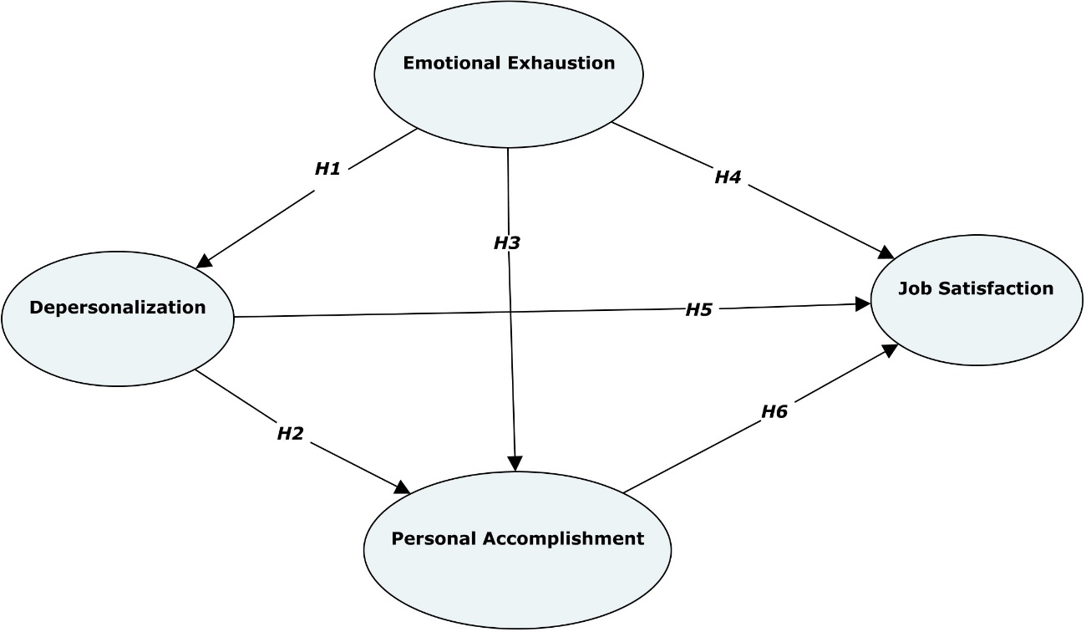
Figure 1. Hypothesized causal model.

Materials and Methods
Participant Recruitment and Ethical Statement
The study was based on a cross-sectional research design. Initially, all information about the purpose of the research, as well as all questions and instructions for answering the questionnaires, were sent to the General Council of Social Work of Spain. After this, the General Council oversaw the inclusion of the questions on the platform of the organisation’s website, and the questionnaire was sent to all the professionally qualified social workers via email. In this email, their collaboration was requested, and the procedure for accessing a self-administered survey via the Internet (https://es.surveymonkey.com/) was described. In the documentation provided to each respondent, their consent to participate in the study was requested, and the confidentiality of the data was guaranteed. In order to resolve any possible doubts that might have arisen regarding both the purposes of the research and the use of the results or the completion of the instrument, a telephone number was attached whereby consultations could be made with members of the research team, should they be necessary.
The study was carried out with the approval of the Ethics and Research Commission of the General Council of Social Work of Spain.

Measurement Instruments
Burnout was evaluated with the Maslach Burnout Inventory (Maslach & Jackson, 1986), adapted for Spanish samples (Gil-Monte and Peiró, 1999). This instrument is composed of 22 items and consists of three subscales intended to measure the symptoms of burnout: EE (nine items, e.g. Due to my work, I feel emotionally exhausted), DP (five items, e.g. I think I treat some clients as if they were objects) and PA (eight items, e.g. I feel like I am positively influencing the lives of others through my work). The participants rated each item on the survey, using a 7-point scale to indicate how frequently they experienced the situation described in the item during the past year, ranging from 0 (“Never”) to 6 (“Always”). Low scores on PA at work and high scores on EE and DP correspond to high levels of burnout. The internal reliability analyses, calculating the value of Cronbach’s alpha, presented high values on the scales of EE (α = 0.89) and PA (α = 0.75) and lower values on the scale of DP (α = 0.70).
Job satisfaction, which is considered a positive and pleasant attitudinal response resulting from the subjective perception of work experiences, was evaluated with the Job Satisfaction Survey (Spector, 1997). In this case, a version translated into Spanish by Marion-Landais (1993) was used. This survey’s scale is composed of 36 items measuring nine dimensions of job satisfaction: pay (e.g. I feel I am being paid a fair amount for the work I do) , advancements and promotions (e.g. There is really too little chance for promotion on my job), supervision (e.g. My supervisor is quite competent in doing his/her job), fringe benefits (e.g. I am not satisfied with the benefits I receive), contingent rewards (e.g. When I do a good job, I receive the recognition for it that I should receive), working conditions (e.g. Many of our rules and procedures make doing a good job difficult), relationships with co-workers (e.g. I like the people I work with), nature of work (e.g. I sometimes feel my job is meaningless), and communication (e.g. Communications seem good within this organisation). Each dimension is composed of four items measured on a 6-point Likert scale (1 – disagree very much; 6 – agree very much) reflecting the degree of agreement or disagreement on the part of the participants in relation to the formulated expressions. Cronbach's alpha coefficient (α) in our study was α = 0.90 for the total test.
Finally, several control variables were included that could affect the relationship between burnout dimensions and job satisfaction. Variables related to the personal characteristics of social workers were (a) gender (0 = man, 1 = woman), (b) age (years), (c) type of cohabitation (0 = without a regular partner, 1 = with a regular partner), (d) having children in the home (0 = with children, 1 = without children), and (e) suffering from a chronic illness (0 = no, 1 = yes).
Work-related variables were (f) work setting (0 = private, 1 = public), (g) sector of the population served (0 = specialised social services, 1 = community social services), and (h) work experience (0 = <15, 1 = >15).

Data Analysis
The data were analysed with IBM SPSS version 20 (IBM Corp., 2011) and SmartPLS version 3.2.8 (Ringle et al., 2015). A descriptive analysis of the sample was also run in SPSS. To validate and contrast the proposed hypotheses, a structural equations model was proposed. We used the Partial Least Squares Structural Equation Modelling (PLS-SEM) approach because it is a commonly accepted method to estimate structural equation models (Hair et al., 2013). PLS-SEM is a second-generation multivariate data analysis method that is often used in social science research because it can test theoretically supported linear and additive causal models. This analysis was run in SmartPLS (Ringle et al. 2015).
The parameters of the measurement and the structural model were estimated in a single step. Despite this, the recommendations established by Chin (2010) and Hair et al. (2013) were followed to present the results, first evaluating the measurement model and then evaluating the statistical significance of the parameters. This process thus ensures the validity and reliability of the measurements.

Results
Descriptive Statistics
The participants were 947 social workers (90.1% women) with an average age of 39.4 years (SD = 8.9, range = 21-63). The average age of the women was 39.5 years (SD = 8.8) and that of the men was 39.3 (SD = 8.9). Most of the professionals were married or lived with a partner (69.8%, n = 661), and 51.6% (n = 489) did not have children. Approximately one-third of those surveyed (32.0%, n = 303) had been in their current position for less than 5 years, 42.9% (n = 406) from 5‒15 years, and 25.1% (n = 238) for more than 15 years. Of the total number of participants, 613 (64.7%) worked in the public sector and 293 (35.3%) in the private sector. Six hundred and one participants (63.5%) worked in specialised social services (mental health, the elderly, education, children, and families), whereas 346 (36.5%) were engaged in community social services, which are considered the gateway to the social protection system.
The results obtained indicate that the study sample was similar to the general population of social workers in Spain in terms of gender, age, and professional experience, according to reports by Urien-Angulo et al. (2019). All participants gave their informed consent.

Measurement Model Evaluation
The following procedures were carried out to validate the measurement model: (a) a calculation of the individual reliability of the item using the factorial load in the case of reflective constructs (EE, DP, PA, and JS), and (b) an examination of the validity of the construct.
Several tests were carried out to determine whether the questionnaire was sufficiently dependable. The first test focused on determining whether to accept an item as part of a reflective construct. For this purpose, the items had to have factorial load (λ) or simple correlations equal to or greater than 0.707 (Carmines and Zeller, 1979). However, some authors have claimed that this rule (λ ≥ 0.707) should not be as rigid in the initial stages of scale development (Hair et al., 2013) and have suggested that items with loads between 0.4 and 0.7 could be removed from a scale if their suppression leads to an increase in the average variance extracted (AVE) or the Composite Reliability index (p_{c}) is above the suggested threshold values (AVE = 0.5; p_{c} = 0.7). Hence, three items (MBI_04, MBI_07, and MBI_15) were eliminated due to very weak loads (≤ 0.4). Loads for 16 items ranged from 0.552 to 0.687, while the remaining item loads were above 0.7. The rest of the items were maintained for this study, given their contribution to the content validity (AVE = 0.5; p_{c} = 0.7). Table 1 shows the results.

Table 1. Structural model measurement tool: convergent reliability and validity.
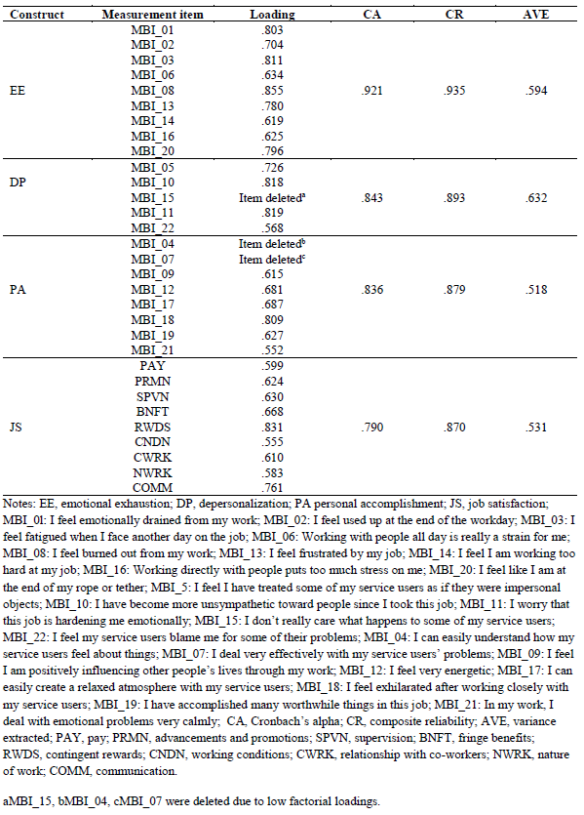
The second test assessed the reliability of the construct through two measures of internal consistency: Cronbach’s Alpha (α) and the Composite Reliability index (p_{c}). The interpretation of both values was similar, using the proposal of Hair et al. (2013), suggesting 0.7 as a reference point for both α and p_{c}. The results of Table 1 show that all constructs were dependable and had satisfactory internal consistency.
The convergent validity test also helped to determine the reliability of a partial least squares (PLS) instrument, calculated through the average variance extracted (AVE). As can be seen in Table 1, the AVE coefficient for reflective constructs was greater than 0.5. According to these suggestions, all AVE measures were valid.
Finally, it is necessary to assess the discriminant validity. For this purpose, Fornell and Larcker’s (1981) method was used, which is based on the idea that a construct should share more variance with its items than with other constructs in each model. In this sense, Table 2 shows that the square root of the AVE was greater than the correlation between the variables. This means that all constructs were more related to their items than to those of other constructs.

Table 2. Measuring instrument: discriminant validity.
 | DP | EE | JS | PA
DP | .795
EE | .535 | .771
JS | -.346 | -.559 | .657
PA | .320 | .353 | -.272 | .720
Note: DP, depersonalization; EE, emotional exhaustion; JS, job satisfaction; PA personal accomplishment.
Diagonal: square root of the average variance extracted (AVE).

Structural Model Evaluation
Once the reliability and validity of the constructs had been verified, an analysis of the relationship between the constructs and the predictive capacity of the endogenous variables was carried out. Therefore, we assessed the weight and nature of the relationships (hypothesis) between the different variables. This assessment involved the use of two basic indicators: the explained variance (R²), which indicates the predictive power of the model, and the standardised path coefficients (β), which indicate the strength of the relationships between dependent and independent variables (Johnson et al., 2006).
Regarding the predictive capacity of the model, the R² of the dependent variables must be equal to or greater than .1 since lower values provide little information (Falk and Miller, 1992). Chin (1998) established the following reference values: from .67 is “substantial”, from .33 is “moderate”, and from .19 is “weak”. The values of R² obtained in this model showed a scarce predictive power for the variables EE and PA (R² = .029 and .148, respectively), and a moderate valuation for the variables DP and JS (R² = .335 and .333, respectively). Table 3 shows these results.

Table 3. Summary of variance explained (R²). Stone-Geisser test (Q²).
Construct | R² | Q²
EE | .029 | .016
DP | .335 | .179
PA | .148 | .148
JS | .333 | .320
Note: DP, depersonalization; EE, emotional exhaustion; JS, job satisfaction; PA personal accomplishment.

To establish how exogenous variables in dependent constructs contribute to the variance explained, the values obtained in the path coefficients were used (β). According to Chin (1998), these values must reach at least .2 to be considered significant. It should be noted that the non-parametric bootstrap technique was used with a resampling procedure with replacement, considering 947 cases with 5,000 samples, as recommended by Hair et al. (2013). Commonly used critical values for two-tailed tests are 1.65 (significance level = 10%), 1.96 (significance level = 5%), and 2.57 (significance level = 1%). As shown in Table 4, only hypothesis H₅ was not significant.

Table 4. Structural model results.
Hypothesis | Suggested effect | Path coefficients | t-value (bootstrap) | pValue | Support
H₁: _{+EE → +DP} | + | .518*** | 20.343 | .000 | Yes
H₂: _{+DP → -PA} | - | -.184*** | 5.259 | .000 | Yes
H₃: _{+EE → -PA} | - | -.255*** | 6.908 | .000 | Yes
H₄: _{+EE → -JS} | - | -.519*** | 20.753 | .000 | Yes
H₅: _{+DP → -JS} | - | -.04^{ns} | 1.282 | .200 | No
H₆: _{+PA → +JS} | + | .076*** | 2.675 | .008 | Yes
Control variables |  | Path coefficients | t-value (bootstrap) | pValue | Support
Gender → DP |  | -.084*** | 2.884 | .004 | Yes
Age → DP |  | -.181*** | 6.553 | .000 | Yes
Work sector → DP |  | .089*** | 2.900 | .004 | Yes
Chronic illness → EE |  | .119*** | 3.599 | .000 | Yes
Group_leaders → JS |  | .082*** | 3.041 | .002 | Yes
Sector_population → DP |  | .102*** | 3.329 | .001 | Yes
Sector_population → EE |  | .124*** | 3.809 | .000 | Yes
Sector_population → JS |  | -.072*** | 2.782 | .005 | Yes
Notes: EE, emotional exhaustion; DP, depersonalization; PA personal accomplishment; JS, job satisfaction

When examining the relationships between the three dimensions of burnout, we observed that the relationship between EE and DP among social workers was positive and significant (β_{EE→DP} = .518; t = 20.343; p < .01), which supports hypothesis H₁. A negative and significant relationship was observed between DP and PA (β_{DP→PA} = -.184; t = 5.259; p < .01), which supports hypothesis H₂. Likewise, there was a negative and significant relationship (β_{EE→PA} = -.255; t = 6.908; p < .01) between EE and PA in the social workers sample, which supports hypothesis H₃.
The following set of hypotheses examined the relationship between the three dimensions of burnout and job satisfaction among social workers. EE had a negative and significant relationship with JS (β_{EE→JS} = -.519; t = 20.753; p < .01), thus confirming hypothesis H₄. Therefore, social workers experiencing higher levels of EE will have lower levels of JS. DP did not present a significant relationship with JS, so hypothesis H₅ was not supported (β_{DP→JS} = -.040; t = 1.282; p > .05). Finally, PA presented a positive and significant relationship with JS, thereby supporting hypothesis H₆ (β_{PA→JS} = .076; t = 2.675; p < .01). In this case, the magnitude was very small.
In the case of control variables, there appear to have been some significant associations with EE, DP, and JS. Female social workers showed significantly lower levels of DP (β_{GENDER→DP} = -.084; t = 2.884; p < .01) than men. Older age was significantly associated with lower levels of DP (β_{AGE→DP} = -.181; t = 6.553; p < .01). The development of activity in the public sector obtained a significantly higher score in DP (β_{WORK_SECTOR → DP} = .089; t = 2.900; p < .01) than the activity of practitioners who worked in the private sector. Social workers having a chronic disease had a significant and positive association with DP (β_{CHRONIC_ILLNESS → DP} = .119; t = 3.599; p < .01). Social work team leaders showed significantly higher levels of JS (β_{GROUP_LEADERS→ JS} = .082; t = 3.041; p < .01) than those without this type of responsibility. Work in community social services (as opposed to that in specialised social services) was significantly associated with greater DP (β_{SECTOR_POPULATION→ DP} = .102; t = 3.329; p < .01), greater EE (β_{SECTOR_POPULATION→ EE} = .124; t = 3.809; p < 0.01), and lower JS (β_{SECTOR_POPULATION→ JS} = -.072; t = 2.782; p < .01).
To measure the predictive power of model-dependent constructs, the Stone-Geisser procedure or Q² parameter (cross-validated redundancy) was used. This test was run using the blindfolding technique. Parameter Q² must be greater than zero to have predictive validity (Chin, 1998) since values above zero determine that the predictability of the model is relevant (Sellin, 1995). As Table 3 shows, all Q² values met this condition. Therefore, the predictive relevance of the model in relation to endogenous latent variables was supported.
Finally, we calculated the standardised residual value of the mean square root (SRMR), which is the average difference between the predicted and observed correlations (variances and covariances) based on the standard error of the residual. Therefore, it can be considered as a measure of goodness-of-fit of the model for PLS-SEM (Henseler et al., 2014). According to Hu and Bentler (1999), values lower than .08 are generally considered a good fit. The SRMR value obtained from this model was .057, which indicates an adequate level of fit. Figure 2 illustrates the results.

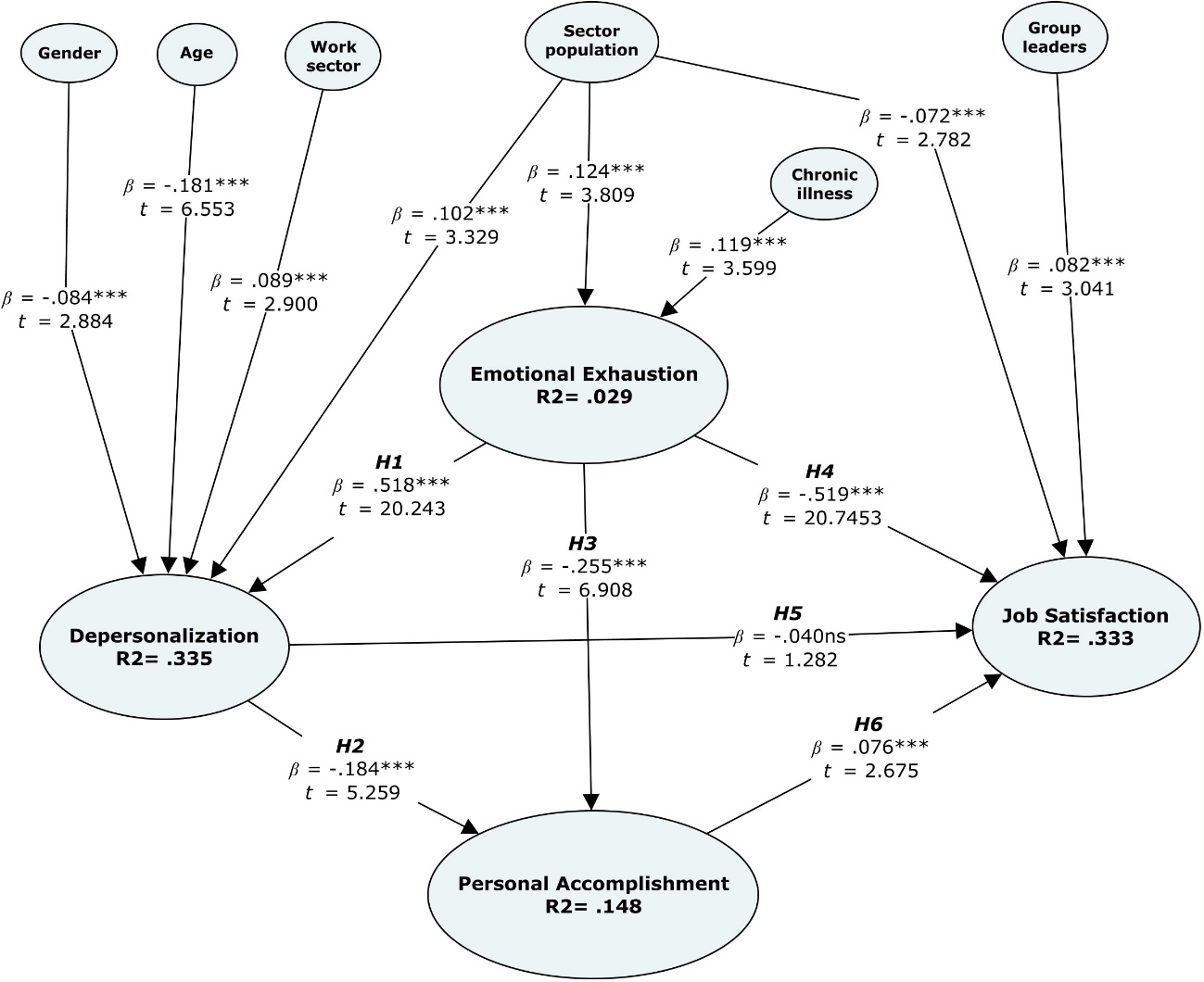 Figure 2. Structural model

Discussion
As stated in the introduction, this research had a twofold objective: (a) to analyse the relationships between the dimensions of burnout from the theoretical model proposed by Taris et al. (2005), and (b) to analyse the relationships between the dimensions of burnout and job satisfaction. These objectives have been achieved using a sample of 947 Spanish social workers. The PLS-SEM technique has allowed us to test the validity and reliability of the instrument as well as the predictive power and relations in the structural model.
In line with the hypotheses developed about the relationships between burnout dimensions, our findings support the idea that high levels of EE among social workers are associated with high levels of DP. DP was associated with low levels of PA, and EE had direct effects on feelings of PA in the sample of social workers. These findings are consistent with the model of Taris et al. (2005), as DP and a reduction in PA develop simultaneously from EE. Previous literature has also supported some of the relationships between the dimensions of burnout found in this research. For instance, several studies found EE levels to be positively associated with DP and negatively associated with PA, and DP to be negatively associated with PA among social workers (Hussein et al., 2014; Lizano and Mor Barak, 2015; Hussein, 2018). Houkes et al. (2011) found evidence of a strong influence of EE on DP and of DP on PA in a study of 212 Dutch medical doctors.
The structural equation model adopted in this study demonstrated a series of relationships (raised as hypotheses) between the dimensions of burnout and job satisfaction among social work practitioners. The findings show that EE had a significant and negative relationship with job satisfaction. Numerous studies of social workers support the idea that workers with high EE levels typically have low JS scores. This negative relationship has been supported by several authors (Bhana and Haffejee, 1996; Hombrados-Mendieta and Cosano-Rivas, 2011; Lizano and Mor Barak, 2015; Soto-Rosales and González-Losada, 2018). However, some studies have not found the expected relationship between EE and job satisfaction in samples of child protection workers and social workers. Stalker et al. (2007) showed that Canadian child social workers scored high on overall JS despite having high scores on a measure of EE, indicating that these two elements can co-exist together. Hence, social workers who experience a sense of EE in relation to their work and the working relationships established within the organisation may have reduced levels of satisfaction.
DP had a very small negative relationship with job satisfaction, although it was not statistically significant. Lizano and Mor Barak (2015), using a sample of public child welfare social workers from the United States, found that DP did not predict JS. A possible explanation for the null relationship found is that EE is more likely to influence wellbeing outcomes given the fact that workload may influence wellness. Conversely, DP is a manifestation of an interpersonal dimension of burnout and may not directly impact affective wellbeing (Lizano and Mor Barak, 2015).
PA was significantly and positively associated with job satisfaction, although its magnitude was very small. This relationship is also supported in studies such as that of Bhana and Haffejee (1996) who used a sample of child welfare social workers in South Africa. Similarly, Caravaca et al. (2018) found that the PA dimension was statistically associated with the overall satisfaction of social workers who work in Spanish prisons.
The control variables used evidenced some significant associations with the constructs of the proposed model. In this sense, DP seemed to be lower among female social workers and those of more advanced age and with more experience. The analysis also indicated that working in the public sector and working in community social services increased the scores of DP in the sample of social workers, and that team leaders showed higher levels of job satisfaction.
The results obtained in this research provide additional relevant information to the current body of literature on burnout among social workers. The results have highlighted the importance of EE among social workers as a significant consideration to address with respect to the optimal development and management of social work organisations. The existence of burnout in social service organisations causes negative feelings among social workers that, in the end, have a negative impact on job satisfaction.

Limitations and Future Research
The findings of this study should be interpreted with caution due to various empirical design considerations. First, the cross-sectional design limits the interpretation of causal relationships between variables and suggests that future research should be approached with longitudinal designs to determine possible causal relationships between different variables among social workers.
Secondly, due to the voluntary nature of the survey and the fact that the sample consisted of individuals who self-selected to participate, the findings are not necessarily generalisable to all Spanish social workers. Thirdly, the elimination of elements of the MBI due to a lower weighting is problematic and affects the comparability of the results with other studies that used a non-modified version of the MBI. Fourth, several subscales met the inclusion criteria but had factor loads or coefficients that were lower than recommended.
Finally, the self-administered questionnaire suggests that the existence of biases is possible. Sekaran and Bougie (2009) pointed out that there is a tendency for participants to respond to research instrument questions based on what is considered most favourable in terms of current social norms and standards, regardless of their true feelings. One option to reduce this problem in future research would be to collect data from multiple sources.

Implications
The results of this study have important practical implications. Our findings support the model proposed by Taris et al. (2005) in which EE develops first. Then DP followed by a reduction in PA. Thus, burnout prevention measures should focus on specific organisational and situational determinants that have been shown to influence EE (Diestel and Schmidt, 2010). Managers should be aware of the factors that predict burnout and identify employees at an early stage of the process to minimise burnout (Alarcon, 2011). Managers should consider two types of interventions: individual and organisational. Regarding individual interventions, they should focus on increasing the worker’s personal resources (e.g., implementing strategies to actively address problems, having family friendly policies, facilitating self-care, or training in self-confidence). On the other hand, organisational interventions should focus on reducing the stressful elements of work (e.g. work overload or emotional demands) or on increasing labour resources (e.g. job autonomy, support from supervisors, teams and colleagues, on-going professional development opportunities, or social support).

Conclusion
This study supports the integrative model of Taris et al. (2005) in which higher levels of EE lead to higher levels of DP among social workers. In addition, higher levels of DP are associated with lower levels of PA. This study has shown a relationship between burnout and the components of EE, PA, and JS in a sample of social workers. Social workers’ personal and work characteristics such as gender, age, chronic illness, work setting, sector of the population served, and having responsibility over work teams are significantly associated with EE, DP, and job satisfaction.

References
Alarcon, G. M. (2011) ‘A meta-analysis of Burnout with job demands, resources, and attitudes’, Journal of Vocational Behavior, 79(2), pp. 549-562.
Aragón, J. L. (2006) ‘El síndrome de quemarse por el trabajo en diversos grupos profesionales de los Servicios Sociales de la provincia de Valencia’, in Gil-Monte, P., Salanova, M., Aragón, J.L., and Schaufeli, W. (eds), El síndrome de quemarse por el trabajo en Servicios Sociales, Valencia, Diputación de Valencia.
Asif, S., Munrer, S., Munir, S. and Naeem, A. T. (2013), Impact of altruism and courtesy on employees’ attitudes: A study of telecom industry of Pakistan’, Middle East Journal of Scientific Research, 18(6), pp. 815–820.
Bhana, A., and Haffejee, N. (1996) ‘Relation among measures of burnout, job satisfaction, and role dynamics for a sample of child-care social workers’, Psychological Reports, 79(2), pp. 431–434.
Campbell, N. S., Perry, S. J., Maertz, C. P., Allen, D. G., and Griffeth, R.W. (2013) ‘All you need is . . . resources: The effects of justice and support on burnout and turnover’, Human Relations, 66(6), pp. 759–782.
Caravaca, F., Carrión, J., and Pastor E. (2018) ‘Síndrome de burnout y satisfacción laboral en profesionales del trabajo social en prisiones de España’, Revista Española de Sanidad Penitenciaria, 20(2), pp. 40-47.
Carmines, G., and Zeller, R. (1979) Reliability and validity assessment, Beverly Hills, Sage.
Chin, W. (1998). ‘Issues and opinion on structural equation modelling’, MIS Quarterly, 22(1), pp. VII–XVI.
Chin, W. (2010) ‘How to write up and report PLS analyses’ in Vinzi, V., Chin, W., Henseler, J., and Wang, H. (eds) Handbook of Partial Least Squares: Concepts, Methods and Applications, Berlin, Springer.
Cuesta, A. B. (2007) Situación laboral de las trabajadoras sociales en La Rioja. Nuevos retos y propuestas de futuro, Logroño, Colegio Oficial de Diplomados en Trabajo Social y Asistentes Sociales de La Rioja.
Diestel, S. and Schmidt, K.H. (2010) ‘Direct and interaction effects among the dimensions of the Maslach Burnout Inventory: Results from two German longitudinal samples’, International Journal of Stress Management, 17(2), pp. 159–180.
Dormann, C., and Zapf, D., (2001) ‘Job satisfaction: a meta-analysis of stabilities’, Journal of Organizational Behavior, 22(5), pp. 483–504.
Facal, T. (2012) ‘Prevalencia del síndrome de burnout en trabajadores sociales de los servicios sociales comunitarios’, Portularia: Revista de Trabajo Social, XII(1), pp. 59–69
Falk, R. and Miller, N. (1992) A primer for soft modelling. Akron, The University of Akron Press.
Figueiredo-Ferraz, H., Grau-Alberola, E., Gil-Monte, P. R. and García-Juesas, J. A. (2012) ‘Burnout and job satisfaction among nursing professionals’, Psicothema, 24(2), pp. 271-276.
Fogarty, T. J., Singh, J., Rhoads, G. K., and Moore, R. K. (2000) ‘Antecedents and consequences of Burnout in accounting: Beyond the role stress model’, Behavioral Research in Accounting, 12(1), pp. 31-67.
Fornell, C. G., and Larcker, D. F. (1981) ‘Evaluating structural equation models with unobservable variables and measurement error’ Journal of Marketing Research, 18(1), pp. 39–50.
Fuente-Roldán, I. N., and Sánchez-Moreno, E. (2012) ‘Trabajo social, síndrome de estar quemado por el trabajo y malestar psíquico: un estudio empírico en una muestra de trabajadores sociales de la comunidad de Madrid’, Portularia: Revista de Trabajo Social, XII, pp. 121-130.
Gil-Monte, P. R., and Peiró, J. M. (1999) ‘Validez factorial del Maslach Burnout Inventory en una muestra multiocupacional’, Psicothema, 11(3), pp. 679-689.
Golembiewski, R. T., Munzenrider, R. F., and Stevenson, J. G. (1986) Phases of burnout: Developments in concepts and applications, New York, Praeger.
Griffin, M. L., Hogan, N. L., Lambert, E. G., Tucker-Gail, K. A. and Baker, D. N. (2010) ‘Job involvement, job stress, job satisfaction, and organizational commitment and the Burnout of correctional staff’, Criminal Justice and Behavior, 37(2), pp. 239-255.
Hair, J. F., Ringle, C. M., Sarstedt, M. (2013) ‘Partial least squares structural equation modeling: rigorous applications, better results and higher acceptance’, Long Range Planning, 46(1/2), pp. 1-12.
Henseler, J., Dijkstra, T., Sarstedt, M., Ringle, C., Diamantopoulos, A., Straub, D., et al. (2014) ‘Common beliefs andreality about partial least squares: Comments on Rönkkö & Evermann (2013)’ Organizational Research Methods, 17(2), pp. 182–209.
Hobfoll, S. E. (1989) ‘Conservation of resources. A new attempt at conceptualizing stress’, American Psychologist, 44(3), pp. 513–24.
Hombrados-Mendieta, I., and Cosano-Rivas, F. (2011) ‘Burnout, workplace support, job satisfaction and life satisfaction among social workers in Spain: A structural equation model’ International Social Work, 56(2), pp. 228–246.
Hon, A. and Lu, L. (2010) ‘The mediating role of trust between expatriate procedural justice and employee outcomes in Chinese hotel industry’ International Journal of Hospitality Management, 29(4), pp. 669–676.
Houkes, I., Winants, Y., Twellaar, M., and Verdonk, P. (2011) ‘Development of burnout over time and the causal order of the three dimensions of burnout among male and female GPs. A three-wave panel study’ BMC Public Health, 11, 240.
Hu, L. and Bentler, P. (1999) ‘Cutoff criteria for fit indexes in covariance structure analysis: Conventional criteria versus new alternatives’, Structural Equation Modeling, 6(1), pp. 1–55.
Hussein, S. (2018) ‘Work Engagement, Burnout and Personal Accomplishments Among Social Workers: A Comparison Between Those Working in Children and Adults’ Services in England’ Administration and Policy in Mental Health and Mental Health Services Research, 45(6), pp. 911–923.
Hussein, S., Moriarty, J., Stevens, M., Sharpe, E., and Manthorpe, J. (2014) ‘Organisational Factors, Job Satisfaction and Intention to Leave Among Newly Qualified Social Workers in England’, Social Work Education, 33(3), pp. 381–396.
IBM Corp. (2011) IBM SPSS Statistics for Windows, Version 20.0. Armonk, IBM Corp.
Jenaro, C., Flores, N., and Arias, B. (2007) ‘Burnout and coping in humans service practitioners’, Professional Psychology: Research and Practice, 38(1), pp. 80–97.
Jepsen, D. and Hung-Bin, S. (2003) ‘General job satisfaction from a developmental perspective: Exploring choice-job matches at two career stages’ The Career Development Quarterly, 52(2), pp. 162–179.
Johnson, M., Herrmann, A. and Huber, F. (2006) ‘The evolution of loyalty intentions’, Journal of Marketing, 70(2), pp. 122–132.
Kim, Y. K. and Back, K. (2012) ‘Antecedents and consequences of flight attendants' job satisfaction’, Service Industries Journal, 32(16), pp. 2565-2584.
Lázaro, S. (2004) ‘El desgaste profesional (síndrome de burnout) en los trabajadores sociales’, Portularia, 4, pp. 499–506.
Lázaro, S. (2006) Cenizas de un ideal. Estudio sobre el proceso de burnout en trabajadores sociales, Madrid, Universidad Pontificia de Comillas.
Lee, H. W. and Lin, M. C. (2014) ‘A study of salary satisfaction and job enthusiasm - Mediating effects of psychological contract’, Journal of Applied Financial Economics, 24(24), pp. 1577–1583.
Lee, J., Lim, N., Yang, E., and Lee, S. M. (2011) ‘Antecedents and consequences of three dimensions of Burnout in psychotherapists: A Meta-Analysis’, Professional Psychology: Research and Practice, 42(3), pp. 252-258.
Leiter, M. P. and Maslach, C. (2005) ‘A mediation model of job burnout’, in Antoniou, A. and Cooper, C. L. (eds), Research companion to organizational health psychology, Cheltenham, Edward Elgar.
Lim, N., Kim, E. K., Kim, H., Yang, E., and Lee, S. M. (2010) ‘Individual and work-related factors influencing burnout of mental health professionals: A meta-analysis’, Journal of Employment Counseling, 47(2), pp. 86–96.
Lizano, E., and Mor Barak, M. (2015) ‘Job burnout and affective wellbeing: A longitudinal study burnout and job satisfaction among public child welfare workers’, Children and Youth Services Review, 55, pp. 18–28.
Marion-Landais, C. A. (1993) A cross-cultural study of leader-member exchange quality and job satisfaction as correlates of intra-dyadic work-value congruence, Tampa, University of South Florida.
Maslach, C. and Jackson, S. E. (1986). Maslach Burnout Inventory Manual, Palo Alto, Consulting Psychologists Press.
Maslach, C. and Leiter, M. P. (2016) ‘Understanding the Burnout experience: Recent research and its implications for psychiatry’, World Psychiatry, 15(2), pp. 103-111.
Nagar, K. (2012) ‘Organizational commitment and job satisfaction among teachers during times of burnout’, Vikalpa, 37(2), pp. 43-60.
Nahar, L., Hossain, A., Rahman, A. and Bairagi, A. (2013) ‘The Relationship of Job Satisfaction, Job Stress, Mental Health of Government and Non-Government’, Employees of Bangladesh. Psychology, 4(6), pp. 520-525.
Penn, M., Romano, J. L., and Foat, D. (1988) ‘The relationship between job satisfaction and burnout: A study of human service professionals’, Administration in Mental Health, 15(3), pp. 157-165.
Ringle, C. M., Wende, S., and Becker, J. M. (2015) SmartPLS 3. SmartPLS (accessed January 4, 2019).
Rouleau, D., Fournier, P., Philibert, A., Mbengue, B., and Dumont, A. (2012) ‘The effects of midwives’ job satisfaction on burnout, intention to quit and turnover: a longitudinal study in Senegal’, Human Resources for Health, 10, pp. 1-14.
Rutherford, B. N., Hamwi, G. A., Friend, S. B., and Hartmann, N. N. (2011) ‘Measuring salesperson Burnout: A reduced Maslach Burnout Inventory for sales researchers’, Journal of Personal Selling and Sales Management, 31(4), pp. 429-440.
Saunders, K. M. (2019) Essays on Health Economics, WHU – Otto Beisheim School of Management.
Schaufeli, W. B., Leiter, M. P., and Maslach, C. (2009) ‘Burnout: 35 years of research and practice’, Career Development International, 14(3), pp. 204-220.
Schermuly, C., Schermuly, R. A. and Meyer, B. (2011) ‘Effects of vice-principals' psychological empowerment on job satisfaction and Burnout’, International Journal of Educational Management, 25(3), pp. 252-264.
Sekaran, U. and Bougie, R. (2009) Research methods for business, West Sussex, Wiley.
Sellin, N. (1995) ‘Partial least square modelling in research on educational achievement’ in Bos, W. and Lehmann, R. (eds), Reflections on educational achievement, New York, Waxmann.
Shepherd, C. D., Tashchian, A., and Ridnour, R. E. (2011) ‘An investigation of the job Burnout syndrome in personal selling’, Journal of Personal Selling and Sales Management, 31(4), pp. 397-410.
Soto-Rosales, A. and González-Losada, S. (2018) ‘Satisfacción laboral y desgaste profesional en trabajadores de servicios sociales de atención a la infancia’ Trabajo Social Global, 8(14), pp. 80-107.
Spector, P. E. (1997) ‘Job Satisfaction: Application, Assessment, Causes, and Consequences, London, SAGE.
Stalker, C., Mandell, D., Frensch, K., Harvey, C., and Wright, M. (2007) ‘Child welfare workers who are exhausted yet satisfied with their jobs: How do they do it?’ Child and Family Social Work, 12(2), pp. 182–191.
Taris, T. W., Le Blanc, P. M., Schaufeli, W. B., and Schreurs, P. (2005) ‘Are there causal relationships between the dimensions of the Maslach Burnout Inventory? A review and two longitudinal tests’, Work and Stress, 19(3), pp. 238–255.
Urien-Angulo, B., Díez-Valdés, V., and Osca-Segovia, A. (2019) ‘Justice, satisfaction and counterproductive behaviour : A Job Demands-Resources (JD-R) theory study on Social Workers’, Cuadernos de Trabajo Social, 32(1), pp. 141–152.

