Characterization of industrial Açaí pulp residues and valorization by microwave-assisted extraction
Rafaella T. Buratto, María José Coceroª and Ángel Martín^{a*}
¹BioEcoUva, Research Institute on Bioeconomy. High Pressure Processes Group. Department of Chemical Engineering and Environmental Technology, University of Valladolid, c/ Doctor Mergelina s/n 47011 Valladolid (Spain)
* Correspondence: mamaan@iq.uva.es (A. M.)
Characterization of industrial Açaí pulp residues and valorization by microwave-assisted extraction
Rafaella T. Buratto, María José Coceroª and Ángel Martín^{a*}
¹BioEcoUva, Research Institute on Bioeconomy. High Pressure Processes Group. Department of Chemical Engineering and Environmental Technology, University of Valladolid, c/ Doctor Mergelina s/n 47011 Valladolid (Spain)
* Correspondence: mamaan@iq.uva.es (A. M.)
Abstract: Açaí (Euterpe oleracea Mart.) is a black-purple berry typically found in Amazon Rainforest. E. oleracea is a natural phytochemical source, which shows a high content of polyphenols and flavonoids. Due to its increasing commercial value, the cultivation of this fruit in northern Brazil is growing quickly, and with it the increasing production of waste by this industry also poses a growing problem. This study presents a characterization of all residual fractions of the industrial processing of açaí and assesses its potential as biomass and phytochemicals source, determining the content of lipids, extractives, sugars, ashes, proteins, and the phytochemical composition of each residual fraction, and also studies the extraction of these compounds by intensified microwave-assisted techniques. The oil content represents 43.1% of the dry pulp weight, in which fatty acids such as oleic acid (58.5%), linoleic acid (22.3%), palmitic acid (11.4%) and stearic acid (4.1%) were identified. The pulp and seeds showed potential as antioxidant agent with ORAC (oxygen radical absorbance capacity) values of 89760 and 65263 µmol TE/100g_{DM}. Microwave pre-treatments allowed to increase the polyphenol contents and the antioxidant activities of extracts obtained from the pulp and seed residues, yielding products of interest for the cosmetic or food industry.
Keywords: Euterpe Oleracea Mart.; açaí by-products; residues; antioxidant activity; microwave assisted extraction

1. Introduction
Açaí is a black-purple berry obtained from Euterpe oleracea palm plant, wieldy found in northern South America. The palm was first described by Karl Friedrich Philipp von Martius in the second volume of Historia Naturalis Palmarum (1824). Its name comes from the Brazilian Portuguese, in an adaptation of the Tupian word yasa'I – fruit that cries [1]. According to Cronquist order, E. Oleracea is classified as Magnoliophyta (Class: Liliopsida; Subclass: Arecidae; Order: Arecales; Family: Arecaceae; Subfamily: Arecoidae – Euterpe oleracea Mart.). E. Oleracea palm grows optimally in waterlogged or humid areas. Approximately six trunks compose this tree, which can be as high as 20 meters. In E. oleracea palm, berries grow in bunches and show a spherical and small shape. The fruit consists of skin, pulp and seed. The seed is the largest part of the fruit, having an average diameter of 1.2 cm of a total fruit diameter of around 1.5 cm [2].
Açaí (E. Oleracea mart.) is mainly used to produce açaí pulp, typically consumed in north of Brazil, and now also known due to its antioxidant properties and its high content of bioactive compounds. Just in Pará (Brazilian state), 180 thousand tons of açaí pulp are consumed per year [3]. A processing company produces a large amount of residue per day because just a small part of fruit is eatable, around 5-15 wt% depending on the origin and maturity of the fruit. Seeds represent approximately 80 wt% of the total fruit [4].
During the pulping process, pulp is separated from seeds (which constitute the first fraction of residue). In a second step, pulp is clarified by a filter where a slurry, constituted by fibres and other solid residues produced during the separation of pulp from seeds, is removed (thus forming a second fraction of residue). Finally pulp is analyzed to certify its safety for consumption, and when a pulp batch is considered inappropriate for consumption, the batch is destined to residue in its totality (constituting a third fraction of residue). An overview of the manufacturing process with all residual fractions is presented in Figure 1.

Figure 1. – Scheme of açaí processing industry.
The valorisation of these residual fractions is important for the economy and the sustainability of the process. Since the seed represents a large fraction of the total amount of waste produced, previous works have focused on the valorisation of seeds, in most cases considering them as an energy source. For example, Teixeira et al. [5] evaluated the economic feasibility of using seeds in thermal power plants, concluding that a back-pressure steam turbine was the best option, while Itai et al. [6] evaluated the use of the seeds in a gasification unit, and Nagata et al. [7] developed a seed drying method to increase the energy efficiency of the process.. More recently, the application of açaí residues as raw materials for a biorefinery has been researched, also focusing on the lignocellulosic fractions (seeds and slurry fibres), by the Lima et al. [8], who evaluated the production of fermentable sugars from the seed and fibre waste fractions by a hydrothermal method. On the other hand, Sato et al. [9] proposed a pyrolysis method to produce a biochar from these lignocellulosic fractions that could be used for soil conditioning. These applications of the lignocellulosic residues of the açaí industry are promising, but these residues could also be a source of bioactive compounds such as antioxidants. Although the content of such compounds in the waste fractions has not been evaluated yet, several studies have highlighted the high content of these compounds in the fresh açaí fruit.
According to these studies, the composition of açaí is variable and it can change depending on environmental conditions such as amount of rain, harvest period, soil pH and composition, or genetic variation, among others. Seeds are composed by cellulose and hemicellulose (63-81%), proteins (5-6%), lipids (2-3%), and minerals (2-6%) [10]. Polyphenols in the plant mainly comprise protocatechuic acid, different dimers of procyanidin, and epicatechin [11]. Lipids present in the plant include fatty acids, phospholipids, sterols, sphingolipids and terpenes [12].
In E. Oleracea fruit, oil content is an important fraction of the material, representing around 45% of the dry mass (DM). On the fruit, fatty acids can appear free as monomers or linked as triglycerides, and they are composed by different unsaturated fatty acids, especially oleic (60%), palmitic (20-22%), linoleic (12%), palmitoleic (2-6%), and stearic acids (2%) [10,13,14]. The structure of the main fatty acids present in E. Oleracea is represented in Figure 2. The main interest of oil rests on the presence of long-chain, unsaturated compounds such as omega-9 fatty acids, and essential fatty acids such as stearic acid. Moreover, the oil has antioxidant potential provided by polyphenols, phenolic acids such as vanillic acid, syringic acid, p-hydroxybenzoic acid, protocatechuic acid, ferulic acid, catechin and numerous procyanidin oligomers [15]. Plotkin and Balik [16] have reported several therapeutic properties of this oil, including the antidiarrheal effect.

Figure 2. – Structure of fatty acids in E. oleracea Mart. oil.
The most interesting compounds are identified in the pulp fraction. According to literature, in the pulp of Euterpe Oleracea mart. berry some relevant compounds are present, such as anthocyanins (Cyanidin, Pelargonin), flavonoids (homo-orientin, orientin, catequin epicatechin, p-cumaric), prothocyanidins, and some other useful products (quercetin, vanilic, ferulic, and gallic acid) [17,18]. According to Food Technology Institute of São Paulo (ITAL/ SP), 100 g of fresh fruit has 336 mg of anthocyanins.
These compounds, present in the natural pulp, are expected in different concentration in the residual products of açaí processing. Moreover, each residual product has a different oil content that can cause impedance during the extraction if it is not removed previously. All studies about characterization of açaí berry are based on fresh pulp or seeds content, and for this reason it is necessary to perform a specific and detailed characterization of its residual fractions and by-products.
Regarding the extraction of these valuable compounds from the residual fraction, maceration is a traditional methodology to extract phytochemicals from natural materials. To perform this process, the raw material is soaked in water and/or organic solvent, and the extraction usually takes place at room temperature and requires many hours to be concluded. Depending on the raw material, sometimes it is necessary to increase the temperature of the process to achieve a better extraction yield.
Microwave-Assisted Extraction (MAE) and pressurized MAE (PMAE) are methodologies that can be used as pre-treatment in the maceration process, allowing to reduce the time needed to achieve the maximum extraction yield because the microwave energy acts into the slow diffusion steps of the extraction [19]. Microwaves provide energy that heats the intracellular water, increasing the pressure inside of the vegetal cell, which promotes the cell-wall rupture [20]. Due to this, the internal-cell content is released, resulting in a drastic acceleration of the diffusion step. The increased temperature provided by microwave energy changes the dielectric constant, and it also helps to reduce the time for extraction [21], contributing to reduce the degradation of antioxidants and other bioactive compounds during the extraction.
The objective of this work is to characterize E. oleracea residues from industry (pulp – not suitable for human consumption–, seeds, and slurry) as biomass and potential phytochemical source, determining the content of lipid, extractives (according to their total polyphenol, anthocyanin and flavonoid content, and antioxidant activity by oxygen radical absorbance capacity (ORAC) value), sugar, ashes, fixed mineral, fibre, protein, and the phytochemical composition of each residual fraction by the same methodology. Furthermore, the extraction of these compounds by intensified microwave-assisted techniques, MAE and PMAE, is researched. The final purpose is to evaluate the possibilities for valorization of the industrial residues of this growing industry in northern Brazil.

2. Materials and Methods

2.1 Materials

2.1.1. Raw material
The raw material was obtained from Obidos-PA-Brazil, consisting of seeds, slurry (fibers and skins retained by the filter), and pulp (not suitable for human consumption). Sample preparation was specific for each fraction of residue: seeds (which constitute the first fraction of residue) had an average diameter size of 1.2 cm, and they were milled to a size lower than 5 mm, employing a Retsch SM100 knife-mill, and then dried in an oven at 45◦C during 48 h. The second and third residue fractions (slurry and pulp, respectively) were frozen at -80◦C and then lyophilized (Telstar LyoQuest) during 72h.

2.1.2. Solvents and chemicals used for extraction and analyses
The following chemicals and solvents were used in extraction experiments and in analyses: monobasic potassium phosphate (Panreac, 99%), NaOH (Panreac), NaCl (Panreac), HCL (Sigma-Aldrich, 37%), Na₂HPO₄.12H₂O (COFARCAS), NaH₂PO₄.2H₂O (COFARCAS), trolox (Sigma-Aldrich, 97%), fluorescein sodium (Sigma-Aldrich, 95%), sulfuric acid (Panreac, 72%), n-hexane (Panreac, 95%), ethanol absolute (Panreac, 99.9%), calcium carbonate (Panreac, 99%), boric acid (Panreac, 99.8%), Folin-Ciocalteau reagent (Sigma-Aldrich, 2N), sodium carbonate anhydrous (Panreac, 99.5%), potassium hydroxide buffer (0.025 M KCl), trihydrate buffer (CH₃CO₂Na.3H₂O 0.4M) at pH 4.5., NaNO₂ (Sigma-Aldrich, 99%), aluminum chloride hexahydrate ( Sigma-Aldrich, 99%), and 2,2-azobis(2-methylpropionamidine) dihydrochloride (AAPH) (Sigma-Aldrich, 99%).

2.2. Biomass characterization

2.2.1. Residual moisture
The samples present a residual moisture determined by drying the sample at 45 ◦C during 24 h and measuring the weight loss after drying. This process is also required as pre-treatment for Soxhlet extraction. Final moisture content is given in percentage.

2.2.2. Determination of extractives
The extracts employed in characterization assays were obtained using a Soxhlet apparatus and a sequence of solvents (hexane, water, and ethanol) was used to extract each fraction.
An extraction thimble was placed in a Soxhlet apparatus (4.0 g of material), wherein 100 mL of hexane was applied as solvent to remove the oil content in each fraction. The material stayed in reflux for 6 h and temperature was regulated in order to have 4 cycles per hour. After extraction, hexane was evaporated in a vacuum evaporation equipment and the oil extracted was solubilized in acetone for a better manipulation. When the oil extraction was finalized, the thimble was placed in an oven at 45◦C until it achieved constant mass (established when the loss-mass is smaller or equals 0.1 mg). The recovered extractives were stored in a refrigerator until further characterization analyses.
Once the thimble achieved a constant mass, the mass was recorded and the thimble containing the sample matrix was placed again in a Soxhlet apparatus to determine water extractive compounds, using 100 mL of ultrapure water. The material stayed in reflux during 12 h or until the condensed water was colourless. Temperature was regulated in order to have 4 cycles per hour. After this, the filled thimble was placed in an oven at 45◦C until it achieved constant mass. The procedure was repeated again with ethanol as solvent. Both extracts were dried using a vacuum evaporator, but in this case the extract was not solubilized in acetone at the end of process. The amounts of water extractable compounds and ethanol extractable compounds were also determined by the mass lost and confirmed by the dry mass after vacuum evaporation. For polyphenol characterization, the procedure was repeated, avoiding the vacuum evaporation extraction step, and extractives recovered were stored for analysis.

2.2.3. Determination of structural carbohydrates and lignin
Carbohydrates are an important part of the biomass residues. They can be part of structure where they are bound linked, or they can be non-structural. To characterize carbohydrates, a resistant tube was used where 300 mg of sample (after the extraction of extractives described in the previous section) were added together with 3 mL of sulfuric acid (72% v/v), and incubated for 60 min at 30 ◦C, under stirring. After incubation time, samples were diluted with 84 mL of pure water. Tubes were transfered into an autoclave at 121◦C during one hour.
Finally, the content inside tubes was filtered with a vacuum pump in a cellulosic filter. The solid retained on the filter was washed with hot deionized water and then dried at 105◦C, for at least one hour, until constant weight. After recording the dry mass, samples were transferred to a muffle furnace at 575◦C for at least 6 h and until constant mass was achieved to determine the percentage of acid insoluble ash.
The liquid produced in the filtration was recovered for complementary analysis, to determine the contents of soluble lignin and structural carbohydrates. Acid soluble lignin (ASL) was measured by UV-visible spectrophotometer (UV-2550, Shimadzu) at 240 nm. To determine structural carbohydrates, 20 mL of liquid was treated by calcium carbonate until neutralization at pH 5-6, and using of 0.2 µm nylon filter to prepare sample to HPLC analysis. This method was applied in accordance to ‘Laboratory Analytical Procedure (LAP) NREL/TP-510-42618’ [22].

2.2.4. Protein content
Protein content was indirectly measured by a Total Kjeldahl Nitrogen (TKN) method. This method requires a digestion of sample in sulfuric acid at 370◦C during 4 h, adding copper sulphate as a catalyst. After digestion, DHNa was added and then samples were steam distilled in a solution of boric acid and a violet colour marker. Violet colour becomes green during the distillation, and the intensity of green colour is proportional to nitrogen content. Finally, the TKN number is given by the amount of ammonia in the receiving solution. To calculate the percentage of protein it is necessary to correct the NKT number with a standard nitrogen factor (6.25), as described in standard laboratory Analytical procedure (LAP) NREL/TP-510-42625 [23].

2.2.5. Total Ash Content
Ash content is the amount of inorganic material in a biomass. It can be divided in two types: structural and extractable. Total ash content measures the amount of inorganic content in biomass. It was determined according to ‘Laboratory Analytical procedure (LAP) NREL/TP-510-42622’ [24]: Two samples of 1 g of the material were dried in an oven at 105◦C eliminating the volatile content until constant weight. Afterwards, they were calcined in a muffle furnace at 575◦C for at least 1 hour, until constant mass was achieved. The same procedure was used to determine the structural ash, but in this case using the solid residue of acid hydrolysis (see structural carbohydrates and lignin method). Extractable ash is calculated by the difference between structural ash and total ash.

2.3. Intensification of the extraction process

2.3.1. Maceration
The maceration process started when the raw material was placed in the glass extractor, mixed and homogenized with the solvent. Temperature and stirring were kept constant. Pure ethanol, pure water, and ethanol/water (1:1 v/v), acidified at pH 3.0, were used as solvents. Experiments at two temperatures were performed: 40◦C and 60◦C. These low extraction temperatures were selected in order to minimize the possible degradation of the target compounds, which mostly are antioxidant compounds that are prone to thermal degradation. In order to determine the time required to complete the extraction, in preliminary experiments times of up to 24 h were tested. It was observed that the extraction did not achieve equilibrium even after that time, but that minor variations in the extraction yield were observed after times ranging from 60 to 180 min, depending on the extraction conditions. Therefore, these total maceration times were considered to determine the extraction curves.

2.3.2. Microwave-assisted Extraction (MAE)
Before the extraction, the raw material and solvent were placed in an open flask and homogenized under constant and moderate stirring for 2 min. The flask (vessel volume: 100mL, raw material concentration: 0.04 g/mL) was then introduced into the pre-heated circular energy microwave (CEM Discovery) where the pre-treatment takes place. The microwave was set to a constant power (300 W), maintained until ebullition of the solvent. Depending on the solvent composition (water/ethanol proportion), the time required varied between 20 s and 25 s. After pre-treatment, the sample was suddenly cooled introducing the flask into a cold bath and then it was subjected to maceration.

2.3.3. Pressurized Microwave-assisted Extraction (PMAE)
The PMAE process is similar to MAE procedure, with the difference in the flask used, as in the PMAE the flask is closed and it has a pressure controller. Again, the microwave was set to constant power (300 W), varying the temperature till ebullition and after the application of microwaves the sample was suddenly cooled introducing the flask into a cold bath.

2.3.4. Experimental design
The maceration process was studied varying the solvent (pure ethanol, pure water, and ethanol-water (1:1 v/v) mixtures) and the temperature applied (40◦C and at 60◦C). The influence of the microwace pretreatment was studied carrying out maceration experiments without microwave pretreatment, MAE experiments and PMAE experiments at two different pressures: 1.5 bar and 3 bar.

2.4. Analytical procedure for characterization of extractives

2.4.1. Characterization of oil extract
Determination of the composition of oil obtained by Sohxlet extraction was carried out by the procedure presented by Fernández Moya et al. [25], and quantified according to Carelli and Cert [26]. Analyses were carried out in the Seville Oil Institute (Spain). Gas Chromatography (GC)(Agilent-7890) was employed to quantify and determine the amount of the main triglycerides in the in the extract. GC used a capillary column Quadrex Aluminium-Clad 400-65HT (30 m x 0.25 mm x 0.10 µm), injector at 370◦C (split of injection at 1:80), and oven at 335◦C, and a flame ionization detector (FID) at 370◦C. The first step of the sample preparation was the evaporation of the solvent, and then sample was diluted in heptane with 10% (w/w) of triheptadecanoin (17:0-17:0-17:0) as internal standard.

2.4.2. Characterization of extractives in water and in ethanol
The extractives obtained by Sohxlet extraction using water and ethanol as solvents were characterized in terms of total polyphenols content (TPC), total anthocyanins contents (TAC), total flavonoids content (TFC) and antioxidant activity by oxygen radical absorbance capacity (ORAC).
For TPC analysis a capped test tube was used, adding 40 μL of the extract, 3 mL of ultrapure water and 200 μL of Folin-Ciocalteau reagent. It was also necessary to prepare a control sample using 40μL of extraction solvent, 3 mL of ultrapure water and 200 μL of Folin-Ciocalteau reagent. Tubes were closed and homogenized at 40°C for 5 min. After this period, 600μL of Na₂CO₃ (20% v/v) solution was added, tubes were vigorously stirred and kept in hot-water-bath at 40°C for 30 min. Finally the samples were analyzed by spectrophotometer (UV-2550 Shimadzu ) (λ= 765 nm). The TPC concentration is given in Gallic acid equivalent per 100 g of dry material [27].
The TAC analyses were performed with the aid of a spectrophotometer (UV-2550 Shimadzu ) . Samples were diluted (1:4) in a potassium hydroxide buffer (0.025 M KCl) at pH 1.0 and buffered with acetate trihydrate buffer (CH₃CO₂Na.3H₂O 0.4 M) at pH 4.5. Samples were diluted in both buffers solution, at pH 1.0 and pH 4.5, and each dilution was measured at 520 nm and 700 nm. The concentration of anthocyanins in each sample is given in g of cyanidin equivalent per 100 g of dry material [28].
To determine TFC, 25 μL of sample, 125μL of deionized water, and 7.5 μL NaNO₂ 5% (v/v) were mixed in a tube. The mixture was incubated at room temperature for 6 min. After the incubation time, 15 μL of AlCl₃·6H₂O (10% v/v) and 100 μL NaOH (1M) were added to each tube. Each sample was analyzed in a Spectrophotometer (UV-2550 Shimadzu ) at 510 nm [29].
For ORAC assays, in a plate suitable for use in the fluorimeter (Fluostar Optima - BMG Labtech) (12x8 wells), 150 μL of fluorescein sodium salt solution (100 nM), previously prepared in phosphate buffer (pH 7.4) was added in each used well, and, per triplicate, 25 μL of blank, Trolox® (6-Hydroxy-2,5,7,8,tetra-methylchroman-2-carboxylic acid) standard, or sample, in their designated wells. Trolox® standards were previously prepared in phosphate buffer (PBS) pH 7.4, at different concentrations (13μM, 25 μM, 50 μM, 100 μM, and, 200 μM). Once completed, the plate was placed inside the fluorimeter (Fluostar Optima - BMG Labtech) to incubate at 37◦C for 30 min. After the incubation time 25 μL of 2,2-azobis(2-methylpropionamidine) dihydrochloride (AAPH) (240mM in PBS) was added in each used well. The values obtained in this experiment are summarized over time and given as micromole of Trolox® equivalents (TE) per 100 g of dry material (μmol TE / 100 g of dry material (DM)) [30, 31].

2.4.3. Sample morphology
Sample morphology was observed by SEM analysis using a FLEX SEM 1000 (Hitachi), before and after Soxhlet extraction. For this, a dry sample was placed in a support for SEM and covered by a gold layer.

3. Results and Discussion

3.1. Biomass characterization
The characterization of E. Oleracea residue from industry is reported on a dry mass base. All results are compiled on table 1.
Table 1. Biomass characterization results (% of dry mass).
 | Moisture | Extractives |  |  | Structural Carbohydrate |  |  | Protein | Ash
Fraction |  | Oil | Aqueous | Ethanolic | Cellulose | Hemicellulose | Lignin
Pulp | 1.8 | 43.1±0.05 | 23.6±5.65 | 1.4±0.40 | 5.9±0.15 | 4.3±0.03 | 9.2±1.54 | 7.6 ±0.34 | 1.03
Seed | 8.5 | 3.5±0.08 | 13.1±4.03 | 0.9±0.63 | 8.5±0.10 | 48.1±0.45 | 16.4±1.70 | 9.3±1.52 | 0.96
Slurry | 8.2 | 1.2±0.21 | 3.4±0.03 | 0.3±0.22 | 18.6±0.16 | 20.7±0.27 | 36.2±1.00 | 5.8±0.88 | 0.67

Extractives represent a total of 68.1%, 17.5%, and 4.9% on pulp, seed, and slurry residues, respectively. Pulp is the richest fraction in terms of extractives, with an oil content of 43.1%, of which 23.6% are aqueous extractives, 1.4% are ethanol extractives and the remaining compounds are hexane extractives. The amount of oils is low in seeds and slurry fractions, constituting 3.5% and 1.2%, respectively. However, it has to be removed in order to avoid any interference, because it was observed that oil disturbed the aqueous extraction process.
The seeds are a good source of extractives, and the aqueous extract obtained also showed good characteristics as a source of antioxidant compounds (see section 3.2.2). Lignocellulosic analyses show that the açaí seeds are rich in hemicelluloses, which represents around 48% of total mass.
Slurry is the poorest fraction in terms of the amount of extractives. This was expected because slurry is constituted by all the unwanted fragments (such as seed fibers) resulting from filtering. In the industry, when this fraction is recovered it has a purple color, given by anthocyanins present on pulp, but it is degraded among time, finally showing a brown tone. In a lignocellulosic analysis, slurry showed an 18.6% of cellulose, 20.7 % of hemicellulose, and a high amount of lignin of 36.2%.
Seeds and slurry can be proposed as lignocellulosic biomass feedstock. On industry, cellulose has applications on glucose and ethanol production, and hemicellulose has been applied as additive in film and barrier coating [32, 33]. The key aspect for a successful application of these fractions is a correct fractionation and purification method, such as the method proposed by Cantero et al. [34]. Lignin is a complex structure, its application on industry depends on its fractionation into smaller units, such as cellulose, hemicellulose and bound phenols [35].
The protein contents, determined by TKN Method, were 9.3%, 7.6%, and, 5.8%, for seeds, pulp, and slurry, respectively. These amounts of protein can be considered low, making açaí residue unsuitable as animal feed. As reference, pet food protein value is around 18-36%. The seeds have been tried as additives, but their high content of tannins gives them an astringent flavour, which can interfere in acceptance of it by animals [36].
Figure 3 presents SEM micrographs that show the morphology of the different biomass fractions. The process to obtain the pulp in the industry consists on mixing the material with hot water under constant stirring proportioned by the continuous rotation of shaft-mixer. Hot water is necessary to avoid the microbial growth in the product. In general, the pulping process is similar to a maceration process, and as a result the slurry matrix is more damaged. On the other hand, seeds are removed by a secondary stream at the beginning of the pulping process. As a result, the extractives content in this fraction of residue is better preserved. Fibres are responsible for protecting the internal content of seeds during the germination, so most fibres are in the seed fraction, but the movement of pulping shafts break same of them that are subsequently removed from the pulp by filtering. Therefore, it is possible to find fibres in both fractions.
Figure 3. SEM Characterization of biomass fractions: (a) milled seeds, (b) slurry, (c) Fibres

3.2. Extracts characterization

3.2.1. Oil
Açaí pulp oil is composed by long-chain triglycerides, and the main components are palmitodiolein (26.97%) and triolein (17.18%), as described in Table 2, where the triglycerides profile present in pulp oil are summarized based on total oil fraction. The oil is composed mostly of oleic (58.5%), linoleic (22.3%), palmitic (11.4%), stearic (4.1%), and palmitoleic (3.7%) acids.
The oil obtained from açaí can be interesting for nutraceutical applications because of its high concentration of oleic acid, the presence of essential fatty acids such as linoleic acid that are not naturally produced by human metabolism, and the strong presence of other unsaturated chain acids. The ratio between unsaturated and saturated fatty acids can be used as quality parameter. In this case, the pulp oil has a ratio of 2.3.
Açaí oil characteristics are comparable to olive oil in terms of fatty acids proportion presented in Alimentarius codex of 2003 (oleic 58.5-83.2%, linoleic 2.8-21.1%, and palmitic 7.8-18.8%). It was also observed that in both oils, triolein and palmitodiolein are the main triacylglycerols in the oil. The proportion of palmitodiolein was quite higher in açaí oil than in olive oil (12-20%), and triolein content is much higher in olive oil (40-59%) [37].
Based on these results, Açaí oil can be proposed as omega source for industry depending on the lipolysis process. Bioprocess has been successfully applied to this goal by the enzymatic lipase of triacylglycerol that allowed to release oleic and linoleic fatty acids [38].
Table 2. Triglycerides on Açaí pulp oil extract.
 | Pulp Oil
Triglyceride | Average (%) | sd
POO | 26.97 | 0.2
OOO | 17.18 | 0.36
POL+PoOL | 12.57 | 0.14
POP | 11.76 | 0.16
PLP+PPoO | 6.68 | 0.28
OOL | 5.63 | 0.14
SOL | 3.9 | 0.12
PLS | 3.48 | 0.37
PLL | 3.14 | 0.16
SOO | 2.26 | 0.14
PLPo+PoPoO | 1.37 | 0.12
POS | 1.73 | 0.03
OLL | 1.63 | 0.42
SLL | 1.19 | 0.03
SLS | 0.26 | 0.05
SOS | 0.25 | 0.03
P: palmitic, 16:0; Po: palmitoleic, 16:1; S: Stearic, 18:0; O: oleic, 18:1; L: linoleic, 18 :2.

3.2.2. Characterization of aqueous and ethanolic extracts
The aqueous extract obtained from Soxhlet extraction is composed by sugars, nitrogen compounds and minerals, among other water-soluble compounds such as anthocyanin and some polyphenols. In the aqueous extract, pulp contains 23.6% of extractives on dry mass, seeds contains 13.1%, and slurry contains 1.4%. Ethanolic extractives were not present in significant amounts, which may be due to the previous aqueous extraction. Both extracts, ethanolic and aqueous, were analysed according their total anthocyanin (TAC), polyphenol (TPC) and flavonoid (TFC) content. Extracts were also characterized according to their antioxidant activity by oxygen radical antioxidant capacity (ORAC). The main results are summarized in Table 3.
The ORAC values for water-soluble antioxidant compounds obtained from the pulp and slurry were 89760 and 7870 µmol TE/100 g_{DM}, respectively. The ORAC values found are close to those provided by the ORAC Database of the U.S. Department of Agriculture for pulp and skin : 99700 µmol TE/100 g_{DM}. This antioxidant capacity in water-soluble phase is similar to that observed in the same fraction of Sage spices (98714 µmol TE/100 g_{DM}), almost thirty times bigger than that of Goji Berry (3170 µmol TE/1100 g_{DM}), and sixty times than the value of red grape (1640 µmol TE/100 g_{DM}). Seeds extracts had 65263 µmol TE/100g_{DM} of antioxidant activity, similar to the pulp antioxidant capacity.
Açaí pulp and seeds have shown a higher amount of aqueous soluble polyphenols, 2.86 and 1.77 GA eq/100 g_{DM}, respectively, than ethanol soluble polyphenols, 0.33 and 0.28 GA eq/100 g_{DM}, respectively. On the other hand, a similar amount of polyphenols content has been found in both phases of slurry fraction, 0.16 GA eq/100 g_{DM} in water and 0.10 GA eq/100 g_{DM} in ethanol extract.
There is a similar concentration of water-soluble compounds in pulp (0.253 g/100 g_{DM}) and seed (0.242 g/100 g_{DM}) fractions, and similar results are observed for ethanolic extract 0.104 g/100 g_{DM} on pulp and 0.116 g/100 g_{DM} on seeds. On slurry fractions, the value in the ethanolic extract (0.090 g/100 g_{DM}) was slightly higher than in the aqueous extract (0.082 g/100 g_{DM}), which is probably associated with the pre-treatment applied in the industry.
Anthocyanin was identified in pulp fraction at a concentration of 293.29 mg/100 g_{DM}, which is close to the value found by Iaderoza et al. [39]: 336 mg/100 g_{DM}, and Schauss et al. [40]: 319.19 mg/100 g_{DM}. The presence of anthocyanin was not observed on the slurry fraction, as expected, as this compound can be easily degraded resulting from a bad storage condition on industry and transportation.

Table 3. Characterization of extracts
Material | TFC  (g GAE/100g _{DM}) | TPC  (g GAE/100g _{DM}) | TAC  (mg /100g _{DM}) | ORAC  (µmol TE/100g _{DM})
Seeds | 0.242 | 1.77 | - | 65263
Slurry | 0.082 | 0.16 | - | 7870
Pulp (dry) | 0.253 | 2.86 | 293.29 | 89760

3.4. Extraction experiments
The study about extraction was divided into two main parts. In the first, the goal of the experiments was to determine the best conditions to extract polyphenols from slurry and seeds by conventional maceration in order to maximize the amount of Total Polyphenol Content (TPC) in the extracted material. The parameters considered were the solvent used (water,ethanol/water 1:1 v/v, and ethanol), temperature (40◦C, and 60◦C), and time of extraction.
In figure 4, results of the extraction experiments from the slurry fraction are plotted. Among the tested solvents, the highest TPC contents were found for the mixture ethanol/water (1:1 v/v), being significantly higher at 60◦C, Extractions did not achieve a constant TPC value even after 24 h, and the maximum values after 24 h were 499.6 and 370.9 mg GAE/100 g_{DM}, at 60◦C and 40◦C respectively. In experiments where water was used as solvent, temperature did not affect the extractions, and the concentrations of TPC were around 100 mg GAE/100 g_{DM} both at 40◦C and 60◦C. The slurry fraction has a residual oil content which can hamper the penetration of solvent into the matrix. When ethanol was used as a solvent, the best yield was obtained by applying the lower temperature of 40◦C, being 88 mg GAE/100 g_{DM}.
As in the experiments with the slurry, the best results of seeds extractions in terms of TPC content were obtained when ethanol/water (1:1 v/v) was applied as a solvent. The maximum TPC value found was 6.69 g GAE/100 g_{DM}, at 60◦C. However, the extracts showed degradation after 1 hour of extraction. At a lower temperature of 40◦C, the maximum TPC value reached was lower but no significant degradation was observed. For the other solvents tested, a tendency to better extraction was observed when higher temperature (60◦C) was applied. The pulp fraction was not included in this first step of the study.

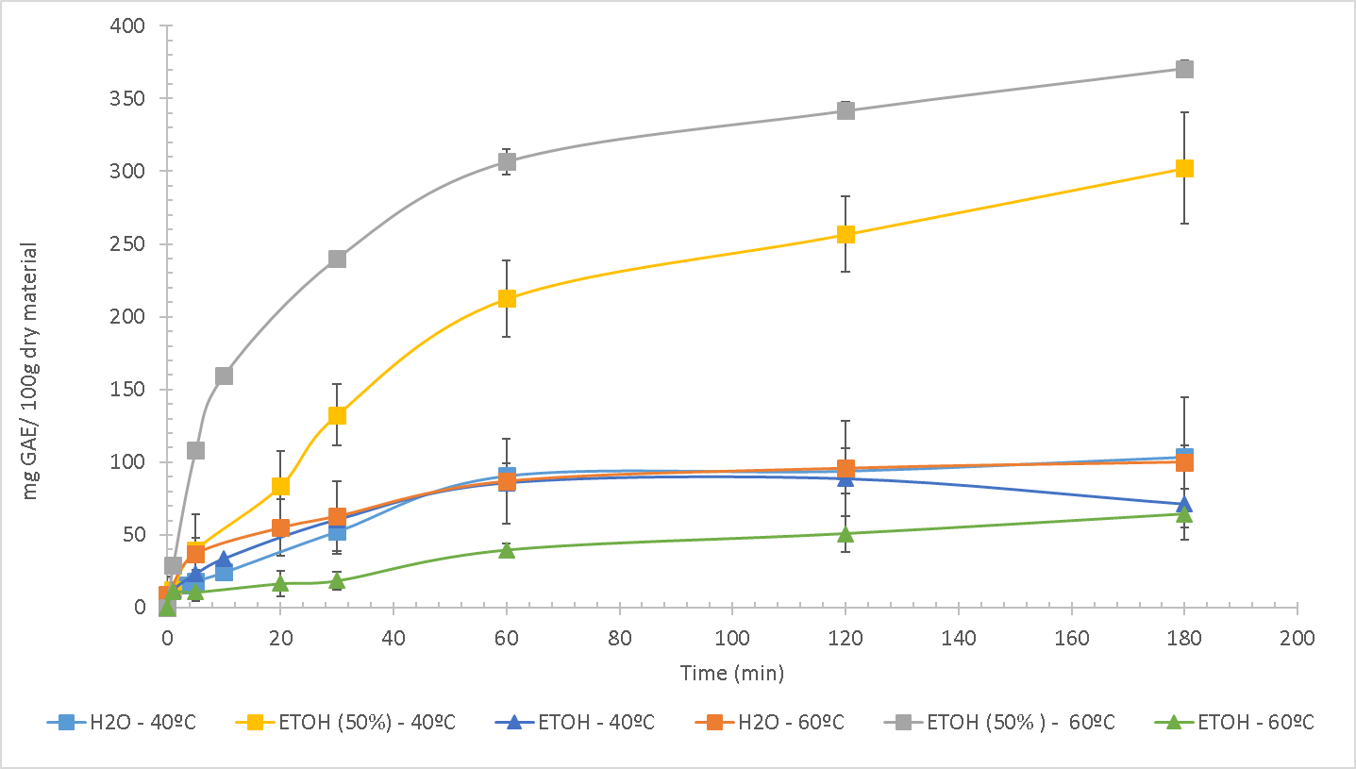
Figure 4. Extraction curve of slurry fraction at 40° and 60°C, using ethanol, water and ethanol/water (1:1) as the solvents.
The second step of the experimental plan starts from the best conditions found for the extraction process by maceration. The goal of this second step was to increase the TPC value applying the MAE and PMAE pre-treatment as intensification process. Figure 5 shows the results of the extraction experiments at 60◦C, using ethanol/water (1:1 v/v) with and without microwave pre-treatments. Extraction curves demonstrate that extract was enriched in terms of TPC value when MAE was applied. For an extraction time of 5 min, a value of 258 mg GAE/100 g_{DM} was achieved when MAE was used, while this value was 108 mg GAE/100 g_{DM} when no pre-treatment was applied. In PMAE two different pressures were studied: 1.5 bar and 3.0 bar. The TPC value increased to 424 mg GAE/100 g_{DM} and 479 mg GAE/100 g_{DM} at these two pressures, respectively, showing significant influence of applied pressure compared to conventional extraction when pressure was increased to 1.5 bar, while the pressure increment from 1.5 to 3 bar had a smaller influence. Although the pre-treatment process could improve the extraction of TPC from the slurry, this value still remained significantly lower compared to the value achieved in seed extracts. Similarly, treating the seed fraction by microwave energy increased the extracted TPC (Figure 6). The material treated by MAE had TPC value of 5.40 g GAE/100 g_{DM}, while by PMAE value was increased to 8.33 g GAE/100 g_{DM}. In both cases, considering the same extraction time, the extraction of polyphenols was more efficient when the microwave pre-treatment was applied, compared to conventional maceration (3.87g GAE/100 g_{DM}). To carry out this study it was necessary to remove the oil presented in the seeds fraction, as oil presence was an obstacle to the benefits promoted by the MAE pretreatment. In contrast, the oil presence had no significant influence on the conventional maceration when the same solvent was used.
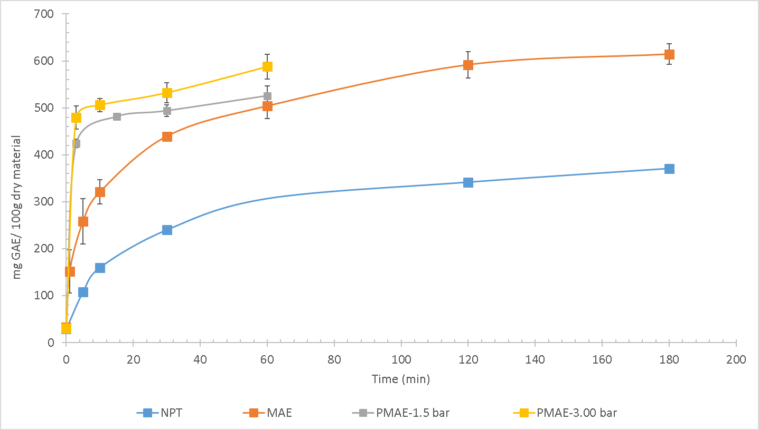
Figure 5. Extraction curve of slurry fraction with microwave pre-treatments using ethanol/water (1:1) as the solvent at 60◦C.

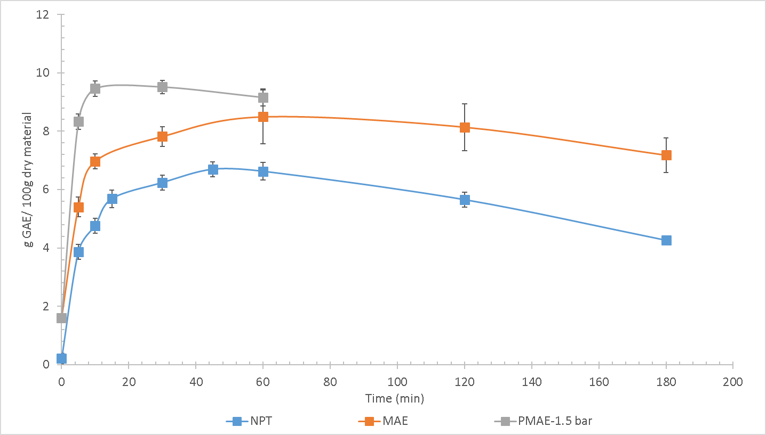
Figure 6. Extraction curve of seeds fraction with microwave pre-treatments using ethanol/water (1:1) as the solvent at 60◦C.
The polyphenols extraction was performed from the residual, non-edible pulp fraction using the optimum conditions obtained in the previous study (60◦C, water/ethanol (1:1 v/v)). The same tendency was followed (Figure 7), as the results show that conventional maceration reached the TPC value of 3.94 g GAE/100 g_{DM}, which was increased to 5.82 g GAE/100 g_{DM} when MAE was applied. In both cases, the maximum TPC was achieved after 15 min of extraction. Increasing temperature improved the polyphenol extraction. In this sense, PMAE allows to achieve higher temperature, being more efficient than the use of MAE: using PMAE pre-treatment, the TPC values were 8.83 g GAE/100 g_{DM} and 12.31 g GAE/100 g_{DM}, for pressures of 1.5 and 3.0 bar, respectively.
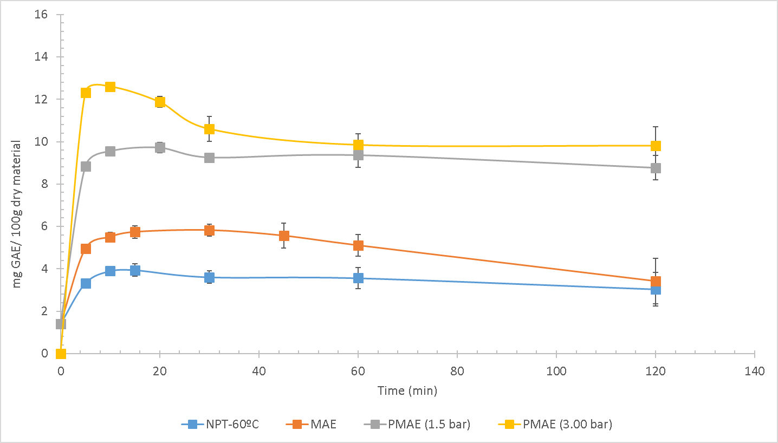
Figure 7. Extraction curve of pulp fraction with microwave pre-treatments using ethanol/water (1:1) as the solvent at 60◦C.

Although the best results for polyphenol extraction were found at a temperature of 60°C, high temperatures promote the rapid degradation of the extracted anthocyanin. The extraction of anthocyanin by conventional method would be more advantageous if carried out at temperatures below 40°C. A possibility to prevent degradation of the anthocyanin is to shorten the extraction time, since after the pretreatment the anthocyanin value was close to the highest value. Total anthocyanin content was maximum when the PMAE (1.5 bar) was used, being 1115.8 mg AE/100 g_{DM}. However, the increase in pressure to 3 bar and consequently increase in temperature produced decreased the total anthocyanin content to 221.4 8 mg AE/100 g_{DM}.
In summary, results showed that the temperature was an important parameter on the extraction process of bioactive compounds from açaí by-product, in its three fractions (slurry, seeds and not-edible pulp). However, the control of temperature was essential to avoid the early degradation of phytochemicals presented in the extract. The microwave pre-treatment favored the extraction process, promoting a fast temperature rise in a short period of time.
ORAC was used to measure the antioxidant capacity of extracts and its enhancement after the different pre-treatments applied. At Figure 8 the pertinent results related to the antioxidant activity of the extracts are summarized. The microwave pretreatment of açaí by-products (pulp, seeds, and, slurry) generated a positive effect on the antioxidant activity of extracts. Appling PMAE (1.5 bar), the extract obtained from pulp had an ORAC value of 176170 μmol TE/100 g_{DM}, and therefore the antioxidant activity was 1.8 times higher than the value obtained through the conventional process, which was 96594 μmol TE/100 g_{DM}. The ORAC value found by conventional maceration extraction is close to the data provided by the ORAC Database of U.S. Department of Agriculture for pulp and skin: 99700 μmol TE/100 g_{DM}. The antioxidant activity of seeds extracts was similar to those observed in pulp extracts, 182456μmol TE/100 g_{DM}. Based on these results, both extracts obtained from this byproduct have potential as antioxidant additive with possible applications in cosmetic and alimentary industries. The antioxidant activity of slurry extract showed a significant improvement through the microwave pre-treatment. The ORAC value was increased from 9550 μmol TE/100 g_{DM} (no pre-treated – NPT) to 10480 μmol TE/100 g_{DM} applying MAE, and the value increased to 12088 μmol TE/100 g_{DM} when PMAE (1.5bar) was applied. Although the antioxidant activity found for the slurry extract had a value that is comparable to other fruits such as Goji Berry (3170 μmol TE/100 g), this fraction of the açaí by-product can be considered less relevant for valorization processes and less applicable to industries due to its lower antioxidant activity compared to the seed and pulp fractions.

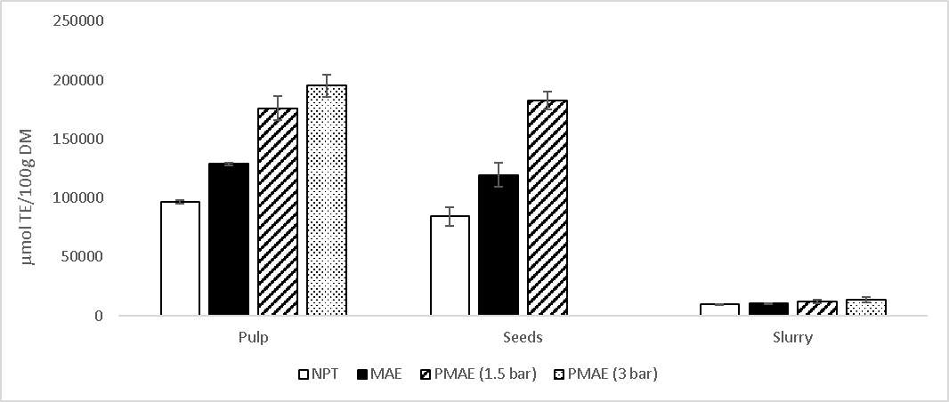
Figure 8. Antioxidant activity (ORAC) of extracts.

4. Conclusions
The main residual by-products of the industrial processing of açai were characterized. In terms of extractive compounds, the pulp fraction showed a high potential as oil source, with contents up to 43% on dry mass. On pulp oil, fatty acids were present such as oleic acid (58.5%), linoleic acid (22.3%), palmitic acid (11.4%) and stearic acid (4.1%). Pulp and seeds had considerable amounts of water-soluble extractives, 23% and 13%, respectively. Moreover, these extracts presented important amounts of total polyphenols and flavonoids, with a high value of ORAC activity. Although the slurry presented lower amounts of total extractives, polyphenols and flavonoids in comparison to the other fractions, the water-soluble slurry extract presented a certain antioxidant activity. Values were lower than expected, which was attributed to previous process applied at the industry.
Cellulose, hemicellulose and lignin are the main components of the slurry fraction, with contents of 18%, 20%, and, 36%, respectively. On seeds, the main component found was hemicellulose, with contents up to 48%. This residual fraction could be proposed as feedstock of these components on lignocellulosic biorefinery by hydrolysis of oligomers in small sugar-fractions.
Microwave Assisted Extraction (MAE) and pressurized MAE (PMAE) were successfully applied as pre-treatment for extraction from slurry, seeds and pulp residual fractions. The study revealed that the extraction with an ethanol/water mixture (1:1 v/v) was more advantageous than the extraction with pure solvents. TPC values were higher when the temperature of extraction was 60◦C, compared to 40◦C.
When pretreatment was applied, MAE enabled to achieve higher concentrations of polyphenols during the extraction. After 30 minutes of extraction, the TPC values found for the slurry fraction increased from 370 mg GAE/100 g_{DM} to 614 mg GAE/100 g_{DM}, and this pattern was also observed for the pulp fraction, increasing from 3.61 g GAE/100 g_{DM} to 5.82 g GAE/100 g_{DM}, and for the seed fraction, increasing from 6.24 g GAE/100 g_{DM} to 7.82 g GAE/100 g_{DM}. The PMAE technique permitted to apply higher temperatures without solvent evaporation, reaching even higher TPC values. After PMAE (1.5 bar, 300W) was applied, the maximum of TPC value was 424 mg GAE/100 g_{DM} for extraction from slurry, and, 8.33 g GAE/100 g_{DM} and 8.83 g GAE/100 g_{DM} from seeds and pulp fractions, respectively.
The antioxidant activity of extracts obtained from slurry, pulp and seeds was also improved when microwave pre-treatment (MAE and PMAE) was applied, being higher by the use of PMAE as pre-treatment. Applying PMAE, the antioxidant activity of pulp and seed extracts was approximate two times higher than the value obtained by the conventional process, reaching ORAC values of 176170 μmol TE/100 g_{DM} and 182456 μmol TE/100 g_{DM}, respectively. Therefore, extracts obtained from seed and pulp residues have potential as antioxidant additives, and could have possible applications in cosmetic and alimentary industries.

Acknowledgments: The author Rafaella T. Buratto is grateful to ‘‘Conselho Nacional de Desenvolvimento Científico e Tecnológico – CNPq”, Brazil (200737/2015-5) for providing her doctoral scholarship. Authors acknowledge the financial support from CTQ2016-79777-R project of the Spanish Ministry of Economy.

References
- Barbosa, P.A.L. (1951). Pequeno Vocabulario Tupi-Protuguês, 1st ed. Livraria São José, Rio de Janeiro.
- Lorenzi, H., Noblick, L., Kahn, F., Ferreira, E.. Flora Brasileira: Arecaceae (Palmeiras). Inst. Plantarum, Nov. Odessa (2010) 211–212.
- Oliveira, M., De Carvalho, J.E.U., Do Nascimentio, W.M.O., Muller, C.H. (2002). Cultivo do açaizeiro para produção de frutos. Embrapa Amaz. Orient. Circ. técnica.
- Altman, R.F.A. (1956). O caroço de açaí. Instituto agrônomico Norte, Belém, Pará.
- Teixeira, M. A., Escobar Palacio, J. C., Sotomonte, C. R., Silva Lora, E. E., Venturini, O. J., Abmann, D. Assaí- an energy view on an Amazon residue. Biomass and Bioenergy 58 (2013) 76-86. https://doi.org/10.1016/j.biombioe.203.08.007
- Itai, Y., Santos, R., Branquinho, M., Malico, I., Ghesti, G. F., Brasil, A. M. Numerical and experimental assessment of a downdraft gasifier for electric power in Amazon using açaí seed (Eutrepe oleácea Mart.) as a fuel. Renewable Energy 66 (2014) 662-669. https://doi.org/10.1016/j.renene.2014.01.007
- Nagata, G. A., Souto, B. A., Perazzini, M. T. B, Perazzini, H. Analysis of the isothermal condition of acai berri residues for biomass applications. Biomass and Bioenergy 132 (2020) Article number 105453. https://doi.org/10.1016/j.biombioe.2019.105453
- De Lima, A. C. P., Bastos, D. L. R., Camarena, M. A., Bon, E. P. S., Cammarota, M. C., Teixeira, R. S. S., Gutarra, M. L. E. Physicochemical characterization of residual biomass (seed and fiber) from açaí (Euterpe olracea) processing and assessment of the potential for energy production and bioproducts. Biomass Conversion and Biorefinery, (2019). https://doi.org/10.1007/s13399-019-00551-w
- Sato, M. K., de Lima, H. V., Costa, A. N., Rodrigues, S., Pedroso, A. J. S., de Freitas Maia, C. M. B. Biochar from Acai agroindustrial waste: study of the pyrolysis conditions. Waste Management 96 (2019) 158-167. https://doi.org/10.1016/j.wasman.2019.07.022
- Rogez, H., 2000. Açaí: Preparo, Composição e Melhoramento da Conservação, Belém, Brazil: EDUFPA.
- Rodrigues, R.B., Lichtenthäler, R., Zimmermann, B.F., Papagiannopoulos, M., Fabricius, H., Marx, F., Maia, J.G.S., Almeida, O. Total oxidant scavenging capacity of Euterpe oleracea Mart. (açaí) seeds and identification of their polyphenolic compounds. J. Agric. Food Chem. 54 (2006) 4162–4167. https://doi.org/10.1021/jf058169p
- Fahy, E., Cotter, D., Sud, M., Subramaniam, S. Lipid classification, structures and tools. Biochim. Biophys. Acta 1811 (2011) 637–47. https://doi.org/10.1016/j.bbalip.2011.06.009
- Lubrano, C., Robin, J.R., Khaiat, A. Fatty acid, sterol and tocopherol composition of oil from the fruit mesocarp of six palm species in French Guiana. Oléagineux 49 (1994) 59–65.
- Mantovani, I.S.B., Fernandes, S.B.O., Menezes, F.S. Constituintes apolares do fruto do açaí (Euterpe oleracea M. - Arecaceae). Rev. Bras. Farmacogn. 13 (2003) 41–42. https://doi.org/10.1590/S0102-695X2003000300016
- Pacheco-Palencia, L. A., Mertens-Talcott, S:, Talcott, S. T. Chemical Composition, Antioxidant Properties, and Thermal Stability of a Phytochemical Enriched Oil from Ac¸ ai (Euterpe oleracea Mart.) J. Agric. Food Chem., 56 (2008) 4631–4636
- Plotkin, M.J., Balick, M.J. Medicinal uses of South American palms. J. Ethnopharmacol. 10 (1984) 157–179. https://doi.org/10.1016/0378-8741(84)90001-1
- Kang, J., Li, Z., Wu, T., Jensen, G.S., Schauss, A.G., Wu, X. Anti-oxidant capacities of flavonoid compounds isolated from acai pulp (Euterpe oleracea Mart.). Food Chem. 122 (2010) 610–617. https://doi.org/10.1016/j.foodchem.2010.03.020
- Heinrich, M., Dhanji, T., Casselman, I. Acai (Euterpe oleracea Mart.) - A phytochemical and pharmacological assessment of the species’ health claims. Phytochem. Lett. 4 (2011) 10–21. https://doi.org/10.1016/j.phytol.2010.11.005
- Garcia-Perez, J. V., García-Alvarado, M. A., Carcel J. A., Mulet, A. Extraction kinetics modeling of antioxidants from grape stalk (Vitis vinifera var. Bobal): Influence of drying conditions, J. Food Eng. 101 (2010) 49–58.
- Vinatoru, M., Mason, T.J., Calinescu, I. Ultrasonically assisted extraction (UAE) and microwave assisted extraction (MAE) of functional compounds from plant materials, rAC Trends Anal. Chem. 97 (2017) 159–178.
- Sólyom, K., Kraus, S., Mato, R. B., Gaukel, V., Schuchmann, H. P., Cocero, M. J. Dielectric properties of grape marc: Effect of temperature, moisture content and sample preparation method, J. Food Eng. 119 (2013) 33–39.
- Sluiter, A., Hames, B., Ruiz, R., Scarlata, C., Sluiter, J., Templeton, D., Crocker, D. (2008). Determination of Structural Carbohydrates and lignin in biomass, (LAP) NREL/TP-510-42618.
- Hames, B., Scarlata, C., Sluiter, A. (2008). Determination of Protein Content in biomass, (LAP) NREL/TP-510-42625.
- Sluiter, A., Hames, B., Ruiz, R., Scarlata, C., Sluiter, J., Templeton, D. (2005). Determination of Ash in Biomass, (LAP) NREL/TP-510-42622.
- Fernández-Moya, V., Martínez-Force, E., Garcés, R. Identification of Triacylglycerol Species from High-Saturated Sunflower (Helianthus annuus) Mutants. J. Agric. Food Chem. 48 (2000) 764–769.
- Carelli, A.A., Cert, A. Comparative study of the determination of triacylglycerol in vegetable oils using chromatographic techniques. J. Chromatogr. A 630 (1993) 213–222. https://doi.org/10.1016/0021-9673(93)80458-K
- Singleton, V.L., Orthofer, R., Lamuela-Raventós, R.M. Analysis of total phenols and other oxidation substrates and antioxidants by means of folin-ciocalteu reagent. Methods Enzymol. 299 (1999) 152–178. https://doi.org/10.1016/S0076-6879(99)99017-1
- AOAC Official Method, 2005. Total Monomeric Anthocyanin Pigment Content of Fruit Juices, Beverages, Natural Colorants, and Wines, in: AOAC International, 37.1.68.
- Michalska, A., Ceglińska, A., Zieliński, H. Bioactive compounds in rye flours with different extraction rates. Eur. Food Res. Technol. 225 (2007) 545–551. https://doi.org/10.1007/s00217-006-0452-4
- Ganske, F., 2006. ORAC Assay on the FLUOstar OPTIMA to Determine Antioxidant Capacity. Offenburg, Germany.
- Ou, B., Hampsch-Woodill, M., Prior, R.L. Development and validation of an improved oxygen radical absorbance capacity assay using fluorescein as the fluorescent probe. J. Agric. Food Chem. 49 (2001) 4619–4626. https://doi.org/10.1021/jf010586o
- Zhu Ryberg, Y., Edlund, U., Albertsson, A.C. Innovative approaches for converting a wood hydrolysate to high-quality barrier coatings. ACS Appl. Mater. Interfaces 5 (2013) 7748–7757. https://doi.org/10.1021/am401102h
- Mikkonen, K.S., Heikkinen, S., Soovre, A., Peura, M., Serimaa, R., Talja, R.A., Helén, H., Hyvönen, L., Tenkanen, M. Films from oat spelt arabinoxylan plasticized with glycerol and sorbitol. J. Appl. Polym. Sci. 114 (2009) 457–466. https://doi.org/10.1002/app.30513
- Cantero, D.A., Martínez, C., Bermejo, M.D., Cocero, M.J. Simultaneous and selective recovery of cellulose and hemicellulose fractions from wheat bran by supercritical water hydrolysis. Green Chem. 17 (2015) 610618. https://doi.org/10.1039/c4gc01359j
- Cocero, M.J., Cabeza, Á., Abad, N., Adamovic, T., Vaquerizo, L., Martínez, C.M., Pazo-Cepeda, M.V. Understanding biomass fractionation in subcritical & supercritical water. J. Supercrit. Fluids 133 (2018) 550–565. https://doi.org/10.1016/j.supflu.2017.08.012
- Seye, O., Souza, R.C.R., Bacellar, A.A., Morais, M.R. (2008). Caracterização do Caroço de Açaí Como Insumo Parageração de Eletricidade Via Gaseificação. 7 Congresso Internacional sobre Geração distribuída e Energia no meio Rural, Fortaleza, Brasil.
- Boskou, D., Blekas, G., Tsimidou, M. (2006). Olive Oil, Chemistry and Technology, in: Olive Oil ; Chemistry and Technology. 2 Nd Edition. pp. 41–43. https://doi.org/10.1016/B978-1-893997-88-2.50008-0
- Perez, M.M., Spiropulos Goncalves, E.C., Santos Salgado, J.C., Rocha, M. de S., de Almeida, P.Z., Vici, A.C., Infante, J. da C., Manuel Guisan, J., Rocha-Martin, J., Costa Pessela, B., Teixeira de Moraes Polizeli, M. de L. Production of Omegas-6 and 9 from the Hydrolysis of Acai and Buriti Oils by Lipase Immobilized on a Hydrophobic Support. Molecules 23 (2018) 3015. https://doi.org/10.3390/molecules23113015
- Iaderoza, M., Baldini, V.L.S., Draetta, I.D.S., Bovi, M.L.A. Anthocyanins from fruits of acai (Euterpe oleraceae Mart.) and jucara (Euterpe edulis Mart.). 32 (1992) 41–46.
- Schauss, A.G., Wu, X., Prior, R.L., Ou, B., Patel, D., Huang, D., Kababick, J.P. Phytochemical and nutrient composition of the freeze-dried amazonian palm berry, Euterpe oleraceae Mart. (Acai). J. Agric. Food Chem. 54 (2006) 8598–8603. https://doi.org/10.1021/jf060976g

