CO₂-Rich and CO₂-Lean streams as activators of reducing metals for the green hydrogen GENERATION AND THE catalytic production of FORMATE.

Juan I. del Río ^{a,b}, Miguel Almarza ª, Ángel Martín ^{a*}, María D. Bermejo ^{a,}

ª BioEcoUva, Bioeconomy research institute, PressTech Group, Department of Chemical Engineering and Environmental technology, Universidad de Valladolid, Prado de la Magdalena s/n, 47011 Valladolid, Spain

^{b} Grupo Procesos Químicos Industriales, Department of Chemical Engineering, Universidad de Antioquia UdeA, Calle 70 No. 52-21, Medellín 050010, Colombia

*Corresponding author Tel.: +34 983 18 40 77
E-mail address: angel.martin.martinez@uva.es (Ángel Martín)
Graphical abstract

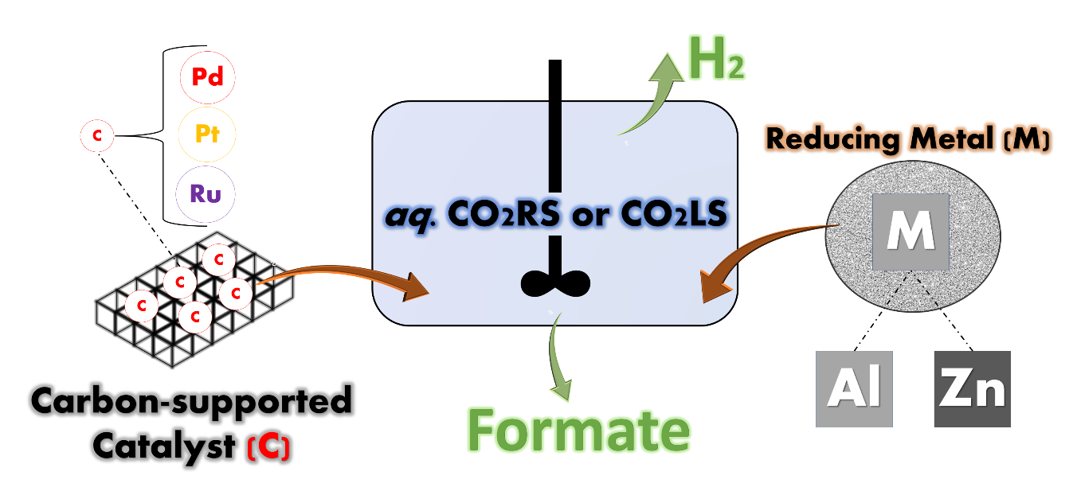

Highlights

- CO2RS and CO2LS can be utilized as activators of the metal-water splitting.
- The aluminum and Pd5AC system produced the highest formate yield.
- Only Pd5AC catalyst showed formation of active hydride specie.
- Pd5AC presented higher metallic dispersion and lower deactivation by oxidation.
- Aluminum produced faster H₂ generation rates than zinc in both CO2RS and CO2LS.

Abstract
The ongoing pursuit of carbon mitigation and utilization encourages the study of common and more abundant materials, capable of facilitating the technical readiness of the processes involved. In this context, the present work aims at evaluating the CO₂-rich and CO₂-lean streams from the basic aqueous absorption CO₂ capture processes, for the in-situ generation of green hydrogen through the metal-water splitting technology, to convert captured CO₂ into formate. Experiments have been carried out using aluminum and zinc as reducing agents, and the commercial catalysts palladium, platinum and ruthenium supported on activated carbon, using a batch stirred reactor. Aluminum and Pd5AC constituted the best metal/catalyst system, with a formate yield of 22%, selectivity of 32%, and conversion of 67%. The H₂-TPR characterization of the catalysts, before and after reaction, showed that only Pd5AC catalyst shows insights of active hydride specie, responsible for the reduction of captured CO₂. The in-situ hydrogen evolution was studied during prolonged 10 h experiments, in absence of catalyst, to compare the performance of the proposed basic streams and reducing metals, generating high reliability data in search for feasibility and future integration of CO₂ and H₂ economies.

Keywords: Catalysts assessment, CO₂ utilization, hydrogen evolution, formic acid production, metal-water splitting

- Introduction
Current changes in worldwide economic scenario are challenging the achievement of the past-decades objectives of cutting the CO₂ emissions and reducing oil and natural gas dependency. The increase of demand of fossil fuels in 2040 can increase up to 30% [1], and the necessity of mitigating the subsequent CO₂ emissions is still on the table. In this context, one of the most successful carbon capture and storage (CCS) technologies is the absorption of CO₂ with aqueous solutions of ammonia (generally any basic dissolution used for CO₂ capture is known as CO₂ Capture-Solvent Lean stream, CO2LS, in absorber/stripper columns, yielding a CO₂-Rich stream, CO2RS) containing an equilibria of ammonia bicarbonate, carbonate and carbamate [2][3]. Once captured, CO₂ can be stored for example in depleted oil and gas fields, or in deep saline aquifer formations and in deep coal seams that cannot be mined anymore and are widely distributed around the world in sedimentary basins, usually several kilometers below the earth's surface [3]. To store CO₂, it must be transported from the production site to the place of storage or use. CO₂ is transported via gas pipelines, ships or trains, depending on how economical the means of transport are [4].

In addition to capturing and storing CO₂, there are different CO₂ utilization approaches, framed in the so-called CO₂-Economy. In the first place, CO₂ can be used directly without no chemical conversion in applications such as refrigerant (supercritical state), in food and beverages, as fire extinguisher, in concrete materials, in oil wells, pharmaceuticals, as a solvent or antisolvent, etc [5]. In the second place, its indirect utilization implies the chemical transformation into other compounds, such as useful chemicals and fuels [6][7][8]. CO₂-derived fuels with high energy density are gaining more attention as energy vectors for fulfilling the energy storage demands [9], where formic acid (FA), methane and methanol are prominent [10][11][12].

Hydrothermal catalytic reduction of captured CO₂ using reducing metals is one of the methods to obtain formic acid that remains on the research focus [13][14]. The method starts with the in-situ generation of H₂, by metal-water splitting, with the subsequent reduction of CO₂ in presence of catalyst, following the overall reaction pathway:
M⁰+H₂O→M_{x}O_{y}+H₂+CO₂→HCOOH (1)[13]

where M⁰ is a reducing metal (e.g. aluminum and zinc). In our most recent work, the endeavors laid the implementation of milder reactions conditions for ammonia-based CO₂ absorption derivatives, while contrasting its performance toward more common substrates like sodium bicarbonate, using commercial Pd 5 wt% over activated carbon catalyst [15]. Likewise, catalytic metals like ruthenium displayed high efficiency in reducing CO₂ to formate when supported on alumina or activated carbon, using sodium bicarbonate as a source of CO₂, at 80°C, 5 MPa of H₂ and a reaction time of one hour [16]. This study concluded that the optimum ruthenium content is 2% because higher ruthenium percentages reduce its Turnover Number (TON). González et al. [17] compared the performance of activated carbon-supported catalysts, loaded with 5 wt% of metals Pd, Ru, Ni, Co and Re, on the reduction of sodium bicarbonate to formate in a semi-continuous flow reactor, at 25 °C and 0.1 MPa of hydrogen. The catalytic activity decreased in the order Pd/C > Ru/C > Ni/C > Re/C ≈ Co/C, reaching a marginal formate molar yield (carbon-based) up to ~3.7% after 72 h, with Pd/C. Not many antecedents are available for Pt based catalyst in the reduction of captured CO₂ with reducing metals, though abundant reports are available for electrochemical and photocatalytical conversion of CO₂ [18][19][20][21]. However, the reduction of captured CO₂ by Pt based catalyst into formate has been proved with glycerol as reducing agent [22]. Based on the review by Gunasekar et al. [23], compared to other possible catalytic supports, such as BaSO₄, CaCO₃ and γ-Al₂O₃, the activated carbon exhibited better catalytic performance, thanks to its hydrophobic nature that allows accumulation of H₂ on the support’s surface.

Other advances have been recently accomplished with homogeneous catalysts containing Ru, Rh or Ir [24][25], displaying high selectivity and yield to formate, even at mild conditions, but still dealing with several drawbacks when facing industrial scale up, concerning the separation and recyclability of these catalysts [26].

On the other hand, metals used as reductants for CO₂ hydrogenation are of great interest to be utilized as in-situ reducing agents, generating molecular hydrogen by the metal water-splitting reaction, that is favored under alkaline conditions [27]. In this matter, aluminum and zinc are beneficial to this process because they are two of the most abundant metals, with high availability in the market, and can be also found as residues at a low cost. The byproducts generated from water-splitting reaction are hydroxides and metal oxides, which for the case of Al and Zn are of great interest in catalysis industry and water treatment. For aluminum, the main subproduct is aluminum hydroxide (boehmite), which is a precursor for production of alumina [28], a well-known material as support in catalysis; and zinc hydroxide is used as a precursor for the preparation of zinc hydroxy stannate materials as catalyst for photodegradation of harmful organic dye [29]. Al and Zn hydroxides/oxides provide excellent adsorption capacities of phosphate from wastewater, due to their excellent adsorption capacities, good reaction kinetics and selectivity [30]. However, on the light of a circular-economy and zero-emissions practice, in the field of CO₂ hydrogenation it would make more sense to reduce these oxidated byproducts back to the zero-valent metals for reutilization, in a process driven by solar power [31]. In this process, the hydrogen produced from water can be categorized as green, if using renewable energy sources in the process without carbon emissions [32].

It is clear that the reduction of captured CO₂ as bicarbonate using reducing metals like Mn, Al and Zn, have shown effectiveness, displaying yields up to 81% and 2 h [10][33]. Despite these works, not much literature is available about the comparison of different supported metal catalysts, reducing metals and CO2RS/CO2LS streams on the simultaneous reduction of captured CO₂ from the ammonia-based process and hydrogen generation from metal-water splitting reaction.

The present study aims at two main objectives: i) studying the generation of hydrogen with different metal/catalyst systems and CO2RS/CO2LS, by means of a hydrogen evolution analysis during prolonged experiments (10 hours), in absence of catalyst, and ii) ii) evaluating different commercial catalysts in the reduction of captured CO₂ by an energy-efficient technology like the aqueous ammonia absorption, where the hydrogen needed is generated by a metal-water splitting reaction in-situ, forming the metal/catalyst system. These studies are important because they allow screening different catalysts for the reduction process, while understanding the influence of the reaction media on the hydrogen generation. Also, they allow determining the most active catalyst and metals for CO₂ reduction and H₂ generation in situ, a broadened study compared to previous publications using only one catalyst and reducing metal [15]. These results will feed potential integrations of carbon capture processes and the green hydrogen production in the frame CO₂ and hydrogen economies.

- Materials and methods

2.1 Chemicals
As CO₂-Rich streams (CO2RS), ammonium carbamate (AC) (99%) and sodium bicarbonate (SB) (100%) diluted in water MilliQ were used at 0.5 mol/L. As CO₂-Lean stream (CO2LS), an aqueous solution of ammonia at 0.5 mol/L was used. Fine powders of commercial Pd/C catalyst of 5 wt% (Pd5AC), Pt/C catalyst of 5 wt% (Pt5AC) and Ru/C catalyst of 5 wt% (Ru5AC) were used as received. The reducing metals used were aluminum powder (Al) (99.5%) and zinc powder (Zn) (99.5%). Activated charcoal RX3-Extra (Norit) was used for catalyst support blank experiments. All reagents, except aluminum powder (Goodfellow), sodium bicarbonate (COFARCAS-Spain), and ammonia (Panreac) were purchased from Sigma-Aldrich. Hydrogen (99.99%) was provided by Linde.

2.2 Experiments for hydrogen generation
In order to evaluate the effect of both CO2RS and CO2LS on the hydrogen generation, batch experiments were conducted in absence of catalyst for 10 h at 120 ºC, using 24 mmol of Al or Zn, in 0.5 mol/L aqueous solution of carbamate (initial pH=9.2), sodium bicarbonate (initial pH=10.1) (as CO2RS), or NH₃ (initial pH=11.5) (as CO2LS), using a Parr Instruments stainless steel reactor (25 mL Micro Stirred Reactors Series 4791, maximum pressure 20 MPa, maximum temperature 350 °C) with stirring at 700 rpm, autogenous pressure, and ramp heating of 14 °C/min, equipped with a band heater. Gas samples were taken in intervals of 2 h, using Tedlar® bags, to quantify the hydrogen concentration by GC-TCD. In these experiments, a reduced liquid filling volume percentage of 25% was employed to avoid draining out of liquid and solids when sampling the gas, due to the depressurization.

2.3 Experiments for catalysts assessment
The comparison of the different metals as hydrogen source from water, as well as the evaluation of the selected catalysts for the conversion of capture CO₂ were carried out in batch, using the same Parr reactor. Before each run, metals and catalysts were weighed, and physically mixed inside the batch reactor. Ammonium carbamate was weighed and diluted in water so that its initial concentration was 0.5 mol/L. Once the reactor was sealed, a gentle flow of nitrogen was passed through the headspace to purge the remaining air out of the system, followed by heating up, at 14 ºC/min, to a constant temperature of 120 °C. Once reached, reaction proceeded for 2 h. After the reaction, the vessel was quickly immersed in a water bath to cool it down to room temperature, followed by collection of liquid and gas samples for formate and hydrogen quantification. For the catalytic experiments, conditions were fixed to 6 moles of reducing metal per carbamate mole, 3.8 mmol of catalyst metal (for a comparison basis of metals Pd, Ru, Pt) per mole of carbamate, and 70% of the volume of the reactor filling at room temperature. Experiments with pure-hydrogen (2.5 MPa of 99.99% pure-hydrogen), instead of reducing metals (Al or Zn), were done under the same reaction conditions, to conduct reducibility analyses of the catalysts by H₂-TPR technique. Experiments were duplicated to establish experimental uncertainty.

2.4 Products characterization

2.4.1 Liquids
Once the reactor was cooled down, the liquid sample was collected and filtered through a 0.22 mm filter. For quantification of formic acid (FA), carbamate and sodium bicarbonate concentrations, the liquid samples were analyzed by HPLC (Waters, Alliance separation module e2695) using an RAZEXTM ROA-Organic Acid H+ column with RI detector (Waters, 2414 module). The mobile phase was 25 mM H₂SO₄ with a flow rate of 0.5 mL/min. The temperatures of the column and the detector were 40 °C and 30 °C, respectively.

The yield and selectivity of formic acid, as well as conversion of the carbamate were calculated as in equations 2 to 4. Turnover number (TON) is a useful parameter to evaluate and compare the performance of catalysts, defined as the number of substrate moles converted to target product by mol of surface active-metal in catalyst [34], and was calculated by equation 5:

$Y_{FA}=\frac{C_{FA,f}}{C_{cs,i}}x100$ (2)
$X_{CS}=\frac{C_{cs,f}-C_{cs,i}}{Ccs,i}x100$ (3)
$S_{FA}=\frac{Y_{FA}}{X_{CS}}x100$ (4)
$TON=\frac{C_{cs,i}*Y_{FA}}{ncatalyst_{metal}*D}x100$ (5)

Where $Y_{FA}$ is the yield of formic acid, $X_{CS}$ is the conversion of carbamate, S_{FA} is the selectivity of formic acid, C_{FA,f} is the final molar concentration of formic acid, C_{CS,i} is the initial molar concentration of carbon source, C_{CS,f} is the final molar concentration of carbon source, $ncatalyst_{metal}$ is the number of moles of active metal in catalyst per liter of reaction solution, and D is the metallic dispersion, determined as described below in the solids characterization section.

2.4.2 Solids
Particle size of reducing metals, before reaction, was measured with a Malvern Mastersizer 200 laser diffraction instrument, operated in dry mode using a Scirocco accessory. Transmission electron microscopy (TEM) was performed to determine particle size and distribution of nanoparticles in raw catalysts tested, by analyzing different TEM micrographs. For that, samples were suspended on a copper grid, and analyzed in a JEOL JEM-1011 HR equipment (JEOL, Tokyo, Japan) at 100kV.

The catalysts were also analyzed by hydrogen Temperature-Programmed Reduction (H₂-TPR), consisting of heating the samples up to 1000 ºC under a flow of H₂/Ar (10% v/v; 50 cm³/min) at a rate of 10 ºC/min, in a Autochem II 2920 Micromeritcs equipment. Hydrogen consumption was monitored by the thermal conductivity detector. Before the detector, an ice trap was used to retain any water formed during the reduction.

Metallic dispersion [35], for each active metal (Pd, Pt and Ru), was calculated by the relationship between particle size (dVA), the area per metal atom on the surface (am), the metal atomic volume (Vm) and the atomic radio (r) (equations 6-8):

$D=6\frac{Vm}{am*dVA}x100$ (6)
$am=πr^{2}$ (7)
$Vm=\frac{4π}{3}r^{2}$ (8)

The mean particle size (dVA) of the active metals in catalysts was determined using ImageJ 1.52a software, by measuring the length of 450-500 particles in 8-10 different TEM images, in a scale ranging between 20-1000 nm.

The solid byproducts of the reactions comprise the mixture of exhausted metal and catalyst, which could not be separated. They were characterized by X-ray diffraction (XRD). Before analysis, the samples were dried in an oven under vacuum overnight at 45 °C, to remove the remaining moisture. A BRUKER D8 DISCOVER A25 equipment was used, with 3 kW Generator, 2.2 kW type FFF Cu-ceramic tube, LynxEye Detector, operating at 40 kV and 30 mA. The database used for identifying the phases was the PDF-2 Released in 2013 (ICDD).

Textural properties analysis of the solids before reaction were conducted in an ASAP 2420 equipment with nitrogen adsorption at 77 K. All samples were degassed prior to each analysis. The surface area was determined by the BET method, and the pore size and volume by BJH method.

SEM micrographs observations were conducted over the solid byproduct after CO₂ reduction experiments, comprising a mixture of exhausted metal and catalyst, to determine the morphology and surface particle changes. For this, a Quanta 200FEG ESEM (Environmental Scanning Electron Microscope) equipment was used, operating at 20kV. Samples were coated with gold in a K575 sputter coater, and images were generated with a BSED detector.

2.4.3 Gases
The evolution of pressure in the reaction vessel was registered by a Picotech instrument-Technology ADC-20 & TERM, attached to a pressure transducer Desin TPR-20 (error ± 0.2 MPa). Given the low pressure (<2.15 MPa) of the reaction system, its behavior can be approximated to the ideal gas, and the use of ideal gases equation is adequate. With this information, the number of mol of hydrogen produced ($nH2$) was calculated using equations 9 and 10 :

$nH2=\frac{P_{s,f} * V_{s,f}}{R* T_{s,f} }*xH2$ (9)
$V_{s,f}=V_{s,t}-V_{s,l}$ (10)

Where, P_{s,f} is the final absolute pressure; T_{s,f} is room temperature; V_{s,f} is the final overhead volume; V_{s,t} is the total volume of the reaction system; V_{s,l} is the final volume of liquid collected; R is the ideal gas constant (83.14472 L*mbar*K⁻¹*mol⁻¹); xH2 is the fractional molar composition of hydrogen, measured by a GC-TCD Varian 4900 equipment, using Molsieve 5A-10m and Poraplot Q-10m columns. Then, the molar yield of hydrogen ($YH2)$ is calculated as shown in equation 11.

$YH2=\frac{nH2}{nM }$*100 (11)
Where, $nH2$is the number of mol of hydrogen produced and $nM$ is the number of mol of reducing metal used.

- RESULTS AND DISCUSSION

3.1 Hydrogen evolution analysis of Al and Zn under CO2RS and CO2LS
To understand the process’ overall reaction (reaction 1) that lead to producing formate under the aqueous streams, it is necessary first to study the performance of metals Al and Zn in terms of H₂ evolution. To do it, batch experiments were conducted during 10 h under CO₂-Rich stream (CO2RS) (aqueous AC and SB, 0.5 mol/L), and CO₂ Capture-Solvent Lean stream (CO2LS) (aqueous NH₃, 0.5 mol/L), in absence of catalyst. Fig. 1S depicts the pressure evolution in the reactor, where the peaks observed correspond to the depressurization caused by gas samplings every 2 h. In general, Al presented faster H₂ generation rates than Zn (Fig. 1), in consonance to the formate yield results as discussed before. A maximum of 52.2 mmol of H₂ was yielded with NH₃ in 10 h, followed by 22.7 mmol of H₂ with solvent SB and 17 mmol of H₂ with AC. Solvents NH₃ and SB have initial pH of 11.5 and 10.1, respectively, whereas for AC initial pH is 9.2, thus indicating that pH influences the hydrogen generation. From our previous work [15], a better result for SB was also observed compared to AC in the production of FA at a higher temperature of 250 ºC, thus indicating that Pd5AC and aluminum powder conformed a good catalytic system for the reduction of SB. From these observations, it can be concluded that SB responds better than AC to the increments of operation time and temperature toward FA and H₂ generation. Furthermore, as discussed in our last work [39], with the same particle size, reducing metals exhibit different values of standard reduction potential and electronegativity, where metals with low electronegativity and more negative reduction potential are more active toward water splitting. This is why Al is better than Zn for activating H₂ generation, thanks to its more negative value of standard reduction potential of -1.676, against -0.7618 for Zn.

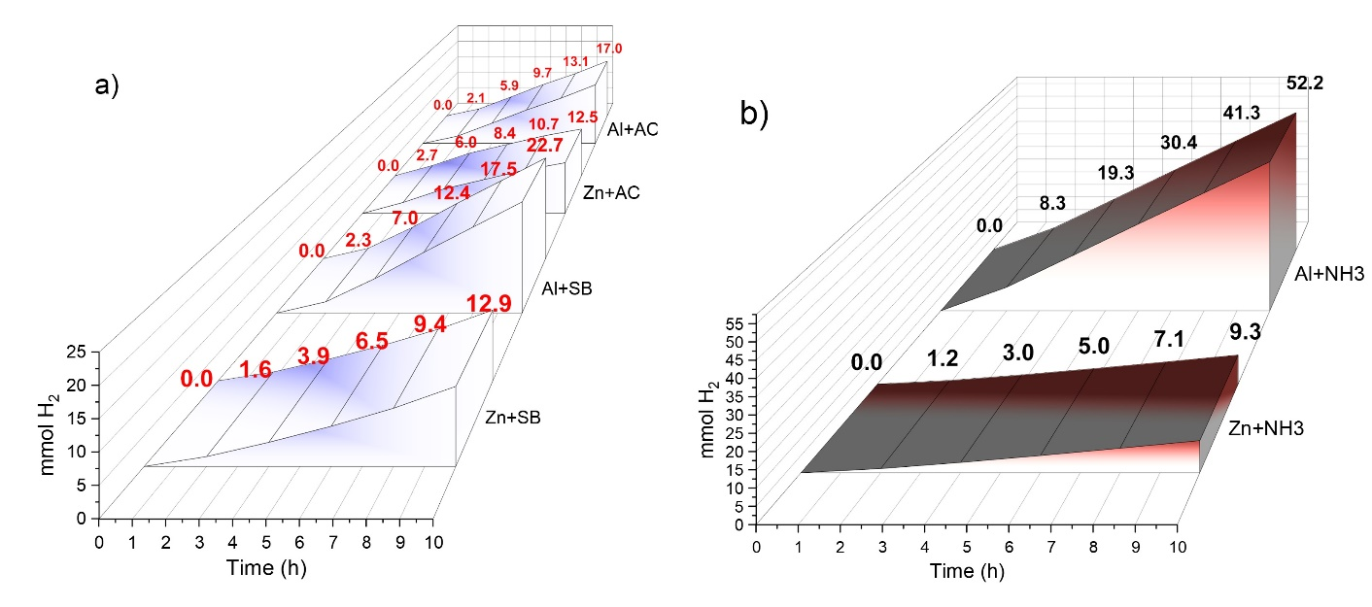
Fig. 1. H₂ evolution using Al and Zn during 10 hours experiments at 120 ºC, in absence of catalyst, under selected a) CO2RS (aqueous AC and SB) and b) CO2LS (aqueous NH₃).

3.2 Performance of selected metals and catalysts for the reduction of capture CO₂
Table 1 shows that measured particle size of Al and Zn fine powders are almost equal (18.9±0.6 µm and 19.6±2.1 µm, respectively), thus allowing discarding its possible influence on the hydrogen generation results, being known that hydrogen release is highly dependable of this parameter [36]. Fig. 2 plots the yield, conversion and selectivity of FA and final H₂ partial pressure in the reactor as a function of the catalyst and reducing metal type, at 120 ºC and 2 h. Catalyst Pd5AC showed the highest activity toward FA formation, up to 21.6 ± 3.2%, with a calculated TON=195, when using Al as reductant, and a negligible yield of 0.33± 0.05% with Zn (TON=2.98), associated to a lower final H₂ partial pressure. Also, as aforementioned, Zn has a less negative standard reduction potential, hence a lower availability of H₂, affecting the FA yield even with active catalyst Pd5AC. The resulting yield of the system Al/Pd5AC is comparable to our previous publication (i.e. 21.1±1.9%) [15], under the same conditions of 120 ºC, 2 h, Al:AC molar ratio of 6 and 70% volume filling. Catalyst Ru5AC showed a marginal FA yield, only when using Al as reductant, of 1,95% (TON=18.8), associated to a lower surface area (844.39 m²/g), lower metallic dispersion and larger particle size, as will be discuss later. This allowed concluding that Pd5AC catalyst presents an overall better performance than Ru5AC, in accordance to E. González et al. [17]. For its part, Pt5AC catalyst showed inactivity toward FA formation with both metals, and this could be attributed to its higher activity toward the decomposition of formate into H₂ and CO₂ [37]. Comparing with literature results, Su et al conducted similar experiments with carbamate in ethanol, but under high pressure (2.75 MPa) of hydrogen during 1 h reaction in anhydrous ethanol at 20 ºC, where Ru and Pt 5% over AC were nearly inactive, and Pd5AC was the catalyst with the best performance [38]. Likewise, for a similar TON=162 (FA yield of 17.6%) Su et al used high pressure of hydrogen (2.75 MPa) and ethanol 30%. The benefits were the decrease in temperature (20 ºC) and time (1 h). This means that intake of ethanol, which adds an extra cost, can be compensated by a cheaper reductant like aluminum, preferably from residues for economic feasibility, and mild temperature reaction, with the possibility of in-situ generating green hydrogen.
Table 1. Textural properties of solids before reaction
Sample | Surface area (m²/g) | Pore volume (cm³/g) | Pore size (Å) | Particle size – d90 (µm)
Pd5AC | 948.96 | 0.44 | 55.05 | -
Pt5AC | 1490.63 | 0.81 | 58.74 | -
Ru5AC | 844.39 | 0.36 | 57.05 | -
Al fine-powder | 0.04 | 0 | 29.49** | 18.87±0.6*
Zn fine-powder | 0.24 | 0 | 77.1*** | 19.61±2.1*
* d90 percentile (Mastersizer)
** by DFT (Density Functional Theory)
*** by BET
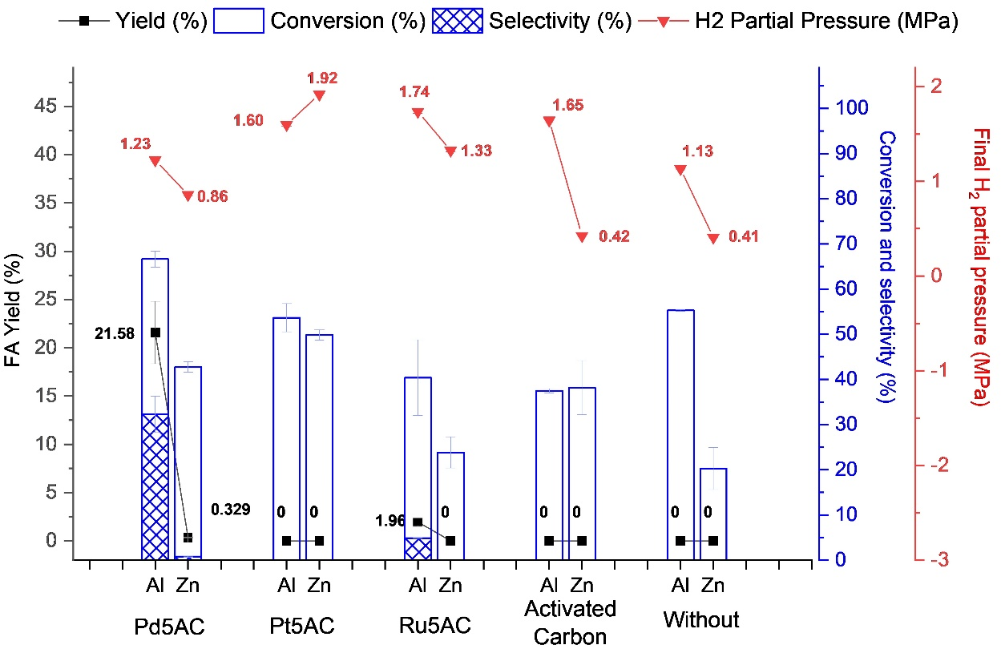
Fig. 2. Catalytic performance of different metal/catalyst systems in terms of FA yield and selectivity, AC conversion and final H₂ partial pressure. Reaction conditions: 2 h, metal:carbamate molar ratio of 6, catalyst metal:carbamate molar ratio of 3.8 mmol, 70% of filling and 0.5 M of initial concentration.

3.3 Effect of type of catalyst in the H₂ yield.
For most of the catalysts, Al produced higher H₂ final partial pressure than Zn, up to 1.74 MPa (with Ru5AC). The difference is more appreciable in control experiments with activated carbon and without catalyst (up to 1.65 MPa with Al and 0.42 MPa with Zn) (see Fig. 2). Likewise, Fig. 3 presents the comparison of FA and hydrogen yield for all metal/catalyst combinations, where, accordingly to the pressure, Al produced a higher H₂ yield (10.6%) than Zn (8.64%), with the most active catalyst Pd5AC. The H₂ yield (4.4%) from experiments without catalyst, being non-zero, suggests that carbonaceous supports may play a role in the H₂ generation, where the reducing metal powder is dispersed onto the support’s high surface area, thus increasing the contact area between metal and water. In this sense, the higher surface area of Pt5AC (1490.6 m²/g) and Zn powder (0.24 m²/g), may have contributed to the highest yield with Zn of 19.7%, along with the fact that this catalyst is active toward decomposition of formate into H₂ and CO₂, as discussed before. Besides, as will be discussed later on the light of TPR analysis, the higher H₂ yield observed for Pt and Ru catalysts might be associated with the fact that these catalysts, at the reaction conditions studied, unlikely tend to adsorb H₂ to form hydrides, in contrast to Pd catalyst which tends to adsorb H₂ by forming both superficial and strong Pd-Hydrides, supporting the influence of the nature of the noble metal on the hydrogen evolution and the subsequent capture CO₂ reduction step (see Fig. 2S).
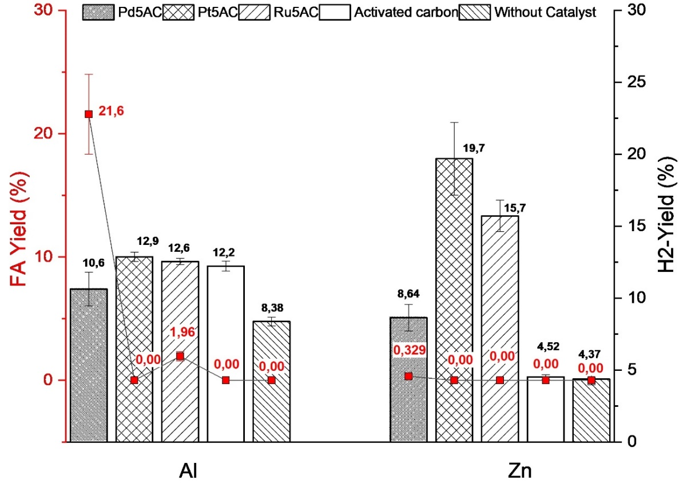
Fig. 3. FA and H₂ yield for the different metal/catalyst systems. Reaction conditions: 2 h, metal:carbamate molar ratio of 6, catalyst metal:carbamate molar ratio of 3.8 mmol, 70% of filling and 0.5 M of initial concentration.

3.4 XRD results
The solid residues after reaction with Al and Zn, using Pd5AC as catalyst, were characterized by XRD to determine oxidized by-products. Fig. 4 shows the analyses of remaining unreacted elementary metals (Al and Zn) along with a mixture of oxides and hydroxides. Carbonates were also detected, suggesting that part of the conversion of carbamate is due to the formation of these compounds. From this, can be concluded that, under the reaction conditions studied, i) a complete conversion of the elementary metals is difficult to achieve in 2 h, and ii) reducing metals can react with the CO2RS, taking place an intake or re-capture of CO₂ to form carbonates.
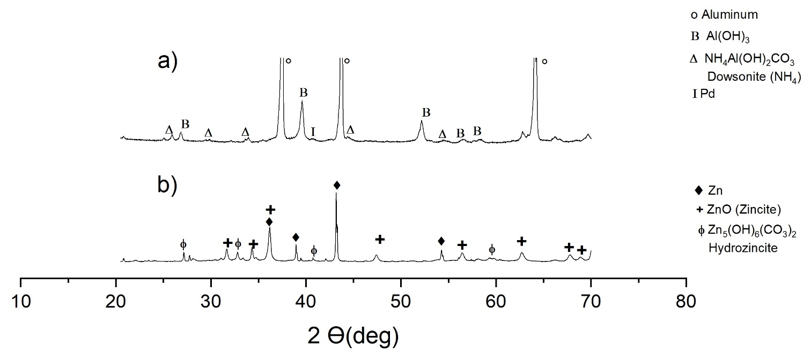
Fig. 4. XRD diffractograms of solid residue after reaction with catalyst Pd5AC and metals a) Al, and b) Zn. Reaction conditions: 120 ºC, 2 h, metal:carbamate molar ratio of 6, catalyst metal:carbamate molar ratio of 3.8 mmol, 70% of filling and 0.5 M of initial concentration.

3.5 SEM Observations
The solid samples after reaction with Al and Zn, in presence of Pd5AC, were surface characterized by SEM-BSE. In this technique, the intensity of the backscattered-electrons (BSE) correlates with larger atoms (greater weight and atomic number Z), appearing as brighter areas, while dark areas are smaller atoms with lower number [40]. In Fig. 5 a), a smooth bright layer of aluminum hydroxides and carbonates (detected by XRD) appear covering the surface of round shapes of unreacted elementary aluminum. Fig. 5 b) reflects the oxidation of pure zinc to form ZnO (lighter areas), by the appearance of crystalline microstructures with needle like shapes. The globular darker shapes can be ascribed to the carbon support, and unreacted metal.

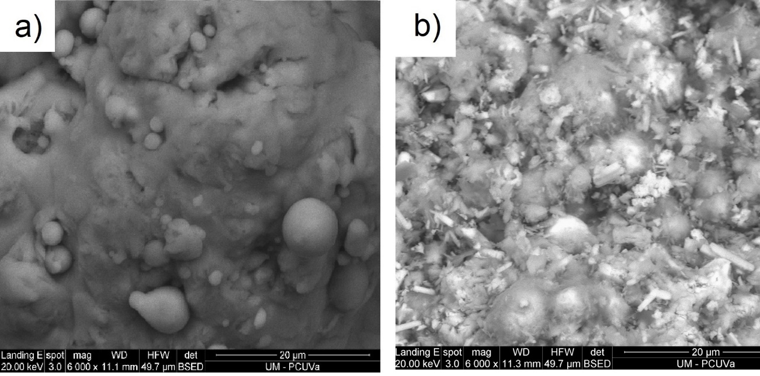
Fig. 5. Micrographs of solid residues after reduction with powder of a) Al and b) Zn. Reaction conditions: 120 ºC, 2 h, metal:carbamate molar ratio of 6, catalyst metal:carbamate molar ratio of 3.8 mmol, 70% of filling and 0.5 M of initial concentration.

3.6 H₂-TPR analyses
The temperature programed reduction technique is a useful tool for determining the different oxidation state species of a catalyst. These analyses were conducted to understand the behavior of the metal-active sites of the catalysts before and after the process of reduction of carbamate, using pure-hydrogen as reducing agent to avoid possible interactions of reducing metals (Al and Zn) with the technique.
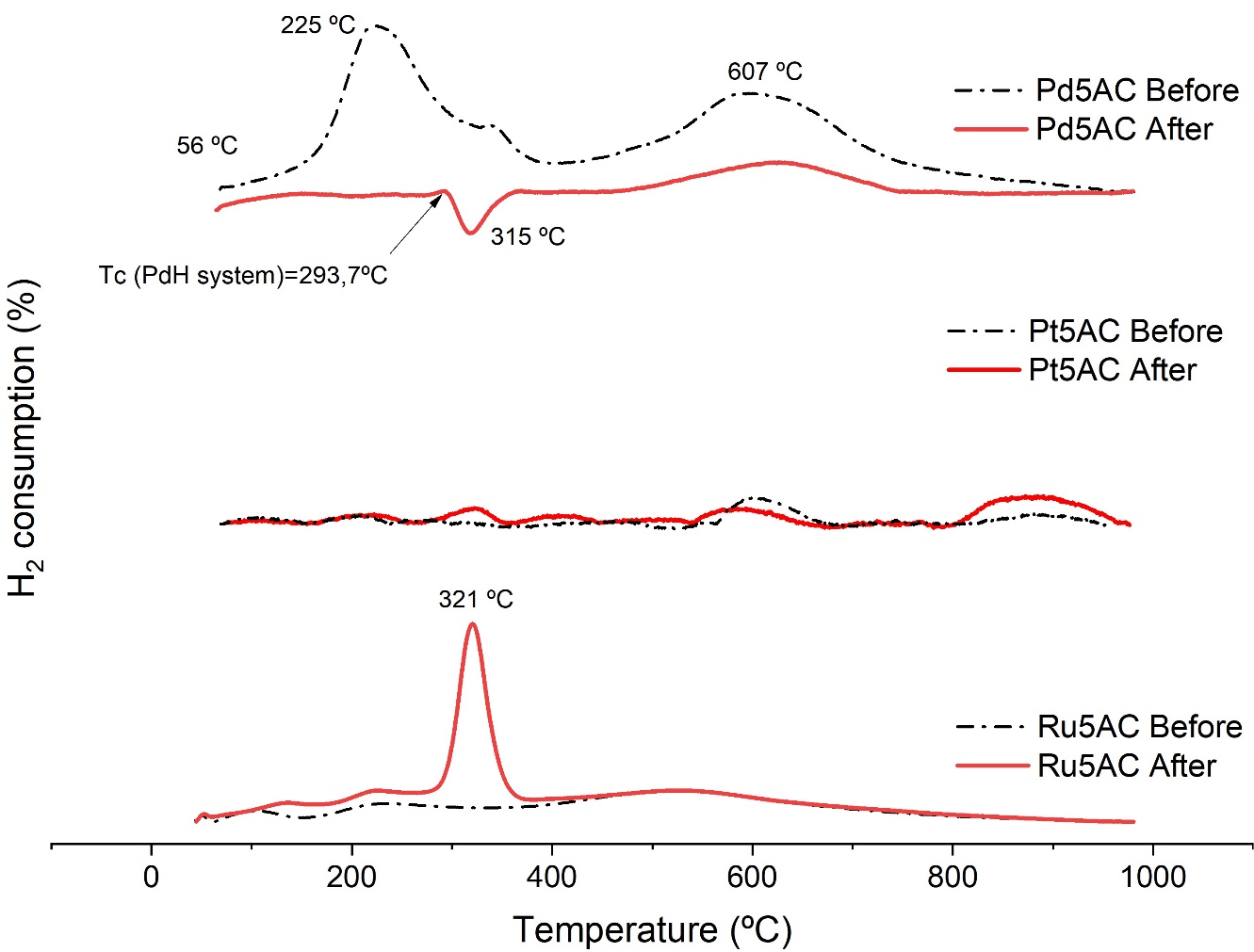
Fig. 6. H₂-TPR curves of catalysts Pd5AC, Pt5AC and Ru5AC before and after reduction of carbamate with pure-hydrogen. Reaction conditions: 2 h, 2.5 MPa of 99.99% pure-hydrogen, catalyst metal:carbamate molar ratio of 3.8 mmol, 70% of filling and 0.5 M of initial concentration.

From H₂ consumption curves before reaction for Pd5AC (Fig. 6) a positive peak is present with a maximum at temperature 225 ºC, which corresponds to PdO species strongly interacting with the support [41], where a complete reduction of Pd (II) to Pd (0) takes place [42]. This event is followed by a wider peak with maximum H₂ consumption at 607 ºC, ascribable to gasification of the carbon lattice, that usually onsets from 600 ºC for carbon supports [43][44]. After reaction, Pd5AC catalyst presented only a negative peak beginning at 293.7 ºC, which has been reported as the critical point (Tc) of the palladium hydride system (PdH_{x}, x=0.205) [45], reaching a maximum peak at 315 ºC. This behavior means that, during the TPR, hydrogen was desorbed/released from the catalyst, instead of consumed, and was also found in the reduction of capture CO₂ to formate in our previous report [15]. This phenomenon is related to the decomposition of a metal-hydride, suggesting the possible existence of palladium hydride PdH, which is a reducing specie. For a reaction temperature of 120 ºC, and a Tc of PdH system of 293.7ºC, the activity of a possible hydride should remain during the whole process. Nevertheless, further characterization should be undergone to fully characterize Pd-hydride species in the catalyst after reaction. Also, no peaks of oxides reduction were evident after reaction, meaning a low deactivation by oxidation. Therefore, the superiority of Pd5AC catalyst can be summarized in three main facts: i) possible active palladium hydride specie was formed during the mild reaction temperature given its negative enthalpy of formation, a conditions required to favor its formation at low temperature and pressure [46][47], ii) the palladium low heat of hydrogen absorption, compared to other metals like Ni and Pt [48] [49], and iii) palladium promotes the diffusion of H protons throughout the carbon support by a hydrogen spillover mechanism [50].

The null activity of Pt5AC catalyst observed in the catalytic experiments is consistent with the TPR profiles before and after reaction, where no significant consumption of hydrogen was observed, meaning that most of the Pt is in reduced state, but remained unchanged during the carbamate to formate process. The deficient performance of Pt5AC can be explained by an insufficient hydrogen pressure (2.5 MPa) to form active hydride species, which in this case requires much higher pressures of at least 27 GPa [51].

TPR curve for Ru5AC, before reaction, shows a flat behavior, indicating that the catalyst is completely reduced. However, after reaction the catalyst presented a greater oxygen elimination of 0.3 g/g_{cat} (compared to Pd5AC and Pt5AC) with a single significant peak appearing at 321 ºC, ascribable to oxidation state Ru (III) [52] [53], revealing that this catalyst quickly deactivated during the process and did not develop metallic hydrides, reflected in the low formate yield of 1.76% (see Table 2). Although ruthenium, similarly as platinum, cannot form stable hydrides at moderate pressures [54], the observed activity of Ru5AC catalyst can be understood by the ability of reduced ruthenium to adsorb and desorb hydrogen over its metallic surface, generating empty coordination sites that allows co-adsorption of reactant molecules and its conversion by hydrogen transfer [55].
Table 2. Formate yield and oxygen elimination during H₂-TPR characterization of catalysts. Reaction conditions: 2 h, 2.5 MPa of 99.99% pure-hydrogen, 70% of filling and 0.5 M of AC initial concentration.
Sample | Particle size (nm)* | Dispersion  (%)* | FA Yield  (%) | TON | Oxygen eliminated  (g/g)
 |  |  |  |  | Before Reaction | After reaction
Pd5AC | 3.81±1.98 | 29.44% | 38.98±2.3 | 357.7 | 0.18 | 0.12
Pt5AC | 7.11±5.0 | 15.18% | 0 | 0 | 0.15 | 0.14
Ru5AC | 6.59±5.2 | 15.77% | 1.76±0.01 | 16.6 | 0.17 | 0.30
*By TEM image analysis

3.7 TEM images analyses
Fig. 3S depicts selected images of all catalysts tested, clearly observing that most of the nanoparticles are round and dispersed, with gauss (Pd5AC) and Lognormal (Pt and Ru5AC) distributions. The particle size measured for Pd5AC (3.81nm) is consistent with previous reports of similar catalysts comprising 5% palladium over carbon, ranging between 3-5nm (based on TEM and CO chemisorption analyses) and metallic dispersion of 17-25% [17][56][57][38]. For its part, platinum and ruthenium catalysts presented comparatively poor dispersions of about 15% (Table 2), with larger particle sizes ranging between 6.6-7.11 nm, features known to strongly affect the catalytic activity [58], as observed before when comparing the selected catalyst for the reduction of carbamate.

- Conclusions
Among the tested catalysts, Pd5AC displayed the best performance toward formate yield from CO₂ captured in aqueous ammonia, because of its high dispersion (29.4%) and low deactivation by oxidation and was the only catalyst to show insights of formation of possible active hydride species. Although Zn displayed a certain formate yield (0.33%), aluminum was the most efficient, up to 21.6%, while presenting faster H₂ generation rates than Zn. Both CO2RS/CO2LS streams showed activation of the hydrogen generation, and this effect was strongly influenced by initial pH. The present study suggests that both type of streams are potential hydrothermal media for hydrogen generation and formic acid production, which are value-added chemicals with increasing markets in the short term. This represents a potential integration of carbon capture utilization and storage (CCUS) with the hydrogen production in the frame CO₂ and H₂ economies.

Declaration of competing interest
The authors report no declarations of interest.

Acknowledgements
This project has been funded by Junta de Castilla y León through FEDER FUNDS under the BioEcoUVa Strategic Program (CLU-2019-04), and by Fundación Naturgy through the 1st Award to Research and Innovation in the Energy Sector. Juan Ignacio del Río gratefully acknowledges Universidad de Valladolid for the predoctoral and postdoctoral fellowships, and the financial support provided by the Ministry of Science, Technology and Innovation of Colombia within the framework of the call No. 914-2022 (Contract No. 80740-098-2022).

Supplementary Information
The following items are provided as Supplementary Information:
Fig. 1S. Reactor's pressure evolution during 10 hours of hydrogen generation experiments at 120 ºC, in absence of catalyst, using Al & Zn under aqueous AC and SB as CO2RS (a and b respectively), and NH3 as CO2LS (c).
Fig. 2S. Proposed mechanism of a) hydrogen generation, b) PdHx formation, and c) capture CO2 reduction
Fig. 3S. TEM micrographs of catalyst a) Pd5AC, b) Pt5AC, c) Ru5AC before reaction with hydrogen as reducing agent.
REFERENCES
[1] Bashir MF. Oil price shocks, stock market returns, and volatility spillovers: a bibliometric analysis and its implications. Environ. Sci. Pollut. Res 2022;29: 22809-22828
[2] Nocito F, Dibenedetto, A. Atmospheric CO2 mitigation technologies: carbon capture utilization and storage. Current Opinion in Green and Sustainable Chemistry 2020; 21: 34–43, doi: 10.1016/j.cogsc.2019.10.002.
[3] Hekmatmehr H, Esmaeili A, Pourmahdi M, Atashrouz S, Abedi A, Ali Abuswer M, Nedeljkovic D, Mohammad L, Sherif F, Mohaddespour A. Carbon capture technologies: A review on technology readiness leve. Fuel 2024;363:130898, doi: 10.1016/j.fuel.2024.130898
[4] Al Baroudi H, Awoyomi A, Patchigolla K, Jonnalagadda K, Anthony EJ. A review of large-scale CO2 shipping and marine emissions management for carbon capture, utilisation and storage. Applied Energy 2021; 287:116501. doi: 10.1016/j.apenergy.2021.116510.
[5] Valluri S, Claremboux V, Kawatra S. Opportunities and challenges in CO2 utilization. J. Environ. Sci 2022; 113: 322–344.
[6] Koytsoumpa EI, Bergins C, Kakaras E. The CO2 economy: Review of CO2 capture and reuse technologies. J. Supercrit. Fluids. 2017; 132: 3–16, doi: 10.1016/j.supflu.2017.07.029.
[7] Chen X, Gao R, Qiang W, Kehao H, Wang F, Deng C, Xu L, Zhang C, Jun KW, Seok KK, Zhao T, Wan H. Direct hydrogenation of CO2 to liquid hydrocarbons over K/Fe-C catalysts: effect of porous carbon matrix and K modification. Fuel 2024; 364: 131031. doi: 10.1016/j.fuel.2024.131061
[8] Andérez-Fernández M, Ferrero S, Queiroz JPS, Pérez E, Álvarez CM, Martín A, Bermejo MD. Formic acid production by simultaneous hydrothermal CO2 reduction and conversion of glucose and its derivatives. J. Taiwan Institute of Chemical Engineers. 2022; 139: 104504. doi: 10.1016/j.jtice.2022.104504
[9] Jarvis SM, Samsatli S. Technologies and infrastructures underpinning future CO2 value chains: A comprehensive review and comparative analysis. Renew. Sustain. Energy Rev., vol. 85, pp. 46–68, 2018.
[10] Jin F, Gao Y, Jin Y, Zhang Y, Cao J, Wei Z, Smith Jr RL. High-yield reduction of carbon dioxide into formic acid by zero-valent metal/metal oxide redox cycles. Energy Environ. Sci. 2011; 4,. 3: 881–884, doi: 10.1039/C0EE00661K.
[11] Najafabadi AT. CO2 chemical conversion to useful products: an engineering insight to the latest advances toward sustainability. Int. J. Energy Res.2013; 37, 6: 485–499.
[12] Wang W, Xiang M, Fy Y, Wang W, Duan J. Three-dimensional porous Cu-Zn/NF catalysts for efficient photocatalytic reduction of CO2 in alkaline environment for methanol preparation in a monolithic microreactor. Fuel 2024;357: 129778. doi: 10.1016/j.fuel.2023.129778
[13] Liu X, Zhong H, Wang C, He D, Jin F. CO2 reduction into formic acid under hydrothermal conditions: A mini review. Energy Sci. Eng. 2022; 10,5: 1601–1613.
[14] Verma P, Zhang S, Song S, Mori K, Kuwahara Y, Wen M, Yamashita H, An T. Recent strategies for enhancing the catalytic activity of CO2 hydrogenation to formate/formic acid over Pd-based catalyst. J. CO2 Util. 2021; 54: 101765, doi: 10.1016/j.jcou.2021.101765.
[15] Del Río JI, Pérez E, León D, Martín A, Bermejo MD. Catalytic hydrothermal conversion of CO2 captured by ammonia into formate using aluminum-sourced hydrogen at mild reaction conditions. J. Ind. Eng. Chem. 2021; 97: 539–548.
[16] Hao C, Wang S, Li M, Kang L, Ma X. Hydrogenation of CO2 to formic acid on supported ruthenium catalysts. Catal. Today. 2011; 160, 1: 184–190, doi: 10.1016/j.cattod.2010.05.034.
[17] González E, Marchant C, Sepúlveda C, García R, Ghampson IT, Escalona N, García-Fierro JL. Hydrogenation of sodium hydrogen carbonate in aqueous phase using metal/activated carbon catalysts. Appl. Catal. B Environ. 2018; 224: 368–375.
[18] Huang Z. CO2 hydrogenation over mesoporous Ni-Pt/SiO2 nanorod catalysts: Determining CH4/CO selectivity by surface ratio of Ni/Pt. Chem. Eng. Sci. 2022; 247: 117106
[19] Ma Z, Li P, Ye L, Wang L, Xie H, Zhou Y. Selectivity reversal of photocatalytic CO 2 reduction by Pt loading. Catal. Sci. Technol. 2018; 8, 20: 5129–5132.
[20] Zhang QH, Han WD, Hong YJ, Yu JG. Photocatalytic reduction of CO2 with H2O on Pt-loaded TiO2 catalyst. Catal. Today. 2009; 148, 3–4: 335–340.
[21] Umeda M, Niitsuma Y, Horikawa T, Matsuda S, Osawa M. Electrochemical reduction of CO2 to methane on platinum catalysts without overpotentials: strategies for improving conversion efficiency. ACS Appl. Energy Mater. 2019; 3, 1: 1119–1127.
[22] Valekar AH, Oh KR, Lee SK, Hwang YK. Simultaneous production of lactate and formate from glycerol and carbonates over supported Pt catalysts. J. Ind. Eng. Chem. 2021; 101: 66–77.
[23] Gunasekar GH, Park K, Jung KD, Yoon S. Recent developments in the catalytic hydrogenation of CO 2 to formic acid/formate using heterogeneous catalysts. Inorg. Chem. Front. 2016; 3, 7: 882–895.
[24] Yan N, Philippot K. Transformation of CO2 by using nanoscale metal catalysts: cases studies on the formation of formic acid and dimethylether. Curr. Opin. Chem. Eng. 2018; 20: 86–92, doi: 10.1016/j.coche.2018.03.006.
[25] Singh AK, Singh S, Kumar A. Hydrogen energy future with formic acid: A renewable chemical hydrogen storage system. Catal. Sci. Technol. 2016; 6, 1: 12–40, doi: 10.1039/c5cy01276g.
[26] Gürsel IV, Noël T, Wang Q, Hessel V. Separation/recycling methods for homogeneous transition metal catalysts in continuous flow. Green Chem. 2015; 17, 4: 2012–2026.
[27] Jin, F, Zeng X, Liu J, Jin Y, Wang L, Zhong H, Yao G, Huo Z. Highly efficient and autocatalytic H2O dissociation for CO2 reduction into formic acid with zinc. Sci. Rep. 2014; 4: 4503, doi: 10.1038/srep04503
[28] Krokidis X, Raybaud P, Gobichon AE, Rebours B, Euzen P, Toulhoat H. Theoretical study of the dehydration process of boehmite to γ-alumina. J. Phys. Chem. B, 2001; 105, 22
: 5121–5130.
[29] Lopes OF Mendonca VR, Umar A, Chuahan MS, Kumar R, Chauhan S, Ribeiro C. Zinc hydroxide/oxide and zinc hydroxy stannate photocatalysts as potential scaffolds for environmental remediation. New J. Chem. 2015; 39, 6: 4624–4630, doi: 10.1039/c5nj00324e.
[30] Bacelo H, Pintor AMA, Santos SCR, Boaventura RAR, Botelho CMS. Performance and prospects of different adsorbents for phosphorus uptake and recovery from water. Chem. Eng. J. 2019; 381: 122566, doi: 10.1016/j.cej.2019.122566.
[31] Charvin P, Abanades S, Lemort F, Flamant G. Hydrogen production by three-step solar thermochemical cycles using hydroxides and metal oxide systems. Energy & Fuels. 2007; 21, 5: 2919–2928.
[32] Ishaq H, Dincer I, Crawford C. A review on hydrogen production and utilization: Challenges and opportunities. Int. J. Hydrogen Energy. 2022; 47,62:26238-26264
[33] Zhong H, Wang L, Yang Y, He R, Jing Z, Jin F. Ni and Zn/ZnO Synergistically Catalyzed Reduction of Bicarbonate into Formate with Water Splitting. ACS Appl. Mater. Interfaces. 2019; 11, 45: 42149–42155.
[34] Umpierre AP, de Jesus E, Dupont J. Turnover numbers and soluble metal nanoparticles. ChemCatChem. 2011; 3, 9: 1413–1418.
[35] Sevjidsuren G. Effect of different support morphologies and Pt particle sizes in electrocatalysts for fuel cell applications. J. Nanomater. 2010, Art. ID 852786
[36] Razavi-Tousi SS, Szpunar JA. Effect of structural evolution of aluminum powder during ball milling on hydrogen generation in aluminum–water reaction. Int. J. Hydrogen Energy. 2013;. 38, 2: 795–806.
[37] Fujitsuka H, Nakagawa K, Hanprerakriengkrai S, Nakagawa H, Tago T. Hydrogen Production from formic acid using Pd/C, Pt/C, and Ni/C catalysts prepared from Ion-exchange resins. J. Chem. Eng. Japan. 2019; 52, 5: 423–429.
[38] Su J, Lu M, Lin H. High yield production of formate by hydrogenating CO 2 derived ammonium carbamate/carbonate at room temperature. Green Chem. 2015; 17, 5: 2769–2773.
[39] Del Rio JI, Martin A, Bermejo MD. Coupling the solvent-based CO2 capture processes to the metal water-splitting for hydrogen generation in a semi-continuous system. Int. J. Hydrogen Energy. 2023; 48,72: 27892-27906
[40] Wang ZL, Liu Y, Zhang Z. Handbook of Nanophase and Nanostructured Materials: Materials systems and applications I, vol. 3, 2003.
[41] Aznarez A, Gil A, Korili SA. Performance of palladium and platinum supported on alumina pillared clays in the catalytic combustion of propene. RSC Adv. 2015; 5, 100: 82296–82309.
[42] Juszczyk W. Characterization of supported palladium catalysts: III. PdAl2O3. J. Catal. 1989;120, 1: 68–77, doi: https://doi.org/10.1016/0021-9517(89)90251-0.
[43] Trépanier M, Tavasoli A, Dalai AK, Abatzoglou N. Co, Ru and K loadings effects on the activity and selectivity of carbon nanotubes supported cobalt catalyst in Fischer–Tropsch synthesis. Appl. Catal. A Gen. 2009; 353, 2: 193–202.
[44] Zhang G, Li Z, Zheng H, Fu T, Ju Y, Wang Y. Influence of the surface oxygenated groups of activated carbon on preparation of a nano Cu/AC catalyst and heterogeneous catalysis in the oxidative carbonylation of methanol. Appl. Catal. B Environ. 2015; 179: 95–105.
[45] Manchester FD, San-Martin A, Pitre JM. The H-Pd (hydrogen-palladium) system. J. Phase equilibria. 1994; 15, 1: 62–83.
[46] Kohlmann H. Metal hydrides, in Encyclopedia of Physical Science and Technology (3rd Ed), Elsevier, 2003
[47] Yang X, Li H, Ahuja R, Kang T, Luo W. Formation and electronic properties of palladium hydrides and palladium-rhodium dihydride alloys under pressure. Sci. Rep. 2017; 7, 1: Art no 3520.
[48] Christensen OB, Stoltze P, Jacobsen KW, Nrskov JK. Effective-medium calculations for hydrogen in Ni, Pd, and Pt. Phys. Rev. B. 1990; 41, 18: Art no 12413.
[49] Andreasen A. Predicting formation enthalpies of metal hydrides. Risø–Risø National Laboratory, Roskilde, Denmark, 2004.
[50] Adams BD, Chen A. The role of palladium in a hydrogen economy. Mater. Today. 2011; 14, 6: 282–289, doi: https://doi.org/10.1016/S1369-7021(11)70143-2.
[51] Scheler T. Synthesis and properties of platinum hydride. Phys. Rev. B, 2011: 83, 21: Art no 214106.
[52] Man B. Oxidation modification of Ru-based catalyst for acetylene hydrochlorination. RSC Adv. 2017; 7, 38: 23742–23750.
[53] Zhang Z. Ru-Co (III)-Cu (II)/SAC catalyst for acetylene hydrochlorination. Appl. Catal. B Environ. 2016; 189: 56–64.
[54] Kuzovnikov MA, Tkacz M. Synthesis of ruthenium hydride. Phys. Rev. B. 2016; 93, 6: art no. 64103.
[55] Müller TE. Hydrogenation and Hydrogenolysis with Ruthenium Catalysts and Application to Biomass Conversion, in ; Ruthenium An Element Loved by Researchers, Ed. Intechopen 2021.
[56] Neri G, Musolino MG, Milone C, Pietropaolo D, Galvagno S. Particle size effect in the catalytic hydrogenation of 2, 4-dinitrotoluene over Pd/C catalysts. Appl. Catal. A Gen. 2001; 208, 1–2: 307–316.
[57] Rozmysłowicz B, Maki-Arvela P, Tokarev A, Leino AR, Eranen K, Murzin DY. Influence of hydrogen in catalytic deoxygenation of fatty acids and their derivatives over Pd/C. Ind. Eng. Chem. Res. 2012; 51, 26: 8922–8927.
[58] Jeong H Kwon O, Kim BS,Bae J, Shin S, Kim HE, Kim J. Lee H. Highly durable metal ensemble catalysts with full dispersion for automotive applications beyond single-atom catalysts. Nat. Catal. 2020; 3, 4: 368–375.

