Hydrothermal production of high-molecular weight hemicellulose-pectin, free sugars and residual cellulose pulp from discarded carrots
Marta Ramos-Andrés, Beatriz Aguilera-Torre and Juan García-Serna*
Grupo de Procesos a Alta Presión, Instituto de Bioeconomía de la Universidad de Valladolid (BioEcoUVa), and Departamento de Ingeniería Química y Tecnologías del Medio Ambiente,
Escuela de Ingenierías Industriales, Universidad de Valladolid, 47011, Valladolid, SPAIN
* Corresponding author, Tel.: +34983184934, e-mail: jgserna@iq.uva.es
Abstract
Discarded carrots account for 30% of the total production ending up in landfills, land, or a small part as cattle food. Valorization of discarded carrot pulp was studied by hydrothermal treatment, fractionating free sugars, hemicellulose and pectin in the liquid phase and residual pulp in the solid phase. Extraction took place in flow-through mode at 140, 160 and 180 ºC, achieving recoveries up to 211.0 g/kg dry pulp of free sugars, 29.13 g/kg dry pulp of homogalacturonan pectin, and 70.45 g/kg dry pulp of arabinogalactan hemicellulose. The residual pulp reached a cellulose content of 57.5 wt% while before the treatment it was 10.7 wt%. Most of the free sugars were extracted in the preheating stage in batch, so they could be obtained separately from the biopolymers. The flow-through extraction allowed to obtain hemicellulose and pectin of molecular weights > 30 kDa. The evolution of different ranges of molecular weight was studied in detail for a better understanding of the phenomenon of autohydrolysis and the link between hemicellulose and pectin. The ample molecular weight distribution in the hydrolyzate allows for a subsequent fractionation via ultrafiltration membranes, to obtain a high molecular weight fraction for applications such as film-forming (in combination with the residual pulp).
Keywords: arabinogalactan; homogalacturonan; biorefinery; carrot pulp; autohydrolysis; molecular weight

- Introduction
Annually around one third of global food production, i.e. 1.3 billion tons of food, ends up being discarded (Rajinipriya et al., 2018). Vegetable waste is at the top, being these residues produced at various stages in the value-chain from pre to post-harvesting. There is a twofold problem with the carrot discards waste: first, a significant economic loss for the industry and second a serious damage to the environment due to putrefaction. Vegetal food wastes are often characterized by high moisture content and a high organic load that makes it vulnerable to microbial activity and therefore difficult to treat or handle (Nayak and Bhushan, 2019). Unfortunately, no special treatments are carried out for this type of organic waste, but it is more common for it to end up in landfills, be used as fertilizer material (Christiaens et al., 2015), be dumped in the field, or be sold for animal feed (Surbhi S et al., 2018).
Carrot (Daucus carota L.) is one of the most important root vegetables cultivated worldwide, with a global annual production estimated in 36 million tons (Encalada et al., 2019). They are a source of phytonutrients such as carotenoids, vitamins (A, B, C, D, E, and K), minerals (calcium, potassium, phosphorus, sodium, and iron), and bioactive compounds, as well as being rich in dietary fiber (Riganakos et al., 2017). Carrots can be consumed in their fresh form or as juice. After obtaining the juice, between 30-50 % of the initial mass remains as pulp, a material that the producing company considers to be an industrial organic waste (Varanasi et al., 2018a). In addition to the pulp, it is known that during the processing of carrots about 11 % of the initial mass is lost in the form of peels, tubers and attached flesh (de Andrade Lima et al., 2018). Companies that grow or process carrots have another type of waste, the so-called discarded carrots. The discards are those carrots that will not reach the consumer due to a number of defects, mainly size, diameter, length or shape. The last type of waste appears at the end of the value chain, when they are discarded at the supermarket and/or at home due to change in their appearance, expiration date, etc. As with the rest of similar food waste, its management is based on landfilling, dumping in the field or use as animal feed (Surbhi S et al., 2018). In order to improve sustainability in the production of carrots, it is necessary to recover the tons of waste by transforming them into high value-added products (Hiranvarachat and Devahastin, 2014). In order to study the valorization, the characterization of carrot pulp on a dry basis includes as main components water extractives: sucrose (14.3 wt%), glucose (7.9 wt%) and fructose (5.4 wt%), while structural compounds are cellulose (16.8 wt%), hemicellulose (4.0 wt%), pectins (4.2 wt%) and lignin (6.9 wt%) (De Vrije et al., 2010).
Despite free sugars are the major components, few studies have focused on their use. One possible destination of these sugars is fermentation for the production of ethanol, favored by the presence of nutrients (Aimaretti and Ybalo, 2012). Several studies targeted the maximum of juice from carrots, recovering the greatest amount of sugars (Grimi et al., 2007). To this end, they used pulsed electric field and applied alternative washing and pressing processes. More recently, A. L. Clementz et al. (2019) valorized the sugars of carrot discards through fermentation for bioethanol production in combination with brewery discarded yeast.
Given its interest at industrial level, the vast majority of research has focused on the recovery of pectins from discarded carrots. Pectin is widely used as a functional ingredient, standing out for its ability to thicken and gel food system and stabilize food emulsions (Idrovo Encalada et al., 2020). It is also recognized as health-promoting ingredient, especially when its molecular weight is moderate (Martínez et al., 2010). The pectin content in carrot is relatively low compared to other raw materials commonly used for pectin production: carrot pulp has a content of 4.2-7.4 %, while citrus peel has 25-30 % and sugar beet pulp has 15-30 %, all on a dry basis (Dranca and Oroian, 2018). However, the fact that so much carrot waste is generated has led to increased research into the extraction of pectin from this raw material. Nowadays, the largest production of commercially pectin is centered in citrus-producing countries of South America and the European region (Dranca and Oroian, 2018). On the other hand, carrot is much more geographically distributed. Recent studies have shown that pectin yield could be not as important as pectin quality, showing that tomato pulp (7.55% pectin content) and carrots are very interesting raw materials due to the properties of their pectins (Grassino et al., 2016). With regard to pectin extraction, acid extraction is the most recurrent technique in literature. Jafari et al. (2017) studied the influence of the main variables in the extraction of pectin from discarded carrot pulp (pH, temperature, heating time and liquid/solid ratio). Going into more detail, recently Neckebroeck et al. (2020) studied the potential as emulsifying of the carrot pectin subdomains, distinguishing the homogalacturonan domain from the rhamnogalacturonan domain. These domains were also extracted by the action of an acid. Despite this and other studies, the structure of pectin is still not fully understood. Natarajmurthy et al. (2016) investigated the link between β-carotene and pectins in carrots. They indicated that this association leads to a reduction in the prooxidant effect of β-carotene and an improvement in the apoptotic effect, so the association would be of great interest. Similarly, in a recent work by Idrovo Encalada et al. (2020), an orange-coloured pectin-enriched fraction was obtained from discarded carrots by means of high-power-ultrasound and bacterial hemicellulose. The product proved to be of great interest as a food-additive. Sucheta et al. (2020) also extracted pectin, in this case accompanied by anthocyanins, phenolics and antioxidants. These pectins were obtained from black carrot pulp by means of hot acidic water and three methods that were compared: microwave, ultrasound and conventional heating.
Cellulose, as the second most abundant component of discarded carrots, is, together with pectins, the most highly valorizated polysaccharide. Cellulose from biomass has many interesting properties for industry, such as the production of biocompatible nanocomposite films with antibacterial activity (Wang et al., 2020). With regard to discarded carrots, Rajinipriya et al. (2018) used ball milling and acid hydrolysis to obtain nanofibrillated cellulose and nanocrystalline cellulose, respectively. The recovery of fibres without carotenoids or lignin was performed by treating the carrot with hydrogen peroxide before milling. On the other hand, before acid hydrolysis, the carrot was subjected to alkaline treatment in the process of obtaining nanocrystalline cellulose. Both cellulose products were used to make films. In addition, Varanasi et al. (2018b) produced nanofibers of discarded carrots using a mechanical process without any chemical treatment. For the removal of extractives, a previous blanching with hot water was applied. The nanofibers had a similar composition in cellulose and hemicellulose, and were used to make films. Sogut and Cakmak (2020) also made films with chitosan as the main ingredient, valorising the cellulose of the carrot pulp by milling and treating it with sodium hydroxide at high temperature. De Vrije et al. (2010) developed a different application for carrot pulp cellulose, using it in the production of hydrogen by biotechnological process together with glucose and fructose mixtures. Finally, it is worth highlighting the work of Berglund et al. (2020) dedicated to the production of discarded carrot nanofibres by means of a process optimized at pilot scale by life cycle assessment combined with life cycle costing.
The hemicellulose group of carrots is arabinogalactan. Immerzeel et al., (2006) studied in detail the structure of the carrot with regard to arabinogalactan and pectins. According to their study, the large presence of galacturonic acid could favor a union between pectins and arabinogalactans. The extraction of arabinogalactan would result in a sustainable raw material for many potential applications such as food additive (moderate molecular weight), chemical industry (transformation into chemicals such as furfural), polymeric materials (films, hydrogels and carriers), biosurfactants, and paper making additives or flocculant agents (e.g. cationic hemicelluloses) (Peng and She, 2014). However, to our knowledge, there are no studies on the extraction of hemicelluloses from discarded carrots for subsequent valorization.
Finally, if it is considered a global valorization of discarded carrots, it is worth highlighting the research of A. Clementz et al. (2019b). In this work, ethanol was obtained from free sugars, carotenoids were extracted, and a final fraction rich in fiber was obtained. The study offers three alternative processes that vary in product quality, yield, equipment and costs.
Although discarded carrots have not been studied from the point of view of hydrothermal extraction, other residual biomasses have been. Rodríguez et al. (2009) studied the influence of operational variables (temperature, time, solid/liquid ratio) on the hydrothermal treatment of rice straw for the extraction of sugars. The products obtained were glucose, xylose, arabinose and acetic acid. After the treatment, a cellulose pulp with very good properties was obtained from the residual pulp. As in the present work, the classic objective of hydrothermal treatment has been to obtain hemicellulose. In this context, Neto et al. (2020) performed an optimization of the hydrothermal treatment applied to sawdust from Eucalyptus. Xylooligosaccharides were the hemicelluloses obtained, with interesting health properties and a maximum yield of 60 mg/g. Likewise, Borrega et al. (2018) applied hydrothermal treatment to birch wood and Kraft pulp to obtain xylan hemicelluloses and viscous-grade residual pulp. The Kraft pulp treatment produced a pulp with high cellulose purity and good properties. In addition, post-hydrolysis applied to the pulp in flow-through mode allowed the recovery of high purity xylan of molecular weight around 10 kDa. Although pectins are not usually obtained by hydrothermal treatment, Martínez et al. (2010) conducted non-isothermal hydrothermal fractionation of sugar beet pulp to obtain hemicellulose and pectins together. A kinetic study was carried out to control the molecular weight of pectin, as the objective was to reduce it to make them potential prebiotic ingredients. The hemicelluloses reached an overall yield of 30 g/100 g sugar beet pulp, and the residual pulp stood out for its abundant cellulose content.
The present work is the first to performed hydrothermal extraction of pulp from discarded carrots, obtaining four components of interest: free sugars, hemicelluloses, pectins, and residual pulp with abundant cellulose content. Until now, individual components of discarded carrots have been valorized, mainly pectins and cellulose, but not hemicellulose. These hemicelluloses together with pectins were obtained with high molecular weights thanks to the extraction system in flow-through mode, characterized by a low residence time and therefore low autohydrolysis. The extraction of pectins has usually been performed using an acid agent, thus hydrothermal extraction in flow-through mode is novel. The detailed analysis of the evolution of the molecular groups in this work allows a more detailed understanding of the extraction process. The study of the joint extraction of hemicelluloses and pectins has made it possible to study the link between them and will help determine whether their joint use in terms of applications is beneficial, or on the contrary, it is more interesting to separate them. The particular molecular weight distribution of the extracts obtained makes the use of several ultrafiltration membranes feasible and interesting. These membranes would allow the separation and purification of the biopolymers in different fractions. After this process, the biopolymers would be good candidates for applications such as film forming. The high extraction yield associated with the hydrothermal treatment in flow-through mode leaves a residual pulp with abundant cellulose content. This makes it interesting for many applications such as the forming of films in combination with hemicelluloses and pectin. Finally, the characterization of residual pulp has shown how the majority of the free sugars were extracted in the preheating stage before the hydrothermal treatment.
- Materials and methods
  - Raw material and sample preparation
Discarded carrots were supplied by Muñozval S.L. (Valladolid, Spain). They were washed properly with tap water and stored in a cool, dry and dark place for very shorts periods, so their composition and physical properties would not be affected. The carrots were processed with a juice extractor to separate the pulp from the juice. The juicer (Moulinex ZU5008 Infinity Press Revolution) works continuously with a power of 300 W, making a cold pressing of the pulp, so that the moisture content is reduced and juice separation is maximized. Each 1 kg of fresh discarded carrots yielded approximately 0.545 kg of pulp.
  - Analysis of the raw materials (pulp and juice)
The moisture and total solids content were determined in the discarded carrot, discarded carrot pup and discarded carrot juice. The moisture content in discarded carrot pulp was determined in order to express all results on a dry weight basis (Sluiter et al., 2008a). The composition of the dry pulp was determined according to the standard methods published by National Renewable Energy Laboratory (NREL), as in previous works of the authors (Ramos-Andrés et al., 2019). The sample was subjected to two consecutive Soxhlet extractions, the first using water followed by another using hexane (Sluiter et al., 2008c). With these extractions, the content of polar and non-polar extracts was determined, respectively. The protein content was evaluated by the standardized Kjeldahl method (Hames et al., 2008). Polysaccharides and lignin were determined through a two-step acid hydrolysis (Sluiter et al., 2004). The hydrolysis process fractionates the biomass into acid-insoluble material (acid-insoluble lignin and ash) and acid-soluble material (cellulose, hemicellulose, pectin and acid-soluble lignin). Polysaccharides were hydrolyzed into monomeric sugars, which are quantified by HPLC following the method described in section 2.4.1. Acid-insoluble lignin was quantified by UV-vis spectroscopy. The acid-insoluble lignin was measured gravimetrically. The amount of inorganic material in the carrot pulp was measured as ashes by oxidation at 550 °C until constant weight (Sluiter et al., 2008b).
  - Hydrothermal treatment
Extraction of hemicelluloses, pectins and sugars from the pulp was performed using a flow-through pilot reactor, previously described by Ramos-Andrés et al., 2019. Although the pilot plant has 5 reactors in series, only one of the reactors was used for the present extraction experiments. The carrot pulp was introduced into the reactor, which has a volume of 2 L, with the help of a cartridge that facilitates its handling. The reactor with the biomass inside was filled with fresh water using a pump and preheated to 90 °C. A constant flow of fresh water was pumped in by-pass through the pilot plant, through a heater and a series of heat exchangers. When this water had reached the desired extraction temperature, it stopped passing as a by-pass and starts to be passed through the reactor from top to bottom. The temperature in the reactor was also adjusted to the desired temperature, and after a few minutes of adaptation, the extraction was considered to have started. The autohydrolysis liquor passed through three heat exchangers to be cooled down and to recover energy by supplying it in part to the incoming fresh water stream. Finally, the extract passed through a go-back pressure valve that keeps the plant pressurized. The cold extract was collected in a tank. The sample-taking port located at the outlet of the reactor allows following the process through the sampling at different extraction times: 0, 10, 20, 30, 40, 60 and 80 min from the beginning of the operation. The extraction temperatures were 140, 160 and 180 °C so that the severity factor (logR₀) was in the range 2.18 to 3.08 (140 °C), 2.77 to 3.67 (160 °C), and 3.36 to 4.26 (180 °C). The experiments were carried out with a constant water flow of 10 L/h. The pressure was sufficient to keep the water in liquid phase (up to 18 barg). Before starting each experiment, a cold pressure test was carried out to check that there were no problems with clogging or leaks in the plant. The residual extracted pulp was collected from the cartridge and frozen at -25 °C until further characterizations and uses.
  - Analysis
    - Chemical characterization
Composition analysis of the liquid samples was done by High-Performance Liquid Chromatography (HPLC) as previously described by Ramos-Andrés et al., 2019. A SUGAR SH-1011 Shodex column was used for the identification and quantification of sugars, uronic acids, aldehydes, organic acids, and degradation compounds. The column was maintained at 50 °C and the mobile phase had a flow of 0.8 ml/min of 0.01 N sulfuric acid in Milli-Q water. Degradation compounds (5-HMF and furfural) were determined with a Waters dual λ absorbance detector 2487 (210 nm and 254 nm). Sugars, uronic acids, aldehydes, and organic acids were identified and quantified with a Waters IR detector 2414. To determine the amount of hemicelluloses and pectins, liquid samples were subjected to a standardized hydrolysis step to break all the oligosaccharides and polysaccharides into monomers. Briefly, 15 mL of Milli-Q water and 0.8 mL of sulfuric acid (72 %) were mixed with 5 mL of the liquid sample. The solution was autoclaved at 121 °C for 1 h. Hydrolyzed samples were neutralized with CaCO₃ and filtered (Pore size 0.22 μm, diameter 25 mm, Nylon; FILTER-LAB) before the HPLC analysis. The standards employed for the analysis were: sucrose (99%), galacturonic acid (97%), glucose (99%), galactose (99%), fructose (99%), arabinose (99%), glycolaldehyde (99%), formic acid (98%), acetic acid (98%), levulinic acid (98%), acrylic acid (99%), 5-hydroxymethylfurfural (99%), and furfural (99%), all of them from Sigma-Aldrich. The concentration of hemicelluloses was calculated using anhydrous corrections of 0.9 and 0.88 for galactose and arabinose, respectively. For pectins, composed of galacturonic acid, the factor of 0.9 was used.
    - Molecular size distribution
Molecular size characterization was carried out by Size Exclusion Chromatography (HPLC-SEC) using the method previously described by Ramos-Andrés et al., 2019. It was used a GPC column (SB-803 HQ; Shodex) protected by a guard column (SB-G; Shodex). The column was maintained at 35 °C. A flow rate of 0.5 ml/min (NaNO₃ 0.1 M + NaN₃ 0.02% in Milli-Q water) was used as mobile phase. The molecular weight distribution of hemicelluloses and pectin was determined using a Waters IR detector 2414. The calibration curve was calculated with a set of 5 pullulan standards (STANDARD P-82; Shodex) dissolved in Milli-Q water, ranged between 6.1 and 113 kDa of weight-average molecular weight. Assuming that the concentration of the different molecular weight group of compounds is proportional to the signal of the refraction index (RI) detector, chromatographic curves were integrated and the area under the curve of the RI detector intensity was divided into different regions. Following this strategy, hemicelluloses and pectins can be classified depending on their molecular weight in different groups: (1) pentamers, (2) hexamers, (3) 1-5 kDa, (4) 5-10 kDa, (5) 10-30 kDa, and (6) >30 kDa. The groups of trimers and tetramers were extremely low and their presence was neglected.
    - Structural characterization (FTIR, TGA, SEM)
The extraction of hemicelluloses and pectins from carrot pulp was analyzed by changes in the molecular structure of carrot pulp before and after treatment at 180 °C. The moisture in the pulp was removed by freeze-drying before analysis.
The method used was Attenuated total reflectance (ATR) – Fourier transform infrared spectroscopy (FT-IR) (Bruker, Alpha model, with a Platinum ATR single reflection diamond module). Absorbance spectra were obtained in the wavenumber range from 4000 to 400 cm⁻¹, acquiring 64 scans per sample at a resolution of 4 cm⁻¹.
Thermogravimetric analysis (TGA) was also carried out in a TGA/SDTA RSI analyzer of Mettler Toledo. Samples of approximately 10 mg were heated at a rate of 10 °C/min under N₂ atmosphere (60 N ml/min flow) from a temperature of 50 °C up to a temperature around 900 °C.
The surface morphology of the pulp before and after extraction at 180 ºC was determined by scanning electron microscopy (SEM) using a SEM JSM-820 (Joel). A gold evaporator Balzers SCD003 with a gold thickness 25-30 nm was employed. The accelerating voltage was 20 kV and the samples were placed under high vacuum conditions.
- Results and discussion
  - Raw material characterization
The discarded carrots had a moisture content of 94.12 wt%. After separation into pulp and juice, a significant proportion of the solids were transferred to the juice in the form of microparticles of pulp. This resulted in a total solids content of the juice of 10.30 wt%. Consequently, the discarded carrot pulp had a moisture content of 89.70 ± 1.56 wt%. Through the characterization of the carrot pulp was determined its composition in dry basis: proteins (2.26 wt% ± 0.44), water extractives (63.87 ± 1.28 wt%), hexane extractives (1.20 ± 0.79 wt%), cellulose (10.71 ± 0.40 wt%), hemicelluloses (8.43 ± 0.02 wt%), pectin (5.78 ± 0.34 wt%) and lignin (7.75 ± 0.24 wt%).
Water extractives were the major components of carrot pulp. These components were mainly free sugars, as shown by the characterization results: pectin (8.01 ± 1.13 wt%), sucrose (47.28 ± 1.71 wt%), glucose (30.44 ± 0.78 wt%), and fructose (14.27 ± 2.06 wt%). The molecular weight distribution of the water extractives confirmed the presence of monomers (glucose and fructose), dimers (sucrose) and polysaccharides with an average molecular weight of 2 kDa. A standardized hydrolysis treatment was applied to the water extractives according to section 2.4.1., showing that the polysaccharides of molecular weight of 2 kDa are water-soluble pectin formed by galacturonic acid units. The water extractives accompanied the polysaccharides in the extract obtained from the hydrothermal treatment. The hexane extractives represent a very small percentage of the pulp composition, but of great importance, since carotenoids are present in this extract along with a low percentage of lipids.
The hemicelluloses were arabinogalactan, formed by 68.60 ± 0.18 wt% of galactose and 31.40 ± 0.18 wt% of arabinose. This was consistent with carrot characterizations of previous research (Ribas-Agustí et al., 2014). Apart from the free sugars (sucrose, glucose, and fructose) and the sugars from the hemicelluloses (galactose and arabinose), only galacturonic acid was identified. Consequently, the pectin present in discarded carrots has been considered to be homogalacturonan, i.e. formed by monomeric units of galacturonic acid. The lignin in carrot pulp (7.75 ± 0.24 wt%) was made up of 90.22 ± 1.75 wt% of what is considered acid-soluble lignin and 9.78 ± 1.04 wt% of acid-insoluble lignin. Acid-soluble lignin comprises those compounds that after acid hydrolysis, emit in the wavelength 205 nm (Gallina et al., 2018). The high proportion of acid-soluble lignin is interesting for obtaining polysaccharides with high antioxidant capacity due to the presence of phenolics and aliphatic hydroxyl groups (Huang et al., 2019). Lignin provides with rigidity and hydrophobicity and the polysaccharides with flexibility and hydrophilicity. This amphiphilicity improves biocompatibility and mechanical strength together, interesting properties for applications as drug carriers among others (Dong et al., 2020). In addition to the fact that the percentage of acid-insoluble lignin was low, it should be noted that the percentage of ash was near zero or below the detection limit of the analytical equipment.
  - Extraction of hemicelluloses, pectin, free sugars and by-products from carrot pulp

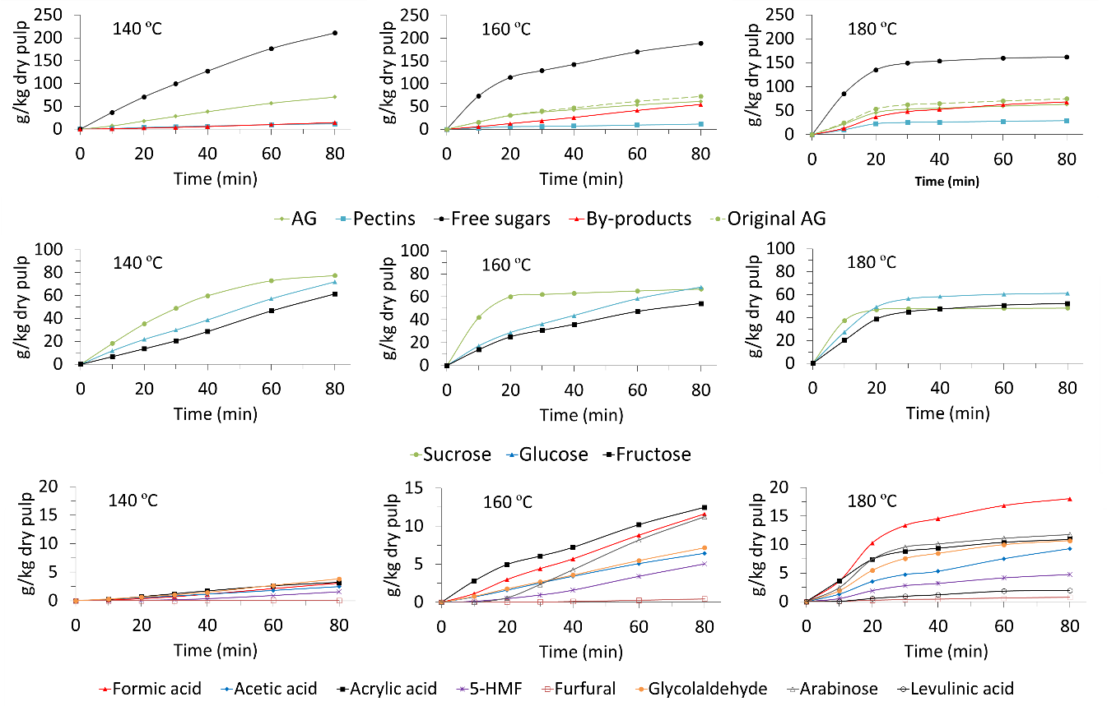
Fig. 1. Hydrothermal extraction (g/kg dry pulp) of arabinogalactan (AG), original AG, pectins, free sugars, and by-products at 140, 160 and 180 ºC
As Fig. 1 shows, the total degree of extraction of free sugars seems to be similar for the three temperatures, as they are non-structural sugars easily extractable with hot water. The highest extraction yield was obtained at 140 °C (211.0 g/kg dry pulp), followed by 160 °C (189.3 g/kg dry pulp) and 180 °C (161.9 g/kg dry pulp). The lower yield at higher temperatures could be due to both degradation under the effect of temperature and the extraction during the preheating stage, as this liquid was not recovered as part of the product as explained at the end of this section. Free sugars were those also present in the juice (see sucrose, glucose and fructose). Fig. 1 shows that at 140 °C the recovery of sucrose tended to decrease until it is practically nil between 60-80 min (2.96 < logR₀ < 3.08), with a final extraction of 77.53 g/kg dry pulp. Due to the hydrolysis of sucrose, both glucose and fructose recovery increased over time. Glucose was in the whole range in higher proportion than fructose, which might be due to both fructose was less present in the raw material and glucose is less susceptible to degradation than fructose. The final extraction values of glucose and fructose were 71.96 g/kg dry pulp and 61.45 g/kg dry pulp, respectively. At 160 °C the recovery of sucrose practically stopped after 20 min (logR₀ = 3.07) with a final value of 66.75 g/kg dry pulp. The maximum extraction was 68.39 g/kg dry pulp for glucose and 54.17 g/kg dry pulp for fructose. At 180 °C the three free sugars reached a plateau after 20 min (logR₀ = 3.66), just a very low accumulated extraction slope of fructose. Glucose was in higher proportion than fructose (61.26 g/kg dry pulp vs. 52.28 g/kg dry pulp) and sucrose was rapidly hydrolyzed after 10 min of extraction (logR₀ = 3.36) giving rise to a final recovery of 48.39 g/kg dry pulp.
The extraction of hemicellulose and pectin (Fig. 1), unlike free sugars, requires subcritical water above 120 ºC. At temperatures above 120 ºC, water ionization is enhanced forming H₃0⁺ ions which cause partial depolymerization of hemicellulose and pectin. Hemicellulose has acetyl groups while pectin has both acetyl and methyl groups. Cleavage of acetyl and methyl groups leads to the further formation of H₃O⁺ ions that catalyze the depolymerization of hemicellulose and pectin. This process is known as autohydrolysis and is affected by the temperature and extraction time (Gallina et al., 2018). The cleavage occurred mainly in the solid (before the hemicellulose is liberated) rather that in the liquid. Structurally arabinogalactan is formed by a long chain of galactose units that has shorter branches where arabinose is located. Autohydrolysis resulted in the formation of different fragments of arabinogalactan. When this cleavage was high, even monomeric units of the arabinose sugar were released. Two types of extraction yields have therefore been calculated: that of arabinogalactan taking into account released arabinose (original AG) and that which does not take into account free arabinose (AG). The extraction value of original AG increased with temperature, reaching a value of 70.45 g/kg dry pulp at 140 °C, where there was no arabinose monomer in the medium. At 160 °C the original AG extraction reached 72.48 g/kg dry pulp, while the AG recovery was 61.25 g/kg dry pulp. At 180 °C a yield of 74.97 g/kg dry pulp of original AG was obtained, resulting in 63.21 g/kg dry pulp of AG.
Pectins can be classified into those that are actually soluble in water at room temperature and those that require a suitable ionic point to favor acidic conditions (i.e. usually extracted with diluted acid solutions). Hydrothermal extraction is an alternative to the latter, and allows both types of pectin to be obtained. It is known that temperature also leads to the degradation of pectins, which could cause a very similar quantity to be obtained at 140 °C than at 160 °C (Fig. 1). However, the amount of pectin obtained at 180 °C was more than double that obtained at 140 and 160 °C. Although at 180 °C the degradation was considerably high, this seems to be balanced by a higher extraction due to the effect of temperature, which results in a higher overall yield. The final values obtained were 11.39 g/kg dry pulp (140 °C), 11.86 g/kg dry pulp (160 °C) and 29.13 g/kg dry pulp (180 °C). According to Fig. 1, it seems that at 140 °C a certain type of pectin was extracted. At 160 °C same pectins continued to be extracted between 0-20 min, but there was an interval between 20-40 min in which the degree of extraction decreased probably because other type of pectins not so easily extracted at 140 °C begin to be partially extracted. After this period, pectins were extracted at a rate similar to the initial period. At 180 °C many more pectins were extracted between 0-20 min than at previous temperatures, so reaching this temperature seems to be key in the extraction of the type of pectins that were not obtained at logR₀ < 3.37.
The by-products came from the degradation of sugars, pectins and hemicelluloses and increased along with time and temperature as can be seen in Fig. 1. The maximum value reached was 14.21 g/kg dry pulp (140 °C), 54.43 g/kg dry pulp (160 °C) and 68.22 g/kg dry pulp (180 °C). Several by-products were present and can be seen in Fig. 1; in a first degree (1) glycolaldehyde from retro-aldol condensation of glucose (Piqueras et al., 2017), (2) HMF from dehydration of glucose and galactose (C6 sugars), (3) furfural from dehydration of fructose and arabinose (C5 sugars), and (4) arabinose and (5) acetic acid from the autohydrolysis of hemicelluloses (Nitsos et al., 2016). In a second level were other by-products such as (6) levulinic acid from HMF, (7) formic acid from HMF and furfural, and (8) acrylic acid (Nitsos et al., 2016).
At 140 °C, the by-product that reached the highest recovery value at the end of extraction was glycolaldehyde, followed by acrylic acid, formic acid, acetic acid, HMF, and finally, in very low proportion, furfural. At 160 °C acrylic acid and formic acid, secondary by-products, outperformed glycolaldehyde which did not increase as much as at 140 °C probably because it degraded to other by-products. At this temperature, arabinose monomeric units increased significantly after 20 min (logR₀ = 3.07), when the hemicelluloses were more degraded. The by-product that reached the highest value was acrylic acid, followed by formic acid, arabinose, glycolaldehyde, acetic acid, HMF and a small proportion of furfural. At 180 °C, all by-products were produced rapidly in the first 20 min (logR₀ < 3.66), and then increased, but more slowly. The main by-product was by far formic acid, which came from HMF. This explains why HMF production did not increase from 160 to 180 °C. The second by-product was arabinose from hemicellulose autohydrolysis, followed by acrylic acid, glycolaldehyde, acetic acid, HMF, levulinic acid which had not appeared at lower temperatures, and furfural.

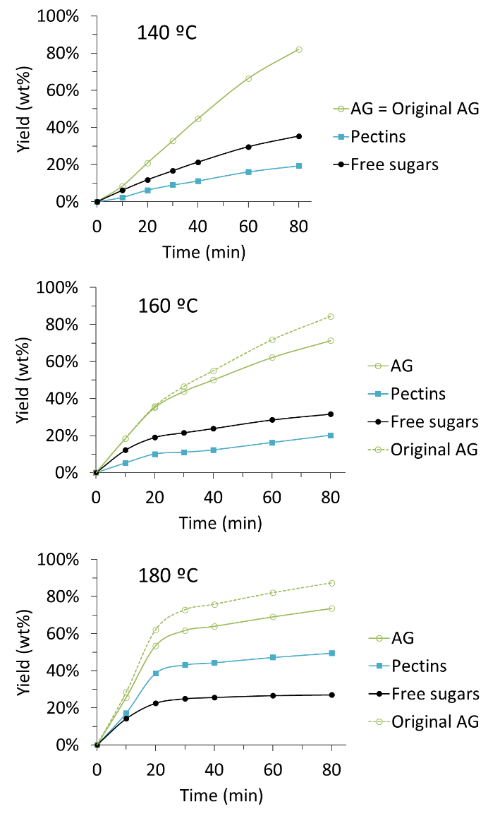
Fig. 2. Extraction yield (wt%) of arabinogalactan (AG), original AG, pectins, and free sugars during the hydrothermal treatment at 140, 160 and 180 ºC
Fig. 2 shows the extraction yield of hemicelluloses, pectins and free sugars taking as reference the amount of each of these products that were in the raw material introduced into the reactor. It is important to note that the yields shown refer to the quantity of each product obtained, which is not the same as the quantity of each product extracted. The actual extraction yield is known to be higher than that shown here. In any case the degradation must be taken into account, as well as the no recovered extract during the preheating, and consequently the maximum yields achieved were the following. From arabinogalactan 82.05 wt% was recovered at 140 °C a value that coincides with the yield of original AG as no monomeric units of arabinose were released. At 160 °C the AG was recovered at 71.34 wt (compared to 84.42 wt% of original AG) while at 180 °C it was recovered at 73.62 wt% (compared to 87.32 wt% of original AG). The extraction yield of original AG is consistent with the characterization of the residual pulp after extraction at 180 °C (with values of 5.61 wt% ± 0.49 as shown in section 3.4). Maximum pectin yields were 19.37 wt% (140 °C), 20.16 wt% (160 °C) and 49.52 wt% (180 °C). The extraction carried out in this flow-through reactor has shown, as in previous research (Gallina et al., 2018), that the semi-continuous operation is the best option for the extraction of hemicellulose and pectin.
Among hemicelluloses, pectins and free sugars, sugars are the easiest components to extract. The most common way of extracting free sugars from vegetables is by separating the juice by applying a mechanical treatment. This separation was carried out in the present work in order to apply hydrothermal treatment for the fractionation of the pulp of discarded carrots. The juice, on the other hand, was subjected to the recovery of its main components (sugar and carotenoids) in another work. The pulp stands out for its biopolymer content, but also for its abundant free sugar content. These sugars are found inside the vacuoles of the cells and can be extracted with hot water at atmospheric pressure. Several studies have applied this method, such as A. Clementz et al. (2019a), which managed to extract 82 % of free sugars from discarded carrots by mixing carrot flakes with water in a ratio of 1:1.5 at 60 ºC, under stirring at 100 rpm for 15 min. Given that the free sugars can be extracted with hot water, it is evident that a significant proportion of the sugars present in the pulp could be extracted in the batch reactor preheating stage together with the flow and pressure stabilization stage, as indicated in section 2.3. During these stages, the sugars have already begun to be extracted, but they were not recovered as part of the hydrolysate product because the operation was not considered to have begun since the operating temperature had not yet been reached. Despite this extraction, the sugars were the main components in the hydrothermal extract. The sugar yield obtained in the extracts, as shown in Fig. 2, was 35.26 wt% (140 ºC), 31.65 wt% (160 ºC) and 27.07 wt% (180 ºC). This implies that up to 64.74 wt% (140 ºC), 68.35 wt% (160 ºC) and 72.93 wt% (180 ºC) were mainly extracted in the preheating at 90 ºC, or degraded by the action of temperature in the hydrothermal treatment. The low concentration of by-products shown in Table 1 and the good extraction yield obtained by A. Clementz et al. (2019a) at 60 ºC for 15 min, leading to the conclusion that these percentages may correspond for the most part to extraction in the preheating at 90 ºC. A slightly higher value at a higher hydrothermal treatment temperature could be explained by the longer preheating time at 90 ºC until the water in the system reached the desired operating temperature (140, 160 and 180 ºC), or even with greater thermal degradation.

  - Molecular weight distribution of extracted free sugars, hemicelluloses and pectin
Fig. 3 represents the evolution of the molecular groups: pentamers, hexamers, between 1-5 kDa, 5-10 kDa, 10-30 kDa and > 30 kDa. The vertical axis of these graphs is the value of the area under the GPC chromatogram, equivalent to the RI detector intensity. The evolution of these groups was compared with the evolution in the concentration of hemicelluloses and pectins. The aim of the analysis was to identify whether both hemicelluloses and pectins were clearly associated with any of the molecular groups.

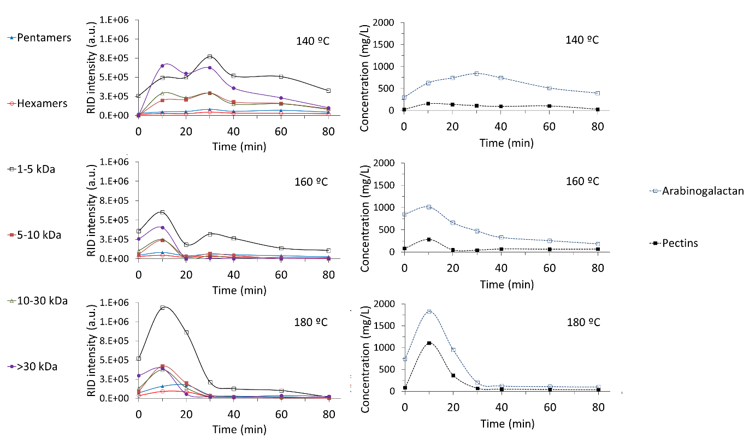
Fig. 3. Evolution of the GPC-concentration of (1) pentamers, (2) hexamers, (3) 1-5 kDa, (4) 5-10 kDa, (5) 10-30 kDa and (6) >30 kDa together with the HPLC-concentration of (1) arabinogalactan and (2) pectins during hydrothermal treatment at 140, 160 and 180 ºC
At 140 °C, at the initial time the only molecular group present was 1-5 kDa. Likewise, the concentration of pectins was very low compared to that of arabinogalactan, so the 1-5 kDa group could be identified as hemicelluloses that are easily released. As time passed, the majority molecular group became > 30 kDa, not yet significantly autohydrolyzed. It was followed by the easily extractable group 1-5 kDa, and then the other molecular groups in an order that matches the decreasing order of their molecular weight: 10-30 kDa, 5-10 kDa, and in very small proportions the pentamers and hexamers. It seems clear that 10-30 kDa and 5-10 kDa were formed from the breakdown of the > 30 kDa group, which was the majority. As the extraction took place, the molecular groups evolved similarly to each other, presenting two maximums, one at 10 min (logR₀ = 2.18) and another at 30 min (logR₀ = 2.65). From 40 min (logR₀ = 2.78), the decrease of the molecular group > 30 kDa was remarkable, leaving 1-5 kDa as the majority group again. The temporal evolution of hemicelluloses and pectins followed a similar trend to that of all the molecular groups. Hemicelluloses peaked at 30 min (logR₀ = 2.18), which could indicate that they were mainly in the molecular group > 30 kDa, which was the majority at that time.
At 160 °C, all the molecular groups were present at the initial moment, unlike at 140 °C. The groups in decreasing order were 1-5 kDa, > 30 kDa, 10-30 kDa, 5-10 kDa, pentamers and hexamers. This order was generally maintained over time. It should be noted that from 20 min (logR₀ = 3.07) the group 1-5 kDa was much higher than the others. This group presented two maximums, one at 10 min (logR₀ = 2.77) like the rest of molecular groups, and another at 30 min (logR₀ = 3.24). The first maximum can be associated with the extraction, since this group is the easiest to extract from the matrix. The second maximum could be associated with the breakage of larger molecular groups that gave rise to fragments in the range 1-5 kDa. This theory would be confirmed by looking at the evolution of hemicelluloses and pectins in the graph on the right. Arabinogalactan presented a maximum at 10 min (logR₀ = 2.77) from a maximum extraction, but then did not present a second maximum at 30 min (logR₀ = 3.24), as the hemicelluloses simply passed from one molecular group to others by autohydrolysis. Pectins peaked at 10 min (logR₀ = 2.77) and then moved to an approximately constant concentration. Consequently, it can be assumed that pectins were again associated with the highest molecular weight group > 30 kDa, and that they were then extracted in low proportion and autohydrolyzed to lower molecular weight groups, as the decrease in the > 30 kDa group was evident.
At 180 °C, at the initial moment of extraction the molecular groups were present in the same order as at 160 °C: 1-5 kDa, > 30 kDa, 10-30 kDa, 5-10 kDa, pentamers and hexamers. The 1-5 kDa group stands out against the other groups, as they were extracted and autohydrolyzed faster than at lower temperatures. The maximum of the curves of all molecular groups of molecular weight > 1 kDa was found at 10 min (logR₀ = 3.36). On the other hand, the lower molecular weight groups, pentamers and hexamers, had their maximum at 20 min (logR₀ = 3.66). This is due to the fact that they came from the autohydrolysis that took place in the other groups mainly after 10 min of extraction. In the molecular group 1-5 kDa some incorporation of hemicelluloses and pectins from higher molecular weight groups can also be observed after 20 min. The evolution in the concentration of arabinogalactan and pectins is clear, a single maximum after 10 min of extraction, and then a pronounced drop.
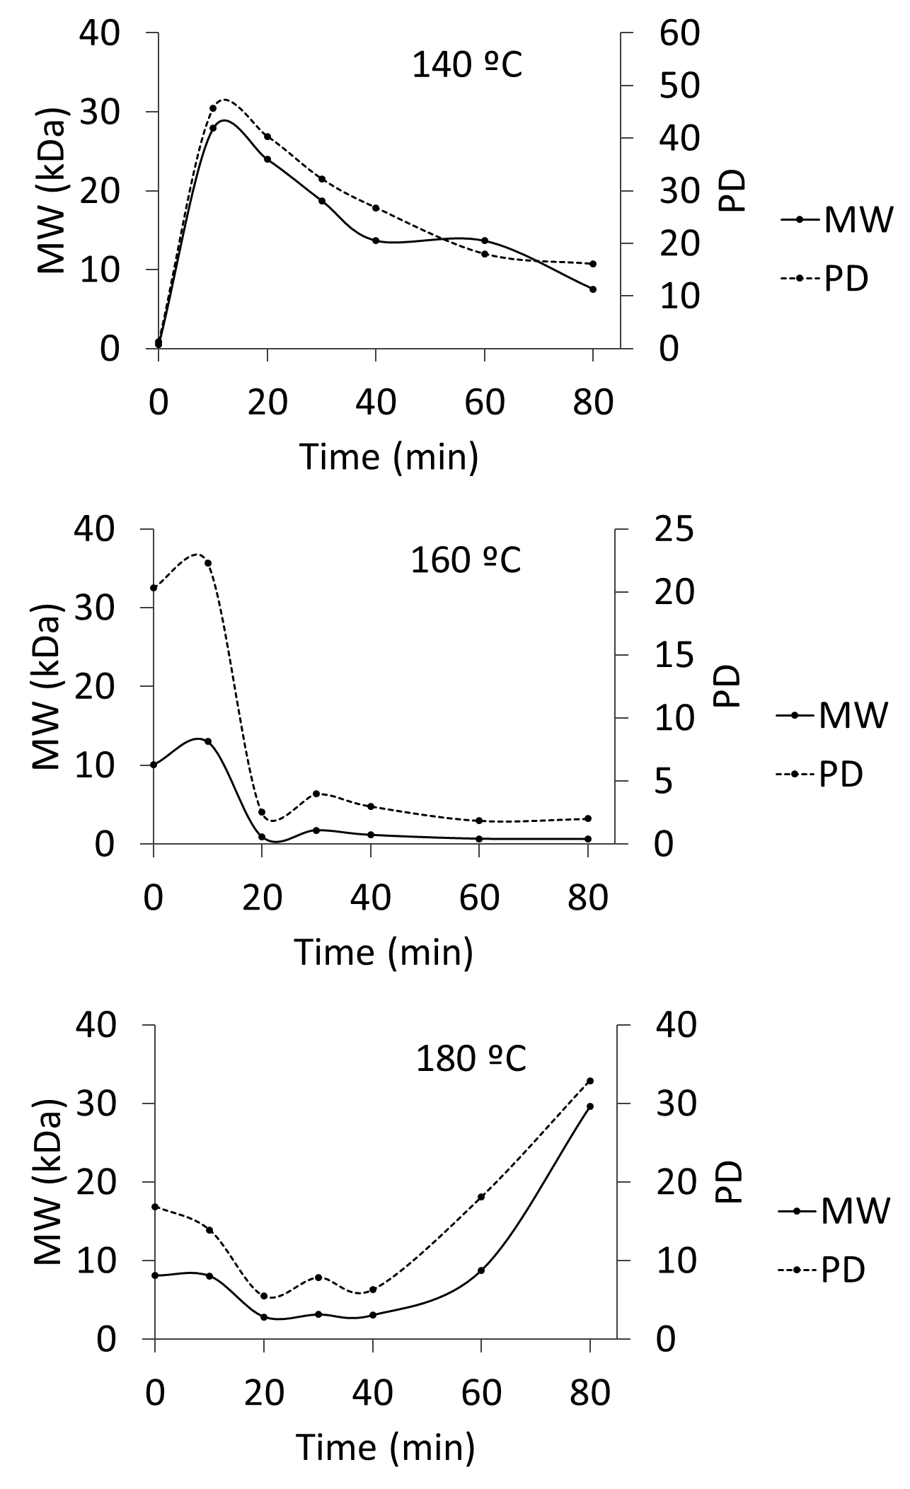
Fig. 4. Weight-average molecular weight (MW) and polydispersity (PD) at the outlet of the reactor during hydrothermal extraction at 140, 160 and 180 ºC
Fig. 4 shows the evolution of the weight average molecular weight (MW) and polydispersity index (PD). At 140 ºC, initially MW and PD increased due to a shift from extracting hemicelluloses and pectins between 1-5 kDa to extracting the group >30 kDa. As the >30 kDa group was extracted and autohydrolyzed to other molecular groups, MW and PD values decreased from 27.92 kDa and 45.74 to 7.53 kDa and 16.10 (10-80 min, logR₀ = 2.18-3.08). At 160 °C, in the first 10 min of extraction hemicelluloses and pectins of higher molecular weight (>30 kDa) were extracted and sucrose was almost entirely removed from the raw material, so that the MW and PD values raised from 10.09 kDa and 20.30 to 13.02 kDa and 22.30 (0-10 min, logR₀ < 2.77). Subsequently, extraction of the molecular group >30 kDa decreased and autohydrolysis phenomenon continued, which resulted in a significant decrease in MW and PD from 13.02 kDa and 22.30 to 0.65 kDa and 2.02 (10-80 min, logR₀ = 2.77-3.67). At 180 °C, the evolution of MW and PD during the first 40 min (logR₀ < 3.96) was equivalent to what happened at 140 and 160 °C, with MW and PD values falling from 8.11 kDa and 16.89 to 3.05 kDa and 6.27. After 40 min, the presence of low molecular weight groups decreased significantly, especially the group 1-5 kDa, which could be due to the fact that it has already been totally extracted from the raw material or has been autohydrolyzed to smaller groups. In addition, hemicelluloses and pectins > 30 kDa continued to be extracted although in very low concentration, which could be due to a better mass transfer in the structure of the already exhausted raw material. This resulted in an increase of MW and PD between 40-80 min (3.96 < logR₀ < 4.26) from 3.05 kDa and 6.27 to 29.60 kDa and 32.89.
  - Chemical and structural characterization of the carrot pulp after hydrothermal treatment at 180 °C
Carrot pulp after hydrothermal extraction at 180 °C was lyophilized to preserve well all the compounds. The characterization of this material in dry basis was: proteins (0.23 wt% ± 0.04), water extractives (17.76 wt% ± 0.35), hexane extractives (2.70 wt% ± 1.75), cellulose (57.46 wt% ± 1.78), hemicelluloses (5.61 wt% ± 0.38), pectin (0.50 wt% ± 0.70), and lignin (15.74 wt% ± 2.42). By removing the water extractives residue form the residual pulp it could become up to 70 wt% cellulose, which makes it of great interest for all those applications that need cellulose, as discussed in the section 3.5.
Table 1 compares the characterization of the pulp before and after extraction at 180 ºC, showing the amount of each of the compounds of interest that was in the reactor before starting the extraction and after it was completed. It also shows the amount recovered in the liquid extract of each of the components and the by-products, analyzed by HPLC according the method described in section 2.4.1. Before the start of the extraction the raw material had a content of 9.47 ± 0.01 g and 6.49 ± 0.02 g of hemicelluloses and pectins, respectively. After extraction, the content was reduced to 1.17 ± 0.01 g and 0.10 ± 0.01 g. Since 7.10 g of hemicelluloses and 3.27 g of pectins were recovered in the extract, this would imply a loss of 1.20 g of hemicelluloses and 3.11 g of pectins due to degradation, which is assumable given that the total of by-products in the extract was 7.66 g. The difference in the content of hemicelluloses and pectins before and after extraction implies an extraction percentage of 87.86 wt% for hemicelluloses and 98.49 wt% for pectins. These high yields prove that practically all of both biopolymers were extracted. The recovery values, also shown in section 3.2, were 73.65 wt% for hemicelluloses and 49.54 wt% for pectins. In the case of free sugars, the actual extraction yield at 180 ºC and according to Table 1 was 94.90 wt%, while the recovery yield of sugars was 27.07 wt%. Given the results, although at 180 ºC it is possible to extract almost all of the biopolymers, this temperature was not the most suitable for the recovery of free sugars, since they are easily extracted at lower temperatures. In fact, 67.84 wt% of the extracted sugars were not recovered because the vast majority was extracted during preheating at 90 ºC and conditioning, and also because of some degradation during the treatment. It is known that most of the unrecovered sugars were preextracted because the total content of by-products was not excessively high: 7.66 g compared to 45.57 g of unrecovered sugars. The preextraction in batch at 90 ºC seems on the contrary very suitable for the recovery of only free sugars. The difference between the dry mass in the reactor before (112.27 g) and after (17.02 g) hydrothermal extraction is made up of (1) the amount of free sugars, hemicellulose, pectins and by-products in the extract (36.21 g), (2) the amount of these components extracted during the preheating or degraded (50.17 g), and (3) an extra amount of extracted components (8.87 g) that were not free sugars, hemicellulose, pectins, or by-products, and could be lignin and/or protein.
Table 1. Mass balance of free sugars, hemicelluloses, pectins and by-products before and after hydrothermal extraction at 180 ºC

 | Initial pulp | Extracted pulp | Extract | Mass balance*
Free sugars (g) | 67.17 ± 0.92 | 3.42 ± 0.01 | 18.18 | 45.57
Hemicellulose (g) | 9.64 ± 0.01 | 1.17 ± 0.01 | 7.10 | 1.37
Pectins (g) | 6.60 ± 0.02 | 0.10 ± 0.01 | 3.27 | 3.23
By-products (g) | n.d. | n.d. | 7.66 | -
Total (g) | 83.41 ± 0.95 | 4.70 ± 0.03 | 36.21 | 50.17
Dry mass in the reactor (g) | 112.27 | 17.02 | - | -
*Note: This value includes pre-extraction during experimental system start-up (filling, preheating to 90 ºC and stabilization for about 20 min) and hydrothermal degradation

  - Structural characterization
3.5.1. FTIR
ATR-FTIR spectra of discarded carrot pulp before and after extraction at 180 ºC was determined (see Figure A.2). The structure changed significantly after carrying out this extraction. All the peaks present in the curve before the extraction continued to be in the curve after the extraction, but their absorbance changed. After extraction, absorbance decreased in only two areas: the 3700 – 3019 cm⁻¹ band, associated with –OH groups, and the 1640 cm⁻¹ peak, associated with the stretching C=O ester of sugars, hemicelluloses and pectins (Mohamed et al., 2011). The rest of the peaks and bands increased their absorbance considerably after extraction, especially the 2930 cm⁻¹ peak associated with asymmetrical C-H stretching of the cellulose (Mohamed et al., 2011). The peaks of the 830 – 1485 cm⁻¹ band also increased their absorbance: 899 cm⁻¹ associated to beta-links in cellulose (Célino et al., 2013), 1024 cm⁻¹ (Schulz and Baranska, 2007) and 1056 cm⁻¹ (Garside and Wyeth, 2004) associated to C-OH, 1101 cm⁻¹ associated to C-O-C glycosidic bond (Garside and Wyeth, 2004), 1158 cm⁻¹ (Dai and Fan, 2010) and 1175 cm⁻¹ (Troedec et al., 2007) associated with C-O-C symmetrical stretching, 1262 cm⁻¹ associated with G ring stretching (Fan et al., 2012), 1315 cm⁻¹ associated with CH2 wagging of cellulose (Célino et al., 2013), 1366 cm⁻¹ associated with C-H (Garside and Wyeth, 2004), and 1427 cm⁻¹ associated with carboxylic acid and COO- vibration (Célino et al., 2013). As a result, after extraction, the absorbance of bonds present in sugars, hemicelluloses and pectins decreased, as they were released from the raw material in a high percentage. The peaks of bonds present in cellulose increased because it became the majority component, being also more accessible due to the extraction of the biopolymers of hemicellulose and pectin.
3.5.2. TGA
A thermogravimetric analysis was carried out on the pulp before and after its hydrothermal extraction at 180 ºC (see Figure A.1). Five thermal degradation zones can be distinguished. In the first region degradation took place at temperatures between 49.7 and 138.9 °C. This matter represents 5.36 wt% of the total, and can be associated with humidity. The next region corresponds to temperatures between 138.9 and 215.6 °C, and in it the degradation of monosaccharide type sugars (glucose and fructose) could take place (Abd-Elrahman and Ahmed, 2009), being 16.56 wt% of the total. The next region is that between 215.6 and 242.4 °C and would correspond to the degradation of sucrose (Abd-Elrahman and Ahmed, 2009), being 11.80 wt% of the total. Next is the region 242.4 and 316.5 °C, which could be associated with the degradation of hemicelluloses and pectins (Cabeza et al., 2015), being 19.40 wt% of the total. The last region is that between 316.5 and 898.5 °C, which can be identified with the degradation of cellulose and lignin (Cabeza et al., 2015), being a 22.41 wt% of the total. Finally, 24.47 wt% of the matter was left undegraded in the form of charcoal.
After extraction the thermogram was clearly divided into three sections. The first section ranges from 50.2 to 176.3 °C and represents 4.78 wt% of the matter that can be associated with moisture. The main region of degradation was that between 175.8 and 361.9 °C, an in the same way as in the carrot pulp, a first zone could be distinguished between 175.8 and 316.5 °C that is associated to monosaccharides, sucrose, hemicelluloses and pectins, being 9.68 wt% of the matter. The next zone of degradation would be that between 316.5 and 361.9 °C, which represents 36.98 wt% of the matter, and can be associated to cellulose. Cellulose and lignin continued to degrade in the final region between 361.9 and 898.2 °C, with a percentage of 33.00 wt% of the total. The final residual carbonaceous material formed was 15.56 wt%.
3.5.3. SEM
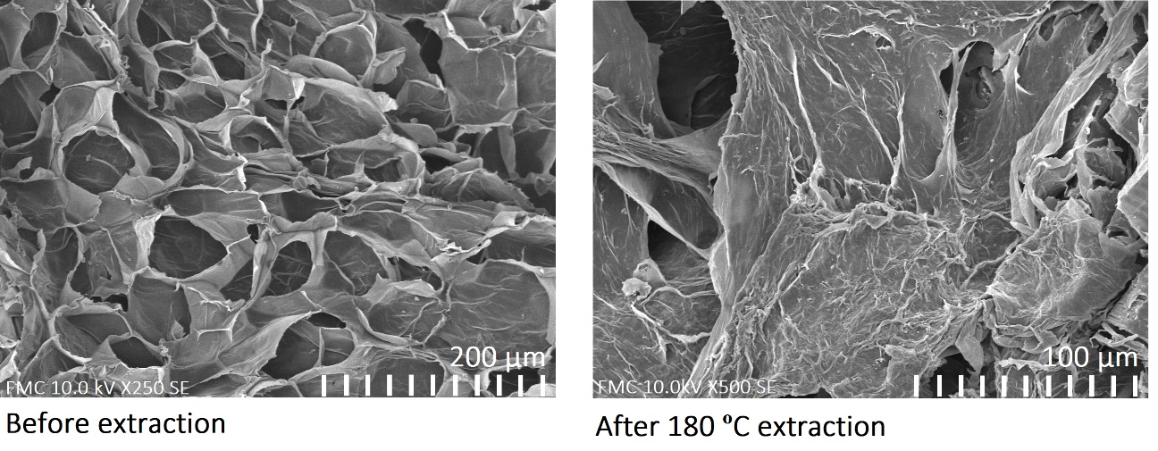
Fig. 5. SEM images of discarded carrot pulp before and after hydrothermal treatment at 180 ºC
Fig. 5 shows two SEM images of carrot pulp before and after hydrothermal treatment at 180 ºC. The change in the structure of carrot pulp is evident, where almost all the free sugars, pectins and hemicelluloses have been extracted. The structure before extraction contains cells arranged regularly and compactly. The new structure shows the presence in high proportion of cellulose linear fibres. This new structure maintains the non-hydrothermally extractable components: cellulose (57.46 ± 1.78 wt%), lignin (15.74 ± 2.42 wt%) and water extractives (17.76 ± 0.35 wt%), as was explained in section 3.4.
Liu et al. (2019) indicated that the cellulose present in the biomass residual pulp can be used to produce cellulose-based ionic liquids, functional composites, adsorbent materials, carbon and aerogels. It is important that the treatment applied to the biomass increases the percentage of cellulose and in turn, leaves cellulose unharmed. An example is the Fenton treatment that increased the cellulose content to 55.8 % in sugarcane bagasse (Den et al., 2018). On the other hand, Nitsos et al. (2013) subjected biomass samples to hydrothermal treatment, and under the severity factor 4.69 (220 ºC, 15 min) increased the cellulose content from 42 % to 63 %, a value similar to this work (57.46 wt%). Bearing in mind all the possible applications, work is currently being conducted on the valorization of the residual pulp obtained in the present study in search of an application as additive within the food packaging sector. Cellulose is a material with excellent properties in this sector due to its biodegradability, mechanical properties and sustainability. Although most of the cellulose used in industrial applications comes from wood, or cotton in the textile industry, it is more suitable from an environmental point of view to use vegetable waste.

- Conclusions
The pulp of discarded carrots was valorized in a novel way by hydrothermal treatment (140, 160 and 180 °C), giving rise to the obtaining of three products in the liquid phase: free sugars (211.0 g/kg dry pulp), homogalacturonan pectin (29.13 g/kg dry pulp) and arabinogalactan hemicellulose (70.45 g/kg dry pulp). The extraction in flow-through mode made it possible to obtain hemicelluloses of molecular weights > 30 kDa together with the 1-5 kDa group, both as majority in the extracts. The detailed study of the molecular weight distribution allowed to determine that pectins are mainly associated to hemicelluloses of > 30 kDa, experiencing also autohydrolysis to lower values. Due to the high extraction yield, the residual pulp content in cellulose was around 60 wt%, being an interesting material for cellulose valorization. Subsequent treatment by ultrafiltration will allow the use of hemicelluloses and pectins of the highest molecular weight in applications such as film forming, where the residual pulp can also be used as an additive.

Acknowledgments
The authors would like to thank the Spanish Economy and Competitiveness Ministry and FEDER Funds EU, Project Reference: CTQ2016-79777-R (MINECO/FEDER, EU) and PID2019-105975GB-I00 (MICINN/FEDER, EU) for funding. Marta Ramos-Andrés would also like to thank to the Spanish Ministry of Education Culture and Sports for the research-university professor training contract (reference FPU15/06366). The authors wish also to thank Muñozval S.L. for the raw material and the advice.
References
Abd-Elrahman, M.I., Ahmed, S.M., 2009. Thermal degradation kinetics and geometrical stability of D-sucrose. Int. J. Polym. Mater. Polym. Biomater. 58, 322–335. https://doi.org/10.1080/00914030902859273
Aimaretti, N., Ybalo, C., 2012. Valorization of carrot and yeast discards for the obtention of ethanol. Biomass and Bioenergy 42, 18–23. https://doi.org/10.1016/j.biombioe.2012.03.022
Berglund, L., Breedveld, L., Oksman, K., 2020. Toward eco-efficient production of natural nanofibers from industrial residue: Eco-design and quality assessment. J. Clean. Prod. 255, 120274. https://doi.org/10.1016/j.jclepro.2020.120274
Borrega, M., Larsson, P.T., Ahvenainen, P., Ceccherini, S., Maloney, T., Rautkari, L., Sixta, H., 2018. Birch wood pre-hydrolysis vs pulp post-hydrolysis for the production of xylan-based compounds and cellulose for viscose application. Carbohydr. Polym. 190, 212–221. https://doi.org/10.1016/j.carbpol.2018.02.064
Cabeza, A., Sobrón, F., Yedro, F.M., García-Serna, J., 2015. Autocatalytic kinetic model for thermogravimetric analysis and composition estimation of biomass and polymeric fractions. Fuel 148, 212–225. https://doi.org/10.1016/j.fuel.2015.01.048
Célino, A., Fréour, S., Jacquemin, F., Casari, P., 2013. Characterization and modeling of the moisture diffusion behavior of natural fibers. J. Appl. Polym. Sci. 130, 297–306. https://doi.org/10.1002/app.39148
Christiaens, S., Uwibambe, D., Uyttebroek, M., Van Droogenbroeck, B., Van Loey, A.M., Hendrickx, M.E., 2015. Pectin characterisation in vegetable waste streams: A starting point for waste valorisation in the food industry. LWT - Food Sci. Technol. 61, 275–282. https://doi.org/10.1016/j.lwt.2014.12.054
Clementz, A., Torresi, P.A., Molli, J.S., Cardell, D., Mammarella, E., Yori, J.C., 2019a. Novel method for valorization of by-products from carrot discards. Lwt 100, 374–380. https://doi.org/10.1016/j.lwt.2018.10.085
Clementz, A., Torresi, P.A., Yori, J.C., Molli, J.S., Cardell, D., Mammarella, E., 2019b. Novel method for valorization of by-products from carrot discards. LWT - Food Sci. Technol. 100, 374–380. https://doi.org/10.1016/j.lwt.2018.10.085
Clementz, A.L., Manuale, D., Sanchez, E., Vera, C., Yori, J.C., 2019. Use of discards of bovine bone, yeast and carrots for producing second generation bio-ethanol. Biocatal. Agric. Biotechnol. 22, 101392. https://doi.org/10.1016/j.bcab.2019.101392
Dai, D., Fan, M., 2010. Characteristic and Performance of Elementary Hemp Fibre. Mater. Sci. Appl. 01, 336–342. https://doi.org/10.4236/msa.2010.16049
de Andrade Lima, M., Charalampopoulos, D., Chatzifragkou, A., 2018. Optimisation and modelling of supercritical CO2 extraction process of carotenoids from carrot peels. J. Supercrit. Fluids 133, 94–102. https://doi.org/10.1016/j.supflu.2017.09.028
De Vrije, T., Budde, M.A.W., Lips, S.J., Bakker, R.R., Mars, A.E., Claassen, P.A.M., 2010. Hydrogen production from carrot pulp by the extreme thermophiles Caldicellulosiruptor saccharolyticus and Thermotoga neapolitana. Int. J. Hydrogen Energy 35, 13206–13213. https://doi.org/10.1016/j.ijhydene.2010.09.014
Den, W., Sharma, V.K., Lee, M., Nadadur, G., Varma, R.S., 2018. Lignocellulosic biomass transformations via greener oxidative pretreatment processes: Access to energy and value added chemicals. Front. Chem. 6, 1–23. https://doi.org/10.3389/fchem.2018.00141
Dong, H., Zheng, L., Yu, P., Jiang, Q., Wu, Y., Huang, C., Yin, B., 2020. Characterization and Application of Lignin-Carbohydrate Complexes from Lignocellulosic Materials as Antioxidants for Scavenging in Vitro and in Vivo Reactive Oxygen Species. ACS Sustain. Chem. Eng. 8, 256–266. https://doi.org/10.1021/acssuschemeng.9b05290
Dranca, F., Oroian, M., 2018. Extraction, purification and characterization of pectin from alternative sources with potential technological applications. Food Res. Int. 113, 327–350. https://doi.org/10.1016/j.foodres.2018.06.065
Encalada, A.M.I., Pérez, C.D., Flores, S.K., Rossetti, L., Fissore, E.N., Rojas, A.M., 2019. Antioxidant pectin enriched fractions obtained from discarded carrots (Daucus carota L.) by ultrasound-enzyme assisted extraction. Food Chem. 289, 453–460. https://doi.org/10.1016/j.foodchem.2019.03.078
Fan, M., Dai, D., Huang, B., 2012. Fourier Transform Infrared Spectroscopy for Natural Fibres, in: Fourier Transform - Materials Analysis. https://doi.org/10.5772/35482
Gallina, G., Alfageme, E.R., Biasi, P., García-Serna, J., 2018. Hydrothermal extraction of hemicellulose: from lab to pilot scale. Bioresour. Technol. 247, 980–991. https://doi.org/10.1016/j.biortech.2017.09.155
Garside, P., Wyeth, P., 2004. Identification of Cellulosic Fibres by FTIR Spectroscopy: Thread and Single Fibre Analysis by Attenuated Total Reflectance. Stud. Conserv. 48, 269–275. https://doi.org/10.1179/sic.2003.48.4.269
Grassino, A.N., Halambek, J., Djaković, S., Rimac Brnčić, S., Dent, M., Grabarić, Z., 2016. Utilization of tomato peel waste from canning factory as a potential source for pectin production and application as tin corrosion inhibitor. Food Hydrocoll. 52, 265–274. https://doi.org/10.1016/j.foodhyd.2015.06.020
Grimi, N., Praporscic, I., Lebovka, N., Vorobiev, E., 2007. Selective extraction from carrot slices by pressing and washing enhanced by pulsed electric fields. Sep. Purif. Technol. 58, 267–273. https://doi.org/10.1016/j.seppur.2007.03.020
Hames, B., Scarlata, C., Sluiter, A., 2008. Determination of Protein Content in Biomass NREL/TP-510-42625, National Renewable Energy Laboratory.
Hiranvarachat, B., Devahastin, S., 2014. Enhancement of microwave-assisted extraction via intermittent radiation: Extraction of carotenoids from carrot peels. J. Food Eng. 126, 17–26. https://doi.org/10.1016/j.jfoodeng.2013.10.024
Huang, C., Wang, X., Liang, C., Jiang, X., Yang, G., Xu, J., Yong, Q., 2019. A sustainable process for procuring biologically active fractions of high-purity xylooligosaccharides and water-soluble lignin from Moso bamboo prehydrolyzate. Biotechnol. Biofuels 12, 1–13. https://doi.org/10.1186/s13068-019-1527-3
Idrovo Encalada, A.M., Pérez, C.D., Rossetti, L., Rojas, A.M., Fissore, E.N., 2020. Carrot pectin enriched fraction as a functional additive: Antioxidant and gelling effects in a model spreadable chia oil-in-water emulsion. Food Hydrocoll. 108. https://doi.org/10.1016/j.foodhyd.2020.106037
Immerzeel, P., Eppink, M.M., De Vries, S.C., Schols, H.A., Voragen, A.G.J., 2006. Carrot arabinogalactan proteins are interlinked with pectins. Physiol. Plant. 128, 18–28. https://doi.org/10.1111/j.1399-3054.2006.00712.x
Jafari, F., Khodaiyan, F., Kiani, H., Hosseini, S.S., 2017. Pectin from carrot pomace: Optimization of extraction and physicochemical properties. Carbohydr. Polym. 157, 1315–1322. https://doi.org/10.1016/j.carbpol.2016.11.013
Liu, Y., Nie, Y., Lu, X., Zhang, X., He, H., Pan, F., Zhou, L., Liu, X., Ji, X., Zhang, S., 2019. Cascade utilization of lignocellulosic biomass to high-value products. Green Chem. 21, 3499–3535. https://doi.org/10.1039/c9gc00473d
Martínez, M., Gullón, B., Yáñez, R., Alonso, J.L., Parajó, J.C., 2010. Kinetic assessment on the autohydrolysis of pectin-rich by-products. Chem. Eng. J. 162, 480–486. https://doi.org/10.1016/j.cej.2010.05.048
Mohamed, G.F., Shaheen, M.S., Khalil, S.K.H., Hussein, A.M.S., Kamil, M.M., 2011. Application of FT-IR Spectroscopy for Rapid and Simultaneous Quality Determination of Some Fruit Products. Nat. Sci. 9, 21–31.
Natarajmurthy, S.H., Askari, M., Pullabhatla, S., Dharmesh, S.M., 2016. A novel β-carotene-associated carrot (Daucus carota L.) pectic polysaccharide. Nutrition 32, 818–826. https://doi.org/10.1016/j.nut.2016.01.002
Nayak, A., Bhushan, B., 2019. An overview of the recent trends on the waste valorization techniques for food wastes. J. Environ. Manage. 233, 352–370. https://doi.org/10.1016/j.jenvman.2018.12.041
Neckebroeck, B., Verkempinck, S.H.E., Vaes, G., Wouters, K., Magnée, J., Hendrickx, M.E., Van Loey, A.M., 2020. Advanced insight into the emulsifying and emulsion stabilizing capacity of carrot pectin subdomains. Food Hydrocoll. 102. https://doi.org/10.1016/j.foodhyd.2019.105594
Neto, F.S.P.P., Roldán, I.U.M., Galán, J.P.M., Monti, R., de Oliveira, S.C., Masarin, F., 2020. Model-based optimization of xylooligosaccharides production by hydrothermal pretreatment of Eucalyptus by-product. Ind. Crops Prod. 154, 112707. https://doi.org/10.1016/j.indcrop.2020.112707
Nitsos, C.K., Choli-Papadopoulou, T., Matis, K.A., Triantafyllidis, K.S., 2016. Optimization of hydrothermal pretreatment of hardwood and softwood lignocellulosic residues for selective hemicellulose recovery and improved cellulose enzymatic hydrolysis. ACS Sustain. Chem. Eng. 4, 4529–4544. https://doi.org/10.1021/acssuschemeng.6b00535
Nitsos, C.K., Matis, K.A., Triantafyllidis, K.S., 2013. Optimization of hydrothermal pretreatment of lignocellulosic biomass in the bioethanol production process. ChemSusChem 6, 110–122. https://doi.org/10.1002/cssc.201200546
Peng, P., She, D., 2014. Isolation, structural characterization, and potential applications of hemicelluloses from bamboo: A review. Carbohydr. Polym. 112, 701–720. https://doi.org/10.1016/j.carbpol.2014.06.068
Piqueras, C.M., Cabeza, Á., Gallina, G., Cantero, D.A., García-Serna, J., Cocero, M.J., 2017. Online integrated fractionation-hydrolysis of lignocellulosic biomass using sub- and supercritical water. Chem. Eng. J. 308, 110–125. https://doi.org/10.1016/j.cej.2016.09.007
Rajinipriya, M., Nagalakshmaiah, M., Robert, M., Elkoun, S., 2018. Homogenous and transparent nanocellulosic films from carrot. Ind. Crops Prod. 118, 53–64. https://doi.org/10.1016/j.indcrop.2018.02.076
Ramos-Andrés, M., Andrés-Iglesias, C., García-Serna, J., 2019. Production of molecular weight fractionated hemicelluloses hydrolyzates from spent coffee grounds combining hydrothermal extraction and a multistep ultrafiltration/diafiltration. Bioresour. Technol. 292, 121940. https://doi.org/https://doi.org/10.1016/j.biortech.2019.121940
Ribas-Agustí, A., Van Buggenhout, S., Palmero, P., Hendrickx, M., Van Loey, A., 2014. Investigating the role of pectin in carrot cell wall changes during thermal processing: A microscopic approach. Innov. Food Sci. Emerg. Technol. 24, 113–120. https://doi.org/10.1016/j.ifset.2013.09.005
Riganakos, K.A., Karabagias, I.K., Gertzou, I., Stahl, M., 2017. Comparison of UV-C and thermal treatments for the preservation of carrot juice. Innov. Food Sci. Emerg. Technol. 42, 165–172. https://doi.org/10.1016/j.ifset.2017.06.015
Rodríguez, A., Moral, A., Sánchez, R., Requejo, A., Jiménez, L., 2009. Influence of variables in the hydrothermal treatment of rice straw on the composition of the resulting fractions. Bioresour. Technol. 100, 4863–4866. https://doi.org/10.1016/j.biortech.2009.04.030
Schulz, H., Baranska, M., 2007. Identification and quantification of valuable plant substances by IR and Raman spectroscopy. Vib. Spectrosc. 43, 13–25. https://doi.org/10.1016/j.vibspec.2006.06.001
Sluiter, A., Hames, B., Hyman, D., Payne, C., Ruiz, R., Scarlata, C., Sluiter, J., Templeton, D., Wolfe, J., 2008a. Determination of Total Solids in Biomass and Total Dissolved Solids in Liquid Process Samples NREL/TP-510-4261, National Renewable Energy Laboratory. https://doi.org/NREL/TP-510-42621
Sluiter, A., Hames, B., Ruiz, R., Scarlata, C., Sluiter, J., Templeton, D., 2008b. Determination of Ash in Biomass NREL/TP-510-42622. Laboratory Analytical Procedure (LAP), National Renewable Energy Laboratory. https://doi.org/NREL/TP-510-42619
Sluiter, A., Hames, B., Ruiz, R.O., Scarlata, C., Sluiter, J., Templeton, D., Energy, D. of, 2004. Determination of Structural Carbohydrates and Lignin in Biomass, Biomass Analysis Technology Team Laboratory Analytical Procedure.
Sluiter, A., Ruiz, R., Scarlata, C., Sluiter, J., Templeton, D., 2008c. Determination of Extractives in Biomass. NREL/TP-510-42619, National Renewable Energy Laboratory.
Sogut, E., Cakmak, H., 2020. Utilization of carrot (Daucus carota L.) fiber as a filler for chitosan based films. Food Hydrocoll. 106. https://doi.org/10.1016/j.foodhyd.2020.105861
Sucheta, Misra, N.N., Yadav, S.K., 2020. Extraction of pectin from black carrot pomace using intermittent microwave, ultrasound and conventional heating: Kinetics, characterization and process economics. Food Hydrocoll. 102, 105592. https://doi.org/10.1016/j.foodhyd.2019.105592
Surbhi S, Rc, V., Deepak R, Hk, J., Kk, Y., 2018. A review: Food, chemical composition and utilization of carrot (Daucus carota L.) pomace. Int. J. Chem. Stud. 6, 2921–2926.
Troedec, M. Le, Peyratout, C., Chotard, T., Bonnet, J.P., Smith, A., Troedec, M. Le, Peyratout, C., Chotard, T., Bonnet, J.P., Smith, A., 2007. Physico-chemical modifications of the interactions between hemp fibres and a lime mineral matrix : impacts on mechanical properties of mortars e ere To cite this version : 10th Int. Conf. Eur. Ceram. Soc. 451–456. https://doi.org/HAL:http://hal.archives-ouvertes.fr/hal-00282100/en/
Varanasi, S., Henzel, L., Sharman, S., Batchelor, W., Garnier, G., 2018a. Producing nanofibres from carrots with a chemical-free process. Carbohydr. Polym. 184, 307–314. https://doi.org/10.1016/j.carbpol.2017.12.056
Varanasi, S., Henzel, L., Sharman, S., Batchelor, W., Garnier, G., 2018b. Producing nanofibres from carrots with a chemical-free process. Carbohydr. Polym. 184, 307–314. https://doi.org/10.1016/j.carbpol.2017.12.056
Wang, P., Yin, B., Dong, H., Zhang, Yibo, Zhang, Yangheng, Chen, R., Yang, Z., Huang, C., Jiang, Q., 2020. Coupling Biocompatible Au Nanoclusters and Cellulose Nanofibrils to Prepare the Antibacterial Nanocomposite Films. Front. Bioeng. Biotechnol. 8, 1–13. https://doi.org/10.3389/fbioe.2020.00986

