Pilot-scale biorefinery for the production of purified biopolymers based on hydrothermal treatment in flow-through reactor cycles
Marta Ramos-Andrés, Sergio Díaz-Cesteros, Natasha Majithia and Juan García-Serna*
Grupo de Tecnologías a Presión (PressTech), Instituto de Bioeconomía de la Universidad de Valladolid (BioEcoUVa), Departamento de Ingeniería Química y Tecnologías del Medio Ambiente, Escuela de Ingenierías Industriales, Universidad de Valladolid, 47011, Valladolid, SPAIN
* Corresponding author, Tel.: +34983423172, e-mail: juan.garcia.serna@uva.es

Abstract
Purified solid fractions of hemicellulose and pectin biopolymers with different molecular weight were produced on a pilot-scale from discarded carrots. The pulp was subjected to hydrothermal extraction on a pilot plant operating in cycles of three flow-through reactors in series at 140 and 180 °C. Two operational modes of start-up (with and without water pre-filling) were tested, showing that it influences the final hydrolysate concentration and the stability of the system. Free sugars, arabinogalactan hemicellulose and homogalacturonan pectin were produced at maximum recoveries of 379.5 g/kg dry pulp, 81.0 g/kg dry pulp and 5.35 g/kg dry pulp, respectively, with the extraction of arabinogalactan reaching a yield of 96.1 % (w/w). The extracted biopolymers were separated and purified through ultrafiltration and diafiltration cycles using a multi-membrane system (30, 10, 1 kDa). Ultrafiltration and especially diafiltration allowed going from extracts with molecular weight, polydispersity and purity values of 14.77 kDa, 19.2 and 22.2 % w/w (140 °C extract) and 8.08 kDa, 18. 2 and 14.9 % w/w (180 °C extract), to fractions with values of 80.36 kDa – 67.77 kDa - 9.85 kDa – 5.23 kDa and 3.86 kDa (molecular weight), 1.3 – 3.8 (polydispersity), and 64.5 – 100 % w/w (purity). The five fractions were freeze-dried and spray-dried. The pilot-scale system allowed the production of purified biopolymer fractions of high purity, different average molecular weight, and in sufficient quantity for their subsequent transformation into products such as biodegradable films.

Keywords
autohydrolysis; films; discarded carrot; purification; hemicellulose; pectin

Introduction
Food waste is a serious problem worldwide. Around 35 % of total food production is wasted in the European Union [1]. Within food waste, vegetable waste is the most abundant. Vegetable food discards are the most abundant and can be produced from cultivation to consumption. The problems derived from this waste are twofold: economic, due to the losses they entail, and environmental, due to the resulting decomposition processes (e.g., emitting methane). Vegetal food waste is usually characterized by high moisture and organic matter content, which makes it susceptible to rapid degradation if it is not managed appropriately. There are currently not many ways of valorizing this waste. The use for animal feed is an option but sometimes logistics are too complicated. As incineration is inefficient due to the high moisture content, a usual destination is landfill [2].
Carrot (Daucus carota L.) is one of the most important cultivated vegetables, with an estimated annual world production of 36 million tons [3]. The most important waste from carrot cultivation is the so-called discarded carrots, those that cannot reach the consumer because they do not meet the standards for size, color, shape, etc. It is estimated that around 30 % of the total amount cultivated ends up being discarded at the various stages [1]. Another type of waste is the pulp derived from the juice industries, which has similar characteristics to fresh carrots but is even more prone to degradation. To apply a valorization process to carrots as vegetable waste, it is necessary to determine their composition. Carrots stand out as a source of phytonutrients such as carotenoids, vitamins (A, B, C, D, E, and K), minerals (calcium, potassium, phosphorus, sodium, and iron), and bioactive compounds [4]. The major components are sucrose (30.20 % w/w), glucose (19.44 % w/w), fructose (9.11 % w/w), cellulose (10.71 % w/w), hemicellulose (8.43 % w/w), pectins (5.78 % w/w), proteins (2.26 % w/w), hexane extractives (1.20 % w/w), and lignin (7.75 % w/w) [5].
Hemicelluloses extracted in their polymeric form have interesting applications as hydrogels, biodegradable barrier films for food packaging, paper additives, adhesives, emulsifiers, stabilizers, thickeners, and binders in the food, pharmaceutical, and cosmetic industries [6]. Pectins are biopolymers present in the primary cell wall and middle lamella of higher plants and they consist mainly in α-galacturonic acid subunits. In the industry, they are mostly obtained from fruit peel, mainly from citrus fruits such as lemon, orange, and lime [7]. Once extracted, pectins are mainly used as additives in the food industry for thickening, gelling, stabilizing, and emulsifying [8]. They are also used as encapsulating agents, and are attributed to interesting properties in the pharmaceutical industry such as lowering cholesterol, reducing blood pressure, and restoring intestinal function.
The most common methods of extraction of hemicelluloses are alkaline, organosolv, acid, and hydrothermal treatment. In the case of pectin, the most common method is acidic extraction using a dilute mineral acid (hydrochloric acid, nitric acid, and sulfuric acid). The hydrothermal method has significant advantages over the others, with biomass and water being the only reagents involved. The cause of extraction in this treatment is the formation of hydronium ions when the water exceeds 120 °C. These ions acidify the medium and cause the extraction of hemicelluloses and pectins, leading in turn to the release of organic acids resulting from the depolymerization of hemicelluloses/pectins. These organic acids autocatalyze the process through the phenomenon of autohydrolysis.
The extraction of hemicelluloses and pectins is always accompanied by certain by-products such as organic acids and compounds derived from their degradation. In the case of carrot pulp, free sugars are the major components of the extract as they are also the major components of the pulp. The presence of by-products and especially the presence of free sugars creates the need to perform a separation and purification treatment of the hemicelluloses and pectins. The most common methods are ethanol precipitation and chromatography, although the most advantageous is ultrafiltration with membranes. Ultrafiltration is a simple process, easy to scale up, does not require chemicals, and has operating conditions close to ambient conditions. Although ultrafiltration improves the concentration and separation of biopolymers, diafiltration is a complementary process that has demonstrated its strong advantages in improving separation and achieving biopolymer purification [9]. Diafiltration consists of adding water to the retentate to subject it to successive cycles in which it is ultrafiltrated, thus facilitating the removal of small compounds that are not of interest. The water addition cycles are repeated until the desired purity is achieved.
Regarding hydrothermal extraction, flow-through or semicontinuous reactors are characterized by having the biomass retained inside and allowing the continuous flow of water through the reactor. In this way, the extracted compounds leave the reaction zone continuously, reducing their depolymerization and degradation. In addition, the continuous inflow of fresh water increases the extraction yield compared to batch extraction. No extreme milling of the biomass is required as there is no need for the creation of a suspension to be pumped as in the case of continuous reactors. One of the strongest features of the reactors used in this work is the system of loading and unloading of biomass by means of a cartridge and previously described [10], which allows the operation with cycles of several reactors in series and at pilot-scale, being the reactors added and removed over time in a fast way. This system is patented [11].
The extraction of hemicellulose and pectin biopolymers with a high molecular weight, and their subsequent separation and purification through ultrafiltration and diafiltration would allow obtaining polymeric fractions with very suitable properties. The main purpose of these fractions would be to act as substitutes for petroleum-derived polymers in the formation of materials such as films for food packaging. Obtaining these films from vegetable food waste is a huge advantage from a bio-economic point of view. Performing the extraction and conditioning process on a pilot scale enables for further processing and the production of bio-based products.
Pilot-scale operation is key to assess technoeconomic feasibility prior to full scale implementation. From a mass and energy balance point of view, operating at pilot provides a better and steadier overall view scale compared to laboratory scale. From a practical point of view, laboratory-scale extraction of biopolymers provides data on the extraction process and the components extracted but does not provide sufficient biopolymer product for proof-of-concept testing of materials.
Several pilot-scale works have been developed for the extraction of hemicelluloses and their transformation or purification. In one of the first works carried out by Thomsen et al., they used a pilot plant consisting of three reactors for the valorization of wheat straw [12]. The objective was to obtain bioethanol by hydrothermal extraction of hemicelluloses (second reactor, preheating in the first reactor) and fermentation of the sugars derived from enzymatic hydrolysis applied to the residual solid (third reactor). Electricity generation from the lignin present in the solid after the enzymatic hydrolysis was also studied. The maximum extraction yield of hemicelluloses was 83 %, but under further optimized conditions a recovery of 70 % of hemicelluloses, 93-94 % of the cellulose converted to fibers, and 89 % of the cellulose in the fibers converted to ethanol were achieved [13].
Makishima et al. applied hydrothermal treatment in a flow-through reactor in a pilot plant for the extraction of hemicelluloses from corncob [14]. The best operating conditions were 200 °C and 10 min, obtaining 82.2 % of the xylan with wide molecular weight distribution. The highest molecular weight fraction was recovered by ultrafiltration and ion exchange resin. Using a different method than the hydrothermal treatment but with the same objective, Jacquemin et al. performed the extraction of hemicelluloses from wheat straw on a pilot-scale by twin screw extrusion [15]. The treatment of the extract was performed by ultrafiltration (purification) followed by ion exchange chromatography (decolorization) and freeze drying. A yield of 24.3 % of total hemicelluloses was obtained and the hemicellulose content of the final powder was 13.9 %, i.e., low purity. The main difficulty was to concentrate and purify at the same time in ultrafiltration as well as the presence of proteins in the extract. The molecular weight cut-off of the ultrafiltration was 10 kDa, and both diafiltration and a higher molecular size might have provided better results.
More recently, Al-Rudainy et al. focused their work on the step from laboratory to pilot-scale of the ultrafiltration process of hemicelluloses [16]. The hemicelluloses came from spent sulfite liquor, a by-product of the sulfite pulping process of wood. The material used in the study contained polymeric hemicelluloses due to the conditions employed. Permeate flux and hemicelluloses retention were lower at pilot-scale, perhaps due to worse hydrodynamics which was studied through computational fluid dynamics. Fouling of the membranes was also studied.
The co-production of the hemicelluloses xylooligosaccharides and butanol from Eucalyptus grandis wood by steam explosion in a pre-pilot scale flow-through reactor was performed by Cebreiros et al. [17]. The best operating conditions were 200 °C, 1.5 MPa, and 10 min, allowing the recovery of about 50 % of the xylan. Enzymatic hydrolysis of 80 % of the glucan in the solid was performed followed by fermentation to butanol. The extract was purified by ion exchange resin.
Other pilot scale works have focused on obtaining pectins by processes that have allowed them to be obtained together with other bioproducts. Kley Valladares-Diestra et al. perfomed extraction of pectins and hemicelluloses (xylooligosaccharides) by applying a citric-assisted hydrothermal treatment to cocoa pod husk, producing bioethanol from the residual solid. The pectin recovery yield was 1.5 % [18]. Banerjee et al. extracted pectins by hydrothermal treatment applied to mango peels with a yield of 15.7-27.2 % and a molecular weight close to 50 kDa. Polyphenols were also co-extracted and the residual solid was interesting for its cellulose (38 %) and lignin (16 %) content [19]. Talekar et al. applied hydrothermal treatment to waste pomegranate peels and recovered pectins accompanied by phenolic compounds with a yield of 18.8-20.9 % and a high molecular weight (131-141 kDa) due to the moderate treatment temperature (115 °C). The solid was subjected to enzymatic treatment and fermentation for bioethanol production [20]. On the other hand, in the work of Klinchongkon et al. pectins were extracted from passion fruit by dilute nitric acid, and then the molecular weight of the pectins was reduced by hydrothermal treatment, which improves their uses as a food supplement or it pharmaceutical industry [21]. Regarding purification, Muñoz-Almagro et al. purified the extracted pectins with a sodium citrate solution using different methods: ethanol precipitation, ultrafiltration/diafiltration and microfiltration/diafiltration. The best method was ultrafiltration/diafiltration, which yielded pectins with a purity of more than 90 % [22].
According to the previous works, the importance of the application of concentration, separation, and purification treatments is evident when biopolymers are extracted on a pilot-scale, as this is the way to prepare them for processing into products. The present work stands out for using a raw material that has not been studied very much, discarded carrots, which contains both hemicelluloses and pectins as well as free sugars and all three can be extracted by the same method. In our previous works, we performed the valorization of carrot pulp through hydrothermal treatment for the extraction of free sugars, hemicelluloses, and pectins at different temperatures [5], the valorization of the juice through the fermentation of free sugars and the encapsulation of carotenoids [23], and the treatment of the hydrothermal extracts applying ultrafiltration/diafiltration to obtain purified fractions of hemicelluloses/pectins of different molecular weight [9].
The present work includes the valorization of the discarded carrot pulp performed on a pilot-scale through hydrothermal extraction using multi-reactor cycles. This allows free sugars, hemicelluloses and pectins to be extracted by treating kilograms rather than grams of biomass. The efficient functioning of the pilot plant results in a very high extraction yield compared to previous works. The extracted biopolymers were separated and purified using several membranes applying ultrafiltration and multiple cycles of diafiltration, and finally they were spray-dried. The global process developed enables, for the first time, the subsequent transformation of the solid purified biopolymer fractions from an agri-food waste into products such as biodegradable barrier films if the molecular weight is high, or food or pharmaceutical additives if the molecular weight is intermediate or low.

Materials and methods

Raw material preparation and characterization
The discarded carrots were supplied by the company Muñozval S.L. (Valladolid, Spain). They were kept refrigerated, in a dry and dark place until use after a short period of time so that their properties would not be affected. The carrots were processed with a 300 W juicer (Moulinex ZU5008 Infinity Press Revolution) which separates the pulp from the juice. Each 1 kg of carrots resulted in approximately 0.545 kg of pulp.
The discarded carrots were fully characterized following the standardized methods published by the National Renewable Energy Laboratory (NREL), as described in our previous work [5]. First, the moisture content of the discarded carrots, carrot pulp, and carrot juice were determined. Once the moisture content was known, the presence of the remaining components was expressed on a dry basis. The dry discarded carrot pulp was subjected to Soxhlet extraction with water and then with hexane. In the water extraction, the concentration of polar extractives was determined, while in the hexane extraction, the presence of apolar extractives was measured. Protein content was determined by the Kjeldahl method. Polysaccharides and lignin were calculated by two-step acid hydrolysis. This hydrolysis divides the matter into acid-insoluble (acid-insoluble lignin and ash) and acid-soluble (acid-soluble lignin, cellulose, hemicellulose, and pectin). Acid-insoluble lignin was measured gravimetrically, as well as the ash, which is the material left after oxidation at 550 °C. Cellulose, hemicellulose, and pectin were hydrolyzed in the second stage of the acid hydrolysis to obtain the monomers, which were subsequently identified and quantified by HPLC according to Section 2.6.1. Finally, acid-soluble lignin was quantified by UV-vis spectroscopy.

Hydrothermal treatment in cycles
The extraction of hemicelluloses/pectins by hydrothermal treatment was performed in a pilot plant consisting of five flow-through reactors in series, schematized in Figure 1. In our previous works, a single reactor was used for spent coffee grounds [24] and for discarded carrot pulp [5] aim at studying the process. In the present work, the five semicontinuous reactors were used in a cyclic operation, in batches of three reactors in series in operation and the other two reactors in loading/unloading. The system is patented [11]. The operation with the reactors in parallel is not contemplated at the moment because the flow entering each reactor individually is not being measured, only the total flow circulating from one reactor to another (in series).
Figure 1. Process flow diagram of the hydrothermal treatment pilot plant.
A constant flow of 10 L/h of fresh water is pumped (P-01) from a tank (D-01) through two concentric tube heat exchangers (12 m total length, ¼” internal tube, 3/8” external tube) and an electric heater of maximum power 5 kW (E-01, 3-02 and H-01, respectively). Understanding ‘X’ as any reactor among reactors R1, R2, R3, R4, and R5, the heated water flows through a valve (V-F’X’) which is open in the first reactor to be used (any of the five reactors). Downstream of this valve there is a three-way valve (V-T’X’) which allows the water to enter the first reactor once the water has reached the desired temperature, or else the water is sent to the outlet stream by bypassing the reactor. The outlet stream passes back through the heat exchangers E-01 and E-02 transferring part of the energy that is invested in heating the feed stream. The outlet stream then passes through a third concentric tube heat exchanger (E-03) which operates with cooling water, and through a go-back pressure valve (V-GO) which keeps the plant pressurized. The cold product is collected in a tank (D-03).
The biomass is loaded into the reactors (2 L) with the help of a stainless-steel cartridge. Carrot pulp corresponding to approximately 1.62 kg of fresh carrots is loaded into each cartridge. The cartridge is introduced into the reactor through the valve V-C’X’ at the bottom. The reactor may or may not be pre-filled with water. In the case of prefilling, water is pumped (P-02) from the tank D-02. Then, the water and the biomass in the reactor are preheated to 90 °C by means of heating resistors located on the wall of each reactor.
Once the water circulating in bypass reaches the desired operating temperature, this temperature is also selected in each of the reactors to be operated and the inlet and outlet of each of these reactors are opened. If reactor R‘X’ is to be operated, at the same time the outlet valve V-0’X’ is opened and the three-way valve V-T’X’ is repositioned so that the water can flow in and out of reactor R’X’. Each of the reactors being operated at the same time has the corresponding three-way valve R’X’ in the reactor inlet position, and the outlet valve V-O’X’ open. As shown in Figure 1, the inlet stream of each reactor corresponds to the outlet stream of the reactor to its left. The outlet stream of R5 is enabled to be the inlet of R1, allowing operation cycles to continue for as long as desired after all five reactors have operated once. The outlet of the last of the reactors working in cycles finds the next three-way valve in the outlet position, so the stream is directed to the outlet passing through the three heat exchangers (E-01, E-02, and E-03), depressurized at valve V-GO, and collected in the tank D-03. Before starting each experiment, a cold pressure test was performed to check for leaks and clogging.
Two extraction experiments were performed at 140 and 180 °C. Table 1 shows the sequence of reactors used in the cycle operation. At both extraction temperatures, a total of 7 reactors were used, working with cycles of up to 3 reactors operating at the same time in series. Since the outlet of the last reactor R5 is enabled to be the inlet of the first reactor R1, reactors R1 and R2 were used on a second occasion after the 5 reactors of the plant were used. R1 and R2 were therefore reloaded with new biomass after the first use enabling the cyclic operation (at 140 °C it occurred at 75 min, while at 180 °C it occurred at 50 min). All 5 reactors were initially filled with biomass and water and preheated to 90 °C until operation started, while reactors R1 and R2 were not preheated with water in their second use, studying the influence that this preheating can have on the operation. The pressure in the plant was sufficient to maintain the water in liquid state (up to 16 barg). The operating time of each reactor was 45 min for 140 °C and 30 min for 180 °C. The outlet of each reactor was sampled periodically through the sampling valves (V-D’X’). The 140 °C extraction was operated for a total of 150 min and sampled and shifted every 15 min, while the 180 °C extraction was operated for a total of 100 min and sampled and shifted every 10 min. The chemical composition and molecular weight distribution of the samples taken were determined according to Section 2.6.1 and 2.6.2, respectively. Approximately 11.3 kg of fresh discarded carrots were treated in each of the two experiments.
Table 1. Sequence of reactors operating in series in the hydrothermal extraction in cycles at 140 and 180 °C.
 | 140 °C |  |  |  |  |  | 180 °C
Time (min) | R1 | R2 | R3 | R4 | R5 | Time (min) | R1 | R2 | R3 | R4 | R5
0-15 | ON | - | - | - | - | 0-10 | ON | - | - | - | -
15-30 | ON | ON | - | - | - | 10-20 | ON | ON | - | - | -
30-45 | ON | ON | ON | - | - | 20-30 | ON | ON | ON | - | -
45-60 | - | ON | ON | ON | - | 30-40 | - | ON | ON | ON | -
60-75 | - | - | ON | ON | ON | 40-50 | - | - | ON | ON | ON
75-90 | ON | - | - | ON | ON | 50-60 | ON | - | - | ON | ON
90-105 | ON | ON | - | - | ON | 60-70 | ON | ON | - | - | ON
105-120 | ON | ON | - | - | - | 70-80 | ON | ON | - | - | -
120-135 | ON | ON | - | - | - | 80-90 | ON | ON | - | - | -
135-150 | - | ON | - | - | - | 90-100 | - | ON | - | - | -

Ultrafiltration and diafiltration
The hydrothermal extracts were subjected to several stages of ultrafiltration and diafiltration in order to recover 2 to 3 purified hemicellulose/pectin fractions from each extract. Concentration was achieved through the 80 % reduction of the feed volume during ultrafiltration. This reduction allowed concentrating the retained compounds by a factor of up to 5. Separation and purification were achieved especially through the diafiltration stages, where a volume of water equal to the volume of the retentate was added to the retentate and passed through the membrane. Five diafiltration cycles were applied to each retentate ensuring the removal of free sugars and by-products.
Figure 2 shows the schematic diagram of the ultrafiltration and diafiltration systems used to treat the 140 and 180 °C hydrolyzates. The first step was to filter the hydrothermal extracts (hydrolyzate) by removing particles larger than 50 µm. The hydrothermal extract obtained at 140 °C (140-Feed) was subjected to a serial configuration of membranes starting with a molecular weight cut-off (MWCO) of 10 kDa and followed by a MWCO of 30 kDa. The first membrane (10 kDa) allowed the initial concentration of the hemicelluloses/pectins and the removal of by-products thought the five diafiltration steps. The second membrane (30 kDa) allowed obtaining two high purity products, one with molecular weight between 10-30 kDa (140-Perm-30 kDa) and the other with molecular weight >30 kDa (140-Ret-30 kDa-DF). In the second membrane (30 kDa), the higher molecular weight compounds were concentrated again by reducing feed volume by 80 %, and were purified by applying five cycles of diafiltration.
The hydrothermal extract obtained at 180 °C (180-Feed) had more presence of lower molecular weight hemicelluloses/pectins than 140 °C due to autohydrolysis. Therefore, in addition to the 10 kDa and 30 kDa membranes, a 1 kDa membrane was incorporated operating in parallel to the 30 kDa membrane (Figure 2). In this way, the higher molecular weight hemicelluloses/pectins were concentrated on the first membrane (10 kDa) and partially purified by five cycles of diafiltration. On the 1 kDa membrane, hemicelluloses/pectins in the range 1-10 kDa were recovered, concentrated and purified (180-Ret-1 kDa-DF). On the 30 kDa membrane, the >30 kDa hemicelluloses/pectins were recovered without preforming ultrafiltration, as the concentration was already high enough. The 30 kDa diafiltration (five cycles) allowed obtaining a product with 10-30 kDa hemicelluloses/pectins in the form of diafiltration water (180-DF-30 kDa), and a product of >30 kDa (180-Ret-30 kDa-DF) purified and already concentrated thanks to the previous membrane (10 kDa).
Figure 2. Schematic diagram of the ultrafiltration and diafiltration configurations used to treat A) 140 °C extract and B) 180 °C extract.
Two of the membranes used were Pellicon 2 Mini Biomax polymeric membranes, flat sheet configuration, made of polyethersulfone, with MWCO of 30 and 10 kDa, and filtration area of 0.1 m². The other membrane was a Prep Scale-TFF polymeric membrane, spiral wound configuration, made of regenerated cellulose, MWCO of 1 kDa, and filtration area of 0.23 m². The feed flow rate was approximately 4.8 L/m²/min and the transmembrane pressure was maintained in the range 2 – 3.5 bar using a manually adjustable valve on the retentate side. After each use, the membranes were cleaned according to the recommendations of the manufacturer.
The feed streams and the products of each membrane were sampled. From membrane ‘X’ the retentate, the retentate after diafiltration, and the permeate were obtained: Ret-X kDa, Ret-X kDa-DF, and Perm-X kDa. The diafiltration waters from the X kDa membrane were named 140-DF-X kDa and 180-DF-X kDa. The liquid samples were analyzed in order to determine their composition according to Section 2.6.1, and their molecular weight distribution according to Section 2.6.2.

Freeze drying of the purified fractions
Freeze drying was used as drying method for the five purified hemicellulose/pectin products. From the 140 °C hydrothermal extract, 140-Ret-30 kDa-DF and 140-Perm-30 kDa products were dried. From the 180 °C hydrothermal extract, the products 180-Ret-30 kDa-DF, 180-DF-30 kDa, and 180-Ret-1 kDa-DF were dried. Liquid samples of the products were frozen overnight at -25 °C and freeze-dried under vacuum (0.180 bar) for 96 h with a condenser temperature of -50 °C. A Telstar Lyoquest -55 unit (Terrasa, Spain) was used. Solid samples were characterized structurally using FTIR, TGA, and SEM according to Section 2.6.3. The solid products were then resolubilized in water and their chemical composition was analyzed according to Section 2.6.1.

Spray drying of the purified fractions
The five purified hemicellulose/pectin fractions were spray-dried. A Mobile Minor spray dryer with a rotary atomizer, from Gea Niro, was used. The liquid products were pumped using a peristaltic pump (Watson-Marlow 520) working at a flow rate of approximately 1 L/h. The pressure at the dryer nozzle was 6 bar. The inlet air temperature was 160 °C, and the outlet air temperature was maintained in the range 90-95 °C by controlling the pumped liquid flow. After drying, the solid products were structurally characterized by FTIR, TGA, and SEM according to Section 2.6.3. The chemical composition (Section 2.6.1) of the solid products after redissolution in water was analyzed.

Analysis

Chemical characterization
The chemical composition of the liquid samples and the redissolved solids was analyzed by high-performance liquid chromatography (HPLC) as described by Ramos-Andrés et al. (2020). A SUGAR SH-1011 Shodex column was employed for the identification and quantification of sugars, uronic acids, aldehydes, organic acids, and degradation compounds. The temperature of the column was maintained at 50 °C. As mobile phase, 0.01 N sulfuric acid in Milli-Q water was used at a flow rate of 0.8 mL/min. Sugars, uronic acids, aldehydes, and organic acids were detected with a Waters IR detector 2414. The concentration of hemicellulose/pectins was determined by standardized hydrolysis which allowed the breakdown of the extracted biopolymers into their monomeric units. The difference in monomer concentration before and after hydrolysis allows the hemicellulose/pectin composition to be determined. Anhydrous correction factors of 0.90 and 0.88 were applied for C6 and C5 sugars, respectively. Briefly, 15 mL of Milli-Q water was mixed with 0.8 mL of sulfuric acid (72 %) and 5 mL of liquid sample. The solution was autoclaved at 121 °C for 1 h. After hydrolysis, the samples were neutralized with CaCO₃ and both before and after hydrolysis the samples were filtered (pore size 0.22 µm, diameter 25 mm, nylon, FILTER-LAB) before HPLC analysis. The degradation compounds (5-HMF and furfural) were detected using a Waters dual λ absorbance detector 2487 (210 nm and 254 nm). The standards used for calibration were: sucrose (99 %), galacturonic acid (97 %), glucose (99 %), galactose (99 %), fructose (99 %), arabinose (99 %), glycolaldehyde (99 %), formic acid (98 %), acetic acid (98 %), levulinic acid (98 %), acrylic acid (99 %), 5-hydroxymethylfurfural (99 %), and furfural (99 %), all of them from Sigma-Aldrich.

Molecular weight distribution
The molecular weight distribution of the liquid products was determined by size exclusion chromatography (HPLC-SEC) following the method already described by Ramos-Andrés et al. [25]. A GPC column (SB-803 HQ; Shodex) with a guard column (SB-G; Shodex) and a column temperature of 35 °C was used. The mobile phase was NaNO₃ 0.1 M + NaN₃ 0.02 % in Milli-Q water with a flow rate of 0.5 mL/min. The molecular weight distribution of hemicelluloses and pectins was detected with a Waters IR detector 2414. The calibration curve was determined using 5 pullulan standards (STANDARD P-82; Shodex) dissolved in Milli-Q water, ranging from 6.1 to 113 kDa of weight-average molecular weight. Considering that the signal intensity of the refractive index detector is proportional to the concentration of each molecular group, the chromatograms were integrated and the area under the curve was divided into different groups, assuming a higher or lower presence of these groups as a function of a higher or lower area. Following this strategy already used previously [5], the molecular groups into which the hemicelluloses/pectins were classified were: (1) pentamers, (2) hexamers, (3) 1-5 kDa, (4) 5-10 kDa, (5) 10-30 kDa, and (6) >30 kDa. The free sugars were grouped into monomers and dimers. The trimer and tetramer groups were in negligible concentration.

Structural characterization (FTIR, TGA, SEM)
Structural characterization was applied to the solid products. One of the characterization methods was attenuated total reflectance (ATR) – Fourier transform infrared spectroscopy (FT-IR) (Bruker, Alpha model, with a platinum ATR single reflection diamond module). Absorption spectra were determined in the wavelength range 4000 to 400 cm⁻¹, with 64 scans per sample and a resolution of 4 cm⁻¹.
The solid samples were subjected to thermogravimetric analysis (TGA) with a Mettler Toledo TGA/SDTA RSI analyzer. Samples of 10 mg were heated at 10 °C/min under nitrogen atmosphere (60 N mL/min) from a temperature of 50 °C to 900 °C.
The surface morphology of two of the solid samples (180-Ret-30 kDa-DF spray-dried and freeze-dried) was determined by scanning electron microscopy (SEM) using JSM-820 SEM (Joel). A gold evaporator (Balzers SCD003) with a gold thickness of 25-30 nm was employed. The accelerating voltage was 20 kV and high vacuum conditions were used.

Results and discussion

Raw material characterization
Characterization of discarded carrot pulp was carried out in our previous work [5]. The moisture content was 89.70 ± 1.56 % (w/w). The other components on dry basis were proteins (2.26 ± 0.44 % w/w), water extractives (63.87 ± 1.28 % w/w), hexane extractives (1.20 ± 0.79 % w/w), cellulose (10.71 ± 0.40 % w/w), hemicelluloses (8.43 ± 0.02 % w/w), pectins (5.78 ± 0.34 % w/w) and lignin (7.75 ± 0.24 % w/w). Water extractives were pectins (8.01 ± 1.13 % w/w), sucrose (47.28 ± 1.71 % w/w), glucose (30.44 ± 0.78 % w/w), and fructose (14.27 ± 2.06 % w/w). Hemicelluloses were arabinogalactan formed by 68.60 % (w/w) ± 0.18 of galactose and 31.40 % (w/w) ± 0.18 of arabinose.

Hydrothermal treatment in cycles
All the data generated in this study are open access in the official repository of the Universidad de Valladolid [26].

Extraction of arabinogalactan, pectin, free sugars, and by-products
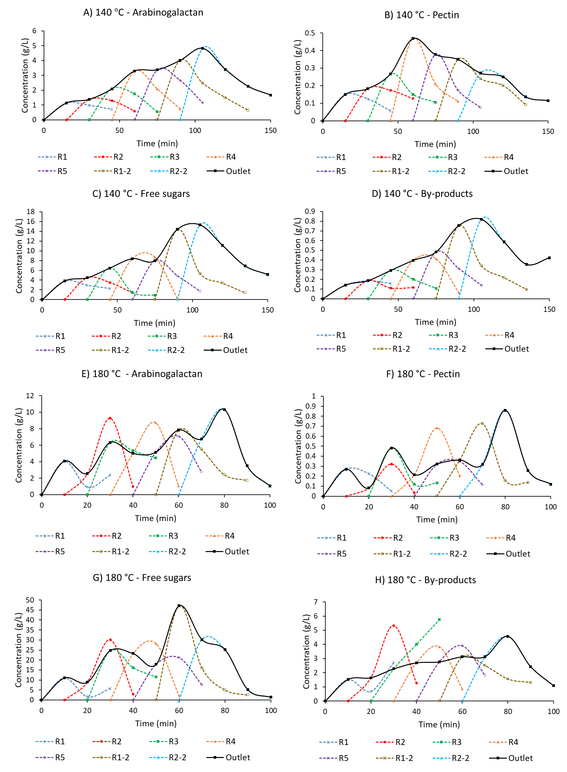
Figure 3. Concentration (g/L) of arabinogalactan, pectin, free sugars and by-products at the outlet of the reactors and at the outlet of the plant.
The pilot plant operation has four distinct phases. First there is the start-up with one, two, and finally three reactors. The second is the operation with a series of three reactors that move as they are exhausted. The prefilling of each new reactor is composed by a solid fill and a liquid fill (which is preheated during the rest period). In the third phase, the operation is maintained with three reactors and two of them are only prefilled with solids but not with liquid (the process flow itself will fill them, reducing dilution). Finally, the fourth phase corresponds to the shutdown, where only two reactors remain in operation and finally one.
Figure 3 shows on its y-axis the concentration of arabinogalactan, pectins, free sugars, and by-products at the outlet of the plant operating at 140 °C and 180 °C, as well as the concentration at the outlet of each of the 7 reactors (R1, R2, R3, R4, R5, R1-2 and R2-2). The curves for each individual reactor show how the outlet concentration started to increase and then decreased, indicating that the biomass in the reactor started to deplete into extractable components. The decreasing of concentration indicates that the selected extraction time was adequate as long as the highest portion of compounds of interest was extracted. The trend at 180 °C was less steady than at 140 °C, which may be due to a higher instability of the operation in terms of maintaining constant operating conditions. Another possible cause is the fast kinetics at 180 °C, which means that certain changes in concentrations cannot be seen by taking a sample every 10 minutes. The residence time of the liquid in the reactor at both 140 and 180 °C was approximately 7 minutes. Sampling every 7 minutes or less would have allowed a better monitoring of the evolution of the variables, especially at 180 °C where the concentrations can change rapidly.
Regarding the evolution of the concentration at the outlet of the plant (continuous line in Figure 3), clearly the lowest concentration occurred when only one reactor was operating (R1). The concentration increased when operating two reactors (R1 and R2) and continues to increase when operating 3 reactors in series. In this period, it increased slightly when R1/R2/R3, R2/R3/R4, and R3/R4/R5 were operating. The concentration increased again when the non-preheated reactors R1-2 and R2-2 (i.e., R1-2 means reactor R1 in the second round, see Table 1) were added, and finally decreased as the reactors were deactivated, the final sequence being R5/R1-2/R2-2, R1-2/R2-2, and R2-2 as can be seen in Table 1. The extraction was clearly higher at 180 °C than at 140 °C for all components, as expected. In the case of extraction at 180 °C, Figure 3 shows again that the plant outlet concentration was more unstable than at 140 °C, with a zigzag trend.
The effect of prefilling the charged reactors with water was studied, to envision what will the best operational strategy. The higher concentration in the reactors R1-2 and R2-2 was due to the non-preheated biomass came in direct contact with the process water at the operational temperature, resulting in a faster extraction than when the water came in contact with water preheated to 90 °C. When preheated water was used the temperature was reduced during the mixing process for a few minutes. However, prefilling the reactor with preheated water avoided strong pressure changes during operation, keeping the operating conditions more stable. In the particular case of pectins at 140 °C the maximum outlet concentration was reached earlier (Figure 3.B), operating with 3 reactors previously filled with water (R2-R3-R4), so the higher extraction mixing temperature in R1-2 and R2-2 did not seem to have an important influence on the extraction of pectins.
The evolution of the cumulative extraction (g/kg dry pulp) of A) arabinogalactan, B) pectins, C) free sugars, and D) by-products at the outlet of the plant can be seen in Figure 4. The extraction increased more moderately in the first minutes of operation as only 1 or 2 reactors were operating (first 3 points in the graphs of Figure 4). In the following minutes there was a slight increase, and finally a sharp increase from the moment when reactors R1-2 and R2-2 were included in the operation. As explained before, this final increase was due to the higher extraction achieved by not preheating with water, and it was more accentuated in the extraction at 180 °C, as the different with the preheating temperature (90 °C) was higher than in the extraction at 140 °C.

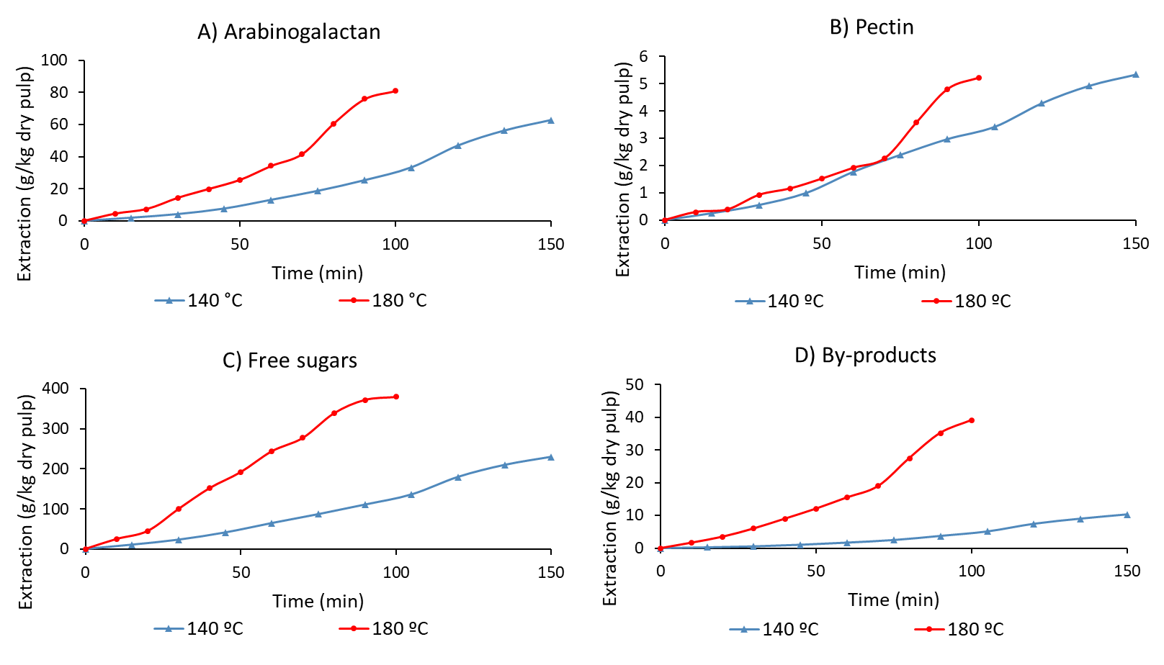
Figure 4. Cumulative extraction (g/kg dry pulp) of A) arabinogalactan, B) pectins, C) free sugars, and D) by-products from discarded carrots over time during hydrothermal treatment at 140 and 180 °C.
The extraction of arabinogalactan was higher at 180 °C (81.01 g/kg dry pulp) than at 140 °C (62.82 g/kg dry pulp). The extraction yield was determined by considering the total component present in the raw material before extraction, so the arabinogalactan yields were 96.1 % (180 °C) and 74.5 % (140 °C). It was appropriate to select a longer operation time at 140 °C than at 180 °C, but it was with the shorter time and operating at 180 °C that the highest yield was obtained. Previous work on the production of hemicelluloses at pilot scale by hydrothermal treatment obtained extraction yields of 83 % [12], 82.2 % [14] and 50 % [17], so that the yield obtained in the present work are adequate considering the innovative way of extraction in multi-reactor cycles.
In the case of pectins the extraction was very similar, slightly higher at 140 °C (5.35 vs. 5.22 g/kg dry pulp) with extraction yields of 9.2 % (140 °C) and 9.0 % (180 °C). This may be due to, as already stated in our previous works [5], the pectins extracted were mainly those associated with high molecular weight arabinogalactan, which was obtained in similar amount at 140 and 180 °C. It can be seen that the evolution of pectin extraction was almost identical at both temperatures until the inclusion of reactors R1-2 and R2-2, when the yield at 180 °C increased considerably with respect to 140 °C. This did not lead to a higher pectin extraction but to a faster extraction.
The extraction of free sugars was much higher at 180 °C than at 140 °C, with a value of 379.51 g/kg dry pulp and 229.76 g/kg dry pulp, respectively. Considering the total free sugars present in the carrot pulp, the yield of free sugars in the hydrothermal treatment was 64.6 % (180 °C) and 39.1 % (140 °C). In our previous work, the pulp after extraction was characterized and it was found that a considerable percentage of free sugars could have been extracted in the preheating [5]. In this work the extract from the preheating was recovered as part of the product, which would explain the high extraction yields achieved. The higher extraction temperature (180 °C) requires a longer preheating time until the desired temperature is reached, which could be the reason for the higher yield of free sugars. In any case, the degradation of the free sugars was low thanks to the selection of a suitable operating time for each temperature. In the case of by-products, there was a greater difference between temperatures, as 39.09 g/kg dry pulp was generated at 180 °C compared to 10.28 g/kg dry pulp at 140 °C.
In short, pilot plant operation is never ideal. Industrial plants often exhibit some instability due to external temperature changes, general utilities (cooling water, steam, etc.) and other operational reasons. In this case, operating with pre-filling and pre-heating the system, pressure and flow are more stable. On the other hand, this causes a loss of efficiency and a lower output concentration. In other works, free sugars are usually obtained by enzymatic treatment applied to the solid of the hydrothermal extraction. However, the abundant content of free sugars in the discarded carrot pulp makes its extraction very efficient in the hydrothermal treatment itself, simultaneously with pectins and hemicellulsoes. The extraction yield of hemicelluloses was also among the highest in bibliography, which is very advantageous due to the fact that the process was performed on a pilot scale.

Biopolymer molecular weight distribution
Figure 5 represents the evolution of the molecular weight distribution of hemicelluloses/pectins at the outlet of the plant, with the y-axis indicating the higher or lower presence of each molecular group (area under the intensity curve of the refractive index detector in the chromatograms of the molecular weight distribution). As can be seen in Figure 5.A, at 140 °C during the first minutes of operation the presence of all molecular groups increased due to the incorporation of the reactors from 1 to 3 (R1, R1/R2, R1/R2/R3). A significant maximum of the >30 kDa group was reached at 60 min of operation. At this time, reactors R3/R4/R5 were operating. This was followed by the 105 min maximum, when reactors R5/R1-2/R2-2 were operating. At 105 min, two maxima can be seen corresponding to the group >30 kDa and especially to the group 1-5 kDa. This may be due to the higher temperature in reactors R1-2 and R2-2 caused a higher autohydrolysis phenomenon that allowed the extraction of a higher proportion of the 1-5 kDa group. This result agrees with Figure 5.B, which shows the concentration of hemicelluloses and pectins at the outlet of the plant over the time. Two maxima can be seen in this Figure. The first maximum at 60 min can be associated with hemicelluloses and pectins and is consistent with the hypothesis that pectins are mainly linked to high molecular weight hemicelluloses [9]. The second maximum (105 min) was only associated to hemicelluloses, so it may be due to the phenomenon of autohydrolysis that allows obtaining hemicelluloses of molecular weight 1-5 kDa. This autohydrolysis would be mainly in the solid before extraction and not in the liquid from other hemicelluloses already extracted. The most abundant molecular groups in decreasing order were, as in previous work [5], >30 kDa, 1-5 kDa, 10-30 kDa, 5-10 kDa, hexamers, and pentamers.
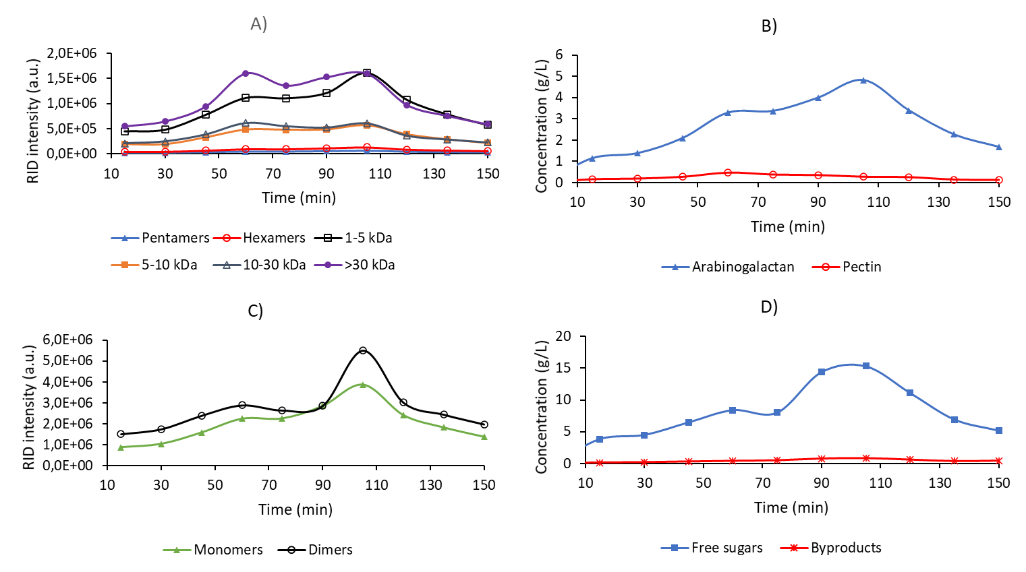
Figure 5. Evolution over time at 140 °C at the outlet of the pilot-plant of A) the abundance of the different molecular groups of biopolymers, B) the total concentration of arabinogalactan and pectins, C) the abundance of the molecular groups of monomers and dimers, and D) the concentration of free sugars and by-products.
Figure 5.C shows the evolution of the presence of monomers and dimers, and Figure 5.D the evolution of the concentration of free sugars and by-products, all at the outlet of the plant. Both monomers and dimers experienced, as well as hemicelluloses, two maxima at minute 60 and 105. The concentration of free sugars showed the same maxima, and the maximum at minute 105 was much higher than the maximum of hemicelluloses and was again associated with operating two of the three reactors without preheating, extracting much more and faster. The concentration of by-products showed only the maximum at minute 105. These by-products would be mainly associated with the higher presence of free sugars and the autohydrolysis of hemicelluloses that occurred at 105 min.
Figure 6 shows the presence of molecular groups and the concentration of biopolymers over time at the outlet of the plant extracting at 180 °C. The continuous variations in the graphs show that the 180 °C operation was less stable than the 140 °C operation. Therefore, each reactor was not analyzed individually. Looking at the outlet of the plant, the presence of different maxima can be appreciated. In the case of hemicelluloses and pectins shown in Figure 6.B, the maximum at minute 80 stood out (reactors R1-2/R2-2 operating). As can be seen in Figure 6.A, the operation without preheating allowed to obtain a higher amount of hemicelluloses of all molecular weights and therefore also a higher amount of pectins associated to the higher molecular weight hemicelluloses. However, the evolution of free sugars (Figure 6.D) shows its most important maximum at minute 60, when reactors R4/R5/R1-2 were operating. The maximum of by-products was at minute 80, coinciding with the maximum of hemicelluloses/pectins. The fact that there is no significant maximum of free sugars at minute 80 may be because the sugars present in R1-2 were extracted so fast that the maximum was shifted to minute 60, while hemicelluloses/pectins needed a few more minutes of operation to reach their maximum. Monomers and dimers (Figure 6.C) were also maximized at minute 60.
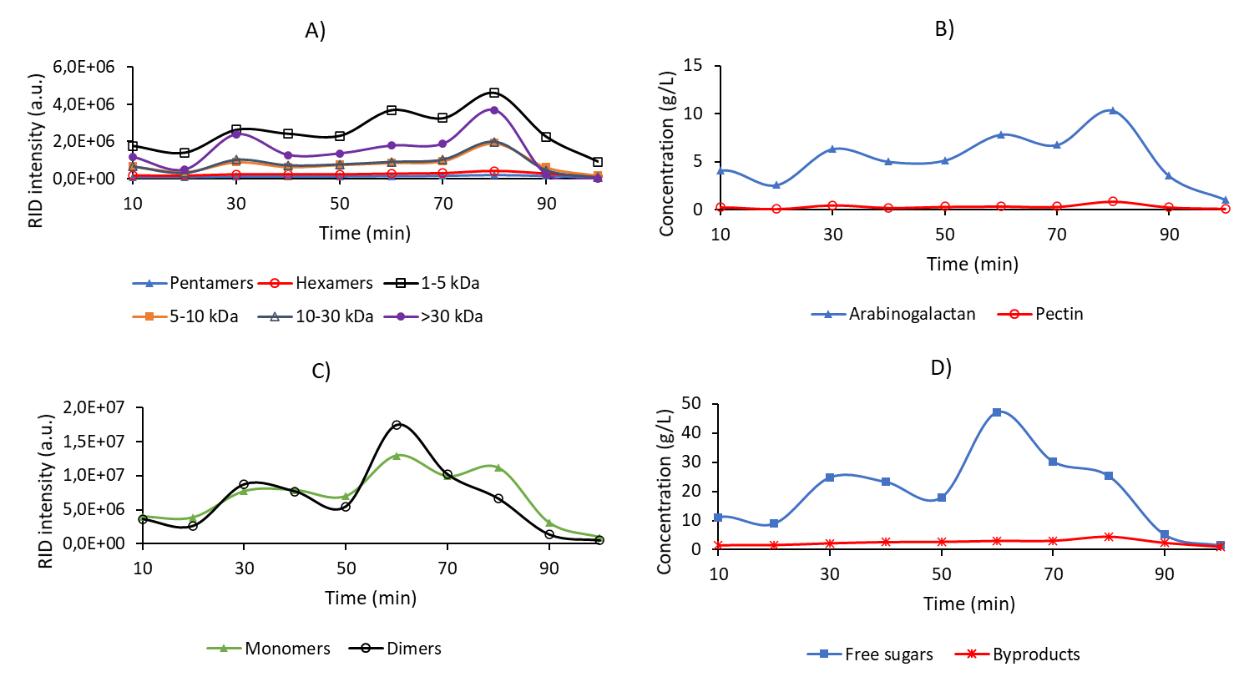
Figure 6. Evolution over time at 180 °C at the outlet of the pilot-plant of A) the abundance of the different molecular groups of biopolymers, B) the total concentration of arabinogalactan and pectins, C) the abundance of the molecular groups of monomers and dimers, and D) the concentration of free sugars and by-products.

Ultrafiltration and diafiltration

Recovery of arabinogalactan, pectin, free sugars, and by-products
As shown in Figure 2, the treatment of the 140 °C extract (140-Feed) was based on applying 10 kDa-ultrafiltration, five cycles of 10 kDa-diafiltration, 30 kDa-ultrafiltration to the purified 10 kDa-retentate, and five cycles of diafiltration to the 30 kDa-retentate. The treatment of the 180 °C extract (180-Feed) was a little different from 140-Feed. One of the differences was that with the 30 kDa membrane, only the five diafiltration cycles were applied without prior ultrafiltration, as the product was already sufficiently concentrated and a higher concentration could have made the membrane operation unfeasible. Since there was a higher amount of 1-5 kDa hemicelluloses in the 180 °C extract, the second difference was that an additional 1 kDa membrane was used. The ultrafiltration/diafiltration resulted in the distribution of the components into the different streams. The distribution shown in Table 2 is based on the samples 140-Feed and 180-Feed initially distributed in Ret-10 kDa and Perm-10 kDa. Then, Ret-10 kDa-DF was distributed in the 30 kDa membrane products. In the case of 180-Feed, Perm-10 kDa was additionally distributed in the 1 kDa membrane products. The percentages corresponding to the diafiltration waters were calculated by material balance.
Table 2. Recovery of free sugars, by-products, arabinogalactan and pectins after ultrafiltration and diafiltration.
 | Free sugars | By-products | Arabinogalactan | Pectins
140-Ret-10 kDa | 16.2 % | 53.4 % | 50.2 % | 59.3 %
140-Perm-10 kDa | 83.8 % | 46.6 % | 49.8 % | 40.7 %
140-Ret-10 kDa-DF | n.d. | n.d. | 46.1 % | 42.3 %
140-Ret-30 kDa | n.d. | n.d. | 39.5 % | 19.3 %
140-Ret-30 kDa-DF | n.d. | n.d. | 24.9 % | 9.3 %
140-Perm-30 kDa | n.d. | n.d. | 6.6 % | 23.3 %
140-DF-10 kDa | 16.2 % | 53.4 % | 4.2 % | 16.9 %
140-DF-30 kDa | n.d. | n.d. | 14.6 % | 10.0 %
 | Free sugars | By-products | Arabinogalactan | Pectins
180-Ret-10 kDa | 22.9 % | 15.4 % | 70.1 % | 74.8 %
180-Perm-10 kDa | 77.1 % | 84.6 % | 29.9 % | 17.5 %
180-Ret-10 kDa-DF | 0.8 % | n.d. | 32.6 % | 74.8 %
180-Ret-30 kDa-DF | n.d. | n.d. | 26.8 % | 62.5 %
180-DF-30 kDa | 0.8 % | n.d. | 5.8 % | 12.3 %
180-Ret-1 kDa | 18.8 % | 6.5 % | 13.1 % | 15.4 %
180-Perm-1 kDa | 58.3 % | 78.1 % | 16.8 % | 2.1 %
180-Ret-1 kDa-DF | 0.5 % | 0.2 % | 4.1 % | 15.4 %
180-DF-10 kDa | 22.1 % | 15.4 % | 37.4 % | n.d.
180-DF-1 kDa | 18.3 % | 6.3 % | 9.0 % | n.d.

As can be seen in Table 2, 83.8 % of the free sugars, 46.6 % of the by-products, 49.8 % of the hemicelluloses, and 40.7 % of the pectins were removed through the 10 kDa permeate in the case of 140-Feed. Approximately half of each component was therefore removed, except for the free sugars, which were removed to a greater extent. The next step was the purification of 140-Ret-10 kDa through five cycles of diafiltration yielding 140-Ret-10 kDa-DF. After this purification all free sugars and by-products were removed. Retention of hemicelluloses decreased a little (from 50.2 to 46.1 %) as well as pectins (from 59.3 to 42.3 %). The purified product was passed through the 30 kDa membrane where most of the hemicelluloses and pectins were retained, with only 6.6 % of the hemicelluloses and 23.3 % of the pectins being removed through 140-Perm-30 kDa. After the application of the five diafiltration cycles to the 30 kDa membrane, the retention of hemicelluloses and pectins decreased considerably from 39.5 to 24.9 % and from 19.3 to 9.3 %, respectively. This indicates that a moderate percentage of the total hemicellulose and pectins had a molecular weight >30 kDa. The 10 kDa membrane diafiltration cycles were responsible for the removal of by-products and free sugars, while the 30 kDa diafiltration cycles were responsible for a better separation of hemicelluloses/pectins of molecular weight 10-30 kDa and >30 kDa.
The results of the 180-Feed treatment can also be seen in Table 2. The initial distribution in the 10 kDa membrane shows a majority removal of free sugars and by-products through the permeate (77.1 and 84.6 %, respectively). 70.1 % of the hemicelluloses and 74.8 % of the pectins were retained in 180-Ret-10 kDa. The higher retention in the 180-Feed compared to the 140-Feed could be associated with the higher total concentration of the feed (29.23 g/L vs. 16.31 g/L). After applying the diafiltration cycles, all by-products were removed, free sugars were removed except for 0.8 %, the retention of hemicelluloses decreased from 70.1 to 32.6 %, and the retention of pectins remained constant (74.8 %). As most of the pectins would be associated with high molecular weight hemicelluloses, it could be that the retained pectins cannot be entrained in the diafiltration. The degree or type of binding between hemicelluloses and pectins may also be different depending on the extraction temperature. The 180-Ret-10 kDa-DF product was subjected to five cycles of diafiltration in the 30 kDa membrane to improve separation and purification. The diafiltration cycles allowed the removal of the low percentage of free sugars, 5.8 % of the hemicelluloses, and 12.3 % of pectins. As a result, the product of highest molecular weight contained 26.8 % of the total arabinogalactan and 62.5 % of the total pectins. The recovery of pectins was much higher in 180 °C than 140 °C (62.5 vs. 9.3 %) so the type of pectins or the type of binding to hemicellulose would be different depending on the temperature. The Perm-10 kDa product was passed through the 1 kDa membrane. Most of the total by-products and free sugars were removed through Perm-1 kDa (78.1 and 58.3 %, respectively). There were very few pectins of molecular weight < 1 kDa (2.1 %) but a certain percentage of hemicelluloses (16.8 %). Five cycles of diafiltration were applied yielding 180-Ret-1 kDa-DF, which contained a small percentage of the free sugars (0.5 %), by-products (0.2 %), hemicelluloses (4.1 %) and pectins (15.4 %).
According to the recovery of hemicelluloses and pectins and the removal of free sugars and by-products, the membrane configuration used has proved adequate. The five diafiltration cycles were essential for the total removal of free sugars and by-products. The retention of these compounds was generally higher in the case of 140 °C extract, which could be due to the effect of the higher molecular weight of the biopolymers that hinders the passage of the smaller compounds. However, hemicelluloses and pectins were initially more retained in the 180 °C extract due to the higher concentration in the feed. Once the biopolymers have been purified, it is very useful to separate them in one or more subsequent membranes in order to recover fractions with different molecular weight, i.e., different applications.

Molecular weight distribution
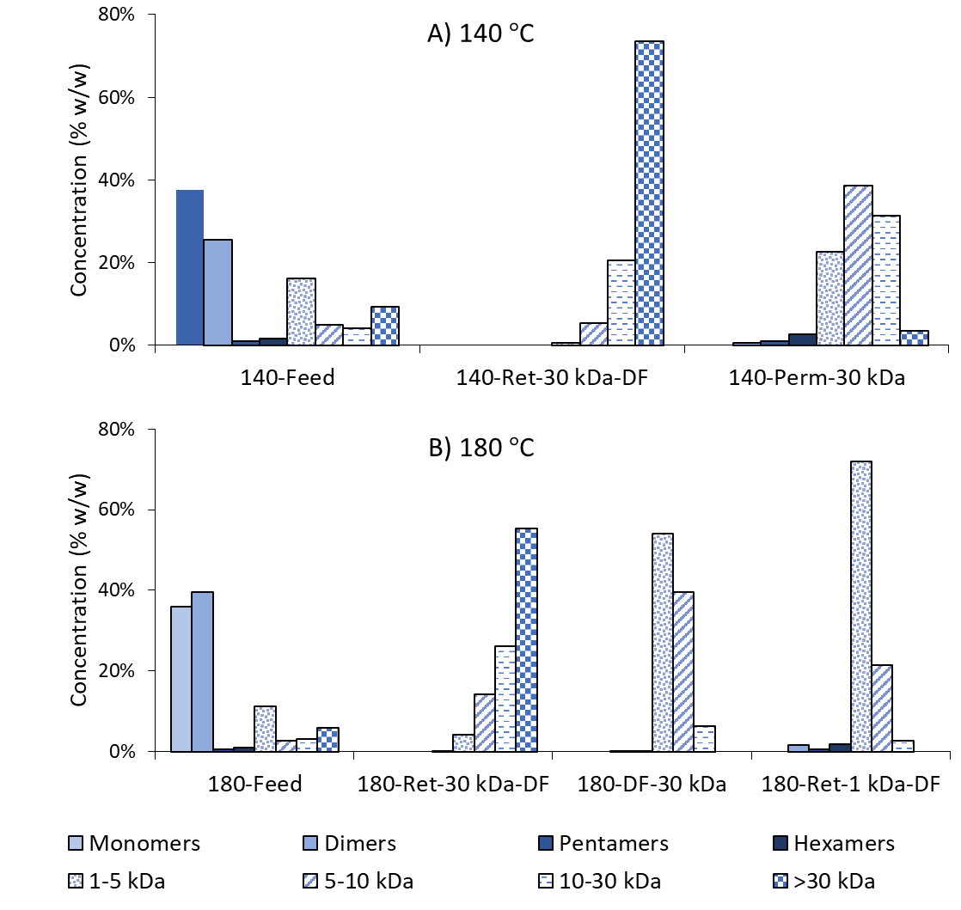
Figure 7. Molecular weight distribution (% w/w) of the feeds and the ultrafiltration/diafiltration products.
Figure 7 shows the molecular weight distribution expressed as a percentage (% w/w) of each molecular group in the feed and in the final products. In the 140-Feed treatment, products associated with >30 kDa (140-Ret-30 kDa) and 10-30 kDa (140-Perm-30 kDa) were obtained. The feed had wide molecular weight distribution, with the largest group being monomers (37.5 %) followed by dimers (25.6 %), hemicelluloses/pectins between 1-5 kDa (16.1 %), hemicelluloses/pectins >30 kDa (9.3 %), and the remaining groups in smaller percentages. The application of the successive stages of ultrafiltration and diafiltration with two membranes resulted in two distinguishable products. The product with the highest molecular weight was most abundant in the group of hemicelluloses/pectins >30 kDa (73.6 %), followed by the 10-30 kDa group (20.4 %), and other minority groups, with no presence of groups with a molecular weight < 1 kDa. The intermediate molecular weight product was predominant in the hemicelluloses/pectins group of 5-10 kDa (38.6 %), followed closely by 10-30 kDa (31.3 %), by 1-5 kDa (22.7 %), and other minority groups.
Figure 7.B shows the three products obtained from 180-Feed. These products were associated with molecular weights >30 kDa (180-Ret-30 kDa-DF), between 10-30 kDa (180-DF-30 kDa), and between 1-10 kDa (180-Ret-1 kDa-DF). 180-Feed had a very similar molecular weight distribution to 140-Feed, except that it was more abundant in dimers than in monomers due to higher extraction. In addition, the percentage of hemicelluloses of molecular weight >30 kDa was lower in 180-Feed due to autohydrolysis (5.9 % vs. 9.3 %). The highest molecular weight product was rich in the group higher than 30 kDa (55.4 %), followed by 10-30 kDa (26.2 %), 5-10 kDa (14.3 %), and other minorities, containing no biopolymers of molecular weight < 1 kDa. Both intermediate and low molecular weight products were abundant in the group 1-5 kDa, which was also the most abundant in the feed (11.1 %). 180-DF-30 kDa contained 54.1 % of 1-5 kDa followed by 39.6 % of 5-10 kDa. 180-Ret-1 kDa-DF contained 71.8 % of 1-5 kDa followed by 21.5 % of 5-10 kDa.
Starting from a wide molecular weight distribution, defined fractions with high, intermediate and low molecular weight have been adequately obtained. High molecular weight fractions can be used in the formation of biomaterials, which is new and promising application in the case of discarded carrots and in general for many agri-food waste products. Obtaining purified fractions of low or intermediate molecular weight is, as has been seen in other studies with pectins, interesting for the application of these biopolymers as additives in food and pharmaceuticals.

Characterization of the feeds and the ultrafiltration/diafiltration products
Table 3 shows the characterization of the hydrothermal extracts as well as the ultrafiltration and diafiltration products obtained. The parameters characterizing the molecular weight distribution are weight-average molecular weight (MW) and polydispersity (PD). The parameters relating to the chemical composition are the concentration of arabinogalactan, pectins, free sugars, by-products, the percentage of biopolymers or purity, the ratio of arabinogalactan to total biopolymers (AG/(AG+P)), and the ratio of galactan to arabinan (G/A) in arabinogalactan. In the 140-Feed treatment, starting from an intermediate molecular weight and high polydispersity (14.77 kDa and PD: 19.2), two products of different molecular weight and low polydispersity were obtained: 80.36 kDa and PD: 2.4 (140-Ret-30 kDa-DF) and 9.85 kDa and PD: 2.1 (140-Perm-30 kDa). Comparing the products before and after applying the diafiltration cycles, in both membranes the molecular weight increased and the polydispersion decreased, which shows the importance of these cycles to improve the separation of the biopolymers. In terms of concentration, both products had a higher pectin concentration than the feed, while the concentration of arabinogalactan was much higher than the feed in the 140-Ret-30 kDa-DF product but was lower in 140-Perm-30 kDa. In the highest molecular weight product hemicelluloses were concentrated by a factor of 6.24 with respect to the feed, and pectins by a factor of 2.33. The highest molecular weight product was mostly arabinogalactan (90.0 %) and the intermediate molecular weight product was mostly pectins (51.3 %). In terms of purity, the starting point was a feed containing 22.2 % biopolymers, which was rich in free sugars. After ultrafiltration in the first membrane, the purity increased to 45.3 %, but it was due to the diafiltration cycles that it was possible to obtain products with 100 % purity.
Table 3. Characterization of the hydrothermal extracts (feeds) and the ultrafiltration/diafiltration products.
 | MW (kDa) | PD | AG (g/L) | Pectins (g/L) | Free sugars (g/L) | By-products (g/L) | Biopolymers (% w/w) | AG/(AG+P) | G/A
140-Feed | 14.77 | 19.2 | 2.79 | 0.83 | 12.10 | 0.60 | 22.2 % | 77.1 % | 1.80
140-Ret-10 kDa | 35.94 | 22.4 | 7.00 | 2.45 | 9.82 | 1.61 | 45.3 % | 74.1 % | 1.89
140-Ret-10 kDa-DF | 58.88 | 6.4 | 6.42 | 1.75 | n.d. | n.d. | 100 % | 78.6 % | 1.40
140-Perm-30 kDa | 9.85 | 2.1 | 1.14 | 1.21 | n.d. | n.d. | 100 % | 48.7 % | 1.39
140-Ret-30 kDa | 62.87 | 4.4 | 27.54 | 3.99 | n.d. | n.d. | 100 % | 87.3 % | 1.85
140-Ret-30 kDa-DF | 80.36 | 2.4 | 17.38 | 1.92 | n.d. | n.d. | 100 % | 90.0 % | 1.84
 | MW (kDa) | PD | AG (g/L) | Pectins (g/L) | Free sugars (g/L) | By-products (g/L) | Biopolymers (% w/w) | AG/(AG+P) | G/A
180-Feed | 8.08 | 18.2 | 3.77 | 0.59 | 21.82 | 3.05 | 14.9 % | 86.4 % | 5.23
180-Ret-10 kDa | 22.7 | 35.0 | 13.21 | 2.22 | 25.00 | 2.35 | 36.1 % | 85.6 % | 2.58
180-Ret-10 kDa-DF | 59.4 | 4.5 | 6.15 | 2.22 | 0.89 | n.d. | 90.4 % | 73.5 % | 2.60
180-DF-30 kDa | 5.23 | 1.3 | 0.33 | 0.08 | 0.22 | n.d. | 64.5 % | 80.3 % | 1.73
180-Ret-30 kDa-DF | 67.77 | 3.8 | 5.06 | 1.85 | n.d. | n.d. | 100 % | 73.2 % | 1.63
180-Ret-1 kDa | 0.83 | 2.0 | 3.08 | 0.57 | 25.61 | 1.25 | 12.0 % | 84.4 % | 2.80
180-Ret-1 kDa-DF | 3.86 | 1.5 | 0.97 | 0.57 | 0.73 | 0.04 | 66.8% | 62.9 % | 1.30

MW: weight-average molecular weight, PD: polydispersity, AG: arabinogalactan, P: pectins, G: galactan, A: arabinan
As can be seen in Table 3, 180-Feed had a lower MW and similar PD to 140-Feed (8.08 kDa and PD: 18.2). The three products obtained had different molecular weights and low polydispersity: 67.77 kDa and PD: 3.8 (180-Ret-30 kDa-DF), 5.23 kDa and PD: 1.3 (180-DF-30 kDa), and 3.86 kDa and PD: 1.5 (180-Ret-1 kDa-DF). Again, the diafiltration cycles effectively increased the molecular weight and drastically reduced the polydispersity. The highest molecular weight product (180-Ret-30 kDa-DF) had a higher concentration than 180-Feed by a factor of 1.34 for arabinogalactan and 3.13 for pectins. The low concentration factor for arabinogalactan was due to no ultrafiltration was applied in the 30 kDa membrane so the solution was not further concentrated, only the diafiltration cycles were applied. Even so, the relatively high concentration factor of pectins was due to at 180 °C certain pectins with a strong binding to arabinogalactan could be obtained in higher proportion than at 140 °C. The intermediate (180-DF-30 kDa) and low molecular weight (180-Ret-1 kDa-DF) products were more diluted than 180-Feed. The high molecular weight product was mostly arabinogalactan (73.2 %), as well as the intermediate molecular weight product (80.3 %) and the low molecular weight product (62.9 %). The fact that there was no product with a majority of pectin was associated with the high retention of pectins together with high molecular weight hemicelluloses.

Fouling of the membranes
Fouling often occurs during the ultrafiltration processes. Figure 8 shows the evolution over time of operation of the two parameters that characterize membrane fouling: transmembrane pressure and permeate flux. The evolution of these parameters can be seen along the ultrafiltration and successive diafiltration cycles in the 10 kDa and 30 kDa membrane. In the 10 kDa ultrafiltration of 140-Feed, there was a marked decrease in permeate flux due to fouling dropping from 277.50 to 28.85 L/m²h. The transmembrane pressure increased slightly, from 2.2 to 2.5 bar. In successive diafiltration cycles, the permeate flow continued to decrease very slightly and became almost constant at a value of approximately 15.3 L/m²h, which shows that the fouling did not increase further as the small compounds were less and less present in the retentate. The transmembrane pressure was lower at the beginning of each diafiltration cycle (when the retentate was more dilute) and increased until the end of the cycle due to the increased concentration of the retentate (usually from 2 to 2.2 -2.7 bar). In the case of 30 kDa membrane, the permeate flux remained almost stable during ultrafiltration decreasing from 37.50 L/m²h to 26.11 L/m²h. This may be due to that no significant fouling took place as the feed was free of by-products and free sugars. However, the transmembrane pressure increased with each diafiltration cycle (usually from 2 to 2.8-3 bar) and decreased again at the beginning of the next cycle. The higher increase in transmembrane pressure during 30 kDa diafitration comparing to 10 kDa could be due to the concentration was much higher.
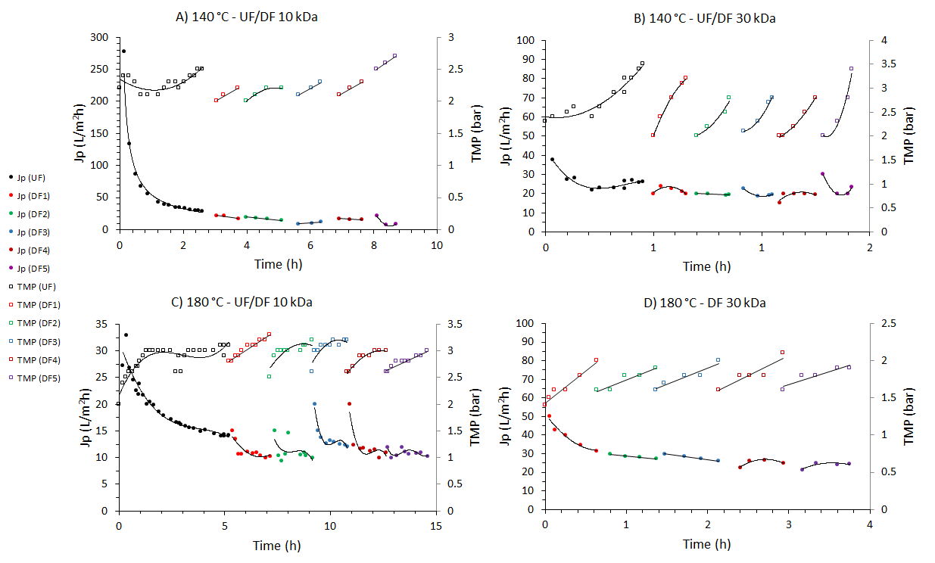
Figure 8. Variations in permeate flux and transmembrane pressure associated with fouling during ultrafiltration and diafiltration cycles for biopolymer separation and purification.
In the 180-Feed treatment with the 10 kDa membrane, the decrease in permeate flux was not as significant as in the 140-Feed processing. The permeate flux value was quite low from the beginning, which may be due to an instantaneous fouling of the membrane at the very beginning of the operation because of a higher total concentration comparing to 140-Feed (29.23 g/L vs. 16.31 g/L). It could also be due to the first use of the membrane was with 140-Feed, and even if the membrane was cleaned afterwards, it might not recover its initial conditions. During ultrafiltration permeate flux decreased from 27.27 to 14.28 L/m²h. The transmembrane pressure evolved in an increasing way in each diafiltration cycle (usually from 2.6 to 3-3.3 bar), recovering its original value at the beginning of each cycle. Finally, with the 30 kDa membrane, only diafiltration cycles were carried out because the concentration was sufficient high. It can be seen how in these cycles the permeate flux experienced a decrease specially in the first cycle (from 50 to 31 L/m²h), and then smaller decreases being almost stable at 21-24 L/m²h. This is due to the initial fouling of the membrane equivalent to that which occurs in ultrafiltration. The transmembrane pressure increased in each cycle (usually from 1.6 to 1.9-2.1 bar) but recovered its initial value at the beginning of the next cycle. The results show that the operation during diafiltration becomes relatively stable, with a decreasing decrease in permeate flux and a similar TMP behavior in each cycle.

Spray drying and freeze drying of the products
The two products from 140-Feed and the three products from 180-Feed were both freeze-dried and spray-dried. The aim was their structural characterization and subsequent use in the formation of biofilms and other possible applications. Spray drying is cheaper and suitable for large quantities, while freeze drying is suitable if the compounds are temperature sensitive or if only small quantities are available. Figure 9 shows the product 180-Ret-30 kDa-DF A) spray-dried and B) freeze-dried. The morphology at the macroscopic level was very different, as spray drying results in a powder while freeze drying results in a sponge-like structure. Figures 9.C and 9.D show the products 180-Ret-30 kDa-DF and 180-DF-30 kDa freeze-dried and spray-dried. 180-DF-30 kDa had a much lighter color than 180-Ret-30 kDa-DF because it is not a retentate and probably because it is abundant in pectins. The differences between spray drying and freeze drying at a microscopic level can also be seen in Figure 10.
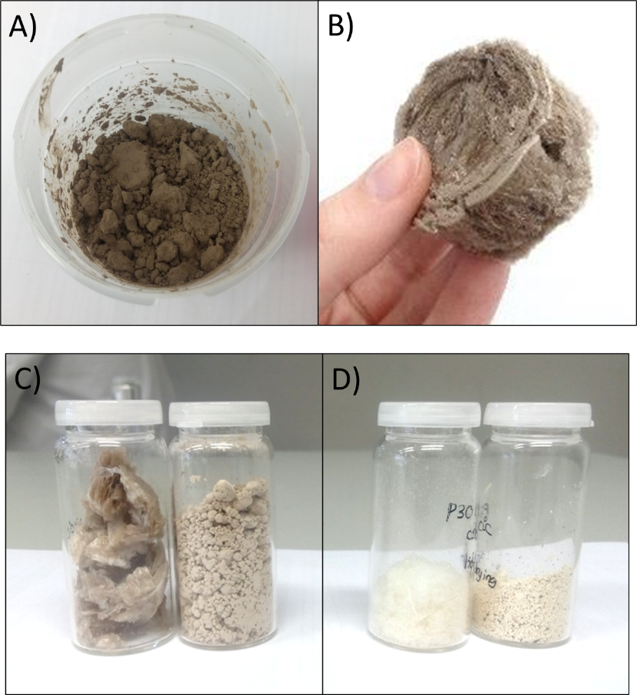
Figure 9. Images of the purified biopolymer solid fractions A) 180-Ret-30 kDa-DF spray-dried, B) 180-Ret-30 kDa-DF freeze-dried, C) 180-Ret-30 kDa-DF freeze and spray-dried, and D) 180-DF-30 kDa freeze and spray-dried.

Structural characterization (TGA, FTIR, SEM)
Figure A1 shows the first derivative of the weight loss curve obtained in TGA. This first derivative shows a series of peaks representing the greatest rates of change on the weight loss curve (inflection points). The temperature corresponding to each peak and the different degradation regions can therefore be identified. The peak area gives an idea of the proportion of material that degrades in that temperature range. Figure A1.A shows the two products obtained from 140-Feed: 140-Ret-30 kDa-DF and 140-Perm-30 kDa, while Figure A1.B shows the products from 180-Feed: 180-Ret-30 kDa-DDF, 180-DF-30 kDa, and 180-Ret-1 kDa-DF. The analysis was applied to spray-dried samples. Three peaks can be seen in the curves of the purified products obtained from 140-Feed. The first peak is present in both products, corresponds to the temperature range 50 – 140 °C and represents the evaporation of the water present in the sample. The humidity was 6.60 % for 140-Ret-30 kDa-DF and 5.00 % for 140-Perm 30 kDa. The next degradation peak was present only in 140-Perm-30 kDa, in the range 140 – 250 °C, where 30.77 % of the sample was degraded. This region represents hemicelluloses and pectins more easily degradable due to their lower molecular weight. The last degradation region occurs mainly at 280 °C and it was present in 140-Ret-30 kDa-DF representing 76.45 % of the sample while in 140-Perm-30 kDa it represented 41.77 % of the sample. As demonstrated in our previous work [9], there are two types of hemicelluloses/pectins, and the more easily degradable ones are present only in the intermediate molecular weight product. The others (last peak) are more resistant to degradation and are present in the highest molecular weight product and to a lesser extent in the intermediate molecular weight product.
As can be seen in Figure A1.B the three products from 180-Feed showed the peak corresponding to moisture removal with percentages of 7.50 % (180-Ret-30 kDa-DF), 3.50 % (180-DF-30 kDa), and 4.16 % (180-Ret-1 kDa-DF). The next peak, corresponding to more easily degradable hemicellulose/pectins, was present in all products including the one with the highest molecular weight. This may be due to the higher autohydrolysis effect that occurred in the 180 °C extraction compared to the 140 °C extraction. The percentages of this group of hemicelluloses/pectins were 12.76 % for 180-Ret-30 kDa-DF (high molecular weight), 69.61 % for 180-DF-30 kDa (intermediate molecular weight), and 66.22 % for 180-Ret-1 kDa-DF (lowest molecular weight). The last degradation peak (280 °C), associated with more resistant hemicelluloses/pectins, was present in the highest molecular weight product (180-Ret-30 kDa-DF) with a percentage of 56.94 %. The presence of more resistant hemicelluloses/pectins was negligible in 180-DF-30 kDa and 180-Ret-1 kDa-DF due to the autohydrolysis effect.
The ATR-FTIR spectra of the products were determined after spray drying and they can be seen in Figure A2. These products were 140-Ret-30 kDa-DF and 140-Perm-30 kDa in Figure A2.A and 180-Ret-30 kDa-DF, 180-DF-30 kDa and 180-Ret-1 kDa-DF in Figure A2.B.
The band in 3600-3000 cm⁻¹ is associated with the O-H stretching vibrations characteristic of the hydroxyl groups of lignocellulosic materials. The intensity in this region was higher for the retentates at both temperatures and lower for permeates (intermediate molecular weight products). The range 3000-2800 cm⁻¹ is related to C-H stretching vibrations. This bond is present in the monosaccharides present in both hemicelluloses and pectins. The intensity was approximately the same for all products.
The band 1800-1500 cm⁻¹ is associated with the carbonyl group (C=O) stretching vibrations. The peak 1738 cm⁻¹ represents the presence of the C=O methyl ester group (COOCH₃) corresponding to pectin structure [27]. In the case of 140 °C, the peak had higher intensity at 140-Perm-30 kDa than at 140-Ret-30 kDa-DF, which can be attributed to a higher presence of pectins (51.3 % vs. 10.0 %). In the case of 180 °C, 180-Ret-1 kDa-DF had the highest intensity, followed closely by 180-Ret-30 kDa-DF and finally 180-DF-30 kDa. This is consistent with the pectin content, which was lower in 180-DF-30 kDa (19.7 %), compared to 180-Ret-1 kDa-DF (37.1 %) and 180-Ret-30 kDa-DF (26.8 %).
The peak 1602 cm⁻¹ is associated to the stretching vibration of the carbonyl group of the carboxylate ion (COO⁻), corresponding to the hemicellulose and especially the pectin structure [28]. This peak was more pronounced at 140 °C in 140-Perm-30 kDa than in 140-Ret-30 kDa-DF. This may be due to the intermediate molecular weight product had a higher proportion of pectins. In the case of 180 °C, the products with the most pronounced peak were 180-Ret-1 kDa-DF followed by 180-Ret-30 kDa-DF and 180-DF-30 kDa. Again, the intensity was higher for those products with a higher proportion of pectins.
The region between 1500-1300 cm⁻¹ includes the peaks 1401, 1366, and 1248 cm⁻¹. The peak 1401 cm⁻¹ is associated to the carboxylic acid and COO⁻ symmetric stretching vibration in hemicelluloses and pectins [29]. This peak followed the same trend as the 1602 cm⁻¹ peak associated with the COO⁻ stretching vibration. The peak was higher at 140 °C for 140-Perm-30 kDa than for 140-Ret-30 kDa-DF, and at 180 °C it followed a decreasing order of 180-Ret-1 kDa-DF, 180-Ret-30 kDa-DF, and 180-DF-30 kDa.
The peak 1366 cm⁻¹ is assigned to C-H deformation in hemicellulose and pectin [30]. The intensity of this peak followed the same trend as peak 1401 cm⁻¹.
The peak 1248 cm⁻¹ is related to C-OH bonding at C6 so it is due to pyranose ring vibration [31]. This implies that it is because of the sugar galactose. The intensity of the peak followed the same trend as the peaks 1401 and 1366 cm⁻¹.
The peaks in the region 1200-950 cm⁻¹ are associated with polysaccharides, in particular with C-C, C-OH-, C-O-C, C-H ring, and side group vibrations [31]. The region 1200-1100 cm⁻¹ is related to C-O-C stretching vibration in the glycosidic ring [27]. At 140 °C, 140-Perm-30 kDa-DF had more intensity at the 1150 cm⁻¹ peak than 140-Ret-30 kDa-DF. At 180 °C, 180-Ret-30 kDa-DF and 180-DF-30 kDa had identical intensity while 180-Ret-1 kDa-DF had slightly higher. This trend could be related to the G/A value (Table 3). At 140 °C, the G/A value was lower for 140-Perm-30 kDa than for 140-Ret-30 kDa-DF (1.39 vs. 1.84), while at 180 °C it was lower for Ret-1 kDa-DF followed by 180-Ret-30 kDa-DF and 180-DF-30 kDa (1.30, 1.63, and 1.73, respectively). Similarly, the intensity of many of the peaks was higher for a lower G/A value, which could be related to the linearity of the arabinogalactan. A lower G/A value is associated with lower linearity, i.e. higher branching and in this case higher intensity in the spectra.
The band 1100-950 cm⁻¹ is related with C-C, C-O, and C-OH stretching vibrations [27]. The peak 1073 cm⁻¹ was in the 140 °C case more pronounced in 140-Perm-30 kDa than in 140-Ret-30 kDa-DF, which could be due to a higher proportion of pectins. In the case of 180 °C, the peak was negligible, which could be due to a lower proportion of pectins in these products or to a different pectins structure. The 1017 cm⁻¹ peak stands out, with high intensity and equal magnitude for all cases. This peak is associated with C-O bonds stretching attributed to carbohydrates, present in all products [30].

Redissolution of the solid products in water
Purified products samples were dried using freeze drying and spray drying. They were then redissolved in water to compare their compositional parameters with those of the liquid sample before drying, checking if there is any difference due to the drying and redissolution process. The results can be seen in Table 4. The 140 °C highest molecular weight product, 140-Ret-30 kDa-DF, showed a slightly higher G/A value after drying, identical purity in all three cases, and a decrease in the percentage of arabinogalactan after drying. This could be due to some loss of solubility of the arabinogalactan if not stirred long enough. In this case it was kept stirred until visually no microparticles were visible, but an overnight stirring would probably ensure complete dissolution of the sample. The intermediate molecular weight product, 140-Perm-30 kDa, showed a slightly higher G/A value after drying as 140-Ret-30 kDa-DF, the purity was similar, and the percentage of arabinogalactan was similar but slightly higher after spray drying.
Table 4. Chemical characterization of the purified biopolymer solid fractions before and after redissolution in water.
 | G/A | Purity (%) | AG/(AG+Pectin)
140-Perm-30 kDa | 1.39 | 100 % | 0.49
F.D. 140-Perm-30 kDa | 1.67 | 95.0 % | 0.50
S.D. 140-Perm-30 kDa | 1.72 | 100 % | 0.54
140-Ret-30 kDa-DF | 1.84 | 100 % | 0.90
F.D. 140-Ret-30 kDa-DF | 2.06 | 100 % | 0.72
S.D. 140-Ret-30 kDa-DF | 2.09 | 100 % | 0.75
180-DF-30 kDa | 1.73 | 64.5 % | 0.80
F.D. 180-DF-30 kDa | 1.64 | 62.1 % | 0.67
S.D. 180-DF-30 kDa | 1.76 | 69.6 % | 0.69
180-Ret-30 kDa-DF | 1.63 | 100 % | 0.73
F.D. 180-Ret-30 kDa-DF | 2.06 | 100 % | 0.77
S.D. 180-Ret-30 kDa-DF | 1.93 | 100 % | 0.77
180-Ret-1 kDa-DF | 1.30 | 66.8 % | 0.63
F.D. 180-Ret-1 kDa-DF | 1.43 | 61.5 % | 0.67
S.D. 180-Ret-1 kDa-DF | 1.44 | 66.9 % | 0.68

G: galactan, A: arabinan, F.D.: freeze drying, S.D.: spray drying
In the case of 180 °C, the intermediate molecular weight product 180-DF-30 kDa had a similar G/A value, similar purity, and a lower percentage of arabinogalactan after drying. In 180-Ret-30 kDa-DF the G/A value was a little higher after drying, the purity was identical, and the percentage of arabinogalactan was similar. Finally, in the low molecular weight product 180-Ret-1 kDa-DF the G/A value increased slightly after drying by both methods, the purity was similar, and the percentage of arabinogalactan was similar.

SEM
Figure 10 shows SEM images of the product 180-Ret-30 kDa-DF dried applying A) freeze drying or B) spray drying. As shown in Figure 9, the morphology is completely different, also at the microscopic level. After freeze drying, the material is in the form of partially perforated sheets, whereas after spray drying it is in the form of amorphous spherical microparticles. Since the material to be dried was a mixture of high molecular weight arabinogalactan and pectin biopolymers, the solid tended to form a film-like structure. During drying, this film underwent micro-cracking in the case of freeze drying. In the spray drying it can be seen how the spherical microparticles had collapsed to form a corrugated structure. This collapse may have been due to changes in partial pressure during the instantaneous evaporation of the microdroplets. The biopolymers have a certain elasticity and therefore manifest these changes in their final morphology. Previous studies have shown that spray drying of biopolymers has similar effects on their morphology as shown here [32].
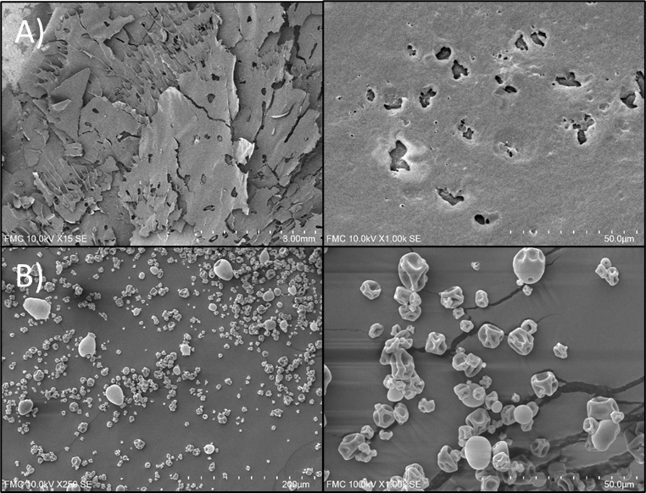
Figure 10. SEM images of the purified biopolymer solid product 180-Ret-30 kDa-DF dried using A) freeze drying and B) spray drying.

Conclusions
Five purified solid fractions of the biopolymers hemicellulose and pectin were obtained for the first time on a pilot-scale from discarded carrots. The biopolymers were hydrothermally extracted (140 and 180 °C) in flow-through reactors working in cycles of three reactors in series. The biopolymers in the extracts were separated and purified using three ultrafiltration membranes (30, 10, 1 kDa). The extraction in cycles allowed the processing of a large amount of raw material compared to a single reactor operation (11.32 kg carrot vs. 1.62 kg). The operation efficiency was high, especially for hemicelluloses, which achieved an extraction yield of 96.1 % (w/w). Two types of reactor start-up were used, with and without water pre-fill and pre-heat. The direct start-up without pre-fill and pre-heat led to a higher hydrolyzate concentration and higher efficiency, but a less steady operation. Detailed study of the molecular weight distribution during extraction showed that the flow-through system allowed the biopolymers to be extracted with a high molecular weight but also accompanied by a high proportion of free sugars (purity 14.9-22.2 %). The treatment by several cycles of ultrafiltration and diafiltration of the two extracts allowed obtaining five purified fractions with a molecular weight range from 3.86 to 80.36 kDa, purities between 64.5 and 100 %, and polydispersion between 1.3-3.8. These fractions were spray-dried and have potential applications in the production of biodegradable films and as additives in the food and pharmaceutical industry. No chemical agent was necessary to obtain these fractions except water and the appropriate pressure and temperature conditions. The residual pulp resulting from the hydrothermal treatment was also an interesting material due to its high cellulose and lignin content.

Acknowledgments
The authors thank the Agencia Estatal de Investigación (Gobierno de España) and FEDER Funds EU for funding project reference PID2019-105975GB-I00 (MICINN/FEDER, EU), and Junta de Castilla y León - Consejería de Educación and FEDER Funds project reference CLU-2019-04. Marta Ramos-Andrés wish to thank the Spanish Ministry of Education, Culture and Sports for the research-university professor training contract (reference FPU15/06366). The authors wish also to thank the company Muñozval S.L. for the raw material supply and the advice.

References
[1] M. Marić, A.N. Grassino, Z. Zhu, F.J. Barba, M. Brnčić, S. Rimac Brnčić, An overview of the traditional and innovative approaches for pectin extraction from plant food wastes and by-products: Ultrasound-, microwaves-, and enzyme-assisted extraction, Trends Food Sci. Technol. 76 (2018) 28–37. https://doi.org/10.1016/j.tifs.2018.03.022.
[2] J. Banerjee, R. Singh, R. Vijayaraghavan, D. MacFarlane, A.F. Patti, A. Arora, Bioactives from fruit processing wastes: Green approaches to valuable chemicals, Food Chem. 225 (2017) 10–22. https://doi.org/10.1016/j.foodchem.2016.12.093.
[3] A.M.I. Encalada, C.D. Pérez, S.K. Flores, L. Rossetti, E.N. Fissore, A.M. Rojas, Antioxidant pectin enriched fractions obtained from discarded carrots (Daucus carota L.) by ultrasound-enzyme assisted extraction, Food Chem. 289 (2019) 453–460. https://doi.org/10.1016/j.foodchem.2019.03.078.
[4] K.A. Riganakos, I.K. Karabagias, I. Gertzou, M. Stahl, Comparison of UV-C and thermal treatments for the preservation of carrot juice, Innov. Food Sci. Emerg. Technol. 42 (2017) 165–172. https://doi.org/10.1016/j.ifset.2017.06.015.
[5] M. Ramos-Andrés, B. Aguilera-Torre, J. García-Serna, Hydrothermal production of high-molecular weight hemicellulose-pectin, free sugars and residual cellulose pulp from discarded carrots, J. Clean. Prod. (2020) 125179. https://doi.org/https://doi.org/10.1016/j.jclepro.2020.125179.
[6] J. Thuvander, A.S. Jönsson, Techno-economic impact of air sparging prior to purification of alkaline extracted wheat bran hemicelluloses by membrane filtration, Sep. Purif. Technol. 253 (2020) 0–4. https://doi.org/10.1016/j.seppur.2020.117498.
[7] A.N. Grassino, F.J. Barba, M. Brnčić, J.M. Lorenzo, L. Lucini, S.R. Brnčić, Analytical tools used for the identification and quantification of pectin extracted from plant food matrices, wastes and by-products: A review, Food Chem. 266 (2018) 47–55. https://doi.org/10.1016/j.foodchem.2018.05.105.
[8] Z. Raji, F. Khodaiyan, K. Rezaei, H. Kiani, S.S. Hosseini, Extraction optimization and physicochemical properties of pectin from melon peel, Int. J. Biol. Macromol. 98 (2017) 709–716. https://doi.org/10.1016/j.ijbiomac.2017.01.146.
[9] M. Ramos-Andrés, B. Aguilera-Torre, J. García-Serna, Production of purified hemicellulose-pectin fractions of different molecular weight from discarded carrots by hydrothermal treatment followed by multistep ultrafiltration/diafiltration, J. Clean. Prod. 321 (2021) 128923. https://doi.org/10.1016/j.jclepro.2021.128923.
[10] G. Gallina, E.R. Alfageme, P. Biasi, J. García-Serna, Hydrothermal extraction of hemicellulose: from lab to pilot scale, Bioresour. Technol. 247 (2018) 980–991. https://doi.org/10.1016/j.biortech.2017.09.155.
[11] G. Gallina, J. García-Serna, Multi-bed pilot plant and process for biomass fractionation, ES20160031191 20160914, 2018.
[12] M.H. Thomsen, A. Thygesen, A.B. Thomsen, Hydrothermal treatment of wheat straw at pilot plant scale using a three-step reactor system aiming at high hemicellulose recovery, high cellulose digestibility and low lignin hydrolysis, Bioresour. Technol. 99 (2008) 4221–4228. https://doi.org/10.1016/j.biortech.2007.08.054.
[13] M.Ø. Petersen, J. Larsen, M.H. Thomsen, Optimization of hydrothermal pretreatment of wheat straw for production of bioethanol at low water consumption without addition of chemicals, Biomass and Bioenergy. 33 (2009) 834–840. https://doi.org/10.1016/j.biombioe.2009.01.004.
[14] S. Makishima, M. Mizuno, N. Sato, K. Shinji, M. Suzuki, K. Nozaki, F. Takahashi, T. Kanda, Y. Amano, Development of continuous flow type hydrothermal reactor for hemicellulose fraction recovery from corncob, Bioresour. Technol. 100 (2009) 2842–2848. https://doi.org/10.1016/j.biortech.2008.12.023.
[15] L. Jacquemin, A. Mogni, R. Zeitoun, C. Guinot, C. Sablayrolles, L. Saulnier, P.Y. Pontalier, Performance evaluation of a semi-industrial production process of arabinoxylans from wheat bran, Process Biochem. 50 (2015) 605–613. https://doi.org/10.1016/j.procbio.2015.01.015.
[16] B. Al-Rudainy, M. Galbe, O. Wallberg, From lab-scale to on-site pilot trials for the recovery of hemicellulose by ultrafiltration: Experimental and theoretical evaluations, Sep. Purif. Technol. 250 (2020) 117187. https://doi.org/10.1016/j.seppur.2020.117187.
[17] F. Cebreiros, F. Risso, M. Cagno, M.N. Cabrera, E. Rochón, G. Jauregui, E. Boix, S. Böthig, M.D. Ferrari, C. Lareo, Enhanced production of butanol and xylosaccharides from Eucalyptus grandis wood using steam explosion in a semi-continuous pre-pilot reactor, Fuel. 290 (2021). https://doi.org/10.1016/j.fuel.2020.119818.
[18] K. Kley Valladares-Diestra, L. Porto de Souza Vandenberghe, C. Ricardo Soccol, A biorefinery approach for pectin extraction and second-generation bioethanol production from cocoa pod husk, Bioresour. Technol. 346 (2021) 126635. https://doi.org/10.1016/j.biortech.2021.126635.
[19] J. Banerjee, R. Singh, R. Vijayaraghavan, D. MacFarlane, A.F. Patti, A. Arora, A hydrocolloid based biorefinery approach to the valorisation of mango peel waste, Food Hydrocoll. 77 (2018) 142–151. https://doi.org/10.1016/j.foodhyd.2017.09.029.
[20] S. Talekar, A.F. Patti, R. Vijayraghavan, A. Arora, An integrated green biorefinery approach towards simultaneous recovery of pectin and polyphenols coupled with bioethanol production from waste pomegranate peels, Bioresour. Technol. 266 (2018) 322–334. https://doi.org/10.1016/j.biortech.2018.06.072.
[21] K. Klinchongkon, P. Khuwijitjaru, S. Adachi, Properties of subcritical water-hydrolyzed passion fruit (Passiflora edulis) pectin, Food Hydrocoll. 74 (2018) 72–77. https://doi.org/10.1016/j.foodhyd.2017.07.034.
[22] N. Muñoz-Almagro, M. Prodanov, P.J. Wilde, M. Villamiel, A. Montilla, Obtainment and characterisation of pectin from sunflower heads purified by membrane separation techniques, Food Chem. 318 (2020) 126476. https://doi.org/10.1016/j.foodchem.2020.126476.
[23] M. Ramos-Andrés, B. Aguilera-Torre, J. García-Serna, Biorefinery of discarded carrot juice to produce carotenoids and fermentation products, J. Clean. Prod. 323 (2021) 129139. https://doi.org/10.1016/j.jclepro.2021.129139.
[24] M. Ramos-Andrés, C. Andrés-Iglesias, J. García-Serna, Production of molecular weight fractionated hemicelluloses hydrolyzates from spent coffee grounds combining hydrothermal extraction and a multistep ultrafiltration/diafiltration, Bioresour. Technol. 292 (2019) 121940. https://doi.org/https://doi.org/10.1016/j.biortech.2019.121940.
[25] M. Ramos-Andrés, B. Aguilera-Torre, J. García-Serna, Hydrothermal production of high-molecular weight hemicellulose-pectin, free sugars and residual cellulose pulp from discarded carrots, J. Clean. Prod. (2020) 125179. https://doi.org/https://doi.org/10.1016/j.jclepro.2020.125179.
[26] M. Ramos-Andrés, S. Díaz-Cesteros, N. Majithia, J. García-Serna, Pilot scale biorefinery with multi-bed hydrothermal treatment operation in cycles - Dataset, Repos. Univ. Valladolid, UVaDoc. (2021).
[27] Y. Ben-Fadhel, B. Maherani, J. Manus, S. Salmieri, M. Lacroix, Physicochemical and microbiological characterization of pectin-based gelled emulsions coating applied on pre-cut carrots, Food Hydrocoll. 101 (2020) 105573. https://doi.org/10.1016/j.foodhyd.2019.105573.
[28] Sucheta, K. Chaturvedi, S.K. Yadav, Ultrasonication assisted salt-spices impregnation in black carrots to attain anthocyanins stability, quality retention and antimicrobial efficacy on hot-air convective drying, Ultrason. Sonochem. 58 (2019) 104661. https://doi.org/10.1016/j.ultsonch.2019.104661.
[29] A. Célino, S. Fréour, F. Jacquemin, P. Casari, Characterization and modeling of the moisture diffusion behavior of natural fibers, J. Appl. Polym. Sci. 130 (2013) 297–306. https://doi.org/10.1002/app.39148.
[30] M. Traoré, J. Kaal, A. Martínez Cortizas, Application of FTIR spectroscopy to the characterization of archeological wood, Spectrochim. Acta - Part A Mol. Biomol. Spectrosc. 153 (2016) 63–70. https://doi.org/10.1016/j.saa.2015.07.108.
[31] M. Fan, D. Dai, B. Huang, Fourier Transform Infrared Spectroscopy for Natural Fibres, in: Fourier Transform - Mater. Anal., 2012. https://doi.org/10.5772/35482.
[32] A. Ekdahl, D. Mudie, D. Malewski, G. Amidon, A. Goodwin, Effect of Spray-Dried Particle Morphology on Mechanical and Flow Properties of Felodipine in PVP VA Amorphous Solid Dispersions, J. Pharm. Sci. 108 (2019) 3657–3666. https://doi.org/10.1016/j.xphs.2019.08.008.

