ORIGINAL ARTICLE

Throwing distance constraints regarding kinematics and accuracy in high-level boccia players
Effets des constraintes de la distance de tir sur la cinématique et la précision des joueurs de boccia

R. Reina ∗, M. Domínguez-Díez, T. Urbán, A. Roldán

Sport Research Centre, Miguel Hernández university, Avd. de la Universidad s/n 03202, Elche (Alicante), Spain

Received 11 October 2016; accepted 13 March 2018

Summary

Aim. — Boccia is a precision sport that requires excellent coordination and control of movements. Eligible impairments for this sport such as ataxia, hypertonia and athetosis cause limitations in a player’s coordination. The aim of this study was to investigate whether different throwing distances might have an impact on kinematics and accuracy across repeated throws.

Method. — Five players belonging to the Spanish Boccia team, all with international experience, participated in this study. Participants were asked to throw ten times to three distances: short (1.5 m), medium (5 m), long (9 m), and throw at maximum speed. Twelve markers were placed on different anatomic points of the players and a comprehensive analysis of 3D-kinematics was designed to obtain the angles of the elbow flexion-extension, trunk inclination, the speed and the throwing time.

Results. — Positive correlations were found between throwing speed and accuracy for medium distances, and negative correlations regarding long distances.

Conclusion. — The degree of spasticity and trunk control might affect performance in this sport.

1. Introduction

Boccia is a sport of precision, consisting of a series of rounds in which players must try to place the game balls (in red or blue colour) as close as possible to the target ball (in white colour). This para-sport has been governed since 2013 by the International Boccia Sport Federation (BISFed) and it is, together with goalball, a sport that is included in the Paralympics programme that does not have a counterpart in the Olympic programme. Playing boccia requires a great tactical ability and concentration by players, an ability to analyse the game, and also good accuracy [1]. Unfortunately, there are few scientific studies reported in the literature that explore this sport [2—5]. Two possible reasons for this are the progressive disappearance of athletes with high sup- port needs (most severe impairments) from big sport events, such as the Paralympic Games [6]; and a lack of interest in the scientific community in a minority group with great inter-individual variability and difficult access to the study sample.

Boccia is a sport practised by people with different eligible impairments (EI) including hypertonia, athetosis, ataxia, impaired passive range of movement (ROM), impaired muscle power, or limb deficiency [7], and the sport is always played in a wheelchair. The EI in boccia [8] must have some impact (i.e. activity limitation) on the performance of the main actions of the game [9]. The main objective of classification in para-sports is to group athletes in different sports classes to minimise the impact of the EI and its severity, ensuring that sport performance is only determined by an athlete’s sporting excellence [10].Accuracy is one of the key performance factors in boccia, as the aim of this para-sport is to place the game balls as close as possible to the target ball (i.e. the jack). A precise throw requires good motor control and coordination of upper extremities, which is a challenge for players with quadriplegic athetosis, ataxia or hypertonia. In order to study the impact that these impairments have on performance, it is necessary to analyse variability across repeated throws.

Movement variability has been studied in many motor actions and sports, although there are few studies in para- sports [11]. Movement variability is also referred to as performance variability, understood as the deviation of a motor sequence or joint positions during the repeated execution of a single task, according to previously established criteria (i.e. in boccia, generally, placing the ball as close as possible to the jack). Neuromuscular fluctuations that are due to an athlete’s impairment cause variations in the movements of the body segments, its speed or acceleration. This variability is studied through kinetic or/and kinematic variables [12]. In para-sports, kinematic analyses have been used to study the patterns of manual wheelchair propulsion in order to prevent [13], but also for enhancing athletic performance [14]. To our knowledge, there is only one study in the literature that has addressed this topic in boccia [3], and although that study has limitations, since it does not mention participant functionality levels or their sport classes, the authors demonstrated clear differences in throwing kinematics between people with and without cerebral palsy [3]. Outcome variability has usually been assessed by calculating the overall scattering of the results obtained during the execution of the task [15]. Players with cerebral palsy tend to present high affected neuromuscular functions related to muscle tone, agonist and antagonist muscle synergies and/or the range of motion of the impaired limbs, causing limitations in upper limb movements [16] and hand function [17] For example, players with hypertonia (assessed with the Australian Spasticity Assessment Scale) [8] present spastic flexor muscles that will affect elbow extension during the throwing action [18], leading to greater variability in throwing. During competitions, players need to plan different strategies that require continuous changes in their throwing movement patterns, and the strength and speed of the throws, meaning that their impairments have an impact on their final sport performance. This study assessed the kinematic parameters involved in throwing actions, such as trunk inclination, angles of elbow flexion and extension, speed and throwing time [5]. We also analysed the effect of throwing distances on throwing kinematics and accuracy in players in classes BC1 and BC2 in the Spanish boccia team. Thus, this study hypothesized that throwing accuracy in international level boccia players is constrained by the throwing distance and players’ impairment level (i.e. different level of neurological impairment).

2. Material and methods

2.1. Subjects

Five boccia players (age = 35.40 ± 5.13 years, body mass = 69.01 ± 18.29 kg, height = 1.68 ± 0.07 m) belonging to classes BC1 (n = 2; one player with spastic quadriplegia and the other one with a mixed picture — spasticity and athetosis) and BC2 (n = 3, two players with spastic quadriplegia and the other one with a mixed picture), and official members of the Spanish boccia team, took part in this study. Athletes’ body mass was obtained using a force platform (Kistler 9287CA, Winterthur, Switzerland), placing the athletes on the platform with their sport wheelchairs. Afterwards, the weight of the wheelchair was subtracted from the total weight measured by the platform and body mass was obtained. Participants’ height was measured on a bench (i.e. players in supine position), measuring from the top of the head to the heel of the right leg. Three of the five players had competed at Beijing 2008 and London 2012 Paralympic Games, and four of the five participants had competed at the Rio 2016 Paralympic Games. Other players of the Spanish boccia team, as foot players belong to BC1 class (n = 1), players from BC3 class (throwing using a ramp, n = 3) and players from BC4 class (other EI, n = 1), were not included in this study. All measurements were carried out in collaboration with the technical team of the Spanish Sports Federation for People with Cerebral Palsy and Brain Injury, obtaining the relevant consent forms.

2.2. Measures

A three-dimensional motion analysis system (Vicon MX, Vicon Motion System Ltd, Oxford, England), with seven cameras (model T10), was used to capture and analyse the motion of the players with a sampling frequency of 200 Hz. This motion analysis system has been used for a broad range of life sciences applications including sports medicine, sports performance, ergonomics or biomechanics, with a well- reported validity and reliability metrics [19,20]. In our study, the spherical markers placed on different anatomic points on the players’ bodies were captured by infrared cameras for analysis. A twelve markers model was used, based on the plug-in gait manufacturer model. The markers were specifically placed on the following anatomical points: four markers on the head [left-front head, LFH; right-front head, RFH; left-back head, LBH; right-back head, RFH]; one on the back side of the acromioclavicular joint of each arm (left shoulder, LS; right shoulder, RS); unilaterally in the throwing arm, over the lateral epicondyle (throwing-arm elbow, TAE);on the scaphoid (RWI — internal, RWE — external); and in the space between the second and third metacarpal (throwing- arm hand, TAH). On the trunk, the markers were placed on the manubrium sternum and the cervical spinous process (ST, C7). Once all the markers were placed, the system synchronised all coordinates from the X-axis (middle-lateral), Y-axis (front-back) and Z-axis (vertical), obtaining a dynamic model for frame-by-frame analysis (Fig. 1).The model used records the angle values of elbow flexion- extension, trunk inclination (in the frontal plane), and the time and speed of each throw. The velocity curve of the most distant marker was used to set the start and the end of the throwing motion. Throw accuracy was registered using a digital camera (Lumix DMC-TZ30), with a photo resolution of 1080 pixels.

2.3. Procedures

Players used their own competition chairs to perform the throws, and they were placed between boxes 3 and 4 on a boccia court, just in front of the vertex of the V line (Fig. 2). Four different throwing situations were established:

• a target 2 m from the front line of the box, located 0.5 m in front of the vertex of the V line (short distance, SD);
• a target at 5 m, over the cross mark of the boccia court (middle distance, MD);
• a target at 9 m, 1 m before the bottom line of the court (long distance, LD);
• and throwing at maximum speed (MS) to pass the end-line, simulating a game situation when players need to move the opponent balls that block the trajectory of their own throws (Fig. 2).

The target size in the three accuracy situations was 10 cm diameter and, in this last situation, a jack (white ball) was placed over the end-line of the court as a reference point. All throws were performed in the same order: SD, MD, LD and MS, and were designed as four sets of 10 throws each. The throwing kinematics and the accuracy scores were recorded for the 40 throws by each player, excepting accuracy in MS. Prior to each set of throws, two extra throws were made as a warm-up and for familiarisation with each situation. Players had 2 minutes rest between sets. All throws were performed with the throwing arm and using the most suitable technique according to each of the distances. The players were asked to choose their preferred ball hardness, most opting for medium and soft balls (Superior, Handilife Sport, Skibby, Denmark). The same instructions were given to the players for SD, MD and LD situations: ‘‘try to place the balls as close as possible to the target’’. In the MS situation, the instruction was: ‘‘throw as fast as possible and keep the ball as straight as possible’’.

According to Trewartha et al. [21], throwing accuracy is calculated by recording the distance of the ball from the target. In our study, a mark was made on the ground indicating the position of the ball after each throw. After completing each set of throws, a zenithal picture was taken, capturing the distribution of the ten spots with respect to the centre of the target. The centre of the target was the middle of a 2 × 2 m reference system, a square whose vertexes were equidistant at 1 m from the centre of the target. The accuracy of the throws by each player in the SD, MD and LD was thus digitised using video analysis software (Kinovea 0.8.15), obtaining the coordinates in the X (middle—lateral) and Y (anterior—posterior) axes for each throw. Finally, Mat- lab software (version 7.11, Mathworks, Natick, MA, USA) was used in order to minimise the distortion of the image caused by the motion and to obtain the real coordinates of the frame and the accuracy spots. Throwing accuracy was calculated using constant error (CE) and the absolute error (AE) in both axis (X and Y), to obtain the directionality and amount of error, respectively. Radial error (RE) was also calculated, representing the module of the error.

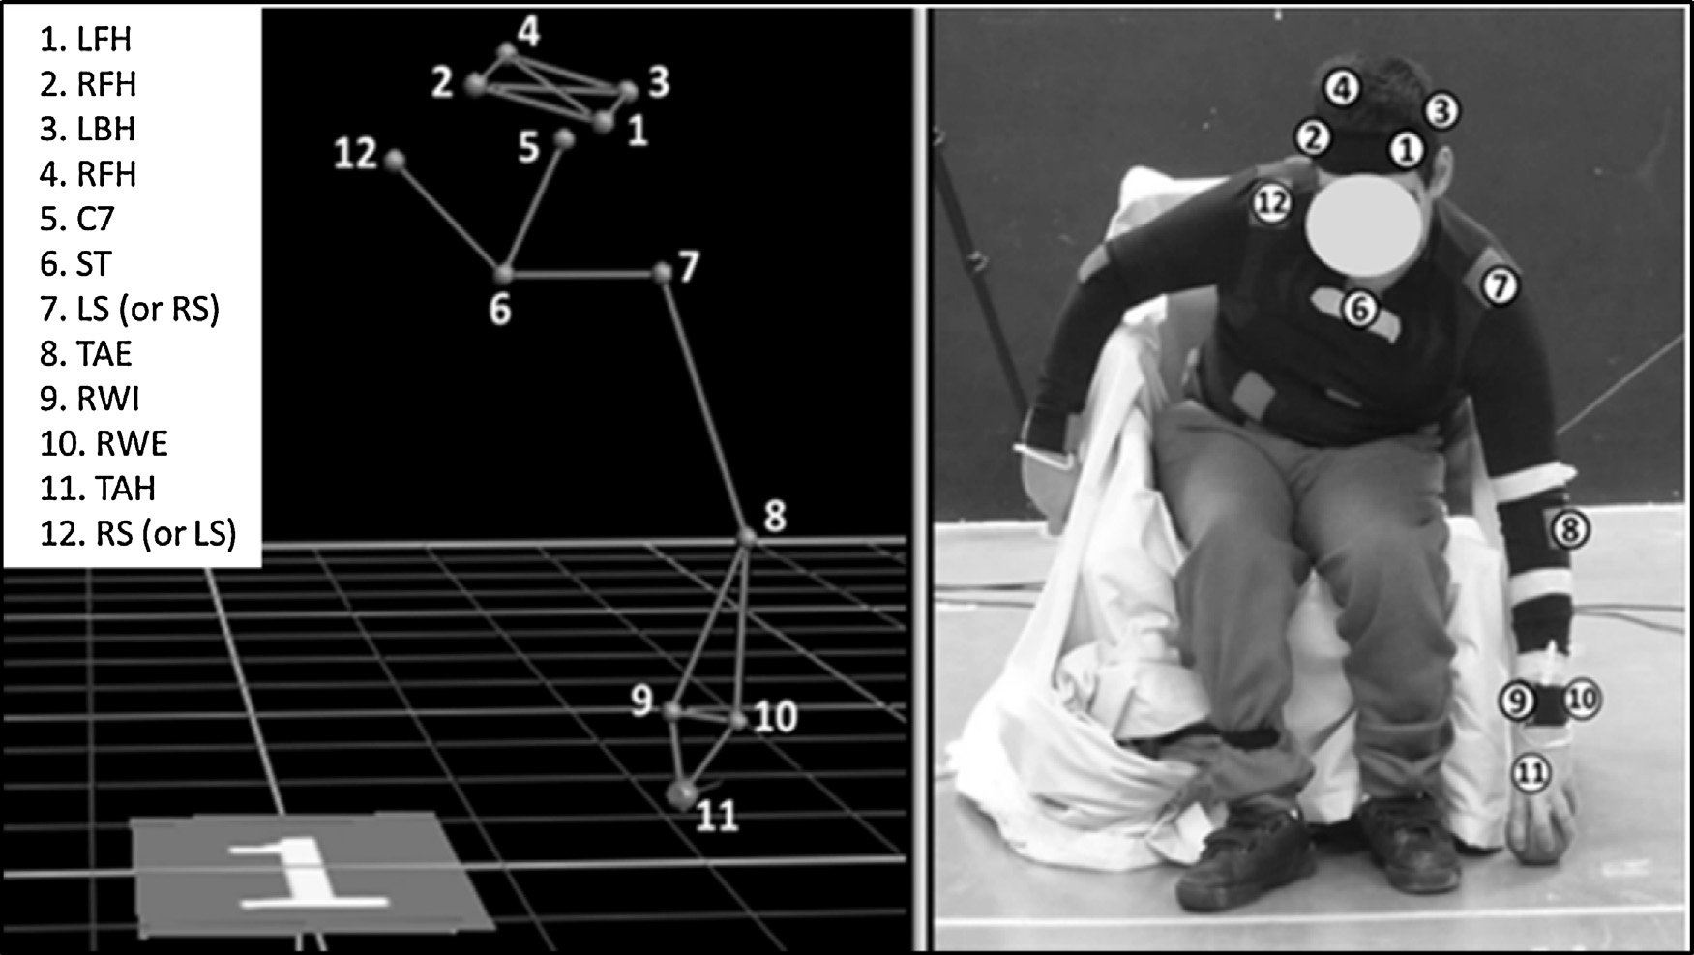

Figure 1A: three-dimensional capture of a player performing a throw using Vicon motion analysis (left), and a representation of the plug-in gait model and the 12 markers (right). LFH: left-front head; RFH: right-front head; LBH: left-back head; RFH: right-back head; C7: 7th cervical vertebra; ST: manubrium sternum; LS: left shoulder; RS: right shoulder; TAE: throwing-arm elbow; RWI: right wrist scaphoid — internal; RWE: right wrist scaphoid — external); TAH: throwing-arm hand.

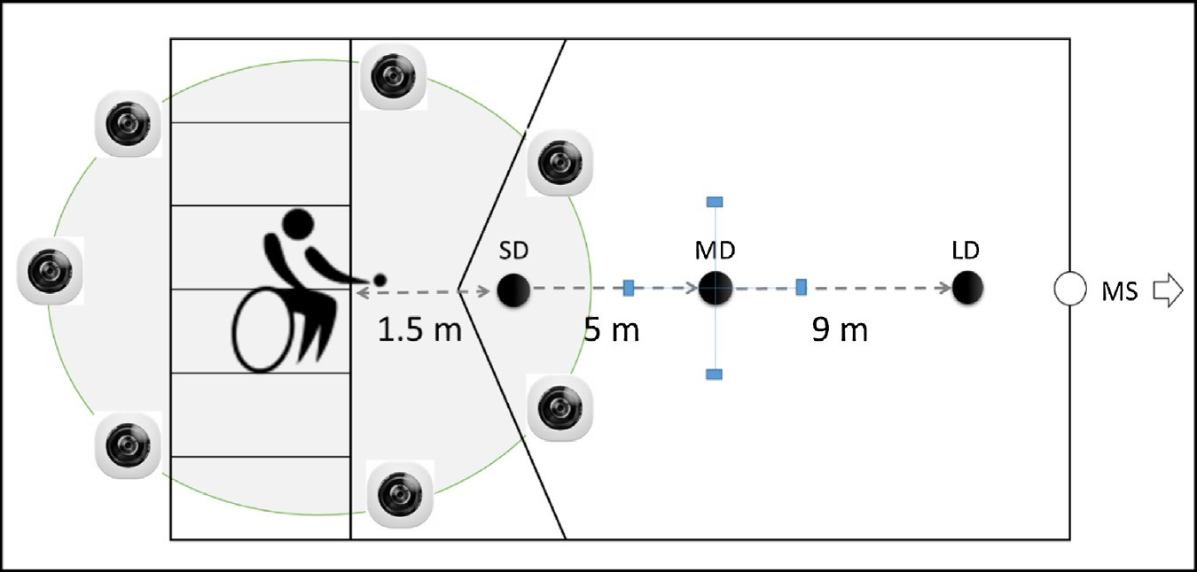

Figure 2 Court positioning of the players and the Vicon cameras. Throwing established situations: short (SD), medium (MD), long (LD) and maximum speed (MS), and the reference system to digitalise the throwing precision points (see on MD).

2.4. Statistical analysis

A repeated-measures ANOVA was conducted to evaluate the effect of throwing situations on kinematics and accuracy introducing the player’s sport classes (BC1 v BC2) as a between-subjects factor. A Bonferroni’s post-hoc analysis was also conducted to best ascertain pairwise comparisons. The strength of the association and the relationships between the variables were measured using a Pearson correlation analysis. The interpretation of the correlations is: low (r ≤ 0.3), moderate (0.3 < r ≤ 0.7) at high (r > 0.7) [22]. The effect size was calculated based on the partial eta-squared (hp2) and interpreted according to Richardson [23] as small (0.01 to 0.059), moderate (0.06 to 0.137) and large (≥ 0.138). The significance level was set at P < 0.05. All pro- posed analyses were performed using the Statistical Package for Social Sciences (version 22.0 for Windows, SPSS Inc., Chicago, IL, USA) software.

3. Results

3.1. Kinematics analysis of throwing

The repeated-measures ANOVA for the kinematics variables showed significant differences between situations for: elbow extension [F(4,35) = 92.27; P < 0.001; hp2 = 0.731], elbow flexion [F(4,35) = 10.98; P < 0.001; hp2 = 0.244], trunk inclination [F(4,35) = 24.85; P = 0.001; hp2 = 0.422], throwing speed [F(4,35)= 385.09; P < 0.001; hp2 = 0.919], and movement time [F(4,35) = 21.31; P < 0.001; hp2 = 0.385]. The pairwise comparison analysis of the four throwing situations indicated that extension and flexion of the elbow, and throwing speed, varied significantly between all distances (P < 0.001). Differences were also found regarding trunk inclination between the SD and MD (P = 0.006) and LD and MS (P < 0.05); and also between MD with regard to LD (P = 0.002) and MS (P = 0.035).The inter-subject analysis also showed significant differences between BC1 and BC2 players regarding elbow flexion [F(3,5) = 26.91; P < 0.001; hp2 = 0.171], trunk inclination [F(3,5) = 6.79; P < .001; hp2= 0.449], throwing speed [F(3,5) = 28.86; P < 0.001; hp2 = 0.467], and throwing time [F(3,5) = 14.43; P < 0.001; hp2 = 0.304]. No significant differences were found regarding elbow extension, although BC1 players usually show a lower range of movement than BC2 players (Fig. 3).

3.2. Throwing accuracy analysis

Fig. 4(a) shows the radial error obtained for the three throwing situations that required accuracy, increasing the error when the distance was longer [F(2,48) = 51.99; P < 0.001; hp2 = 0.515]. The pairwise comparisons analysis also confirmed significant differences between distances (P < 0.001). Results comparing performance and the athletes’ sports classes (BC1 and BC2) showed no significant differences in any of the measured distances. As seen in Fig. 4(b), the average radial error values tended to be higher for BC1 than for BC2 players in SD and LD, however, similar error values for both classes were found in MD. No differences were found for CEx in any of the distances for constant (CE) and absolute (AE) errors, in axis X and Y, observing a general trend of throwing to the left in the three distances. Conversely, significant differences were found in CEy between distances [F(2,48) = 4.28; P < 0.05; hp2 = 0.080],demonstrating a clear trend to exceed the target in SD and LD, and falling short in MD. Significant differences were found for AE in X [F(2,48) = 31.65; P < 0.001; hp2 = 0.392] and Y [F(2,48) = 19.59; P < 0.001; hp2 = 0.286] axis. The same results were obtained in the pairwise comparisons analysis of all throwing distances.

3.3. Relationship between variables of the study

Positive and moderate correlations between throwing speed and performance accuracy, were found at MD (r = 0.313, P < 0.05), and moderate and negative correlations at LD (r = −0.372, P < 0.05). Elbow flexion had a moderate and negative correlation with throwing speed at SD (r = −0.601;P < 0.001) and MD (r = −0.376, P < 0.05). A moderate and positive correlation was also found between throwing speed and elbow extension (r = 0.525; P < 0.001), and negative and moderate correlations with trunk inclination (r = −0.365; P < 0.05) at LD. Other positive correlations were found between the elbow extension and its flexion (r = 0.459;P < 0.05), and with trunk inclination (r = 0.748; P < 0.001).

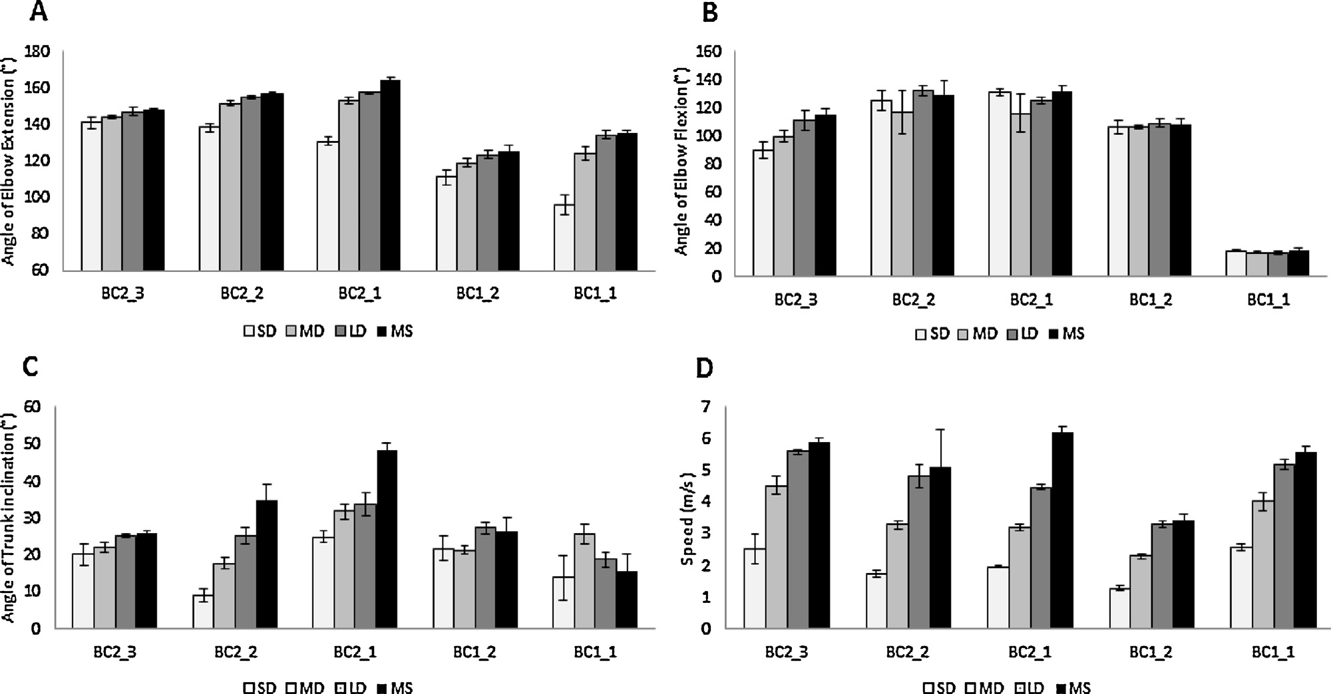

Figure 3 Overview of descriptive statistics (M ± DT) for angle elbow flexion (A) and extension (B), trunk inclination (C) and throwing speed (D), at short (SD), middle (MD), long (LD) and maximum speed (MS).

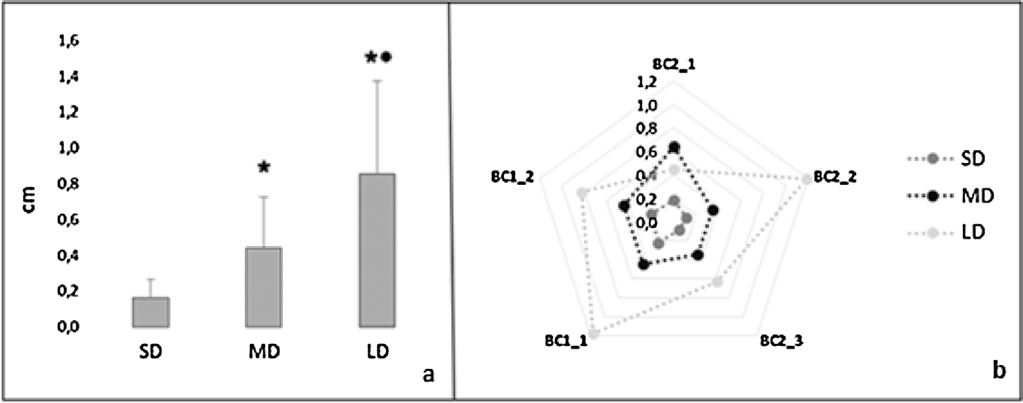

Figure 4 Average radial error values obtained for short (SD), middle (MD) and long (LD) distance (a), and radial error average values for each player (b). *: significant (P < 0.001) differences regarding SD; ** : significant differences (P < 0.001) regarding middle distance.

4. Discussion

It is rare to find studies involving boccia in the scientific literature, especially exploring the underlying performance factors in this para-sport. From a classification point of view, it is possible to identify a series of factors in boccia that should be considered when assigning a sport class to a player according to their functionality. Those factors are: hand function (grip and ball release), upper limb function (throwing arm action and compensatory strategies of the auxiliary arm), lower limb function (potential stabilisation, or playing with the foot), trunk control (ability to stabilise the player’s body on the chair), and the ability to handle the wheelchair within the box area. Clearly, we must add the tactical, psychological and decision-making abilities that will also determine a player’s sport performance.

As mentioned at the beginning of this paper, boccia is practised by players with hypertonia, ataxia and athetosis, among others impairments, and these eligible impairments have an impact on the coordination of the players. Impaired muscle tone, a typical characteristic of people with cerebral palsy, can thus lead players to present poor voluntary motor control and less consistent movements [24]. The current BisFed classification rulebook (2013) differentiates players in the BC1 and BC2 classes depending on whether the predominant impairment is hypertonic, or conversely, is ataxia/athetosis. The throwing kinematics analysis con- ducted with this group of high-level boccia players showed that BC1 players present a shorter elbow range of motion. Such results are explained by the fact that one of the players presented a clear hypertonic impairment (BC1 2), that means a high degree of spasticity in the elbow flex- ors and elbow extensors (biceps-triceps synergy). Huang et al. [3] found similar results when comparing children with cerebral palsy (CP) and normally developed children when

required to throw a boccia ball at a target placed at 5 m. We can see how Player BC1 2, in relation to trunk incli- nation, had the lowest scores for all throwing situations. The high level of spasticity and the limited range of pelvic movement with respect to the trunk and upper limbs that are presented by this player might explain these results. The trunk limitations usually showed by boccia players have been demonstrated previously, comparing them with participants without impairments [3] or comparing them regarding sport class BC1 or BC2 [25]. The second BC1 player (BC1 1) in our study presented a mixed profile (spasticity and athetosis), requiring higher control for their throw. This fact, extrapolated to a game situation, is understood as being the result of a low throwing speed. This is all related to the loss of fine motor control and hand coordination in BC1 players [8]. Ronnqvist et al. [26] found that people with CP required more time to perform a movement and presented those movements with trajectories that are more inefficient or with higher movement variability.

The three throwing distances might be understood as throwing constraints, since a boccia player is a complex system who interacts with the environment, appearing to have self-organised responses in order to achieve the task objective (i.e. placing the jack on the target). There are infinite situations in a game (e.g. ball positions usually change after every throw), which require different player responses, where the movement variability produced by the impairment is a challenge to accuracy. Changes during the game thus act like control parameters that impact a player’s responses, so that they have to adjust their throw in each trial (order parameter), minimising its variability and increasing its accuracy.

The results for both movement and outcome variability differ regarding throwing distances (control parameter); being more or less self-organised (order parameter) accord- ing to each situation. For example, radial error analysis (Fig. 4b) shows how the accuracy of the five players is similar for the SD and MD, which are the most frequent distances at which to play boccia. It must not be forgotten that the throwing action, per se, is already an exhausting activity for people with PC [3], especially for those with the most severe impairments, causing high levels of fatigue that end up affecting the degree of accuracy, throwing speed and their subjective perceived exertion [2]. LD is less common during competitions and therefore it might be a good control parameter, especially used with subjects with severe impairments as they are less able to adapt (be self-organised) to this game scenario. This hypothesis might be supported by the findings of Chang et al. [27], who concluded that the irregular trajectories thrown by people with CP are accompanied by longer movement adjustments and higher difficulties in control. These types of responses can be interpreted as order parameters, all with the aim of achieving better self-organisation. Huang et al. [3] used a unique distance of 5 m, the equivalent to our MD, and demonstrated no differences in accuracy between participants with and with- out CP. This is why a longer distance was set in this study, in order to understand what was happening when players played at the longest distance (close to the end-line of the court) and also comparing the self-organisation ability of five high-level players according to their level of functionality, as determined by their sport class.

The significant correlations found in this study provide plausible explanations for the relationship outlined between control (throwing situations) and the order parameters. A relationship was found between throwing speed and accuracy that seems to be positive for the middle distance and negative for the long distance, and the degree of spasticity presented by players might be an explanation for this relationship. It is important to remember that spasticity is strongly influenced by the speed of movement [28]. That means that when players need to cover a greater distance, they will be required to throw the ball with higher speed, and therefore, the mechanics of the throw will be more strongly affected by their spasticity. On the other hand, the negative and significant correlations obtained between elbow flexion and throwing velocity in SD and MD could be related to the use of compensatory strategies due the limitation of the range of motion in the elbow. In this regard, Reid et al. [29] concluded that people with CP with such limitations seem to use their shoulders and trunk to compensate for this limitation. The positive and significant correlations between throwing speed and elbow extension, and the negative correlation with respect to trunk inclination in the LD, demonstrate that players with a lower degree of spasticity (common in BC2 players) present a greater functional range of motion with which to perform the throwing action. In our study, this conclusion is also supported by the positive correlation between elbow extension and trunk inclination in LD. LD appears here as a throwing situation which can cause major adaptive responses or parameters of order.

5. Conclusions

This paper shows the relationship between movement and outcome variability performed by five high-level players who belong to the Spanish boccia Team. The accomplishment of several throws to less common distances during the game, closer to the bottom line of the court, led to a greater variability in the kinematics variables. This is interpreted as a decrease in accuracy, which is even more accentuated in players with more severe impairments. From a coaching perspective, it is important to high- light that individuals with CP tend to present lower learning capacity due to alterations in their proprioception system [30,31], stating that individuals with CP tend to assimilate better the explicit components of the motor learning (i.e., planning process) through instructions and feedback. These findings may be relevant for coaches and players for several reasons, such as: helping coaches to provide feedback to players about their execution patterns; analysing throwing outcomes such as speed and accuracy; planning throwing strategies to play in the own strong areas of the court, and also playing in the weak areas of the opponents (e.g., the use of long distances against players with severe impairments).

Disclosure of interest

The authors declare that they have no competing interest.

Acknowledgements

The research group would like to thank the players and technical staff of the Spanish Boccia team who took part in this study. This research was conducted under the joint leader- ship of the Miguel Hernandez University of Elche and the Spanish Federation of Sports for People with Cerebral Palsy and Brain Injury (FEDPC).

References

[1] Reina R. La iniciación deportiva adaptada a las personas con discapacidad física. Deportes adaptados a las personas con parálisis cerebral: Boccia. In: Rios M, editor. 565 juegos y tareas de iniciación deportiva adaptada a las personas con discapaci- dad. Barcelona: Paidotribo; 2015. p. 167—218.
[2] Fong DTP, Yam KY, Chu VWS, Cheung RTH, Chan KM. Upper limb muscle fatigue during prolonged Boccia games with underarm throwing technique. Sport Biomech 2012;11(4):441—51.
[3] Huang PC, Pan PJ, Ou YC, Yu YC, Tsai YS. Motion analysis of throwing Boccia balls in children with cerebral palsy. Res Dev Disabil 2014;35(2):393—9.
[4] Reina R, Caballero C, Roldán A, Barbado D, Sabido R. Elec- tromechanical delay in a ball release activity with time- and non-time constrained situations performed by Boccia players. Eur J Hum Movement 2015;35:125—36.
[5] Tsai YS, Yu YC, Huang PC, Cheng HYK. Seat surface inclination may affect postural stability during Boccia ball throwing in chil- dren with cerebral palsy. Res Dev Disabil 2014;35(12):3568—73.
[6] Howe PD, Jones C. Classification of disabled Athletes: (Dis)Empowering the Paralympic practice community. Sociol Sport J 2006;23:29—46.
[7] IPC — Explanatory guide to paralympic classification para- lympic summer sports; 2015 [accessed on 10th June 2016] https://www.paralympic.org/classification.
[8] BisFed- Boccia classification rules; 2013 [accessed on 15th May 2015] http://www.bisfed.com/wp-content/uploads/2014/ 01/BISFed-Boccia-Classification-Rules-2nd-Edition-2013.pdf.
[9] Tweedy S, Vanlandewijck Y. International Paralympic Com- mittee position stand — background and scientific principles of classification in Paralympic sport. Br J Sport Med 2011;45:259—69.
[10] IPC- IPC Athlete’s Classification Code; 2015 [accessed on 10th June 2016] https://www.paralympic.org/sites/default/ files/document/151218123255973 2015 12 17+Classification+ Code FINAL.pdf.
[11] Sosnoff JJ, Rice IM, Hsiao-Wecksler ET, Hsu IM, Jayaraman C, Moon Y. Variability in wheelchair propulsion: a new window into an old problem. Front Bioeng Biotechnol 2015;3:105.
[12] Urbán T, Gutiérrez O, Moreno FJ. Effects of unstable conditions on kinematics and performance variables in young handball players. J Hum Kinet 2015;46:39—48.
[13] Kloosterman MG, Buurke JH, de Vries W, Van der Woude LH, Rietman JS. Effect of power-assisted hand-rim wheelchair propulsion on shoulder load in experienced wheelchair users: a pilot study with an instrumented wheelchair. Med Eng Phys 2015;37(10):961—8.
[14] de Witte AM, Hoozemans MJ, Berger MA, van der Woude LH, Veeger D. Do field position and playing standard influence athlete performance in wheelchair basketball? J Sport Sci 2016;34(9):811—20.
[15] Hernández-Davó H, Urbán T, Sarabia JM, Juan-Recio C, Moreno FJ. Variable training: effects on velocity and accuracy in the tennis serve. J Sport Sci 2014;32(14):1383—8.
[16] Van Thiel E, Meulenbroek RG, Hulstijn W, Steenbergen B. Kinematics of fast hemiparetic aiming movements toward sta- tionary and moving targets. Exp Brain Res 2000;132(2):230—42.
[17] Braendvik SM, Elvrum AK, Vereijken B, Roeleveld K. Rela- tionship between neuromuscular body functions and upper extremity activity in children with cerebral palsy. Dev Med Child Neurol 2010;52(2):e29—34.
[18] Purohit AK, Raju BS, Kumar KS, Mallikarjun KD. Selective musculocutaneous fasciculotomy for spastic elbow in cerebral palsy: a preliminary study. Acta Neurochir 1998;140(5):473—8.
[19] Inokuchi H, Tojima M, Mano H, Ishikawa Y, Ogata N, Haga
N. Neck range of motion measurements using a new three- dimensional motion analysis system: validity and repeatability. Eur Spine J 2015;24(12):2807—15.
[20] Patterson TS, Bishop MD, McGuirk TE, Sethi A, Richards LG. Reliability of upper extremity kinematics while performing different tasks in individuals with stroke. J Motor Behav 2011;43(2):121—30.
[21] Trewartha G, Casanova R, Wilson C. A kinematic analysis of rugby lineout throwing. J Sport Sci 2008;226(8):845—54.
[22] Salaj S, Markovic G. Specificity of jumping, sprinting, and quick change-of-direction motor abilities. J Strength Cond Res 2011;25(5):1249—55.
[23] Richardson JTE. Eta squared and partial eta squared as meas- ures of effect sizes in educational research. Educ Res Rev 2011;6:135—47.
[24] Sanger TD. Arm trajectories in dyskinetic cerebral palsy have increased random variability. J Child Neurol 2006;21(7):551—7.
[25] Roldán A, Reina R, Mathee E, Barbado D. Relationship between five stable trunk tests and the trunk scale used by BisFed during classification in Boccia: toward evidence based classification. Eur J Adap Phys Act 2016;9:52—3.
[26] Ronnqvist L, Rosblad B. Kinematic analysis of unimanual reach- ing and grasping movements in children with hemiplegic cerebral palsy. Clin Biomech 2007;22(2):165—75.
[27] Chang JJ, Wu TI, Wu W, Su FC. Kinematical measure for spas- tic reaching in children with cerebral palsy. Clin Biomech 2005;20(4):381—8.
[28] Lee H, Huang Y, Chen J, Hwang I. Quantitative analysis of the velocity related pathophysiology of spasticity and rigidity in the elbow flexors. J Neurol Neurosurg Psychiatry 2002;72(5):621—9.
[29] Reid S, Elliott C, Alderson J, Lloyd D, Elliott B. Repeatability of upper limb kinematics for children with and without cerebral palsy. Gait Posture 2010;32(1):10—1.
[30] Gofer-Levi M, Silberg T, Brezner A, Vakil E. Deficit in implicit motor sequence learning among children and adolescents with spastic cerebral palsy. Res Dev Disabil 2013;34(11): 3672—8.
[31] Damiano DL, Stanley CJ, Ohlrich L, Alter KE. Task-specific and functional effects of speed-focused elliptical or motor- assisted cycle training in children with bilateral cerebral palsy: randomized clinical trial. Neurorehabil Neural Repair 2017;31(8):736—45.

